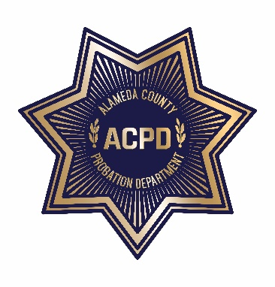
ALAMEDA COUNTY COMMUNITY CORRECTIONS PARTNERSHIP
ADULT REENTRY STRATEGIC PLANNING MEETING

July 24, 2019 3:00 PM – 5:00 PM
Glad Tidings COGIC, 970 Glad Tidings Way, Helen J. Macklin Hall, Hayward, CA 94544

AGENDA

- Call to Order and Introductions
- Review and Adoption of Meeting Minutes from April 3, 2019 (discussion and action)
- Goal 2 - Sub-Committee Reports/Updates (discussion and action)
- Community/Civic Engagement – Raymond Banks and Kamarlo Spooner (Co-Chairs)
- Education – L. Karen Monroe (Chair)/Monica Vaughan (Designee) and Dr. Tina Vasconcellos (Co-Chair)
- Family Reunification/Stability – Co-Chairs: Phyllis Nance, Kevin Bremond and Carol Burton
- Health - Colleen Chawla (Chair)
  - Substance Abuse - Carol Burton and Nathan Hobbs (Co-Chairs)
  - Mental Health - Carol Burton and Sophia Lai (Co-Chairs)
  - Physical Health - Aneeka Chaudhry (Co-Chair)
- Housing – Chris Bazar (Chair)/Linda Gardner (Chair-Designee) and Jeanette Rodriguez (Co-Chair)
- Joint Education/Workforce Development –Patti Castro, Micah Hinkle, Monica Vaughan and Dr. Tina Vasconcellos
- Goal 1 - Recidivism Reduction – Wendy Still (Chair) (discussion)
- “Redesigning the Pathways Home: Alameda County’s Pilot to Positive Reentry” Update – Chief Still (discussion)
- Next Meeting – October 2, 2019 (District 3)
- Public Comments
- Current CAB Vacancies: District 1: (2), District 2: (1), District 3: (1), District 4: (2), and District 5: (1)
- Adjournment

