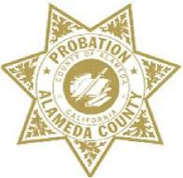

ALAMEDA COUNTY PROBATION DEPARTMENT
COMMUNITY CORRECTIONS PARTNERSHIP
EXECUTIVE COMMITTEE MEETING
Monday, February 4, 2019 from 2:00 PM – 5:00 PM
1111 Jackson Street, 2nd Floor (Rooms 226-228), Oakland, CA 94607
AGENDA
Note: Each member of the public may be allotted no more than 3 minutes to speak on each item. Time limits shall be at the discretion of the Chair of the Committee.
- Call to Order and Introductions
- Public Comment on Any Item Listed Below as for “Discussion Only”

Old Business
- Review and Adoption of Meeting Minutes of November 19, 2018 (discussion and action)

New Business
- Community Advisory Board (CAB) Update (discussion)
  - Current CAB Vacancies: District 1: (2) and District 3: (2)
- Innovations in Reentry (SMART Reentry) Grant – Kelly Glossup (discussion)
- Workgroup Updates
  - Programs and Services (discussion and action) – Neola Crosby
  - Fiscal and Procurement (discussion and action) – Wendy Still/Nancy O’Malley
    - Women’s Services Funding Recommendation, $1 million (discussion and action)
  - Process and Evaluation (discussion and action) – Brendon Woods
  - Data and Information Management (discussion) – Nancy O’Malley
- Adult Reentry Strategic Plan – Recidivism Sub-Committee (discussion and action)
- Next Meeting – March 18, 2019
- Public comment on any item not listed on the Agenda and within the jurisdiction of the Committee
- Adjournment

