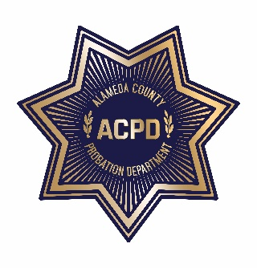
ALAMEDA COUNTY PROBATION DEPARTMENT
COMMUNITY CORRECTIONS PARTNERSHIP
EXECUTIVE COMMITTEE MEETING
REVISED
Monday, May 20, 2019 from 1:00 PM – 3:00 PM
1111 Jackson Street, 2nd Floor (Rooms 226-228), Oakland, CA 94607
AGENDA
Note: Each member of the public may be allotted no more than 3 minutes to speak on each item. Time limits shall be at the discretion of the Chair of the Committee.

- Call to Order and Introductions
- Public Comment on Any Item Listed Below as for “Discussion Only”

Old Business
- Review and Adoption of Meeting Minutes of March 18, 2019 (discussion and action)

New Business
- Workgroup Updates
  - Fiscal and Procurement (discussion and action) – Wendy Still/Nancy O’Malley
    - Programs and Services Workgroup Recommendations (discussion and action)
  - Data and Information Management (discussion) – Nancy O’Malley
- Community Advisory Board Funding Request (discussion and action)
- Adult Reentry Strategic Plan – Recidivism Sub-Committee (discussion and action)
- Cancel the July 22, 2019 meeting; reschedule for August 2019 (discussion and action)
- Public comment on any item not listed on the Agenda and within the jurisdiction of the Committee
- Adjournment

*The meeting will be recorded for note taking purposes only*

