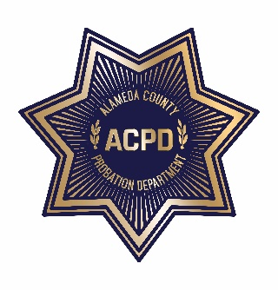
ALAMEDA COUNTY PROBATION DEPARTMENT
COMMUNITY CORRECTIONS PARTNERSHIP
EXECUTIVE COMMITTEE MEETING
Monday, August 5, 2019 from 2:00 PM – 5:00 PM
1111 Jackson Street, 2nd Floor (Rooms 226-228), Oakland, CA 94607
AGENDA
Note: Each member of the public may be allotted no more than 3 minutes to speak on each item. Time limits shall be at the discretion of the Chair of the Committee.

- Call to Order and Introductions
- Public Comment on Any Item Listed Below as for “Discussion Only”

Old Business
- Review and Adoption of Meeting Minutes of May 20, 2019 (discussion and action)

New Business
- Community Advisory Board (CAB) Update (discussion and action)
  - Current CAB Vacancies: District 1: (2); District 2: (1); District 3: (1); District 4: (2); and District 5: (1)
  - Community Advisory Board Request for Daytime Meetings discussion and action)
- BSCC Reentry Grant Award (discussion)
- Circles of Support and Accountability Restorative Justice Model (discussion)
- Workgroup Updates
  - Fiscal and Procurement (discussion and action) – Wendy Still/Nancy O’Malley
  - Process and Evaluation (discussion and action) – Brendon Woods
  - Programs and Services (discussion and action) – Neola Crosby
  - Data and Information Management (discussion) – Nancy O’Malley
- Adult Reentry Strategic Plan – Recidivism Sub-Committee (discussion and action)
- Public comment on any item not listed on the Agenda and within the jurisdiction of the Committee
- Adjournment

