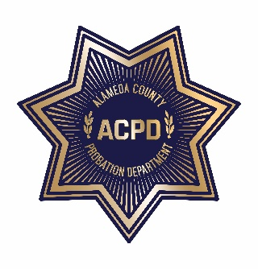
ALAMEDA COUNTY PROBATION DEPARTMENT
COMMUNITY CORRECTIONS PARTNERSHIP
EXECUTIVE COMMITTEE MEETING

Monday, March 16, 2020 from 1:00 PM – 5:00 PM
1111 Jackson Street, 2nd Floor (Rooms 226-228), Oakland, CA 94607
AGENDA
Note: Each member of the public may be allotted no more than 3 minutes to speak on each item. Time limits shall be at the discretion of the Chair of the Committee.

- Call to Order and Introductions
- Public Comment on Any Item Listed Below as for “Discussion Only”

Old Business
- Review and Adoption of January 16, 2020 Meeting Minutes (discussion and action)

New Business
- Community Advisory Board (CAB) Update (discussion and action)
  - Current CAB Vacancies: District 1: (2), District 2: (1), District 3: (2), District 4: (1), and District 5: (0)
- Fairness in Housing Campaign – John Jones III (discussion and action)
- Voting Eligibility – Natasha Middleton (discussion)
- Workgroup Updates (discussion and action)
  - Fiscal and Procurement (discussion and action) – Wendy Still/Nancy O’Malley
    - Approve Transitional Housing (32 beds) in Hayward; $950,000 for the first year and $875,000 annually thereafter (discussion and action)

  - Process and Evaluation (discussion and action) – Brendon Woods
  - Programs and Services (discussion and action) – Neola Crosby
  - Data and Information Management (discussion) – Nancy O’Malley
- Public comment on any item not listed on the Agenda and within the jurisdiction of the Committee
- Adjournment

*The meeting will be recorded for note taking purposes only*

