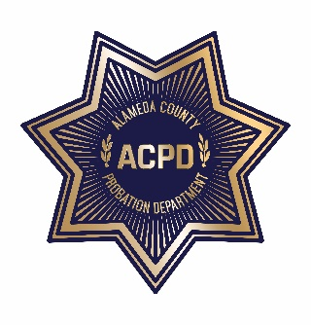
ALAMEDA COUNTY PROBATION DEPARTMENT
COMMUNITY CORRECTIONS PARTNERSHIP
EXECUTIVE COMMITTEE MEETING

Monday, April 6, 2020 from 1:00 PM – 3:00 PM
REVISED AGENDA
To guarantee social distancing, the meeting is a video conference. To join the meeting, click on the “Join Microsoft Teams Meeting” link below from any device. Meeting documents will be shared live during the meeting. Note: Documents cannot be viewed live, if you choose to use the call-in number; refer to Meeting Materials below to access documents.
________________________________________________________________________________
Join Microsoft Teams Meeting
+1 415-915-3950 (Toll)
Conference ID: 293 211 810#

- Call to Order and Introductions
- Public Comment on Any Item Listed Below as for “Discussion Only”

Old Business
- Review and Adoption of January 16, 2020 Meeting Minutes (discussion and action)

New Business
- Community Advisory Board (CAB) Update (discussion and action)
  - Current CAB Vacancies: District 1: (2), District 2: (1), District 3: (2), District 4: (1), and District 5: (0)

- Fairness in Housing Campaign – John Jones III (discussion and action)
- Voting Eligibility – Natasha Middleton (discussion)
- Workgroup Updates (discussion and action)
  - Fiscal and Procurement (discussion and action) – Wendy Still/Nancy O’Malley
    - Approve $10,627,024 for FY 19/20 and $7,649,972 for FY 20/21, as highlighted on the attached Realignment Allocations and Recommendations Spreadsheet

  - Process and Evaluation (discussion and action) – Brendon Woods
  - Programs and Services (discussion and action) – Neola Crosby
  - Data and Information Management (discussion) – Nancy O’Malley
- Public comment on any item not listed on the Agenda and within the jurisdiction of the Committee
- Adjournment

SUBMITTING WRITTEN PUBLIC COMMENT TO THE COMMUNITY CORRECTIONS PARTNERSHIP EXECUTIVE COMMITTEE
Persons who are unable to attend the meeting join the meeting via Microsoft Teams may submit to the Community Corrections Partnership, by the time the proceedings begin, written comments regarding the subject of the meeting. These comments will be made a part of the official public record, and brought to the attention of the Community Corrections Partnership. Written comments should be submitted to: Neola Crosby, Adult Probation Department, 1111 Jackson Street, Oakland, CA 94607, or via email: necrosby@acgov.org or via text at (510)-772-7434 or via Teams “Chat”.
MEETING MATERIALS
Copies of agendas, minutes, and explanatory documents are available through the Alameda County Probation Department’s Calendar of Events website at https://probation.acgov.org/calendar/list.page or by calling Neola Crosby at (510) 268-4145 during normal business hours. The material can be FAXed or mailed to you upon request.
ACCOMMODATIONS
To obtain a disability-related modification or accommodation, including auxiliary aids or services, to participate in the meeting, please contact Neola Crosby at necrosby@acgov.org or (510 268-4145) at least two business days before the meeting.

TRANSLATION
Interpreters for languages other than English are available on request. Sign language interpreters are also available on request. For either accommodation, please contact Neola Crosby at necrosby@acgov.org or (510) 268-4145 at least two business days before the meeting.

