COMMUNITY CORRECTIONS PARTNERSHIP  SUB-COMMITTEE REPORT | - 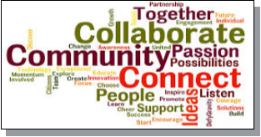
Sub-Committee Name
Health –Physical Health

Facilitator(s)
Aneeka Chaudhry, HCSA

Dates of Meetings
We’ve not yet held official sub-committee meetings, but have had background meetings with partners who will be at the table. Goals for the meetings include:
- Clearly identify target population(s)
- Evaluate usefulness and feasibility of existing measures in Re-Entry Roadmap
- Make recommendations for updated measures
- Make recommendations for data collection/reporting responsibilities

# of Unduplicated Attendees
TBD

Organizations represented at sub-committee meetings
Anticipated invitees:
- Alameda Clinic Consortium (and other community providers)
- Alameda County Health Care Services Agency (Care Connect, Office of Agency Director, Public Health, Behavioral Health)
- Alameda County Probation Department
- Alameda County Sheriff’s Office & WellPath
- Alameda Health System
- Individuals who can bring consumer experience
- RTI

Recommended Performance Measures
TBD

Recommended Strategies
TBD

