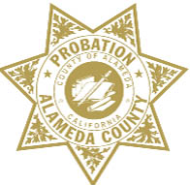

ALAMEDA COUNTY PROBATION DEPARTMENT
COMMUNITY CORRECTIONS PARTNERSHIP

FISCAL/PROCUREMENT WORKGROUP AGENDA
April 26, 2019 • 3:00 PM – 5:00 PM
1111 Jackson Street, 2nd Floor, Rooms 226-228, Oakland

- Call to Order and Introductions
- Public Comment on Any Item Listed Below as for “Discussion Only”
OLD BUSINESS
- Review and Adoption of Meeting Minutes of February 19, 2019
NEW BUSINESS
- AB 109 Funding Distribution Schedule
- Grants Update
- RFP and Contracts Update (discussion and action)
  - Probation Update (discussion)
  - Behavioral Health RFP Update (discussion)
- FY 18/19 Funding (discussion and action)
  - Programs and Services Workgroup Recommendations (discussion and action)
  - Community Advisory Board Funding Request (discussion and action)
- Next Meeting – May 14, 2019 • 3:00 PM – 5:00 PM
- Public Comment (discussion)

