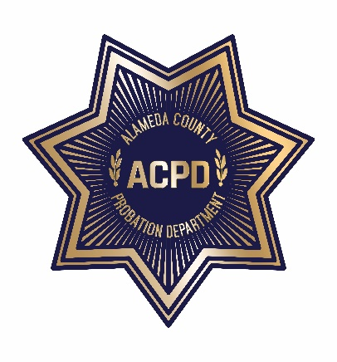

ALAMEDA COUNTY PROBATION DEPARTMENT
COMMUNITY CORRECTIONS PARTNERSHIP

FISCAL/PROCUREMENT WORKGROUP AGENDA
June 2, 2020 • 3:00 PM – 5:00 PM
To guarantee social distancing, the meeting is a video conference. To join the meeting, click on the “Join Microsoft Teams Meeting” link below from any device. Meeting documents will be shared live during the meeting. Note: Documents cannot be viewed live, if you choose to use the call-in number; refer to “Meeting Materials” below to access documents.
Join Microsoft Teams Meeting
+1 415-915-3950 United States, San Francisco (Toll)
(888) 715-8170 United States (Toll-free)
Conference ID: 620 310 528#

- Call to Order and Introductions
- Public Comment on Any Item Listed Below as for “Discussion Only”
OLD BUSINESS
- Review and Adoption of Meeting Minutes of May 5, 2020
NEW BUSINESS
- Grants Update
- RFP and Contracts Update (discussion and action)
  - Probation Update (discussion)
  - Behavioral Health RFP Update (discussion)
- FY 20/21 Funding (discussion and action)
a. Adjusted Base/CBO Realignment Allocations (discussion and action)
- Next Meeting – July 7, 2020 • 3:00 PM – 5:00 PM
- Public Comment (discussion)
SUBMITTING WRITTEN PUBLIC COMMENT TO THE FISCAL AND PROCUREMENT WORKGROUP
Persons who are unable to join the meeting via Teams, may submit to the Fiscal And Procurement Workgroup, by the time the proceedings begin, written comments regarding the subject of the meeting. These comments will be made a part of the official public record, and brought to the attention of the Fiscal and Procurement Workgroup. Written comments should be submitted to: Neola Crosby, Adult Probation Department, 1111 Jackson Street, Oakland, CA 94607, or via email: neola.crosby@acgov.org or via text at (510)-772-7434.

MEETING MATERIALS
Copies of agendas, minutes, and explanatory documents are available through the Alameda County Probation Department’s Calendar of Events website at https://probation.acgov.org/calendar/list.page or by calling Neola Crosby at (510) 268-4145 during normal business hours. The material can be FAXed or mailed to you upon request.

ACCOMMODATIONS
To obtain a disability-related modification or accommodation, including auxiliary aids or services, to participate in the meeting, please contact Neola Crosby at neola.crosby@acgov.org or (510 268-4145) at least two business days before the meeting.

TRANSLATION
Interpreters for languages other than English are available on request. Sign language interpreters are also available on request. For either accommodation, please contact Neola Crosby at neola.crosby@acgov.org or (510) 268-4145 at least two business days before the meeting.
*The meeting will be recorded for note taking purposes only*

