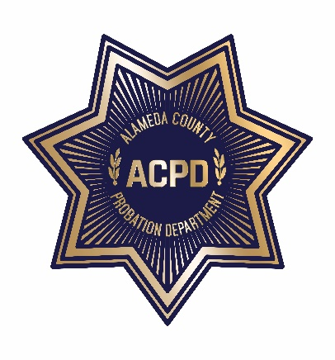

ALAMEDA COUNTY PROBATION DEPARTMENT
COMMUNITY CORRECTIONS PARTNERSHIP

FISCAL/PROCUREMENT WORKGROUP AGENDA
August 27, 2019 • 1:00 PM – 3:00 PM
1111 Jackson Street, 2nd Floor, Rooms 226-228, Oakland

- Call to Order and Introductions
- Public Comment on Any Item Listed Below as for “Discussion Only”
OLD BUSINESS
- Review and Adoption of Meeting Minutes of May 14, 2019
NEW BUSINESS
- Community Advisory Board Recommendations (discussion and action)
  - Request to fund a full-time consumer advocate/attorney
  - Request for childcare at CCPEC-related meetings
  - Request for transportation stipends for systems-impacted individuals to attend CCP/CCPEC-related meetings

- Grants Update (discussion)
- RFP and Contracts Update (discussion and action)
  - Probation Update
  - Behavioral Health RFP Update
- FY 19/20 Funding (discussion and action)
  - Allotment

  - CAB recommendation to increase funding for Father’s Services by $250,000 (total $500,000) and LGBTQ services by $100,000 (total $200,000)

  - CAB transportation stipends to attend CAB meetings, not to exceed $9,000 per fiscal year
- Next Meeting – September 10, 2019 • 3:00 PM – 5:00 PM
- Public Comment (discussion)

