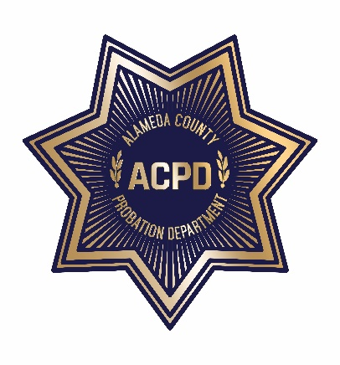

ALAMEDA COUNTY PROBATION DEPARTMENT
COMMUNITY CORRECTIONS PARTNERSHIP

FISCAL/PROCUREMENT WORKGROUP AGENDA
January 5, 2021 • 3:00 PM – 5:00 PM
To guarantee social distancing, the meeting is a video conference. Meeting documents will be shared live during the meeting. Please note: Documents cannot be viewed live if you choose to use the call-in number; refer to “Meeting Materials” below to access documents.
Click here to join the meeting from your computer or mobile app
Or call in (audio only): +1 415-915-3950,,883321833#; (888) 715-8170,,883321833# (Toll-free)
Phone Conference ID: 883 321 833#

- Call to Order and Introductions
- Public Comment on Any Item Listed Below as for “Discussion” only
OLD BUSINESS
- Review and Adoption of December 1, 2020 Meeting Minutes
NEW BUSINESS
- CORE Status Update (discussion)
- Behavioral Health Update (discussion)
- Grants Update (discussion)
- Probation RFP and Contracts Update (discussion)
- FY 20/21 Funding (discussion and action)
  - CAB Recommendations
    - Stimulus Check Lottery
    - District Mentoring Pilot Program
  - BOSS Realignment Housing Project
- AB 109 Designation Account Update (discussion)
- Next Meeting – February 2, 2021 from 3:00 PM to 5:00 PM
- Public Comment (discussion)

SUBMITTING WRITTEN PUBLIC COMMENT TO THE FISCAL AND PROCUREMENT WORKGROUP
Persons who are unable to join the meeting via Teams, may submit to the Fiscal and Procurement Workgroup, by the time the proceedings begin, written comments regarding the subject of the meeting. These comments will be made a part of the official public record and brought to the attention of the Fiscal and Procurement Workgroup. Written comments should be submitted to Lisa Abernathy, Probation Department, 1111 Jackson Street, Oakland, CA 94607, or via email at labernat@acgov.org.
MEETING MATERIALS
Copies of agendas, minutes, and explanatory documents are available through the Alameda County Probation Department’s Calendar of Events website at https://probation.acgov.org/calendar/list.page or by calling Lisa Abernathy at (510) 268-4145 during normal business hours. The material can be faxed or mailed to you upon request.
ACCOMMODATIONS
To obtain a disability-related modification or accommodation, including auxiliary aids or services, to participate in the meeting, please contact Lisa Abernathy at labernat@acgov.org or (510) 268-4145 at least two business days before the meeting.
TRANSLATION
Interpreters for languages other than English are available on request. Sign language interpreters are also available on request. For either accommodation, please contact Lisa Abernathy at labernat@acgov.org or (510) 268-4145 at least two business days before the meeting.

