- Do you currently have individuals working for your agency who have criminal justice involvement? Criminal Justice Involvement is defined as those individuals who are formerly incarcerated, on Parole, on Post Release Community Supervision, and/or community correction supervision (e.g. Probation, Juvenile Detention)? (24 out of 26 responded)
Key Personnel |  | Program Staff |  | Subcontractors
Yes | No | Yes | No | Yes | No
5 | 1 | 9 | 1 | 8 | 0
Total Yes: 22, Total No: 2 Independent Contractors: 2

- How many Vendors submitted a Criminal Justice Involved Hiring Report?
16 Vendors (Includes 2 Independent Contractors)
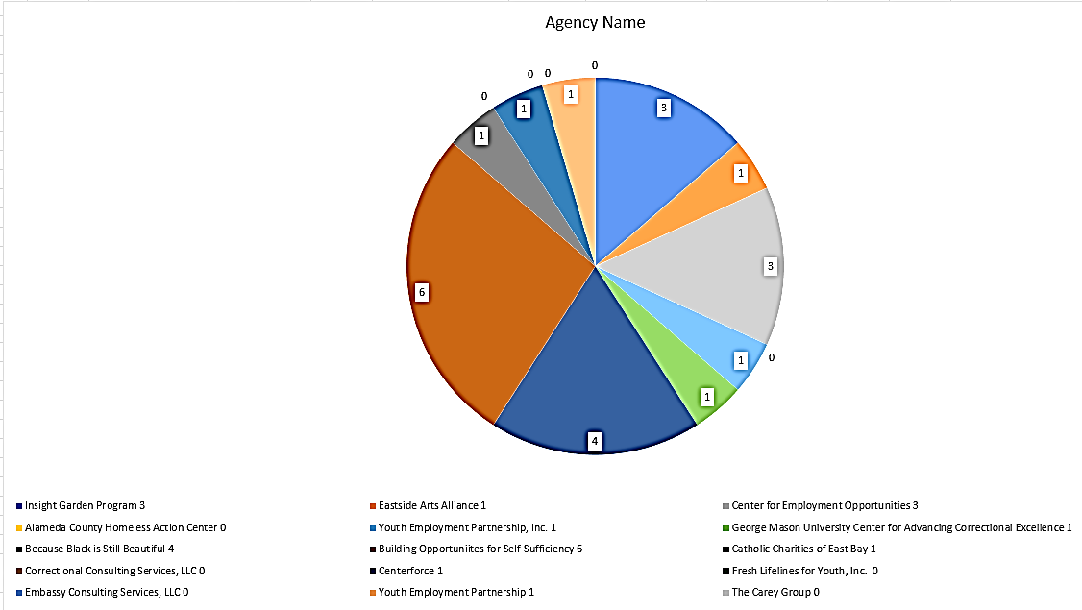

- Please indicate if the CJIS individual is a Key Personnel, Program Staff or Subcontractor?
Key Personnel | Program Staff | Subcontractor | Independent Contractors
6 | 10 | 8 | 2
Total: 26

- How many male, female, and others? (20 out of 26 responded)
Key Personnel |  |  | Program Staff |  |  | Subcontractors
Male | Female | Other | Male | Female | Other | Male | Female | Other
4 | 1 | 0 | 5 | 3 | 1 | 4 | 2 | 0
Total: 20
- How many CJIS individual(s) was released from Local or State Prison? (21 out of 26 responded)
Key Personnel |  |  | Program Staff |  |  | Subcontractors
State | Local | Don’t Know | State | Local | Don’t Know | State | Local | Don’t Know
2 | 2 | 1 | 2 | 1 | 6 | 5 | 1 | 1
State: 9, Local: 4, Don’t Know: 8, Total: 21,

- How many CJIS individual(s) is in a Management or Non-Management position? (21 out of 26 responded)
Key Personnel |  | Program Staff |  | Subcontractors
Management | Non-Management | Management | Non-Management | Management | Non-Management
3 | 2 | 6 | 3 | 1 | 6
Total: 21

- How many CJIS individual(s) part-time or full-time? (2 out of 3 responded)
Key Personnel Only
Full-Time | Part-Time
2 | 3

- What is the ethnic group of the CJIS individual(s)? Key Personnel Only (4 out of 5 responded)

- What language are CJIS individual(s) fluent in? Key Personnel Only (5 out of 5 responded)
English

