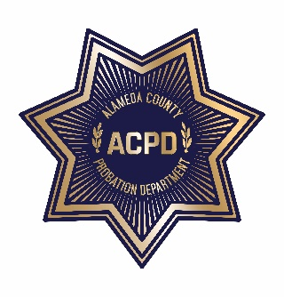
ALAMEDA COUNTY PROBATION DEPARTMENT
COMMUNITY CORRECTIONS PARTNERSHIP
EXECUTIVE COMMITTEE MEETING

Tuesday, October 8, 2019 from 12:00 PM – 5:00 PM
Alameda County Training and Education Center
125 – 12th St., 4th Floor, Hayward-Union City Conference Rooms, Oakland
AGENDA
Note: Each member of the public may be allotted no more than 3 minutes to speak on each item. Time limits shall be at the discretion of the Chair of the Committee.

- Call to Order and Introductions
- Public Comment on Any Item Listed Below as for “Discussion Only”

Old Business (discussion and action)
- Review and Adoption of August 5, 2019 Meeting Minutes

New Business
- Public Safety Realignment Year 7 Status Update (discussion and action)
- BSCC Reentry Grantee Overview (discussion and action)
  - Insight Garden
  - After Innocence
  - A Safe Place
  - Building Opportunities for Self-Sufficiency
  - Community and Youth Outreach
BREAK (10 minutes)
  - Community Works
  - Men of Valor
  - No More Tears
  - Oakland Private Industry Council, Inc.
  - Root and Rebound
  - Sister 2 Sister, Inc.
  - Youth Employment Partnership
  - LaClinica de la Raza, Inc. (not serving AC clients; Vallejo, only)

- Workgroup Updates
  - Fiscal and Procurement– Wendy Still/Nancy O’Malley
i. Approval of $9,341,847 for FY 19/20 (discussion and action)
- Adult Reentry Strategic Plan – Recidivism Sub-Committee (discussion and action)
- Current CAB Vacancies: District 1: (2); District 2: (1); District 3: (1); District 4: (2); and
District 5: (1)
- Public comment on any item not listed on the Agenda and within the jurisdiction of the
Committee
- Adjournment

*The meeting will be recorded for note taking purposes only*

