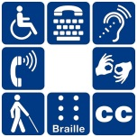

**Target Groups**

* **Long-term Unemployed**
* **Reentry**
* **Public Assistance Recipients**
* **Veterans**

**PUBLIC LIBRARY**

**Lead Provider coordination**

**Adult Schools**

**COMMUNITY COLLEGES**

**CBO INDIVIDUALS W/ DISABILITIES expertise**

**CBO Reentry expertise**

**Mandated partners**

**EMPLOYERS**

**(OJT & Job Placement)**

**Cbo VETERANS expertise**

**Social services**

**SUB-REGIONAL WORKFORCE NETWORK**

**Board priority expand access to individuals w/ disabilities**

**TECHNOLOGY**

**Innovation**

**Board priority expand access through technology**