COUNTY OF ALAMEDA

Questions & Answers

to

RFQ No. 901775

for

Lumber Supplies

Networking/Bidders Conferences Held on April 15, 2019

This County of Alameda, General Services Agency (GSA), RFQ Questions & Answers (Q&A) has been electronically issued to potential bidders via e-mail. E-mail addresses used are those in the County’s Small Local Emerging Business (SLEB) Vendor Database or from other sources. If you have registered or are certified as a SLEB, please ensure that the complete and accurate e-mail address is noted and kept updated in the SLEB Vendor Database. This RFQ Q&A will also be posted on the GSA Contracting Opportunities website located at http://acgov.org/gsa_app/gsa/purchasing/bid_content/contractopportunities.jsp

Alameda County is committed to reducing environmental impacts across our entire supply chain.
If printing this document, please print only what you need, print double-sided, and use recycled-content paper.
Responses to Questions from the Bidders Conferences and Written Questions

- What documents are vendors required to submit for this bid?
Please refer to Exhibit A, pages 6 and 7 in the RFQ and the bid form located in the EZ Sourcing portal - https://ezsourcing.acgov.org/ :

REQUIRED DOCUMENTATION AND SUBMITTALS

All of the specific documentation listed below is required to be submitted with the Exhibit A – Bid Response Packet in order for a bid to be deemed complete. Bidders shall submit all documentation, in the order listed below and clearly label each section with the appropriate title (i.e. Table of Contents, Letter of Transmittal, Key Personnel, etc.) and attached it as PDF file(s) to their online bid submissions through Strategic Sourcing Supplier Portal.
1. Table of Contents: Bid responses shall include a table of contents listing the individual sections of the quotation and their corresponding page numbers.
2. Letter of Transmittal: Bid responses shall include a description of Bidder’s capabilities and approach in providing its goods to the County, and provide a brief synopsis of the highlights of the Proposal and overall benefits of the Proposal to the County. This synopsis should not exceed three pages in length and should be easily understood.
3. Exhibit A – Bid Response Packet: Every bidder must fill out and submit the complete Exhibit A – Bid Response Packet.
(a) Bidder Information and Acceptance:
(1) Every Bidder must select one choice under Item 10 of page 3 of Exhibit A and must fill out, submit a signed page 4 of Exhibit A.
(b) SLEB Partnering Information Sheet:
(1) Every bidder must fill out and submit a signed SLEB Partnering Information Sheet, (found on page 8 of Exhibit A) indicating their SLEB certification status. If bidder is not certified, the name, identification information, and goods/services to be provided by the named CERTIFIED SLEB partner(s) with whom the bidder will subcontract to meet the County SLEB participation requirement must be stated. Any CERTIFIED SLEB subcontractor(s) named, the Exhibit must be signed by the CERTIFIED SLEB(s) according to the instructions. All named SLEB subcontractor(s) must be certified by the time of bid submittal.
(c) References:
(1) Bidders must use the templates on pages 9-10 of this Exhibit A – Bid Response Packet to provide references.
(2) Bidders are to provide a list of 6 clients. References must be satisfactory as deemed solely by County. References should have similar scope, volume and requirements to those outlined in these specifications, terms and conditions.
  - Bidders must verify the contact information for all references provided is current and valid.
  - Bidders are strongly encouraged to notify all references that the County may be contacting them to obtain a reference.
(3) The County may contact some or all of the references provided in order to determine Bidder’s performance record on work similar to that described in this request. The County reserves the right to contact references other than those provided in the Response and to use the information gained from them in the evaluation process.
(d) Exceptions, Clarifications, Amendments:
- This shall include clarifications, exceptions and amendments, if any, to the RFQ and associated Bid Documents, and shall be submitted with your bid response using the template on page 11 of this Exhibit A – Bid Response Packet.
- THE COUNTY IS UNDER NO OBLIGATION TO ACCEPT ANY EXCEPTIONS, AND SUCH EXCEPTIONS MAY BE A BASIS FOR BID DISQUALIFICATION.
4. Key Personnel: Bid responses shall include a complete list of all key personnel associated with the RFQ. This list must include all key personnel who will provide services/training to County staff and all key personnel who will provide maintenance and support services. For each person on the list, the following information shall be included:
(a) The person’s relationship with Bidder, including job title and years of employment with Bidder;
(b) The role that the person will play in connection with the RFQ;
(c) Address, telephone, fax numbers, and e-mail address;
(d) Person’s educational background; and
(e) Person’s relevant experience, certifications, and/or merits.
5. Description of the Proposed Services: Bid response shall include a description of the terms and conditions of services to be provided during the contract term including response times. The description shall identify spare or replacement parts that will be required in performing maintenance services, the anticipated location(s) of such spare parts, and how quickly such parts shall be available for repairs. Finally, the description must: (1) specify how the services in the bid response will meet or exceed the requirements of the County; (2) explain any special resources, procedures or approaches that make the services of Bidder particularly advantageous to the County; and (3) identify any limitations or restrictions of Bidder in providing the services that the County should be aware of in evaluating its Response to this RFQ.
6. Credentials: Copies of any licenses, certifications, or other third party verification of credentials stated as BIDDER QUALIFICATIONS in the RFQ must be submitted with the bid response; Documents must be clearly identified as to which requirement they are responsive.

- Should the bid form include local and state taxes?
The price quoted shall not include local and state taxes.

- What are the ship to locations/addresses for this RFQ?
The ship to locations/addresses for this RFQ will be as follows:

Location | Address
North County Carpenter/Paint/Lock Shop | 2054 Fairmont Drive, San Leandro 94578
South County Carpenter/Paint/Lock Shop | 5325 Broder Blvd, Dublin 94568
South County Combined Shop | 2130 Fairmont Drive, San Leandro 94578
North County Broadway | 661 Washington St, Oakland 94607
North County Oakland Combined Shop | 1225 Fallon St, Oakland 94612
East County Combined Shop | 5325 Broder Blvd, Dublin 94568

- Should pricing from the bidder include shipping charges?
Please refer to page 12 of the RFQ, (PRICING), item 5.b.:

Yes, the County is soliciting a total price. The price quoted shall be the total cost the County will pay. No charge for delivery, drayage, express, parcel post packing, cartage, insurance, license fees, permits, costs of bonds, or for any other purpose, except taxes legally payable by County, will be paid by the County unless expressly included and itemized in the bid.

- Is insurance required for this RFQ?
Please refer to Exhibit B of the RFQ:

EXHIBIT B
INSURANCE REQUIREMENTS - INSURANCE HAS BEEN WAIVED

- How do bidders account for inflation during the life of this contract?
Please refer to the bid form. There are 3 years of pricing required. Please account for any inflationary price adjustments in each year of the contract. Please also refer to page 12 of the RFQ, section L (PRICING), items 1. & 4. :

Prices quoted shall be firm for the first 36 months of any contract that may be awarded pursuant to this RFQ.

Any price increases or decreases for subsequent contract terms may be negotiated between Contractor and County only after completion of the initial term.
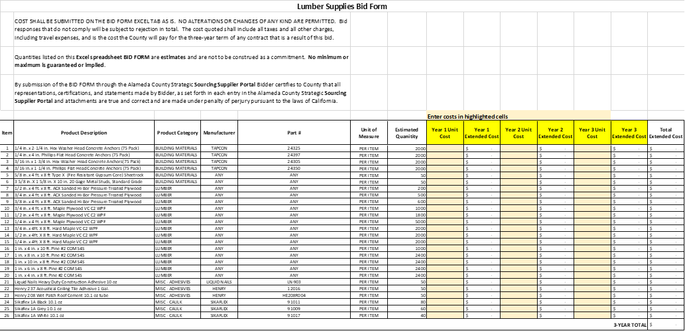

The following participants attended the Networking/Bidders Conference and Vendor Outreach:

 | Company Name / Address | Representative | Contact Information
 | Precious Gleaning Enterprise  1684 Decoto Rd, # 178  Union City, CA 94587 | L Douglas JR | Phone: (510) 815 1818
 |  |  | E-Mail: preciousgleaning@gmail.com
 |  |  | Prime Contractor: No
 |  |  | Subcontractor: Yes
 |  |  | Certified SLEB: Yes

EXHIBIT C
VENDOR LIST

RFQ No. 901775 Lumber Supplies

Below is the Vendor Bid List for this project consisting of vendors who have been issued a copy of this RFP. This Vendor Bid List is being provided for informational purposes to assist bidders in making contact with other businesses as needed to develop local small and emerging business subcontracting relationships to meet the requirements of the Small Local Emerging Business (SLEB) Program: http://www.acgov.org/gsa/departments/purchasing/policy/slebpref.htm.

RFQ No. 901775 Lumber Supplies
Business Name | Name | Phone | Address | City | ST. | Email
Economy Lumber | John Bacon/Matt Sugerman | (510) 261-6100 |  |  |  | jbacon@economylumberco.com
 |  | (510) 658-1826
Larsen Brothers | Sam Larsen | (510) 357-5020 |  |  |  | sam@larsenlumber.com
 |  | (510) 703-2416
Richert Lumber | Matthew Richert | (925) 786-0884 |  |  |  | matt@richertlumber.com
 |  | (925) 846-5040
MacBeath Hardwood | Rick McDaniel | (510) 843-4390
Bailey Fence Company | Karrick Bailey | (510) 783-2980 |  |  |  | baileyfenceco@hotmail.com
 | Benjamin Gleichner
Precious Gleaning Enterprise | L Douglas JR | (510) 815 1818 | 1684 Decoto Rd, # 178 | Union City | CA | preciousgleaning@gmail.com

