COUNTY OF ALAMEDA

Addendum No. 1

to

RFP No. 901789

for

Multimedia Printing Equipment

Specification Clarification/Modification

This County of Alameda, General Services Agency (GSA), RFP Addendum has been electronically issued to potential bidders via e-mail. E-mail addresses used are those in the County’s Small Local Emerging Business (SLEB) Vendor Database or from other sources. If you have registered or are certified as a SLEB, please ensure that the complete and accurate e-mail address is noted and kept updated in the SLEB Vendor Database. This RFP Addendum will also be posted on the GSA Contracting Opportunities website located at http://www.acgov.org/gsa/purchasing/bid_content/ContractOpportunities.jsp.


Alameda County is committed to reducing environmental impacts across our entire supply chain.
If printing this document, please print only what you need, print double-sided, and use recycled-content paper.
The following Sections have been modified to read as shown below. Changes made to the original RFQ document are in bold print and highlighted, and deletions made have a strike through.

Calendar of Events is modified as follows:

CALENDAR OF EVENTS
REQUEST FOR PROPOSAL No. 901789
Multimedia Printing Equipment
EVENT | DATE/LOCATION
RFP Issued | April 22, 2019
Questions Due | April 30, 2019 by 5:00 p.m.
Networking/Bidders Conference/Site Visit | April 30, 2019, 10:00 a.m.  Alameda County Sheriff’s Office  Multimedia Services Unit  5325 Broder Blvd  Dublin, CA 94568
List of Attendees/Vendors Issued | May 1, 2019
Q&A Issued | May 8, 2019 May 17, 2019
Addendum No. 1 Issued | May 13, 2019 May 17, 2019
Response Due | May 28, 2019 June 4, 2019 by 2:00 p.m.  https://ezsourcing.acgov.org
Evaluation Period | May 29, 2019 – July 5, 2019 June 4, 2019 – July 12, 2019
Vendor Interview Dates Announced | June 12, 2019 June 17, 2019
Notice of Intent to Award/Non-Award Issued | July 17, 2019
Notice of Board Award Date Issued | August 1, 2019
Board of Supervisors Board Date | August 6, 2019
Contract Start Date | September 20, 2019

Page 3 of the RFP, Table of Contents is modified as follows:

ATTACHMENTS

Exhibit a - BID RESPONSE PACKET
exhbiit b – security site clearance
exhibit c – vendor list
exhibit d – work order form
exhibit e - print order form
exhibit f – print service invoice
exhbiit g – sample finance report

Page 4 of the RFP, Section A. (INTENT) is modified as follows:

- INTENT
It is the intent of these specifications, terms and conditions to describe multimedia equipment leasing and services required by the Alameda County Sheriff’s Office Crime Laboratory for the Photo & Print Shop at the Santa Rita Jail Facility, located in Dublin, CA.
The County intends to award a five-year contract to lease (with option to renew) to the bidder(s) selected as the lowest responsible bidder whose response meets the County’s requirements. selected as the most responsible bidder whose response conforms to the RFP and meets the County’s requirements.
It is the intent of these specifications, terms and conditions to procure the most environmentally preferable products with equivalent or higher performance and at equal or lower cost than traditional products. Specific requirements from the County’s Sustainability Program that are related to this Bid are included in the appropriate Bid sections.

Page 15 of the RFP, Section G. (G. EVALUATION CRITERIA / SELECTION COMMITTEE) is modified as follows:

B. | Showroom Location  Showroom location must be within 100 miles of the Alameda County in order to be considered for award. | Pass/Fail


EXHIBIT C
VENDOR LIST

RFP No. 901789 – Multimedia Printing Equipment

Below is the Vendor Bid List for this project consisting of vendors who been issued a copy of this RFP. This Vendor Bid List is being provided for informational purposes to assist bidders in making contact with other businesses as needed to develop local small and emerging business subcontracting relationships to meet the requirements of the Small Local Emerging Business (SLEB) Program: http://www.acgov.org/gsa/departments/purchasing/policy/slebpref.htm.

This RFP Q&A is being issued to all vendors on the Vendor Bid List; the following revised vendor list includes contact information for each vendor attendee at the Networking/Bidders Conferences.
901789 - Multimedia Printing Equipment
Business Name | Contact Name | Contact Phone | Address | City | State | Email
ARC | Anthony Tang | (415) 312-4107 | 100 Hooper St. Suite 20 | San Francisco | CA | anthony.tang@e-arc.com
Canon Solutions America | Jeffrey Carvalho | (415) 743-7324 | 201 California Street Suite 100 | San Francisco | CA | jcarvalho@csa.canon.com
Canon Solutions America | Letha Clement | (925) 465-8499 | 1350 Treat Blvd. Suite 150 | Walnut Creek | CA | lclement@csa.canon.com
Canon Solutions America | Allison J. Spooner | (415) 748-0545 | 1350 Treat Blvd. Suite 150 | Walnut Creek | CA | aspooner@csa.canon.com
Canon Solutions America | Julia Thomas | (415) 314-3248 | 1350 Treat Blvd. Suite 150 | Walnut Creek | CA | juthomas@csa.canon.com
Canon Solutions America | Jeffrey Carvalho | (415) 743-7324 | 201 California Street Suite 100 | San Francisco | CA | jcarvalho@csa.canon.com
Canon Solutions USA | Knut Torhus | (415) 743-7303 | 201 California Street Suite 100 | San Francisco | CA | ktorhus@csa.canon.com
Konica Minolta Business Solutions | Michael Young | (925) 262-2845 | 2121 N California Blvd Suite 800 | Walnut Creek | CA | myoung@kmbs.konicaminolta.us
Ricoh | Maurice Stewart | (510) 913-7847 | 1320 Willow Pass Road Suite 200 | Concord | CA | Maurice.Stewart@ricoh-usa.com
Ricoh | Jonathan Sonneborn | (415) 378-5000 | 1320 Willow Pass Road Suite 200 | Concord | CA | Jonathan.Sonneborn@ricoh-usa.com
Sharp | Donna Demarest | (925) 931-4978 | 490 Boulder Court | Pleasanton | CA | Donna.Demarest@SharpUSA.Com
MRC | Kevin McCarthy | (925) 225-8910 | 5050 Hopyard Roade, Suite 100 | Pleasanton | CA | kmccarthy@mrc360.com
Ray Morgan Company | Martin Soares | (925) 400-4166 | 470 Boulder Court, Suite A | Pleasanton | CA | msoares@raymorgan.com
Ray Morgan Company | Eric Boutte | (925) 400-4165 | 470 Boulder Court, Suite A | Pleasanton | CA | eboutte@raymorgan.com
Sharp | Sheila Geldermann | (925) 931-4978 | 491 Boulder Court | Pleasanton | CA | Sheila.Geldermann@SharpUSA.Com
Xerox | Lisa Perez |  | 4301 Hacienda Drive Suite 130 | Pleasanton | CA | lisa.perez@xerox.com
Xerox Corp. | Frank Louie | (916) 561-6108 | 2485 Natomas Park Drive Suite 250 | Sacramento | CA | Frank.Louie@xerox.com

EXHIBIT D
Work Order Form
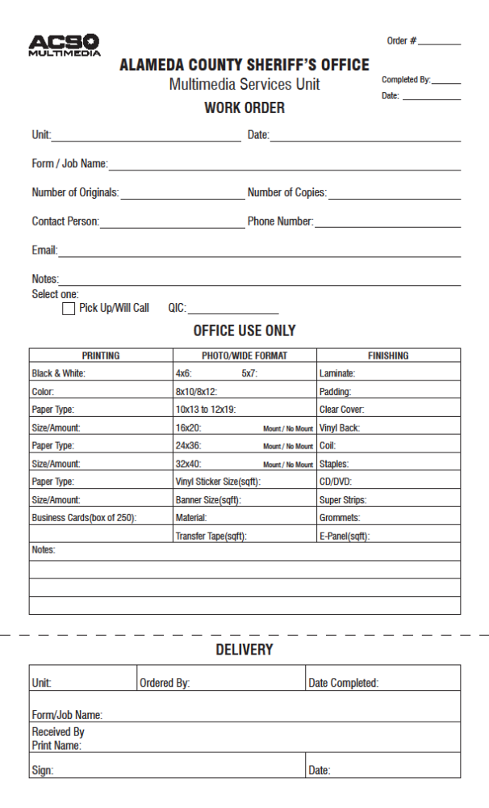
EXHIBIT E
Print Order Form
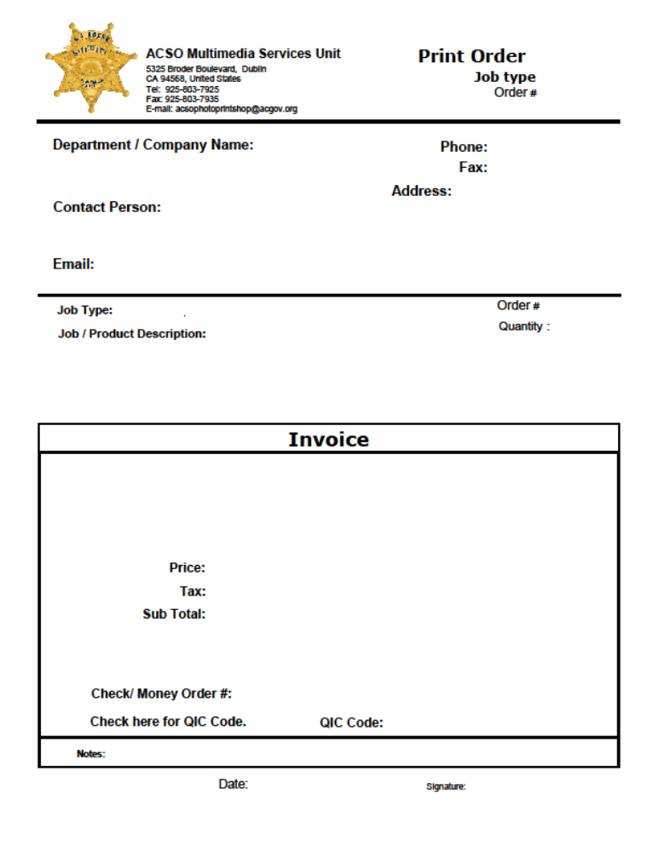
EXHIBIT F
Print Services Invoice
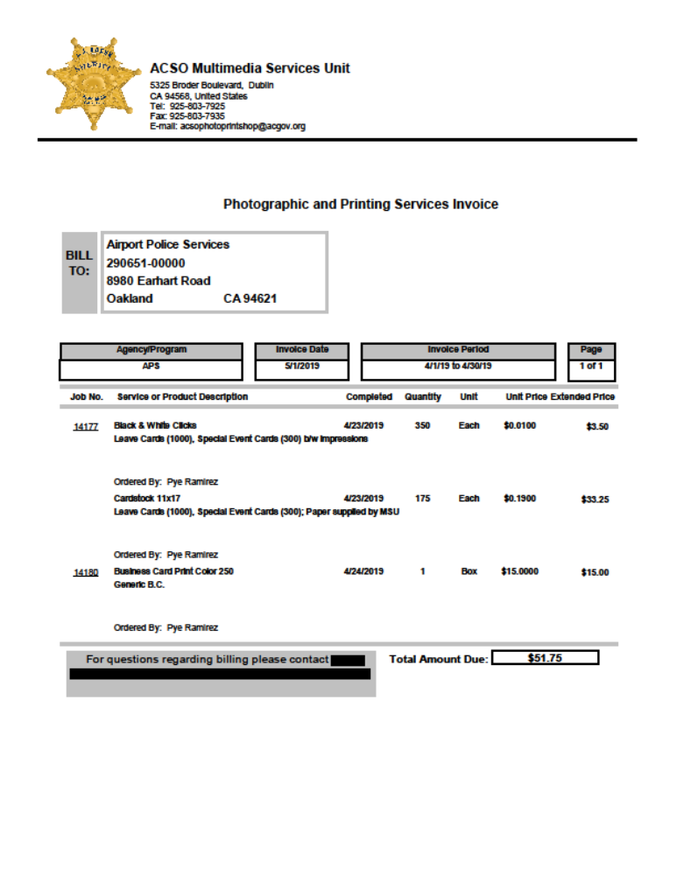

EXHIBIT G
Sample Finance Report


