COUNTY OF ALAMEDA

Questions & Answers

to

RFP No. 902043

for

Microfilm Retention Services

Networking/Bidders Conferences Held on December 2 and 7, 2021

This County of Alameda, General Services Agency (GSA), RFP Questions & Answers (Q&A) has been electronically issued to potential bidders via e-mail. E-mail addresses used are those in the County’s Small Local Emerging Business (SLEB) Vendor Database or from other sources. If you have registered or are certified as a SLEB, please ensure that the complete and accurate e-mail address is noted and kept updated in the SLEB Vendor Database. This RFP Q&A will also be posted on the GSA Contracting Opportunities website located at Alameda County Current Contracting Opportunities.

Alameda County is committed to reducing environmental impacts across our entire supply chain.
If printing this document, please print only what you need, print double-sided, and use recycled-content paper.
Thank you for your participation and interest in the County of Alameda.
All the questions are direct copy and paste from written questions emailed by Bidders. In the answers of these questions, the County of Alameda shall be noted as “County”. The Questions and Answers are the final stance of the County. Please consider this document in preparation of your bid response.
Questions and Answers:
- What are the current dimensions of the microfilm cartons in storage?
Estimates of the current and typical cartons are below. It is subject to change depending on the box type availability.
16mm Microfilm Carton (encases the individual microfilm rolls) - 3 13/16“ L x 1“ W (plus or minus 1/16 inch) x 3 13/16” H
Microfilm Box dimensions (holds several rolls in one box) – 24” L x 9.5” W x 4.5” H
- You mentioned 600 Cu. Ft. in storage (is this correct) ??
Per page 5 of the RFP, Section B (SCOPE) states: The Alameda County Clerk-Recorder’s office currently stores a copy of official public records (in the form of microfilms) in a remote location. The County currently has over 11,500 units of microfilm in varying sizes stored in over 400 cubic feet of storage space.
- You also mention that 10,000 cartons will be added a year for the next 3 years (also what are the sizes).
Information provided on the Bid Form are estimates and quantities are not guaranteed. Microfilm sizes can vary depending on the type of film.
- Can you send a copy of the current agreement in place?
Yes. Please submit a public records request online at: Alameda County Public Records Request.
- Is this RFP award contingent on finding a SLEB (I don’t think we have any options in the bay area?
Bidders that are bidding as a prime must subcontract at least 20% of the total contract value of the contract to a certified SLEB(s). If bidders can not meet the requirement, bidders can requests for an exceptions or clarifications. Any exception or clarifications must be identified on the Exceptions and Clarification form. The County is under no obligation to accept any exceptions or clarifications and any such exceptions and clarifications may be a basis for bid disqualification.
- For transfer/cost purposes, please provide the address of the building where the microfilm is currently kept?
To maintain the security of our documents, the County cannot disclose the full address but it is in the Sacramento Area.
- Please confirm that the microfilm is to be kept over 120 miles from Oakland, CA.
No, per page 5 of the RFP, Section C (BIDDER QUALIFICATIONS) Item b. states:

Contractor’s vault shall be:
(1) At least 120 miles from the Clerk Recorder’s Office located at 1106 Madison Street, Oakland, CA 94607;
(2) At least 120 miles from an earthquake fault line (Bidders may use the State of California website as a reference http://maps.conservation.ca.gov/cgs/fam/ );
(3) Not in a heavy flood zone, to ensure County microfilm and microfiche are adequately protected from external elements (Bidders may use the FEMA website as a reference https://msc.fema.gov/portal/ ); and
(4) Not be beneath a dam. The location of the vault on a map shall be included within proposal.

- Since the microfilm is going to be stored so far away, can the microfilm be sent over electronically instead of physically when requested.
No the documents cannot be sent over electronically. Per page 7 of the RFP, Section D (SPECIFIC REQUIREMENTS) Item 1.g. states: Contractor to retrieve and deliver stored microfilm to County within 24 hours from vault upon request.
- Please detail the indexing parameters, if its by the jacket or roll or both.
Indexed information of films (details on labels of each film) and indexed information of boxes (box label and include all films inside the box).
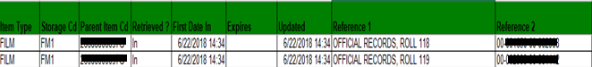
- Can you please send a picture of the sample carton the microfilm is currently stored in.
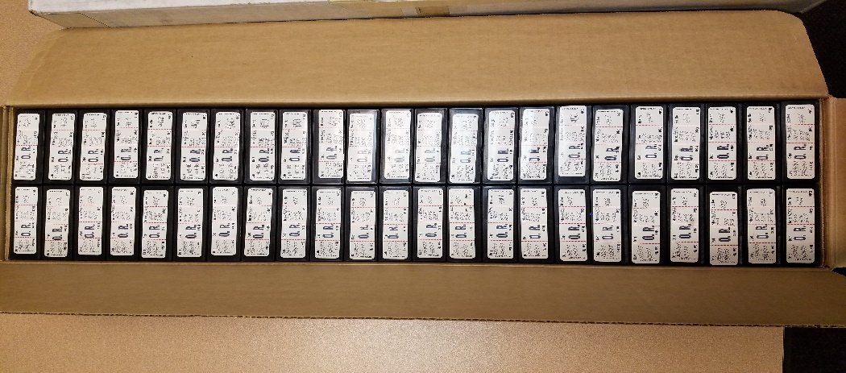

- Are the microfilm / fiche records currently stored in metal cabinets. If so, does the county own them.
The microfilm is stored within their cartons in steel or similar indestructible filing cabinets in a climate-controlled vault. The County does not own the storage furniture.

VENDOR BID LIST
RFP No. 902043 – Microfilm Retention Services

This Vendor Bid List is being provided for informational purposes to assist bidders in making contact with other businesses as needed to develop local small and emerging business subcontracting relationships to meet the requirements of the Small Local Emerging Business (SLEB) Program.
This Q and A is being issued to all vendors on the Vendor Bid List; the following revised vendor bid list includes contact information for each vendor attendee at the Networking/Bidders Conferences.
RFP No. 902043
Business Name | Name | Phone | Address | City | ST. | Email
Admail-Express, Inc. | Brian Schott | ( 510 ) 477-6240 | 31640 Hayman Street | HAYWARD | CA | brian.schott@admail.com
ATHENA MANAGEMENT SOLUTIONS LLC | Kami Johnson | ( 888 ) 327-2525 | 118 GABLE AVE | BERKELEY | CA | kjohnson@athenamanagementsolution.com
Atthowe Transportation Cooperative Corp. DBA Atthowe Fine Art Services | Donnell Campbell | ( 510 ) 654-6816 | 3924 Market Street | OAKLAND | CA | donnell@atthowe.com
B & B Copy Express, Inc. | Ma. Bernarditta Ferriols | ( 510 ) 835-9700 | 1814 Franklin Street, #810 | OAKLAND | CA | beth@bbcopyexpress.com
BKJM Moving Services LLC | Bevlen Klein | ( 510 ) 780-2680 | 3146 Corporate Pl | HAYWARD | CA | jlobaton@ncmss.com
Business Recovery Services, Inc. DBA Bank UP | Michael Santimauro | ( 510 ) 522-9714 | 1301 Marina Village Parkway, Ste. 250 | ALAMEDA | CA | msantimauro@bank-up.com
BMI Imaging Systems | Gordon Shiozaki | (408) 736-7444 x212 | 1115 E. Arques Ave. | Sunnyvale | CA | gshiozaki@bmiimaging.com
Datafile | Andrew Thomas | (614) 885-9050 | 60 Grace Dr. | Powell | OH | andy@datafile-corp.com
Denevi | Michael Denevi | (800) 447-4469 | 21091 Foothill Blvd. | Hayward | CA | michael@denevi.com
Development Services/granthelper | Marie Beichert | ( 415 ) 686-6239 | 1201 Pine St., #155 | OAKLAND | CA | marie@granthelper.com
Earp Events & Fundraising | Laurie Earp | ( 510 ) 839-3100 | 300 Frank H Ogawa Plaza, Suite 253 | OAKLAND | CA | laurie@earpevents.com
Ellen Muir Systems Coaching & Consulting | Ellen Muir | ( 510 ) 220-7665 | 129 Euclid Avenue | SAN LEANDRO | CA | emuirsc@gmail.com
First Impressions Printing, Inc. | Jennifer Stang | ( 510 ) 784-0811 | 25030 Viking Street | HAYWARD | CA | jstang@firstimpressionsprinting.com
Global Document Solutions | Rick Owen | ( 510 ) 372-1743 | 25000 Industrial Blvd. | HAYWARD | CA | rowen@gdocs.com
GRM Information Mgmt Services | Jay Crider | ( 800 ) 932-3006 | 41099 Boyce Road | FREMONT | CA | jcrider@grmdocument.com
GRM Information Mgmt Services | Sue Wodarski | (800) 932-3006 | 41099 Boyce Road | FREMONT | CA | swodarski@grmdocument.com
GRM Information Mgmt Services | Michael Vlahos | 510-933-4225 | 41099 Boyce Road | FREMONT | CA | mvlahos@grmdocument.com
H & K Mfg Co | Karen Thompson | ( 925 ) 828-1659 | 7112 Village Pkwy | DUBLIN | CA | HKMachine@aol.com
Hayward Rv Storage | Shirley Long | ( 510 ) 785-1854 | 3636 Depot Rd | HAYWARD | CA
Inter-City Printing Co Inc DBA Madison Street Press | Paul Murai | ( 510 ) 451-4775 | 614 Madison Street | OAKLAND | CA | paul@madisonstreetpress.com
Iron Mountain | Mark Huss | (610) 792-7327 | 1101 Enterprise Dr. | Royersford | PA | mark.huss@ironmountain.com
Kuda Express Corporation | Lisa Kwee | ( 510 ) 354-3000 | 40577 Albrae St. #E | FREMONT | CA | lisahk@kudaexpress.com
LMT CONSULTING, INC. | GRACE UWADIALE | ( 925 ) 325-8979 | 303 Hegenberger Rd, Suite 308 | OAKLAND | CA | graceu@lmtconsult.com
MCO | Mike McCluskey | (951) 898-2800 | 529 W. Rincon St. | Corona | CA | mike@mco-image.com
Magnolia Engineering and Construction | Tammy Willis | ( 510 ) 460-0248 | 8401 Ney Avenue | OAKLAND | CA | twillisbroker@gmail.com
Mandela Partners | Mariela Cedeno | ( 510 ) 433-0993 | 1344 7th Street | OAKLAND | CA | mariela@mandelapartners.org
Marina Boulevard Storage Ctr | martina mckay | ( 510 ) 537-5169 | 2099 Marina Blvd | SAN LEANDRO | CA | maxmckay@yahoo.com
MBD Consulting | Yonation Hardisty | ( 510 ) 432-6481 | 20298 Marshall St | CASTRO VALLEY | CA | yon@mbyte.com
Millennium CM Group Inc. | Abimbola Ariwoola | ( 510 ) 690-4640 | 1300 Clay Street, Suite 600 | OAKLAND | CA | millenniumcmg@gmail.com
NMT Corporation | Scott Pechacek | (608) 781-0850 x107 | 2004 Kramer St. | La Crosse | CA | scott.pechacek@nmt.com
Raycom Data Technologies | Ayaz Pandhiani | (310) 322-5113 | 1320 E. Imperial Ave. | El Segundo | CA | ayaz@raycomdtech.com
Pacific Print Resources | Jon Lopez | ( 510 ) 595-2205 | 1259 Park Avenue | EMERYVILLE | CA | jlopez@pacificprintresources.com
Plaza Suites | Pat Duarte | ( 510 ) 791-1234 | 39159 Paseo Padre Pkwy # 215 | FREMONT | CA | pat@murcoman.com
Paperless Imaging | Daron Bracht | 916-355-1092 | 101 Parkshore Dr | Folsom | CA | daronb@paperlessimaging.com
PFA | Jim Harper | (619) 224-0124 | 9980 Glenoaks | Sun Valley | CA | jharper@pfainc.com
Selena Feliciano DBA SF Consulting Co. | Selena Feliciano | ( 510 ) 754-9832 | 1054 24th Street | OAKLAND | CA | selena@sfconsultingco.com
Strategic Public Engagement | Kirk G. Mitchel | ( 510 ) 548-5486 | 51 Stevenson Ave | BERKELEY | CA | kgmitchel@aol.com
TonerImagine | Savan Thakkar | (925) 394-0077 | 2021 Las Positas Court #147 | Livermore | CA | savan@tonerimaging.com
Taylor & Associates Library Management Services | Catherine Ghent | ( 510 ) 559-1540 | 964 San Pablo Avenue | ALBANY | CA | taylorlb@taylorlib.com
The Word Factory | Bill Lekas | ( 510 ) 522-3124 | 3215 Encinal Avenue, Suite F | ALAMEDA | CA | wordfact@pacbell.net
Valley Engineering Group Inc | Scott Bohlmann | ( 925 ) 371-5015 | 1512 Catalina Court | LIVERMORE | CA | scott.bohlmann@vegonline.com
Variant Microsystems | Sarita Chugh | ( 510 ) 440-2870 | 4128 Business Center Drive | FREMONT | CA | sarita@variantusa.com
Visions Management International Corporation | Amy Garber | ( 415 ) 895-1459 | 66 Franklin Street, Suite 300 | OAKLAND | CA | amy@visionsmgmt.com
Vital Records Control | Jessica Sawyer | (650) 270-1226 | 2237 Palou Ave | San Francisco | CA | jsawyer@vrcofca.com
Vital Records Control | Scott Reis | (650) 270-3958 | 2237 Palou Ave | San Francisco | CA | sreis@vrcofca.com
Vital Records Control | Sarah Peixoto | (510) 713-3510 | 2237 Palou Ave | San Francisco | CA | speixoto@vrcofca.com
Williams, Adley & Company-CA. LLP | Robert Griffin | ( 510 ) 893-8114 | 7677 Oakport Street, Suite 1000 | OAKLAND | CA | rgriffin@wacllp.com

