COUNTY OF ALAMEDA
REQUEST FOR PROPOSAL No. 902384

for

INMATE TRANSPORTATION VEHICLES

For complete information regarding this project, see Request for Proposal (RFP) posted at Alameda County Current Contracting Opportunities [https://gsa.acgov.org/do-business-with-us/contracting-opportunities/] or contact the County representative listed below.
Thank you for your interest!
Contact Person: Tarana Malmirchegini
Phone Number: (510) 208-9614
Email Address: tarana.malmirchegini@acgov.org
General Services Agency (GSA) – Procurement
RESPONSE DUE
by
2:00 p.m.
on
January 5, 2024
through
Alameda County, GSA-Procurement
EZSourcing Supplier Portal
https://ezsourcing.acgov.org/

Alameda County is committed to reducing environmental impacts across our entire supply chain. Please print only what you need, print double-sided, and use recycled-content paper if printing this document.

CALENDAR OF EVENTS
REQUEST FOR PROPOSAL No. 902384
INMATE TRANSPORTATION VEHICLES
EVENT | DATE/LOCATION
Request Issued | November 7, 2023
Mandatory Site Visit | November 30, 2023 @ 11:00 a.m.  Office of Emergency Services  4985 Broder Blvd.  Dublin, CA 94568
Networking/Bidders Conference | December 5, 2023 @ 10:00 a.m.  Microsoft Teams meeting  Join on your computer, mobile app or room device  Click here to join the meeting  Meeting ID: 266 698 332 654  Passcode: nWWjRK  Download Teams | Join on the web  Or call in (audio only)  +1 415-915-3950  Phone Conference ID: 786 194 571#
Written Questions Due via Email:  tarana.malmirchegini@acgov.org | December 6, 2023 by 5:00 p.m.
List of Attendees | December 7, 2023
Questions &Answers Issued | December 22, 2023
Addendum Issued [only if necessary to amend RFP] | December 22, 2023
Response Due and Submitted through EZSourcing Supplier Portal | January 5, 2024 by 2:00 p.m.
Evaluation Period | December 22, 2023 – February 5, 2024
Optional Vendor Interviews | Week of January 21, 2024
Notice of Intent to Award Issued | February 1, 2024
Board Consideration Award Date | March 19, 2024
Contract Start Date | April 1, 2024
NOTE: All dates are tentative and subject to change.

Alameda County Vendor Outreach
Wednesday, November 15, 2023  10:30 a.m. – 11:30 a.m.  TO ATTEND ONLINE:  Vendor Outreach  Call-in: +1 415-915-3950  Conference ID: 504 517 635# | COME MEET ALAMEDA COUNTY’S  PROCUREMENT TEAM!  This public event is not specific to any RFP, where vendors can speak with GSA professionals, get to know them, and learn more about contracting opportunities with the County.  These are usually conducted on Wednesdays. Dates and locations can be confirmed by checking at  Upcoming Events  [https://gsa.acgov.org/do-business-with-us/upcoming-contracting-events/]
COUNTY OF ALAMEDA
REQUEST FOR PROPOSAL No. 902384
SPECIFICATIONS, TERMS & CONDITIONS
for
INMATE TRANSPORTATION VEHICLES

TABLE OF CONTENTS
Page

CALENDAR OF EVENTS 2
I. STATEMENT OF WORK 5
A. INTENT 5
B. SCOPE 5
C. BACKGROUND 5
D. BIDDER QUALIFICATIONS 6
E. SPECIFIC REQUIREMENTS 6
F. DELIVERABLES / REPORTS 7
G. BIDDERS CONFERENCE(S)/VENDOR OUTREACH 7
II. COUNTY PROCEDURES, TERMS, AND CONDITIONS 9
H. EVALUATION CRITERIA / SELECTION COMMITTEE 9
I. CONTRACT EVALUATION AND ASSESSMENT 15
J. NOTICE OF INTENT TO AWARD 15
K. Bid Protest / Appeals Process 16
L. TERM / TERMINATION / RENEWAL 18
M. BRAND NAMES AND APPROVED EQUIVALENTS 19
N. QUANTITIES 19
O. PRICING 20
P. AWARD 22
Q. METHOD OF ORDERING 24
R. WARRANTY 25
S. INVOICING 25
T. LIQUIDATED DAMAGES 26
U. PERFORMANCE BOND 26
V. PERFORMANCE REQUIREMENTS 26
W. ACCOUNT MANAGER / SUPPORT STAFF 26
III. INSTRUCTIONS TO BIDDERS 27
X. COUNTY CONTACTS 27
Y. SUBMITTAL OF PROPOSALS 27

ATTACHMENTS
EXHIBIT A BID RESPONSE PACKET
EXHIBIT B INMATE TRANSPORT TRUCK – AMBULATORY CAPABLE SPECIFICATIONS RESPONSE
EXHIBIT C INMATE TRANSPORT VAN – AMBULATORY CAPABLE SPECIFICATIONS RESPONSE
EXHIBIT D LARGE TRUCK WITHOUT BATHROOM SPECIFICATIONS RESPONSE
EXHIBIT E LARGE TRUCK WITH BATHROOM SPECIFICATIONS RESPONSE
EXHIBIT F FEDERAL MOTOR VEHICLE SAFETY STANDARD CERTIFICATION
EXHIBIT G SALLY PORT DIMENSIONS

STATEMENT OF WORK

INTENT
It is the intent of these specifications, terms, and conditions to describe current model year cab/chassis inmate transportation vehicles in the following formats: a 23 passenger (or 16 passenger plus two wheelchair passenger) Inmate Transport Truck – Ambulatory Capable; a 13 passenger (or 7 passenger plus one wheelchair passenger) Inmate Transport Van – Ambulatory Capable; a 42 passenger (or 33 passenger plus three wheelchair passenger) Large Truck; and a 36 passenger (or 33 passenger plus one wheelchair passenger) Large Truck with bathroom for use by the Alameda County Sheriff’s Office (ACSO). The County intends to purchase 3 Inmate Transport Vans – Ambulatory Capable, 1 Inmate Transport Truck – Ambulatory Capable, 2 Large Trucks, and 1 Large Truck with bathroom immediately.
The County intends to award a five-year contract (with the option to renew for three years) to the Bidder selected as the most responsible Bidders whose response conforms to the RFP and meets the County’s requirements.

SCOPE AND BACKGROUND
The inmate transportation vehicles will be used to provide inmate transportation to court appointments and other penal institutions, and will replace older buses, which have begun to deteriorate. The new trucks will be used to transport inmates on a minimum of three roundtrips per day from Santa Rita Jail, Dublin, CA to Oakland, CA, five days a week, for a total of approximately 850-1,200 inmates each week. Mileage averages are approximately 975 miles per week. Some vehicles may be used 2-3 times a month to travel as far away as Reno (230 miles each way) or San Diego (470 miles each way).

Trucks shall be durable enough to withstand daily operating demands and provide maximum availability of security compartments with a minimum of maintenance or repair time. Trucks shall be equipped with the features, including but not limited to those listed in these specifications, which are essential for safe, efficient, and comfortable operation by the operator. This implies the utmost in road and traffic visibility under all driving conditions and adequate means for safe, secure inmate transport. Trucks shall be able to maneuver safely and easily in normal and heavy traffic conditions. All trucks shall be new, unused, and delivered with the manufacturer’s standard warranty.
The Sheriff’s inmate transportation vehicles, as specified herein, services the Alameda County’s Rene C. Davidson Courthouse, located at 1225 Fallon Street, Oakland, CA 94612. The trucks access the courthouse through the sally port on the 13th Street side of the building, which is long and narrow, has an angled entry and exit, and has a low height clearance. It is the Bidder’s sole responsibility to determine which trucks and/or equipment will be able to access this courthouse sally port. The County will not accept responsibility for and delivery of any trucks that fails to access the sally port. The inspection and measurement of the County courthouse sally port entrance is critical to the bid process.
A mandatory site visit to all locations will be required for all Bidders submitting a bid. The date and time of the mandatory site visit is on page 2 of the RFP in the Calendar of Events.

BIDDER QUALIFICATIONS
    - BIDDER Minimum Qualifications
- Bidder shall be an authorized dealer or manufacturer of chassis and body with a minimum of at least five years’ experience building or modifying vehicles for use to transport inmates. This must be verified through references or other supporting documents submitted in the bid response packet.
- Bidder shall be a certified commercial grade chassis and industrial truck and body manufacturer or dealer. Bidder must clearly state or demonstrate their experience in the bid response packet by submitting examples of current or previous projects.
- Bidder shall submit Exhibit B, Exhibit C, Exhibit D, Exhibit E, Exhibit F, and Exhibit G as part of their bid response. Please read these exhibits carefully, respond to all items, and submit a completed bid proposal. A lack of full response may result in the disqualification of bid proposal.
- Bidder must also possess all permits, licenses, and professional credentials necessary to supply products and perform services specified under this RFP. Unless noted otherwise in the RFP, for example the item(s) stated above, including any Addendum, Bidder is not required to submit copies or verification of the permits, licenses and credentials; however, Bidder must provide such proof if requested by County.

SPECIFIC REQUIREMENTS
    - VEHICLE SPECIFICATIONS

      - Contractor shall provide vehicle(s) in accordance with the vehicle specifications for the inmate transportation vehicles located in Exhibit B, Exhibit C, Exhibit D, Exhibit E, Exhibit F, and Exhibit G.

      - Contractor shall provide vehicle(s) in accordance with the required audio and video surveillance system specifications (each truck) located in Exhibit B, Exhibit C, Exhibit D, Exhibit E, Exhibit F, and Exhibit G.

      - The prisoner transport trucks must be the latest type, carefully designed and constructed with due consideration to the nature and distribution of the load to be sustained.

      - Contractor must prepare and maintain a record file of all parts and assemblies used to manufacture the prisoner transport trucks. These records shall be maintained in the factory of the contractor for the life of the apparatus. File shall contain copies of any and all reported deficiencies, all replacement parts required to maintain the apparatus, and original purchase documents including specifications, contract, invoices, incomplete chassis certificates, quality control reports, and final delivery acceptance documents.

      - Contractor must meet with the County’s authorized representative to confirm proposed delivery date and location.

      - All equipment furnished must be guaranteed to be of current model year, current manufacturer, and to meet all requirements of these specifications. Workmanship must be of high quality and accomplished in a professional manner so as to ensure a safe and functional apparatus.

      - Manufacturer shall warrant new apparatus of its own manufacture against defective workmanship and materials for a period of at least two years from the date of delivery to the purchaser. A lifetime module body warranty must be provided. Under this warranty, manufacturer's liability is limited to furnishing purchaser, without cost, parts and labor required to replace defective material or workmanship when there is no indication of misuse, neglect, improper maintenance, accident, or overloading the apparatus. Defects shall be reported to seller in writing by the purchaser within the warranty period. Parts and labor will be supplied after inspection by an authorized agent of the manufacturer. Defective parts shall be returned prepaid by purchaser to seller when requested. Warranty shall begin upon acceptance of the manufactured apparatus by the purchaser. All warranties included with this proposal shall be provided by the respective manufacturer and included with bid proposal.

      - In the event that the transport trucks fail to meet the specified requirements, the County will notify the Contractor of corrections required. Failure to make such changes as the County may consider necessary to conform to any clause of the specifications, shall be cause for rejection of the transport trucks.

      - As the County expects to remount this vehicle at some future date, Contractor shall supply a copy of the manufacturer’s current remount warranty with the bid. If the manufacturer does not provide remount services, Contractor shall provide the name, address, phone, and history of the company who does provide the remount services and current copy of their remount warranty.

    - SUMMARY OF ITEMS TO BE PROVIDED PER TRUCK UPON DELIVERY

      - Operator's manual for vehicle and all add-on equipment
- Chassis owner information packet

- Four sets of keys

- Lifetime module warranty

- Factory warranty on chassis

- 7 Year/75,000 miles limited electrical warranty

- 5 Year Paint Warranty

- Module remount engineering checklist

- Climate control information and warranty

- Main schematic

- Electrical equipment amperage ratings

- Wire coding list

- Schematics for standard systems: (As Built)

        - Drive switch console
        - Attendant switch console
        - Climate Control system
        - Module harness routing
        - Interior and exterior lights
- PDF format, computer-aided design (CAD) drawings showing wiring of auxiliary circuits, and/or modifications of standard vehicle wiring which would not be included in the standard vehicle maintenance manual.
- Weighmaster certificate
- Evidence of registration

- Pre-delivery inspection report to show that vehicle is clean, lubricated, serviced and ready for immediate use

- Completely filled fuel tanks

- Two copies of parts, service and operational manuals; manuals shall include “As Built” body wiring diagrams

- Operations Manual

- Schematics for individual options

    - PRE-DELIVERY / FINAL FACTORY INSPECTION
Contractor must provide a pre-build meeting and a final inspection meeting with the County Fleet Manager and Sheriff’s Fleet Manager at the manufacturing facility. If the Contractor is not in the full-time employment of the company who will manufacture the vehicle, the Contractor is required to attend both of these meetings.

At fifty percent completion, Contractor must contact the County Fleet Manager and Sheriff’s Fleet Manager to have a pre-delivery factory inspection of the transport trucks. The intent is to evaluate Contractor’s conformity to the County’s specifications, to determine final interior equipment placements, and to test final interior equipment and configurations.

    - DELIVERY AND ACCEPTANCE (process of delivering, contractual items, sign off docs)

      - Delivery of the vehicle is to be completed within 365 days or less after receipt of purchase order from the County of Alameda. If the delivery is delayed because of strike, injunctions, governmental controls, or by reason of any cause or circumstances beyond the control of the manufacturer, supplier or contract, the time of completion of delivery may be extended upon written request for a time extension from the Contractor. The request for extension must include detailed justification for the length of the time extension.
      - Prior to delivery, the transport trucks shall be serviced and inspected by the manufacturer. A copy of the manufacturer’s inspection and service check sheet, including the manufacturer and vehicle identification, check- off of service and inspections performed and the service manager’s signature shall be furnished with the transport trucks at the time of delivery. The transport trucks’ crankcase, differential and transmission shall be filled to the manufacturer’s recommended capacity. The transport trucks shall be clean and free from defects when delivered.

      - Contractor must provide a lifetime warranty on module boxes and a standard factory warranty for the chassis.
    - TRAINING

      - Contractor must provide a 4-hour session of vehicle operation training. This training will be provided by the Contractor’s qualified personnel to the County of Alameda at our Dublin, CA facility. This will be arranged after delivery of the vehicle and at a time convenient to both parties no later than 30 days after delivery.

DELIVERABLES / REPORTS
    - Contractor will provide factory and/or industry standard warranties. This will include but not limited to all warranty paperwork, manuals for all third party gears, and build sheet reports with installed gears listed and identified.

BIDDERS CONFERENCE(S)/VENDOR OUTREACH
    - The Bidders Conference(s) held on the date(s) specified in the Calendar of Events will have online conference capabilities for remote participation. Bidders can opt to participate via a computer with a stable internet connection (the recommended Bandwidth is 512Kbps) at:
Microsoft Teams meeting
Join on your computer, mobile app or room device
Click here to join the meeting
Meeting ID: 266 698 332 654
Passcode: nWWjRK
Download Teams | Join on the web
Or call in (audio only)
+1 415-915-3950
Phone Conference ID: 786 194 571#
    - Vendor Outreach is usually conducted on Wednesdays at Vendor Outreach Link (Call-in: +1 415-915-3950; Conference ID: 504 517 635#). Dates and locations can be confirmed by checking at: Upcoming Events [https://gsa.acgov.org/do-business-with-us/upcoming-contracting-events/].
    - Information regarding the RFP will be presented during the conference(s). To get the best experience, the County recommends that Bidders who participate remotely use equipment with audio output such as speakers, headsets, or a telephone.
    - Bidders Conference(s) will be held to:
      - Provide an opportunity for Small Local Emerging Businesses (SLEBs) and large firms to network and develop subcontracting relationships to participate in the contract(s) that may result from this RFP.
      - Provide an opportunity for Bidders to request clarification on this RFP and ask specific questions about the project, goods, and services.
      - Provide the County with an opportunity to receive feedback related to this RFP.
    - The Bidders Conference(s) Attendees List will be released in a separate document.
    - Written questions submitted via email by the stated deadline will be addressed in a posted RFP Questions and Answers (Q&A) following the Bidders Conference(s). Should there be a need to amend or revise the RFP, an Addendum will be issued. Any verbal statements, including at any Bidders Conference(s) are not binding. Only the written documents will be binding.
    - Questions regarding these specifications, terms, and conditions are to be submitted in writing via email by 5:00 p.m. on the date specified in the Calendar of Events to:
Tarana Malmirchegini, Procurement & Contracts Specialist
Alameda County, GSA-Procurement
Email: tarana.malmirchegini@acgov.org
    - Attendance at the Bidders Conference(s) and Vendor Outreach are highly recommended but are not mandatory to further facilitate subcontracting relationships. Vendors who attend the Bidders Conference(s) will be added to the Vendor Bid List.
    - Attendance at the site visit is mandatory. Proposals received from the Bidders who do not attend the Mandatory Site Visit will be disqualified.

COUNTY PROCEDURES, TERMS, AND CONDITIONS

EVALUATION CRITERIA / SELECTION COMMITTEE
- Initial Evaluation (Completeness of Response and Debarment and Suspension). All proposals will first be reviewed to determine if they pass the initial Evaluation Criteria (Section A), which are determined on a pass/fail basis.
- Evaluation by County Selection Committee. All proposals that have passed the initial Evaluation Criteria will be evaluated by a County Selection Committee (CSC). The CSC may be composed of County staff and other parties that may have expertise or experience related to the goods or services that are being procured. The CSC will score the proposals according to the Evaluation Criteria set forth in this RFP. Other than the initial pass/fail Evaluation Criteria, the evaluation of the proposals will be within the sole judgment and discretion of the CSC.
- Unrealistic Bids. Bidders should bear in mind that any proposal that is unrealistic in terms of the technical or schedule commitments or unrealistically high or low in cost may be deemed reflective of an inherent lack of technical knowledge or indicative of a failure to comprehend the complexity and risk of the County’s requirements as set forth in this RFP.
- Price Discrepancy. In the case of a discrepancy between the unit price and an extension, the unit price will be used for evaluation purposes.
- Evaluation Criteria Descriptions. The items listed in the Evaluation Criteria should be considered as minimum requirements. All information contained in a proposal and presented in vendor interviews (if there are interviews) will be considered during the evaluation process and included in scoring within the appropriate Evaluation Criteria.
- Evaluation Scores. Proposals will be evaluated and scored on the zero to five-point scale within each Evaluation Criteria below. Scores for all Evaluation Criteria (see the section below) will then be added, according to their assigned weight (below), to arrive at a weighted score for each proposal. A proposal with a higher-weighted total will be deemed of higher quality than a proposal with a lesser-weighted total.
- Shortlist Process: The evaluation process may include a two-stage approach including a preliminary evaluation of the written proposal and preliminary scoring to develop a shortlist of Bidders that will continue to the final stage of optional vendor interview, and reference checks. The preliminary scoring will be based on the total points, excluding any points allocated to references, and optional vendor interview. The three Bidders receiving the highest preliminary scores and with at least 200 points may advance to the next evaluation phase. All other Bidders will be deemed eliminated from the process. All Bidders will be notified of the shortlist participants; however, the preliminary scores at that time will not be communicated to Bidders.
- Reference Checks. The County reserves the right to conduct reference check(s) on all Bidders who submitted a bid proposal. The CSC will then score the reference check(s), as identified in the Evaluation Criteria below, which will then be included in the final score.
- Optional Vendor Interviews. The County may in its sole discretion, conduct vendor interviews. Should the County opt to conduct a vendor interview, the interview may include responding to standard and specific questions from the CSC regarding the Bidders’ proposal. Whether or not a shortlist process is used, the score of any evaluation criterion below may be revised or informed based on the vendor interview.
- Final Score. The final maximum score for any procurement is 550 points, including the possible 50 points for local and small, local and emerging, or local preference points (maximum 10% of the final score; derived from 5% for local preference and 5% for either Small and Local or Emerging and Local preference). Proposals will be ranked by their final scores.
  - Without Vendor Interview. In procurements where there are no vendor interviews, the score received by the evaluation of the written proposal with the reference score added will be the final score.
  - With Vendor Interview. In procurements where there are vendor interviews, the CSC will consider the interview and may adjust the scores received by the evaluation of the written proposal which, with the reference scores added, will be the final score.
- Contact During Evaluation Process. All contact during the evaluation phase must be through the GSA-Procurement department only. Bidders must neither contact nor lobby CSC during the evaluation process. Attempts by Bidders to contact and/or influence members of the CSC may result in disqualification of Bidders.
- Determining Award. As a result of this RFP, the County intends to award a contract to the highest-ranked responsible Bidder(s) as determined by the combined weight of the Evaluation Criteria, whose response conforms to the RFP and whose bid presents the greatest value to the County considering all Evaluation Criteria. The combined weight of the Evaluation Criteria is greater in importance than the cost in determining the best value to the County. The County may award a contract of higher qualitative competence over the lowest priced response.
- The zero to five-point scale range is defined as follows:
0 | Not Acceptable | Non-responsive, fails to meet RFP specification. The approach has no probability of success. If the unmet specification is a mandatory requirement, this score may result in the disqualification of the proposal.
1 | Poor | Below average, falls short of expectations, is substandard to that which is the average or expected norm, has a low probability of success in achieving objectives per RFP.
2 | Fair | Has a reasonable probability of success; however, some objectives may not be met.
3 | Average | Acceptable and likely to achieves all objectives in a reasonable fashion per RFP specification. This will be the baseline score for each item with adjustments based on the interpretation of the proposal by CSC members.
4 | Above Average / Good | Better than that which is average or expected as the norm. Excellent probability of success in achieving all objectives of the RFP requirements and expectations.
5 | Excellent / Exceptional | Exceeds expectations, is very innovative, clearly superior to that which is average or expected as the norm. Excellent probability of success in achieving all objectives and meeting RFP specifications.

- The Evaluation Criteria and their respective weights are as follows:
 | Evaluation Criteria | Weight
 | Completeness of Response:  Responses to this RFP must be complete. Responses must address all the requirements identified within this RFP and all related documents, including any Addenda. Failure to meet the Bidder Minimum Qualifications may also be considered an incomplete response and may result in the disqualification of the Bidder. | Pass/Fail
 | Debarment and Suspension:  Bidders, its principal, and named subcontractors are not identified on the list of Federally debarred, suspended, or other excluded parties located at www.sam.gov/SAM. | Pass/Fail
 | Mandatory Site Visit  Site Visit is MANDATORY for potential Bidders. Proposals received from Bidders who do not attend the Mandatory Site Visit will be disqualified. | Pass/Fail
 | Cost:  The points for Cost will be computed by dividing the amount of the lowest responsive and responsible bid received by each Bidder’s total proposed cost.  Cost evaluation points may be adjusted by considering:  - Reasonableness (i.e., how well does the proposed pricing accurately reflect the Bidder’s effort to meet requirements and objectives?).  - Realism (i.e., is the proposed cost appropriate to the nature of the products and/or services to be provided?). | 15 Points
 | Description of Proposed Inmate Transportation Vehicles:  Proposals will be evaluated considering the RFP specifications and the questions below:  - Does the description of proposed inmate transportation vehicles depict a logical approach to fulfilling the requirements of the RFP?  - Does the description of proposed inmate transportation vehicles match and contribute to achieving the objectives set out in the RFP?  - Truck Design - A comparison will be made of the proposed prisoner transport trucks. Additional credit will be given for features of the proposed design that offer enhanced utility, ease of use or ease of integration with existing prisoner transport trucks equipment and systems. | 25 Points
 | Implementation Plan and Schedule:  Evaluation will include the likelihood that Bidder’s implementation plan and schedule will meet the County’s schedule and is reasonable. Identification and planning for mitigation of risks that Bidder believes may adversely affect any portion of the County’s schedule may be considered. | 10 Points
 | Relevant Experience:  Proposals will be evaluated, including considering the RFP specifications and the questions below:  - How much experience does the Bidder have with similar projects?  - Do the individuals assigned to the project have experience on similar projects?  - How extensive is the applicable education and experience of the personnel designated to work on the project? | 20 Points
 | References (See Exhibit A – Bid Response Packet) | 15 Points
 | Understanding of the Project:  Proposals will be evaluated considering the RFP specifications and the questions below:  - How well has the Bidder demonstrated a thorough understanding of the purpose and scope of the project?  - How well has the Bidder identified pertinent issues and potential problems related to the project?  - How well has the Bidder demonstrated that it understands the deliverables the County expects it to provide?  - How well has the Bidder demonstrated that it understands the County’s schedule and can meet it? | 15 Points
 | Vendor Interview  Should the County opt to conduct a vendor interview, the interview may include responding to standard and specific questions from the CSC regarding the Bidder’s proposal. Whether or not a shortlist process is used, the scores of any evaluation criterion above may be revised or informed based on the vendor interview. | Vendor Interview may be used to revise / inform scores of criteria above
SMALL LOCAL EMERGING BUSINESS PREFERENCE
 | Local Preference: Points equaling 5% of Bidder’s total score for the above Evaluation Criteria will be added. This will be the Bidder’s final score for purposes of award evaluation. | 5%
 | Small and Local or Emerging and Local Preference: Points equaling 5% of Bidder’s total score for the above Evaluation Criteria will be added. This will be the Bidder’s final score for purposes of award evaluation. | 5%

CONTRACT EVALUATION AND ASSESSMENT
    - During the initial 120-day period of any contract awarded, the County may review the proposal, the contract, any goods or services provided, and/or meet with the Contractor to identify any issues or potential problems.
    - The County reserves the right to determine, at its sole discretion, whether:
      - The Contractor has complied with all terms of this RFP and the contract; and
      - Any problems or potential problems with the proposed goods and/or services were evidenced, which makes it unlikely (even with possible modifications) that such goods and/or services have met or will meet the County requirements.
    - If, as a result of such determination, the County concludes that it is not satisfied with the Contractor’s performance under any awarded contract and/or Contractor’s goods and services as contracted for therein, the Contractor may be notified that the contract is being terminated. The Contractor must be responsible for returning County facilities to their original state at no charge to the County. The County will have the right to invite the next qualified Bidder(s) to enter into a contract. The County also reserves the right to rebid this project if it is determined to be in its best interest to do so. The County’s right to go to the next qualified Bidder(s) and/or rebid is not limited by the award of a contract or the 120-day period.

NOTICE OF INTENT TO AWARD
    - At the conclusion of the RFP response evaluation period, all Bidders will be notified in writing by email or US Postal Service mail of the contract award recommendation, if any, by GSA-Procurement. The document providing this notification is the Notice of Intent to Award/Non-Award.
The Notice of Intent to Award/Non-Award will provide the following information:
      - The name(s) of the Bidder(s) being recommended for contract award; and
      - The names of all other parties that submitted proposals.
    - The submitted proposals will be made available upon request no later than five calendar days before approval of the award and contract is scheduled to be considered by GSA.

Bid Protest / Appeals Process
The County of Alameda prides itself on the establishment of fair and competitive contracting procedures and the commitment made to follow those procedures. The following is provided in the event that Bidders wish to protest the bid process or appeal the recommendation to award a contract once the Notices of Intent to Award/Non-Award have been issued. Bid protests submitted prior to issuance of the Notices of Intent to Award/Non-Award will not be accepted by the County.

    - Any bid protest must be submitted in writing by 5:00 p.m. on the SEVENTH (7th) calendar day following the date of issuance of the Notice of Intent to Award/Non-Award, not the date received by the Bidder. The bid protest must be submitted to the office that has been designated for review of protests for this procurement (the Protest Evaluator). For this procurement, the Protest Evaluator is:
GSA–Office of Acquisition Policy
ATTN: Contract Compliance Officer
1401 Lakeside Drive, 10th Floor, Oakland, CA 94612
Email: GSA-BidProtests@acgov.org

A bid protest received after 5:00 p.m. is considered received as of the next calendar day. A protest received after 5:00 p.m. on the SEVENTH (7th) calendar day following the date of issuance of the Notice of Intent to Award/Non-Award will not be considered under any circumstances by the Protest Evaluator or their designee.
Generally, the County will promptly send an email acknowledging receipt of the protest; it is the responsibility of the protestor to confirm that the protest was timely received.
      - The bid protest must contain a complete statement of the reasons and facts for the protest.
      - The protest must refer to the specific portions of all documents that form the basis for the protest.
      - The protest must include the name, address, email address, and telephone number of the person submitting the protest on behalf of the protesting party.
      - The Contract Specialist will send a notification to Bidders if a protest is received.
    - The Protest Evaluator, or their designee, will review and evaluate the protest and issue a written decision. The Protest Evaluator may, at its discretion, do any of the following: investigate the protest, obtain additional information, provide an opportunity to settle the protest by mutual agreement, and/or schedule a meeting(s) with the protesting Bidder and others (as appropriate) to discuss the protest. The decision on the bid protest must be final prior to the award by the GSA Director.
A notification of the decision will be communicated by email and/or US Postal Service mail to the protestor. Notification will be provided to Bidders when a decision has been made on the protest and whether or not the recommendation to the GSA Director in the Notice of Intent to Award/Non-Award will stand.
    - The decision on the bid protest by the Protest Evaluator may be appealed to the Auditor-Controller's Office of Contract Compliance & Reporting (OCCR) located at 1221 Oak St., Room 249, Oakland, CA 94612, Email: OCCR@acgov.org, unless the OCCR determines that it has a conflict of interest in which case an alternate will be identified to hear the appeal and all steps to be taken by OCCR will be performed by the alternate. The Bidder whose bid is the subject of the protest, all Bidders affected by the Protest Evaluator's decision on the protest, and the protestor have the right to appeal if they feel the Protest Evaluator's decision is incorrect. All appeals to the Auditor-Controller's OCCR must be in writing and submitted within SEVEN (7) calendar days following the issuance of the decision, not the date the decision is received by the Bidder. An appeal received after 5:00 p.m. is considered received as of the next calendar day. An appeal received after 5:00 p.m. on the SEVENTH (7th) calendar day following the date of issuance of the decision by the Protest Evaluator will not be considered under any circumstances by the Auditor-Controller OCCR or their designee.
      - The appeal must specify the decision being appealed and all the facts and circumstances relied upon in support of the appeal.
      - In reviewing protest appeals, the OCCR will not re-judge the proposal(s). The appeal to the OCCR must be limited to a review of the procurement process to determine if the contracting department materially erred in following the bid or, if applicable, County contracting policies or other laws and regulations.
      - The appeal to the OCCR must be limited to the grounds raised in the original protest and the written decision by the Protest Evaluator. As such, a Bidder is prohibited from stating new grounds for a Bid protest in its appeal.
      - The Auditor’s Office may overturn the results of a bid process for ethical violations by Procurement staff, County Selection Committee members, subject matter experts, or any other County staff managing or participating in the competitive bid process, regardless of timing or the contents of a bid protest.
      - The finding of the Auditor-Controller’s OCCR is the final step of the appeal process. A copy of the finding of the Auditor-Controller’s OCCR will be furnished to the protestor.
      - The finding on the appeal must be issued before a recommendation to award the contract is considered and contract awarded by the awarded by the GSA Director.
    - The procedures and time limits set forth in this section are mandatory and are each Bidder's sole and exclusive remedy in the event of a bid protest. A Bidder’s failure to timely complete both the bid protest and appeal procedures will be deemed a failure to exhaust administrative remedies. Failure to exhaust administrative remedies, or failure to comply otherwise with these procedures, will constitute a waiver of any right to further pursue the bid protest, including filing a Government Code Claim or legal proceedings.

TERM / TERMINATION / RENEWAL
    - The contract term, which may be awarded pursuant to this RFP, will be five years.
    - By mutual agreement, any contract, which may be awarded pursuant to this RFP, may be extended for an additional three years.
    - The County has and reserves the right to suspend, terminate or abandon the execution of any work, services and/or providing of goods by the Contractor without cause at any time upon giving the Contractor prior written notice. In the event that the County should abandon, terminate or suspend the Contractor’s work, services and/or providing of goods, the Contractor will be entitled to payment for services provided hereunder prior to the effective date of said suspension, termination, or abandonment. The County may terminate the contract at any time for cause without written notice upon a material breach of contract or substandard or unsatisfactory performance by the Contractor. In the event of termination with cause, the County reserves the right to seek any and all damages from the Contractor. In the event of such termination, with or without cause, the County reserves the right to invite the next highest-ranked Bidder to enter into a contract or rebid the project if it is determined to be in its best interest to do so.

BRAND NAMES AND APPROVED EQUIVALENTS
    - Any references in this RFP, including Addendum and other documents, to manufacturers’ trade names, brand names, and/or catalog numbers are intended to be descriptive but not restrictive unless otherwise stated and are intended to indicate the quality level desired. Unless otherwise noted, Bidders may offer any equivalent product that meets or exceeds the specifications; however, if the County, in its sole discretion, determines the product proposed is not equivalent, the Bid may be disqualified, or a lower score awarded by the CSC. Bids based on equivalent products must:
      - Clearly describe the alternate offered and indicate how it differs from the product specified; and
      - Include complete descriptive literature and/or specifications as PDF attachments to the online bid submission as proof that the proposed alternate will be equal to or better than the product named in this RFP.
    - The County reserves the right to be the sole judge of what is equal and acceptable. It may require Bidders to provide additional information and/or samples or disqualify the bid proposal.
    - If Bidders do not specify otherwise, it is understood that the referenced brand will be supplied.

QUANTITIES
Quantities listed herein are estimates and are not to be construed as a commitment. No minimum or maximum is guaranteed or implied.

PRICING
    - All pricing as quoted will not increase, but except as noted below, remain fixed and firm for the term of any contract that may be awarded as a result of this RFP.
    - Unless otherwise stated, Bidder agrees that, in the event of a price decline, the benefit of such a lower price will be extended to the County.
    - Reasonable price increases or decreases for subsequent contract terms may be negotiated between Contractor and County after completion of the initial term.
    - Taxes and freight charges:
      - All prices are to be Freight On Board (F.O.B.) destination. Any freight/delivery charges are to be included in the bid price.
      - The County is soliciting a total price for this project. The price(s) quoted must be the total cost the County will pay for this project, including all taxes (excluding Sales and Use taxes) and all other charges.
      - No charge for delivery, drayage, express, parcel post packing, cartage, insurance, license fees, permits, costs of bonds, or for any other purpose, except taxes legally payable by the County, will be paid by the County unless expressly included and itemized in the bid proposal.
      - Amount paid for the transportation of property to the County of Alameda is exempt from Federal Transportation Tax. An exemption certificate is not required where the shipping papers show the consignee as Alameda County as such papers may be accepted by the carrier as proof of the exempt character of the shipment.
      - Articles sold to the County of Alameda are exempt from certain Federal excise taxes. If applicable, and upon request, the County will furnish an exemption certificate.
    - All prices quoted must be in United States dollars.
    - Price quotes must include any and all payment incentives available to the County.
    - In the evaluation of cost, if applicable, it will be assumed that the unit price quoted is correct in the case of a discrepancy between the unit price and an extension, and the Bidder must honor the unit price quoted.
    - Federal and State minimum wage laws apply. The County has no requirements for living wages. The County is not imposing any additional requirements regarding wages.

AWARD
    - Most Responsive and Responsible Bidder(s)
      - The award will be made to the highest-ranked Bidder who meets the requirements of these specifications, terms, and conditions.
      - Awards may also be made to the subsequent highest ranked Bidder(s) who will be called in order should the County need to contract with another Bidder(s).
      - An award will be recommended for the Bidder(s) that submitted the proposal(s) that best serves the overall interests of the County by attaining the highest overall point score. The award may not necessarily be made to the Bidder(s) with the lowest price.
    - Small Local Emerging Business (SLEB) Program
- Small and Emerging Locally Owned Business: The County is vitally interested in promoting the growth of small and emerging local businesses by means of increasing the participation of these businesses in the County’s purchase of goods and services.
- As a result of the County’s commitment to advancing the economic opportunities of these businesses, Bidders must meet the County’s Small and Emerging Locally Owned Business requirements in order to be considered for the contract award. These requirements can be found online at:
- Alameda County SLEB Program Overview [http://acgov.org/auditor/sleb/overview.htm]; and
- Alameda County SLEB Program Additional Information [https://gsa.acgov.org/do-business-with-us/vendor-support/small-local-and-emerging-businesses/]
- For purposes of this procurement, applicable industries include, but are not limited to, the following North American Industry Classification System (NAICS) Code(s): 336120 and 336211.
- A small business is defined by the United States Small Business Administration (SBA) as having no more than the number of employees or average annual gross receipts over the last three years required per SBA standards based on the small business's appropriate NAICS code.
- An emerging business is defined by the County as having either annual gross receipts of less than one-half that of a small business OR having less than one-half the number of employees AND that has been in business less than five years.
- If a Bidder is certified by the County as either a small and local or an emerging and local business (SLEB), the County will provide up to 5% bid preference for procurements over $25,000.
- If a Bidder is located within Alameda County, the County may provide a 5% local bid preference.
    - County Rights
      - The County reserves the right to reject any or all responses that materially differ from any terms contained in this RFP, including Exhibits and any Addendums, to waive informalities and minor irregularities in responses received, and to provide an opportunity for Bidders to correct minor and immaterial errors contained in their submissions. The decision as to what constitutes a minor irregularity will be made solely at the discretion of the County.
      - Any bid proposals that contain false or misleading information may be disqualified by the County.
      - The County reserves the right to award to a single or multiple Contractors.
      - The County reserves the right to conduct additional procurements for the same or similar goods and/or services or to award to additional contract(s), including to other Bidder(s), during the term of the contract if it determines that additional Contractors are needed to supplement goods and/or services being provided.
      - The County has the right to decline to award this contract or any part thereof for any reason.
    - Procedures
      - A contract must be fully executed by the recommended awardee and the County prior to any services and goods being provided or work being performed.
      - The County uses its Standard Services Agreement terms and conditions for purchases and services. Any terms that are not acceptable to a Bidder must be identified on the Exceptions and Clarifications form in Exhibit A - Bid Response Packet. Bidder may access a copy of the Standard Services Agreement template at:
Alameda County Standard Services Agreement Template [https://acgovt.sharepoint.com/:w:/s/GSADigitalLibrary/EeGBnUyJSMFBoXqtvbj7ly0BqycT5J83NKyIV19tLO6-yA?e=YwGjFP]
The template contains minimal standard language and specific contract terms, including the scope of services that may be drafted and negotiated based on this RFP and the bid proposal(s).
- The RFP specifications, terms, conditions, Exhibits, RFP Addenda, and Bidder’s proposal may be incorporated into and made a part of any contract that may be awarded as a result of this RFP.

METHOD OF ORDERING
    - A written Purchase Order (PO) will be issued after an executed contract and GSA Director approval. If there is any conflict in terms of any PO and the executed contract, the contract will control, even if a PO is issued later. Payment cannot be made to any Contractor until a PO is issued.
    - POs and payments for goods and/or services will be issued only in the name of the Contractor, as identified on the contract.
    - The Contractor must adapt to changes to the method of ordering procedures as required by the County during the term of the contract.
    - Any change orders must be agreed upon in writing by Contractor and County and issued as needed by County.

WARRANTY
    - Bidder expressly warrants that all goods and/or services to be furnished pursuant to any contract awarded arising from the proposal will conform to the descriptions and specifications contained herein, in the submitted proposal, and in supplier catalogs, product brochures, and other representations, depictions or models, and will be free from defects, of merchantable quality, good material, and workmanship. Bidder expressly warrants that all goods and/or services to be furnished pursuant to such award will be fit and sufficient for the purpose(s) intended. This warranty must survive any inspections, delivery, acceptance, or payment by the County.

INVOICING
    - Contractor must invoice the requesting department, unless otherwise directed by County, upon satisfactory receipt of goods and/or performance of services.
    - County will use reasonable efforts to make payment within 30 days following receipt and review of invoice and complete satisfactory receipt of goods and/or performance of services.
    - County will notify the Contractor of any adjustments or corrections that must be made to receive payment on an invoice.
    - Invoices submitted by the Contractor must contain the County PO number, invoice number, remit to address, itemized goods and/or services description, and price as quoted and must be accompanied by an acceptable proof of delivery and any other information requested by the County.
    - Contractor must utilize a standardized invoice format upon request.
    - Invoices must be issued by, and payments made to, the Contractor who is awarded a contract.
    - The County will pay the Contractor, after receipt and approval of an invoice, monthly or as agreed upon, not to exceed the total contract amount. The County will not pay for goods and/or services in advance.
    - In the event the Contractor’s performance and/or deliverable goods have been deemed unsatisfactory by a review committee, the County reserves the right to withhold future payments until the performance and/or deliverable goods are deemed satisfactory.

ACCOUNT MANAGER / SUPPORT STAFF
    - The Contractor must provide dedicated support staff to be the primary contact for all issues regarding the response to this RFP and any contract which may arise pursuant to this RFP.
    - Contractor must also provide adequate, competent support staff that will be able to service the County during normal working hours, Monday through Friday, or as otherwise identified in this RFP. Such representative(s) must be knowledgeable about the contract, products, and/or services offered and able to identify and resolve quickly any issues, including but not limited to order and invoicing problems.
    - Contractor must provide a dedicated, competent account manager who will be responsible for the County account/contract and receive all orders. Contractor account manager must be familiar with County requirements and standards and work with the Alameda County Sheriff’s Office to ensure that established standards are adhered to. This includes keeping the County Contract Administrator informed of department requests as needed.

INSTRUCTIONS TO BIDDERS

COUNTY CONTACTS
    - GSA-Procurement is managing the competitive process for this project on behalf of the County. All contact during the competitive process is to be through the GSA-Procurement department only. Any communication regarding this RFP with other County personnel may result in disqualification.
    - The evaluation phase of the competitive process will begin upon receipt of sealed bid proposals and continue until a contract has been awarded.
    - Contact Information for this RFP:
Tarana Malmirchegini, Procurement & Contracts Specialist
Alameda County, GSA-Procurement
1401 Lakeside Drive, Suite 907
Oakland, CA 94612
Email: tarana.malmirchegini@acgov.org
Phone: (510) 208-9614

    - The GSA Contracting Opportunities website will be the official notification posting place of all bid documents related to this RFP. Each Bidder is responsible for checking the website for any Addendums and other notices related to this RFP. Go to Alameda County Current Contracting Opportunities [https://gsa.acgov.org/do-business-with-us/contracting-opportunities/] to view the posting for this RFP and other current contracting opportunities.

SUBMITTAL OF PROPOSALS
    - Document Submittal
      - All proposal documents must be completed, successfully uploaded, and submitted online through Alameda County EZSourcing Supplier Portal BY 2:00 p.m. on the due date specified in the Calendar of Events. The County strongly recommends uploading early; technical difficulties in downloading/submitting documents through the Alameda County EZSourcing Supplier Portal will not extend the due date and time. No hardcopy, email (electronic), or facsimile proposals will be considered.
      - Bidders must submit an electronic version of their proposal in a PDF file, preferably a single file if 20MB or less.
      - The submitted proposal must conform to and include Exhibit A – Bid Response Packet, as amended or revised by Addendum, including additional required documentation. A Bidder may be disqualified if the most current version of Exhibit A, as revised and published through Addenda, is not used.
      - In whole or in part, proposal responses are NOT to be marked confidential or proprietary. The County may refuse to consider any proposal or part thereof so marked. Bid proposals submitted in response to this RFP may be subject to public disclosure, even if marked confidential or proprietary. The County will not be liable in any way for disclosure of any such records. Please refer to the County’s website at Alameda County Proprietary and Confidential Information Policies [https://gsa.acgov.org/do-business-with-us/contracting-opportunities/policies-procedures/proprietary-confidential-information/].
      - For the proposals to be considered complete, the Bidder must provide responses to all information requested in Exhibit A – Bid Response Packet, as revised by any Addenda.
      - Bidders must submit pricing on the County provided Excel Spreadsheet – Bid Form in EZSourcing Supplier Portal.
    - Submissions Processes
      - All costs required for the preparation and submission of a proposal must be borne by the Bidder.
      - Only one bid proposal will be accepted from any one person, partnership, corporation, or other entity; however, several alternatives may be included in one response. For purposes of this requirement, “partnership” will mean, and is limited to, a legal partnership formed under one or more of the provisions of California or other state’s Corporations Code or an equivalent statute.
      - The final award information will be posted on the County’s “Contracting Opportunities” website.
      - The County reserves the right to reject any proposal.
      - All bid proposals must remain open to acceptance and irrevocable for a period of not less than 180 days unless otherwise specified in the bid documents.
    - Legal Requirements
      - “In submitting a bid to a public purchasing body, the Bidder offers and agrees that if the bid is accepted, it will assign to the purchasing body all rights, title, and interest in and to all causes of action it may have under Section 4 of the Clayton Act (15 U.S.C. Sec. or under the Cartwright Act (Chapter 2, commencing with Section 16700, of Part 2 of Division 7 of the Business and Professions Code), arising from purchases of goods, materials, or services by the Bidder for sale to the purchasing body pursuant to the bid. Such assignment shall be made and become effective at the time the purchasing body tenders final payment to the Bidder”. (California Government Code Section 4552).
      - By submitting a bid proposal, the Bidder expressly acknowledges that it is aware that if a false claim is knowingly submitted (as the terms “claim” and “knowingly” are defined in the California False Claims Act, Cal. Gov. Code, §12650 et seq.), County will be entitled to civil remedies set forth in the California False Claim Act. Such actions may also be considered fraud and subject to criminal prosecution.
      - The Bidder, by submitting a proposal, certifies that it is, at the time of bidding, and will be, throughout the period of the contract, licensed by the State of California to do the type of work required under the terms of the RFP and contract documents. Bidder further certifies that it is regularly engaged in the general class and type of work called for in the RFP and contract documents.
      - The Bidder, by submitting a proposal, certifies that it is not, at the time of bidding, on the California Department of General Services (DGS) list of persons determined to be engaged in investment activities in Iran or otherwise in violation of the Iran Contracting Act of 2010 (Public Contract Code Section 2200-2208).

EXHIBIT A
BID RESPONSE PACKET

INSTRUCTIONS

    - Please read EXHIBIT A – Bid Response Packet carefully; INCOMPLETE BID PROPOSALS MAY BE REJECTED. Alameda County will not accept submissions or documentation after the bid response due date. Successful uploading of a document does not equal acceptance of the document by Alameda County.
    - The bid proposal must comply with all requirements contained in the RFP. It is strongly recommended that Bidders verify and review all Addenda to confirm the use of the most current forms and provide all information requested.
    - The bid proposal submission must conform to and include Exhibit A – Bid Response Packet, as amended or revised by Addendum, including additional required documentation. A Bidder may be disqualified if the most current version of Exhibit A, as revised and published through Addenda, is not used.
    - The following pages require confirmation, declaration, and /or a signature (). These must be either: (1) be printed and have an original signature(s); or (2) be digitally signed via a DocuSign, CongaSign, or other verifiable independent electronic signature services. All signatures must be by an individual authorized to bind the Bidder. These pages must then be uploaded through the Alameda County EZSourcing Supplier Portal as part of the Bidder’s proposal.
- Exhibit A – Bid Response Packet, Bidder Acceptance
- Exhibit A – Bid Response Packet, Debarment and Suspension Certification
- Exhibit A – Bid Response Packet, Small Local Emerging Business (SLEB) Information Sheet
- Must be signed by Bidder
- Must be signed by SLEB Partner if subcontracting to a SLEB
    - Each page of the Bid Response Packet must be submitted through the EZSourcing Supplier Portal as PDF attachment(s) with all required information included and documents attached; any pages of the Bid Response Packet not applicable to the Bidders are to be submitted with such pages or items clearly marked “N/A” or the bid proposal may be disqualified as incomplete.
    - Bidders must not modify the Bid Response Packet or any other County-provided document unless instructed to do so, or the bid proposal may be disqualified.
    - Excel Bid Form must be submitted online through Alameda County EZSourcing Supplier Portal.
    - Bidders must quote price(s) as specified in the RFP, using the form(s) as amended or revised by any Addenda.
    - Any clarifications or exceptions to policies or specifications of this RFP, including all Addenda and other documents must be submitted in the Exceptions and Clarifications form of the Bid Response Packet.
    - Bidders must read all information and follow directions in the EZSourcing Supplier Portal event.
    - File names are restricted to 64 characters for all files uploaded as part of any bid proposal. The file extension (e.g., ".pdf" or ".xls") is counted as part of the file name character limit. Attempting to upload a file with a file name longer than 64 characters may result in an error message or failure to load.
    - Bidders who do not comply with the requirements and/or submit incomplete bid proposal packages are subject to disqualification and their bid proposals rejected.

COUNTY OF ALAMEDA

Exhibit A

BID RESPONSE PACKET

RFP No. 902384
Inmate Transportation Vehicles

BIDDER INFORMATION

Official Name of Bidder:
Street Address Line 1:
Street Address Line 2:
City: |  |  |  | State: |  | Zip Code:
Webpage:
Type of Entity / Organizational Structure (check one):
☐ Corporation ☐ Joint Venture ☐ Partnership
☐ Limited Liability Partnership ☐ Limited Liability Corporation ☐ Sole Proprietor
☐ Non-Profit / Church ☐ Other:
Jurisdiction of Organizational Structure:
Date of Organizational Structure:
Federal Tax Identification Number:
Alameda County Supplier Identification Number (if applicable):
DIR Contractor Registration Number (if applicable):
Primary Contact Information:
Name / Title:
Telephone Number: |  | Alternate Number:
Email Address:

BIDDER ACCEPTANCE

- The undersigned declares that the procurement bid documents, including, without limitation, the RFP, Q&A, Addenda, and Exhibits (the Bid Documents), have been read and accepted.
- The undersigned has reviewed the Bid Documents and fully understands the requirements for this RFP, including, but not limited to, general County requirements, and that each Bidder who is awarded a contract must be, in fact, a prime Contractor, not a subcontractor, to County, and agrees that its bid proposal, if accepted by County, will be the basis for the Bidder to enter into a contract with County in accordance with the intent of the Bid Documents.
- The undersigned agrees to the following terms, conditions, certifications, and requirements found on the County’s website:
  - General Requirements
[https://gsa.acgov.org/do-business-with-us/contracting-opportunities/policies-procedures/general-requirements/]
- Debarment & Suspension Policy
[https://gsa.acgov.org/do-business-with-us/contracting-opportunities/debarment-suspension-policy/]
- Iran Contracting Act (ICA) of 2010
[https://gsa.acgov.org/do-business-with-us/contracting-opportunities/policies-procedures/iran-contracting-act-of-2010-ica/]
- General Environmental Requirements
[https://gsa.acgov.org/do-business-with-us/contracting-opportunities/policies-procedures/general-environmental-requirements/]
- Alameda County SLEB Program Overview
[http://acgov.org/auditor/sleb/overview.htm]
- Alameda County SLEB Program Additional Information
[https://gsa.acgov.org/do-business-with-us/vendor-support/small-local-and-emerging-businesses/]
- First Source
[http://acgov.org/auditor/sleb/sourceprogram.htm]
- Online Contract Compliance System
[http://acgov.org/auditor/sleb/elation.htm]
- The undersigned acknowledges that Bidder is and will remain in good standing in the State of California, with all the necessary licenses, permits, certifications, approvals, and authorizations necessary to perform all obligations in connection with this RFP and any contract that is awarded.
- The undersigned acknowledges that it is the responsibility of each Bidder to be familiar with all of the specifications, terms, and conditions of the RFP and, if applicable, the site condition. By the submission of a bid proposal, the Bidder certifies that if awarded a contract, they will make no claim against the County based upon ignorance of conditions or misunderstanding of the specifications.
- The undersigned acknowledges that Bidder has accurately completed the SLEB Information Sheet.
- Bidder agrees to hold the County of Alameda, its officers, agents, and employees harmless from liability of any nature or kind, including cost and expenses, for infringement or use of any patent, copyright, or other proprietary rights, secret process, patented, or unpatented invention, article or appliance furnished or used in connection with bid proposal and/or any resulted contract or purchase order.
- The undersigned acknowledges ONE of the following (please check only one box):
☐ Bidder is not local to Alameda County and is ineligible for any bid preference; or
☐ Bidder is a certified SLEB and is requesting 10% bid preference; (Bidder must check the first box and provide its SLEB Certification Number in the SLEB PARTNERING INFORMATION SHEET); or
☐ Bidder is LOCAL to Alameda County and is requesting 5% bid preference, and has attached the following documentation to this Exhibit:
- Copy of a verifiable business license issued by the County of Alameda or a City within the County; and
- Proof of six months of business residency, identifying the name of the bidder and the local address. Example of proof includes but are not limited to utility bills, deeds of trusts or lease agreements, etc., which are acceptable verification documents to prove residency.
- By signing below, the signatory warrants and represents that the signer has completed, acknowledged, and agreed to this Bidder Acceptance in their authorized capacity and that by their signature on this Bidder Acceptance, they and the entity upon behalf of which they acted, acknowledged and agreed to this Bidder Acceptance and that all are true and correct and are made under penalty of perjury pursuant to the laws of California.

SIGNATURE:
Name/Title of Authorized Signer:
Dated this day of 20

DEBARMENT AND SUSPENSION CERTIFICATION (PROCUREMENTS $25,000 AND OVER)
The Bidder, under penalty of perjury, certifies that, except as noted below, Bidder, its principal, and any named and unnamed subcontractor:
- Is not currently under suspension, debarment, voluntary exclusion, or determination of ineligibility by any federal agency;
- Has not been suspended, debarred, voluntarily excluded or determined ineligible by any federal agency within the past three years;
- Does not have a proposed debarment pending; and
- Has not been indicted, convicted, or had a civil judgment rendered against it by a court of competent jurisdiction in any matter involving fraud or official misconduct within the past three years.
If there are any exceptions to this certification, insert the exceptions in the following space. For any exception noted, indicate to whom it applies, initiating agency, and dates of action. Exceptions will not necessarily result in denial of the award but will be considered in determining Contractor responsibility.

Notes: Providing false information may result in criminal prosecution or administrative sanctions. The above certification is part of the Proposal. Signing this Proposal on the signature portion thereof will also constitute the signature of this Certification.

BIDDER:
PRINCIPAL: TITLE:
SIGNATURE: DATE:

SMALL LOCAL EMERGING BUSINESS (SLEB) INFORMATION SHEET
Instructions: On the following page is the SLEB Information Sheet. Every Bidder must complete and submit a signed SLEB Information Sheet indicating their SLEB certification status. If the Bidder is not certified, the information sheet must be completed with the name, identification information, and goods/services to be provided by the CERTIFIED SLEB partner(s) with whom the Bidder will subcontract to meet the County SLEB participation requirement. The Exhibit must be signed by EACH of the named CERTIFIED SLEB(s) that will be subcontractors.
If a bidder is unable to meet the SLEB requirements, they must take exception to this requirement in the Exceptions and Clarifications section of this solicitation. Please note that the County is under no obligation to accept any exceptions or clarifications, and any exceptions or clarifications may be the basis for bid disqualification.
SLEB certification must be valid at the time of bid proposal submittal for SLEB primes and SLEB subcontractor(s).
- For SLEB Subcontracting Questions: Please contact the General Services Agency - Office of Acquisition Policy, GSA.OAP@acgov.org.
- For questions/information regarding SLEB certification, including requirements, please contact the Auditor-Controller Agency, Office of Contract Compliance & Reporting – SLEB Certification Unit, OCCR@acgov.org, (510) 891-5500.

SLEB INFORMATION SHEET

In order to meet the Small Local Emerging Business (SLEB) requirements of this RFP, all Bidders must complete this form. If a bidder is unable to meet the SLEB requirements, they must take exception to this requirement in the Exceptions and Clarifications section of this solicitation. Please note that the County is under no obligation to accept any exceptions or clarifications, and any exceptions or clarifications may be the basis for bid disqualification.
Bidders that are not certified SLEBS (for the definition of a SLEB, see Alameda County SLEB Program Overview; [http://acgov.org/auditor/sleb/overview.htm]) are required to subcontract with a SLEB for at least 20% of the total estimated bid amount in order to be eligible for contract award. SLEB subcontractors must be independently owned and operated from the prime Contractor with no employees of either entity working for the other. A copy of this form must be submitted for each SLEB that the Bidder will subcontract with as evidence of a firm contractual commitment to meeting the SLEB participation requirement.
Bidders are encouraged to form a partnership with a SLEB that can participate directly with this contract. One of the benefits of the partnership will be economical, but this partnership will also assist the SLEB to grow and build the capacity to eventually bid as a prime on their own.
Once a contract has been awarded, substitutions of the named subcontractor(s) are not allowed without prior written approval from the Auditor-Controller, Office of Contract Compliance & Reporting (OCCR).
County departments, prime, and subcontractors are required to use the web-based Elation Systems to monitor SLEB subcontractor compliance with Elation Systems; [http://www.elationsys.com/elationsys/].
☐ BIDDER IS A CERTIFIED SLEB (sign at bottom of page)
SLEB BIDDER Business Name:
SLEB Certification #: SLEB Certification Expiration Date:
NAICS Codes Included in Certification:
OR
☐ BIDDER IS NOT A CERTIFIED SLEB and will subcontract % with the SLEB named below for the following goods/services:
SLEB Subcontractor Business Name:
SLEB Certification #: SLEB Certification Expiration Date:
SLEB Certification Status: ☐ Small / ☐ Emerging
NAICS Codes Included in Certification:
SLEB Subcontractor Principal Name:
SLEB Subcontractor Principal Signature: ?

Upon award, Bidder (the Prime Contractor) and all SLEB subcontractors agree to register and use the secure web-based ELATION SYSTEMS. ELATION SYSTEMS will be used to submit SLEB subcontractor participation, including, but not limited to, subcontractor contract amounts, payments made, and confirmation of payments received.

Bidder Printed Name/Title:
Street Address: _ ____________________City__ ____State_ _ Zip Code
Bidder Signature: ? Date:

BIDDER MINIMUM QUALIFICATIONS
Instructions: Bidder must respond and/or provide support documentation that fulfills all the minimum qualifications as identified in the RFP documents.
The Bidder must provide proof of any other permits, licenses, and/or professional credentials necessary to supply products and perform services as specified in this RFP if requested by the County.
Bidder shall be an authorized dealer or manufacturer of chassis and body with a minimum of at least five years’ experience building or modifying vehicles for use to transport inmates. This must be verified through references or other supporting documents submitted in the bid response packet.
Bidder shall be a certified commercial grade chassis and industrial truck and body manufacturer or dealer. Bidder must clearly state or demonstrate their experience in the bid response packet by submitting examples of current or previous projects.
Bidder shall submit Exhibit B, Exhibit C, Exhibit D, Exhibit E, Exhibit F, and Exhibit G. Please read these exhibits carefully, respond to all items, and submit a completed bid proposal. A lack of full response may result in the disqualification of bid proposal

Maximum Length: None

BID FORM
Instructions: Bidder must use the separate County provided Excel Bid Form.
COST MUST BE SUBMITTED AS REQUESTED ON THE COUNTY PROVIDED EXCEL BID FORM. NO ALTERATIONS OR CHANGES OF ANY KIND ARE PERMITTED.
Bid proposals that do not comply may be rejected.
The cost quoted must include all taxes (excluding sales and use tax) and all other charges, including travel expenses. The price quoted will be the maximum cost the County will pay for the term of any contract resulting from this RFP.
Quantities listed on the Excel Bid Form are for example only; they are not to be construed as a commitment of the County to purchase that quantity. No minimum or maximum is guaranteed or implied. The cost quoted will be the price of the items identified, regardless of the quantity purchased.
Bid pricing on all line items is required. If there are any line items that are not priced, the bid may be considered a partial bid and disqualified. Partial bids are not acceptable.
By submission through the Alameda County EZSourcing Supplier Portal, Bidder certifies to County that all representations, certifications, and statements made by Bidder, as set forth in each entry in the Alameda County EZSourcing Supplier Portal and attachments are true and correct and are made under penalty of perjury pursuant to the laws of California.

TABLE OF KEY PERSONNEL
Instructions: Bidder is to provide a Table of Key Personnel. The table is to include all essential personnel associated with providing services to the County, including collaborating partners.
To appropriately evaluate Bidder's qualifications, the table should include the following information for each key person:
- The person’s relationship with Bidder, including job title and years of employment with Bidder.
- Work contact information includes, but is not limited to, the following: work address, office telephone number, mobile work number, and work email address.
- The person's role in connection with the RFP and any awarded contract.
- Educational background; and
- Related experience on similar projects, certifications, and merits.
Maximum Length: There is no limit to the table. There is, however, a 2-page limit per résumé or curriculum vitae. Résumé and curriculum vitae are subject to public disclosure and business addresses should be used not home addresses.

DESCRIPTION OF PROPOSED GOODS
Instructions: Bidder is to provide a Description of Proposed Goods.
The Description of Proposed Goods must describe the overall goods. The Bidder must address how they will meet or exceed each requirement listed in Section D (Specific Requirements), Section E (Deliverables/Reports), Exhibit B (Inmate Transport Truck – Ambulatory Capable Specifications Response), Exhibit C (Inmate Transport Van – Ambulatory Capable Specifications Response), Exhibit D (Large Truck Without Bathroom Specifications Response), Exhibit E (Large Truck With Bathroom Specifications Response), Exhibit F (Federal Motor Vehicle Safety Standard Certification), and Exhibit G (Sally Port Dimensions).
At a minimum, the Bidder must include the following details:
            - Describe how Bidder will meet the desired overall goals, anticipated outcomes, measurable objectives, and critical tasks, including how key personnel will be responsible for achieving them.
            - Explain any unique resources, procedures, or approaches that make the goods/services of Bidder responsive to meeting the minimum qualifications and requirements of the RFP.
            - Identify any limitations or restrictions that exist for the Bidder to provide the services. Explain what measures will be taken to adequately provide the services. (Please note any requests for exceptions or clarifications MUST be identified on the Exceptions and Clarification form. The County is under no obligation to accept any exceptions or clarifications, and any such exceptions and clarifications may be a basis for bid disqualification.)

Maximum Length: None

IMPLEMENTATION PLAN AND SCHEDULE
Instructions: Bidder is to provide an Implementation Plan and Schedule.
In conjunction with the Description of Proposed Goods, the Bidder must include an Implementation Plan and Schedule that specifically addresses the following:
- A timeline of project goals, measurable outcomes, and benchmark activities related to the provision of required services and the key personnel assigned to each.
- The ideal Implementation Plan and Schedule will provide a clear picture of what the County can expect during the contract term and in preparing to start the contract. Bidders should consider the information and questions contained in the Evaluation Criteria and Specific Requirements in preparing the Implementation Plan and Schedule.

Maximum Length: None

EXAMPLES OF CURRENT AND PREVIOUS WORKS
Instructions: Bidder is to provide examples of current and previous works.
- Bidders are to provide examples of current and previous works. This should include pictures of similar builds and reference information for those examples.
Maximum Length: None

REFERENCES
Instructions: On the following page is the templates that Bidders are to use for providing references. Bidders are to provide a list of five references. References must be satisfactory as deemed solely by County.
Services or goods provided by Bidders to the references should have similar scope, volume, and requirements to those outlined in these specifications, terms, and conditions.
Bidder must currently be providing goods and/or services for at least two of the references or have done so within the last five years.
Bidders should verify that the contact information for all references provided is current and valid. If a reference cannot be contacted, it may affect the qualification and scoring of the Bidders’ bid proposals.
Bidders are strongly encouraged to notify all references that the County may be contacting them to obtain a reference.
The County may contact some or all the references provided in order to determine items such as Bidders’ years of experience and performance records on work similar to that described in this request.
The County reserves the right to contact individuals/entities for references other than those provided in the Response and to use any information obtained in the evaluation process.
NOTE: Bidders should not list the County department requesting services/goods as part of the references.

REFERENCES
RFP No. 902384
Inmate Transportation Vehicles

Bidder Name:

Company Name: | Contact Person:
Address: | Telephone Number:
City, State, Zip: | Email Address:
Services Provided / Date(s) of Service:

Company Name: | Contact Person:
Address: | Telephone Number:
City, State, Zip: | Email Address:
Services Provided / Date(s) of Service:

Company Name: | Contact Person:
Address: | Telephone Number:
City, State, Zip: | Email Address:
Services Provided / Date(s) of Service:

Company Name: | Contact Person:
Address: | Telephone Number:
City, State, Zip: | Email Address:
Services Provided / Date(s) of Service:

Company Name: | Contact Person:
Address: | Telephone Number:
City, State, Zip: | Email Address:
Services Provided / Date(s) of Service:
*Use additional pages as necessary

EXCEPTIONS AND CLARIFICATIONS
Instructions: Bidders must use the Exceptions and Clarifications form to identify and list below any and all exceptions and/or clarifications to the RFP and associated Bid Documents and submit them with the bid proposal.
THE COUNTY IS UNDER NO OBLIGATION TO ACCEPT ANY EXCEPTIONS AND CLARIFICATIONS; ANY SUCH EXCEPTIONS AND CLARIFICATIONS MAY BE A BASIS FOR BID PROPOSAL DISQUALIFICATION.
Reference to: |  |  | Description
Page No.  EXAMPLE | Section | Item No.
p. 23 | D | 1.c. | Bidder takes exception to…
*Use additional pages as necessary

INSURANCE REQUIREMENTS
Instructions: Insurance certificates are not required at the time of submission; however, by signing the Bid Response Packet and submitting a bid proposal, the Bidder agrees to meet the minimum insurance requirements and provide any documentation requested by County upon request.
Insurance documentation must be provided to the County before award and include an insurance certificate and additional insured certificate, naming the County of Alameda, which meets the minimum insurance requirements, as stated in the RFP.
The following page contains the minimum insurance limits required by the County of Alameda to be held by the Contractor performing on a contract issued from this RFP:

see next page for county of alameda
minimum insurance requirements

COUNTY OF ALAMEDA MINIMUM INSURANCE REQUIREMENTS

Without limiting any other obligation or liability under this Agreement, the Contractor, at its sole cost and expense, shall secure and keep in force during the entire term of the Agreement or longer, as may be specified below, the following minimum insurance coverage, limits and endorsements. The County reserves the right to modify these requirements, including limits, based on the nature of the risk, prior experience, insurer, coverage, or other special circumstances. If the contractor maintains broader coverage and/or higher limits than the minimums shown below, the County requires and shall be entitled to the broader coverage and/or the higher limits maintained by the Contractor. Any available insurance proceeds in excess of the specified minimum limits of insurance and coverage shall be available to the County.
TYPE OF INSURANCE COVERAGES |  | MINIMUM LIMITS
A | Commercial General Liability  Premises Liability; Products and Completed Operations; Contractual Liability; Personal Injury and Advertising Liability | $1,000,000 per occurrence (CSL)  Bodily Injury and Property Damage
B | Commercial or Business Automobile Liability  All owned vehicles hired or leased vehicles, non-owned, borrowed and permissive uses. Personal Automobile Liability when extended to cover your business is acceptable for individual contractors with no transportation or hauling related activities | $1,000,000 per occurrence (CSL)  Any Auto or Hired and Non-Owned Autos  Bodily Injury and Property Damage
C | Workers’ Compensation (WC) and Employers Liability (EL)  As required by State of California | WC: Statutory Limits  EL: No less than $1,000,000 per accident for bodily injury or disease
D | Endorsements and Conditions:  ADDITIONAL INSURED: County of Alameda, its Board of Supervisors, the individual members thereof, and all County officers, agents, employees, volunteers, and representatives are to be covered as additional insureds on the CGL policy with respect to liability arising out of work or operations performed by or on behalf of the Contractor including materials, parts, or equipment furnished in connection with such work or operations. General liability coverage can be provided in the form of an endorsement to the Contractor’s insurance (at least as broad as ISO Form CG 20 10 11 85 or if not available, through the addition of both CG 20 10, CG 20 26, CG 20 33, or CG 20 38; and CG 20 37 if a later edition is used). Auto policy shall contain or be endorsed to contain additional insured coverage for the County.  - DURATION OF COVERAGE: All required insurance shall be maintained during the entire term of the Agreement. In addition, Insurance policies and coverage(s) written on a claims-made basis shall be maintained and evidence of insurance must be provided during the entire term of the Agreement and for at least five (5) years following the later of termination of the Agreement and acceptance of all work provided under the Agreement, with the retroactive date of said insurance (as may be applicable) concurrent with the commencement of activities pursuant to this Agreement. If coverage is cancelled or non-renewed, and not replaced with another claims-made policy form with a Retroactive Date prior to the contract effective date, the Contractor must purchase “extended reporting” coverage for a minimum of five (5) years after completion of work.  - REDUCTION OR LIMIT OF OBLIGATION: All insurance policies, including excess and umbrella insurance policies, shall be primary and non-contributory coverage at least as broad as ISO CG 20 10 04 13 as respects the County, its officers, officials, employees, or volunteers. Any insurance or self-insurance maintained by the County, its officers, officials, employees, or volunteers shall be excess of the Contractor’ insurance and shall not contribute with it. Pursuant to the provisions of this Agreement insurance effected or procured by the Contractor shall not reduce or limit Contractor’s contractual obligation to indemnify and defend the Indemnified Parties.  - INSURER FINANCIAL RATING: Insurance shall be maintained through an insurer with an A.M. Best Rating of no less than A: VII or equivalent, shall be admitted to the State of California unless otherwise acceptable by Risk Management, and with deductible amounts acceptable to the County. Acceptance of Contractor’s insurance by County shall not relieve or decrease the liability of Contractor hereunder. Self-insured retentions must be declared and approved. Any deductible or self-insured retention amount or other similar obligation under the policies shall be the sole responsibility of the Contractor. The policy language shall provide or be endorsed to provide, that the self –insured retention may be satisfied by either the named insured or County.  SUBCONTRACTORS: Contractor shall include all subcontractors as an insured (covered party) under its policies or shall verify that the subcontractor, under its own policies and endorsements, has complied with the insurance requirements in this Agreement, including this Exhibit.  - JOINT VENTURES: If Contractor is an association, partnership or other joint business venture, required insurance shall be provided by one of the following methods:  - Separate insurance policies issued for each individual entity, with each entity included as a “Named Insured” (covered party), or at minimum named as an “Additional Insured” on the other’s policies. Coverage shall be at least as broad as in the ISO Forms named above.  - Joint insurance program with the association, partnership or other joint business venture included as a “Named Insured”.  - CANCELLATION OF INSURANCE: Each insurance policy required above shall provide that coverage shall not be cancelled, except with notice of cancellation provided to the County in accordance with policy terms and conditions.  - CERTIFICATE OF INSURANCE: Before commencing operations under this Agreement, Contractor shall provide Certificate(s) of insurance and applicable insurance endorsements as set forth in the provisions of this Agreement and this Exhibit C, in forms satisfactory to County, evidencing that all required insurance coverage is in effect. However, failure to obtain the required documents prior to the work beginning shall not waive the Contactor’s obligation to provide them. The County reserves the right to require the Contractor to provide complete, certified copies of all required insurance policies, including endorsements required by these specifications, at any time.
Certificate C-1 Page 1 of 1 Form 2001-1 (Rev. 03/31/20)

EXHIBIT B
INMATE TRANSPORT TRUCK – AMBULATORY CAPABLE SPECIFICATIONS RESPONSE

INSTRUCTIONS: Bidders must submit, with their bid, a fully completed Exhibit B – Inmate Transport Truck – Ambulatory Capable Specifications Response for Inmate Transportation Vehicles. Bids which are submitted without Exhibit B will be disqualified.

A “Yes” response to a requirement in the “Comply” column will mean that the bidder intends to comply with the exact specification, as described in Exhibit B. If the bidder is able to comply with the specification stated, and states “Yes” in the “Comply” column, no further action is required. A “No” response to a specification sentence in the “Comply” column will mean that the bidder is unable to comply with the specification provided by the County.

If a bidder is unable to comply with specific requirements listed in Exhibit B – Inmate Transport Truck – Ambulatory Capable Specifications Response, the bidder is to state “No” in the “Comply” column, and provide a brief explanation in the “Explanation” column. All exceptions, clarifications, and amendments pertaining to Exhibit B shall be described in full, using additional pages, as necessary, to provide complete descriptions. Bidder must clearly reference each exception, clarification, or amendment by its corresponding item number (e.g., Item 1.a. – Specific Ratings, Rear Axle Ration: 5.22 ratio). The County, at its sole discretion, shall have the right to deem acceptable any exceptions, clarifications or amendments stated by the bidder.

A response of “N/A” or no response to any specification column will mean that the bidder is unable to comply with the specification provided by the County.

In Exhibit B, references to specific brand names are intended to describe components that have been determined to best meet operational, performance, or reliability standards of the County, thereby incorporating these standards by reference within the specifications. These specifications are not meant to limit the vendor; they are guidelines to minimum qualifications. The bidder shall indicate their compliance or non-compliance for each line of the Exhibit B section. An “equivalent or better” may be offered by the bidder, subject to evaluation and acceptance by the County. It is the bidder’s responsibility to provide, at bidder’s expense samples, test data, or other documentation, which the County may require to fully evaluate and determine acceptability of an offered substitute. The County reserves the sole right to reject a substituted component that will not meet or exceed County standards. Please refer to Page 20 of this RFP, BRAND NAMES AND APPROVED EQUIVALENTS, for further information on brand names and approved equivalents.

EXCEPTIONS, CLARIFICATIONS, AMENDMENTS TO SPECIFICATIONS: Any and all deviations, exceptions, or alternatives to Exhibit B must be clearly stated, as described below, or the proposal may be considered non-responsive.

Exhibit B – RFP No. 902384
Page 1

I. Inmate Transport Truck – Ambulatory Capable Specifications  Specification Response  1.00 CHASSIS |  |  | Explanation
1.01.00 | OEM CHASSIS  - 2024 Ford F-650 SUPER CAB, 4 x 2, subject to model year changes  - Basic Warranty (2 years, unlimited miles)  - Powertrain Warranty (5 years, 100,000 miles)  - Fire/Rescue Prep Pkg with EPA Special (19F)  - Dual rear wheels  - Provided by vendor  - Single channel frame | COMPLY: YES NO
1.01.01 | SPECIFIC RATINGS  - Drive – 4 x 2  - G.V.W.R. – 25,999 lb. (18D)  - Wheelbase – 215″  - Cab to Axle – 120″  - Rear Differential – 5.29 Axle Ratio | COMPLY: YES NO

1.01.02 | POWERTRAIN  - Engine – 6.7L Power Stroke V8 Turbo Diesel, 330HP@2600RPM, 750ft.lbs@1500RPM  - 50-State Emissions  - Engine Exhaust Brake  - Engine Block Heater (41H)  - Active Regen Control (98R)  - Transmission – Ford TorqShift HD  – 10 speed automatic with PTO provisions  - Engine Cooling System  - Exhaust  - Exhaust system in accordance with Federal Motor Carrier Safety Regulations,  - Part 393.83  - Discharge at the right side of the vehicle – back of cab (91B)  - Tailpipe outlet shall not terminate within six inches of the vertical axis of the  - fuel tank filler openings | COMPLY: YES NO
1.01.03 | STEERING  - Power steering  - Tilt/Telescoping wheel with integral controls | COMPLY:  YES NO
1.01.04 | AXLES AND SUSPENSION  - Front Axle – 10,000 lb. Capacity  - Front Suspension – Taper-Leaf Springs, Parabolic, 10,000 lb. Capacity  - Front Stablizer Bar  - Rear Axle – 17,500 Capacity  - Rear Suspension – Multi-Leaf Springs, 19,000 lb. capacity  - Front and Rear double-acting Shock Absorbers | COMPLY: YES NO
1.01.05 | BRAKING SYSTEM  - Brake System – Hydraulic Brakes  - Air Dryer, Bendix AD/IS with Heater  - Antilock Brake System | COMPLY: YES NO

1.01.06 | TIRES AND WHEELS  - Tires – Six 265/70R19.5G Hankook AH35  - Wheels – Six 19.5 x 7.5 Alcoa Aluminum, 8-Hole | COMPLY:  YES NO
1.01.07 | ELECTRICAL  - Alternator – Dual Heavy Duty Alternators, 357 Amp, (200amp/157amp)  - Batteries – Three 900CA, total 2700 CCA (63D)  - Body Builder Wiring  - Jump Start Stud – Remote Mounted (55M) | COMPLY: YES NO
1.01.08 | INSTRUMENT PANEL AND CONTROLS  - Gauges  - Speedometer  - Tachometer  - Transmission Fluid Temperature  - Oil Pressure  - Fuel – Electronic  - Voltmeter  - Warning Indicators  - Message Center  - Odometer/Trip Odometer  - Engine Hour Meter  - Cruise Control, integral to steering wheel  - Audio – AM/FM Stereo, Bluetooth, clock, audio input jack  - Two Speakers | COMPLY: YES NO

1.01.09 | CAB EXTERIOR  - Exterior Appearance Group (90E)  - Front Bumper – Full Width, Chrome plated steel  - Grille – Chrome surround  - Tow Hooks – Two Front, frame mounted, black  - Mirrors – Trailer Tow, Powered-Sail Mount, with Power Telescoping and Power Folding (54F)  - Windows – Tinted glass  - Lights  - Halogen Headlights  - Clearance/Marker Lights, five, amber lenses  - Daytime Running Lamps (Non-Configurable)  - Horn – Dual electric  - Windshield Wipers – Wash and Variable Intermittent Feature  - Fuel Tank – 65 Gallon, top draw, mounted LH  - Grille Guard, Lower OEM Bumper opening shall have .5” stainless steel Grille | COMPLY: YES NO
1.01.10 | CAB INTERIOR  - Preferred Equipment Package (600A)  - Seats – Cloth, 40/20/40 Fixed driver and passenger  – Cloth, 60/40 Rear Bench Seat with Bolster and Flip-Up Cushion  - Seat Belts – 3-point, lap and shoulder belt type  - Power Appearance Group (90A)  - Power Door Locks  - Power Front Side Windows  - Overhead Console, with integral map lights  - Floor – Black Vinyl  - Climate Control  – Air Conditioner, Heater & Defroster  - Remote Keyless Entry w/2 Key Fobs (85K)  - SecuriLock Passive Anti-Theft system (85A)  - Interior Rear-view mirror  - 110 A/C outlet (55P) | COMPLY: YES NO

1.01.11 | COATINGS  - Exterior – Dark Blue Jean Color  - Interior – Gray | COMPLY:  YES NO
1.01.12 | MUD FLAPS  Black mud flaps shall be installed behind each rear wheel. | COMPLY:  YES NO
1.01.13 | SUSPENSION  A LiquidSpring rear suspension system shall be installed, with a kneeling feature to activate when the rear streetside patient compartment entrance door opens within 60 minutes of the chassis ignition being turned off. An override switch labeled ″DUMP OVERRIDE″ shall be installed on the Compartment #5 door skin. The LiquidSpring control panel shall be installed on the chassis dash to the left of the steering wheel. Location of switch to be confirmed at preconstruction meeting. | COMPLY: YES NO
1.01.14 | CAB SEATS  The 40% streetside rear cab seat bottom shall be removed, and an electrical panel shall be installed to house all the electrical components | COMPLY: YES NO
1.01.15 | EXHAUST  The exhaust shall terminate on the streetside forward of the rear axle. | COMPLY:  YES NO
1.01.16 | DRIVE LINE GUARD  A U-bolt driveline guard shall be installed on the forward portion of each driveline. | COMPLY:  YES NO
1.01.17 | AUXILIARY COMPRESSORS  Two auxiliary air conditioning compressor kits shall be added to the OEM engine. | COMPLY:  YES NO

1.01.18 | CHASSIS MODIFICATIONS  A prewire shall be installed in the back of the cab for future customer- supplied-and-installed equipment. Location shall be confirmed at preconstruction meeting. | COMPLY: YES NO
1.01.19 | CAB CONDUIT  A 5.5″ cab conduit shall be installed between the cab and module located behind the driver’s seat. The driver’s console harness shall be routed through the conduit. | COMPLY: YES NO
1.01.20 | MODULE MOUNTING SYSTEM  The module shall be bolted to the chassis frame in no fewer than twelve locations. Each mounting location shall include a hard rubber isolation pad between the chassis frame and the module lateral. The rearmost lateral(s) shall be connected to the frame extensions with 5/8″ grade 8 bolts. All remaining laterals shall be connected with vertical 3/4″ grade B7 eye bolts fastened to the frame rails with horizontal 3/4″ grade 8 hex bolts. All bolts shall be secured with locking nuts.  Modules 176″L or longer shall have soft rubber washers added above the forward and rear laterals to accommodate chassis frame torsion. | COMPLY: YES NO
2. MODULAR CONSTRUCTION
1.02.00 | All material utilized shall be of the correct type, alloy, and thickness to withstand the intended usage and provide protection against cracking, corrosion, or metal fatigue. All materials utilized shall be of open stock origin, commonly available through local sources, for rapid and economical repair or modification of the body. Any use of proprietary parts or materials in the construction of the body is unacceptable, due to potential delays or difficulties in future repairs or service. NO EXCEPTIONS TO BE TAKEN IN THIS AREA. This specification has been designed and written to fill specific needs of this agency. Where brand name, make, or model of equipment has been specified, no exceptions shall be allowed. Where compartment and cabinet sizes have been specified, bidder must bid substantially (plus or minus 1″) the size specified. | COMPLY: YES NO

1.02.01 | The module shall be transferable to another chassis and shall have a transferable lifetime structural warranty. | COMPLY:  YES NO
1.02.02 | MATERIAL  EXTRUSIONS / SIZE / ALLOY  Structural Tubing / 1ʺ x 2ʺ x 0.125ʺ sq / 6063-T52 Structural Tubing / 2ʺ x 2ʺ x 0.125ʺ sq / 6063-T52 Structural Angle  Cross Members / 3ʺ x 3ʺ x 0.375" / 6061-T6 Structural Channel  Cross Members / 1.5ʺ x 3ʺ x 0.25ʺ / 6061-T6  FORMED SHEETIING / SIZE / ALLOY  Skin/Roof/Compartments/ Subfloors/Doors / 0.125ʺ / 5052-H32 Interior Cabinets / 0.090ʺ / 5052-H32  Diamond Plate / 0.125ʺ /0.08ʺ / 3003-H22 Stainless Steel / 16 ga., 20 ga / 304 # 4B | COMPLY: YES NO

1.02.03 | MODULE DIMENSIONS  Overall Vehicle Dimensions (minimums) Length: 28' 4.75"  Width (excluding mirrors): 8' 6"  Height (approximate): 9' 11.06"  Exterior Module Dimensions (minimums)  Length: 16' 5 "  Width 8' 6"  Height: 7' 4.378"  Interior Dimension (minimums) Length (forward wall to rear wall): 192" Width (left wall to right wall): 96" Height (floor to ceiling): 72"  *Exterior Box Steps Height = 6.5" - 8.5"  *Load Height to Floor Height = 39" | COMPLY: YES NO
1.02.04 | STRUCTURAL FRAMING  Side wall and rear wall construction shall consist of 2″ x 2″ x 0.125″ aluminum square tubing extensions welded together with a maximum of 14″ centers. 1″ x 2″ x 0.125″ aluminum tubing may be utilized in addition to 2″ x 2″ tubing to accommodate custom compartment sizes. The bottom of the wall structure shall be sealed with a welded 2″ x 2″ tube, a 2″ x 2″ angle, or a 0.125″ plate depending upon location. The wall structure shall be capped with a 2″ x 4″ x 0.125″ header upon which a 2″ x 2″ x 0.125″ roof structure is welded. This process provides a unitized roll cage structure for greater occupant safety.  The front wall structure shall be constructed of formed aluminum channels to allow ample space for wiring raceways, heater hoses, and A/C hoses. | COMPLY: YES NO

1.02.05 | FOUNDATION SYSTEM  The foundation system shall consist of a 0.125″ aluminum sheet subfloor with foundation members securely welded under the subfloor. Transverse members (laterals) shall consist of 3″ x 3″ x 0.375″ structural angles. 0.25″ x  1.5″ aluminum stringers shall span longitudinally between the laterals. | COMPLY: YES NO
1.02.06 | MODULE SEAMS  All body and compartment seams at or below floor level shall be full-seam- welded. The entire perimeter of the subfloor shall be completely sealed with a caulking material, creating a watertight seam. | COMPLY:  YES NO
1.02.07 | EXTERIOR SKIN  A Norton NORBOND closed-cell, polyurethane foam tape with high- performance acrylic adhesive shall be utilized full length on all front and rear wall and roof frame members. A polyurethane adhesive sealant shall be applied to the edges of framing members that are bonded with NORBOND tape. An advanced two-part methacrylate structural adhesive shall be used to bond all side wall tubes to the exterior skin and door frames.  The module shall be constructed utilizing full-size sheet construction to minimize body seams. There shall be no corner or mid-body seams. | COMPLY: YES NO
1.02.08 | MODULE ROOF  In order to improve module strength and minimize exposed seams, the roof shall be seamed transversely, shall have a 1.5″ radius along the edges, and shall be welded to 2″ x 4″ wall header tubes 4.75″ below the roof line. The roof shall be supported by positive contact between sidewall framing and roof framing. All seams on the roof surface shall be continuously welded and body-worked on the outside. In order to avoid the possibility of paint and/or weld cracking, no extrusions shall be used in the exterior construction of the roof or corners of the module.  A contoured, 3/8″ aluminum plate, painted to match the module, shall be welded to the roof structure and project through the center of the roof to serve as anchorage for personal fall arrest equipment. Each anchorage is designed and rated for a single person only. | COMPLY: YES NO

1.02.09 | MODULE EXTERIOR COMPARTMENTS  All compartments shall be constructed from formed 0.125″ aluminum, securely welded to the subfloor and structural framing. A baffled drain hole shall be provided in all exterior compartment bottoms that extend below the floor line. All exterior adjustable shelves shall be mounted on heavy-duty aluminum track, which is securely welded to compartment interiors. Each shelf shall support at least 300 lb. of equipment. | COMPLY: YES NO
1.02.10 | COMPARTMENT #1  Interior Dimensions – 15.5ʺ W x 27ʺ H x 36.5″D (Upper) -26"D (Below floor) Doorway Dimensions – 15.5ʺ W x 27ʺ H  Location – Streetside, forward Shelving – Fixed (Floor level) Door(s) – Single  Light(s) – One vertical LED strip light shall be installed  Additional Instructions – Install Fire Extinguisher (Top Shelf Left Side) | COMPLY: YES NO
1.02.11 | COMPARTMENT #2  Interior Dimensions – 32ʺ W x 27ʺ H x 36.5″D (Upper) -26"D (Below floor) Doorway Dimensions – 32.25ʺ W x 27ʺ H  Location – Streetside, forward of wheel wells Shelving – Fixed (Floor level)  Door(s) – Single  Light(s) – One vertical LED strip light shall be installed  Additional Instructions – Install Halligan Mount (Top Shelf Right Side) | COMPLY: YES NO

1.02.12 | COMPARTMENT #3  Interior Dimensions – 90ʺ W x 14ʺ H x 5.5″D Doorway Dimensions – 90ʺ W x 14ʺ H Location – Rear  Shelving – None  Door(s) – Single, bottom-hinged  Light(s) – One vertical LED strip light shall be installed Additional Instructions –  - A single-sided deadbolt shall be installed on the exterior of this Compartment, keyed to match 56434.  - Two 1.5" diameter rubber bumpers shall be installed on the lower outboard edges to limit door travel.  - The compartment door shall open to two bottom-hinged diamond plate doors, each with two latches, to provide interior access to the two sets of wheelchair restraints installed in this compartment. The latches on the interior doors shall be accessible from the exterior only. | COMPLY: YES NO
1.02.13 | COMPARTMENT #4  Interior Dimensions – 13ʺ W x 27ʺ H x 59ʺ D (Upper) -11.25"D (Below floor) Doorway Dimensions – 13ʺ W x 27ʺ H  Location – Curbside, forward of wheel well Shelving – Fixed (Floor level)  Door(s) – Single  Light(s) – One vertical LED strip light shall be installed Additional Instructions –  - One 1.5" diameter rubber bumper shall be installed on the hinged edge to limit door travel.  - Two extend and retract toggle switches shall be installed on the compartment door skin to operate the forward and aft curbside steps independently. | COMPLY: YES NO

1.02.14 | COMPARTMENT #5  Interior Dimensions – 15.5ʺ W x 27ʺ H x 59ʺ D (Upper) -11.25"D (Below floor) Doorway Dimensions – 15.5ʺ W x 27ʺ H  Location – Curbside, forward Shelving – Fixed (Floor level) Door(s) – Single  Light(s) – One vertical LED strip light shall be installed Additional Instructions –  - An LiquidSpring override switch labeled ″DUMP OVERRIDE″ shall be installed on the door skin.  - The wheelchair lift manual operation instructions shall be installed on the Compartment door skin.  - The forward end of the compartment shall be recessed for the wheelchair lift hydraulic unit, there shall be access to the manual pump handle for manual override.  - Fire Extinguisher Installed Behind the Manual WC Lift Operation | COMPLY: YES NO

1.02.15 | MODULE DOORS  The doors shall be box-pan-formed with a total thickness of 2″ and shall accommodate a slam lock two-point rotary latch and a security deadbolt. The doors shall be reinforced to prevent deflection of door from inside due to inmate attack.  Five interior painted hex-punched 0.125″ formed aluminum security doors with a solid perimeter, horizontal latch stile, and deadbolt locks shall be installed in the following locations:  - One in the partition of Cell #1  - Two in Cell #2, from outside areas to center  - One between Cell #2 and Cell #3  - One in the partition of Cell #3.  Two interior painted hex-punched 0.125″ formed aluminum security doors with a solid perimeter, horizontal latch stile, and locking paddle latches shall be installed in the following locations:  - One just inside the Cell #1 exterior door  - One just inside the Cell #2 exterior door | COMPLY: YES NO
1.02.16 | DOOR FRAME AND SEAL  Each door frame shall have a flange for the installation of an air cell hollow core 360-degree compression door seal. This seal creates watertight, dust- free compartment integrity. Door seal shall be knock-on type. Door frames shall be bonded to the adjacent tubes such that no exterior flange is required. | COMPLY: YES NO
1.02.17 | DOOR HINGES  Compartment and passage doors shall have full-length, piano-type, 2.5″W stainless steel hinges, positioned with 0.25″ rivets at each end. The hinges shall be attached with #12 x 0.75″ stainless steel truss head screws spaced 4″ apart, sealed with Sikaflex. All curbside and streetside side-hinged doors shall be hinged on the forward sides, and all rear side-hinged doors shall be hinged on the outboard sides. | COMPLY: YES NO

1.02.18 | DOOR LATCHES (EBERHARD HANDLES)  Shall be flush-mounted, stainless steel, paddle-type slam latches with rotary latch striker posts, which meet FMVSS 206 requirements. Striker shall be adjustable and be secured with a nut from behind the door frame. The striker washer shall not be removed. Guards shall be added to the top of the striker posts at the bottom of double passage door openings to reduce the risk of snagging clothing or leg chains when exiting. Stainless steel 0.1875″ rods shall be used to activate dual rotary latches. Once final adjustments to latches are made, threads are to have Loctite or equivalent applied. All double door compartments shall have an exterior stainless steel paddle handle and rotary latches on each door. Doors shall latch to door frame mounted striker posts only and not to one another. All latches shall have a non-slip surface on the underside of the latch handle. All compartment and module access doors shall be keyed for #J236 keys.  Security cells shall have single-sided or double-sided Schlage deadbolts. All deadbolts and padlocks shall be keyed 56434. Any exposed screws shall be sealed to prevent vandalism. | COMPLY: YES NO
1.02.19 | COMPARTMENT DOOR CONTROL  A heavy-duty, double-spring door control capable of holding the door open at approximately a 90-degree angle on any road surface shall be installed at the top of each compartment door, except Compartment #3 and #4.  Low Profile ring to avoid getting knocked off or place ring lower bottom of door  Two 1.5″ diameter rubber bumpers shall be installed on Compartment #3 lower outboard edges to limit door travel.  One 1.5" diameter rubber bumper shall be installed on Compartment #4 hinged edge to limit door travel. | COMPLY: YES NO
1.02.20 | CURBSIDE DOOR CONTROL  Heavy-duty, double spring door checks capable of holding the doors open at approximately a 90-degree angle on any road surface shall be installed at the Lower on the Door to allow Clearance in RCD Tunnel | COMPLY: YES NO

1.02.21 | COMPARTMENT DOOR SKINS  Each compartment door skin shall be made of 0.080″ bright aluminum diamond plate, shall be removable, and have a latch service opening with a  2.25″ x 4.5″ diamond Plate Cover for lubrication and service. Door skins shall be secured with #8 pan head screws and Sikaflex.  The Compartment #5 door skin shall have the instructions installed for the manual override of the hydraulic wheelchair lift. | COMPLY: YES NO
1.02.22 | ENTRANCE DOOR SKINS  Shall be 0.080″ bright aluminum diamond plate and be removable to service door hardware. A diamond plate cover shall be installed over the latch access hole with #8 pan head screws and Sikaflex. | COMPLY: YES NO
1.02.23 | ENTRANCE DOORWAYS  Three curbside entrance doors shall be provided. The forward and center curbside doorway dimensions shall be 28″W x 73.75″H and the aft curbside doorway shall be 38"W x 67"H. | COMPLY: YES NO
1.02.24 | THRESHOLDS  All compartment and module access door frames shall have full-width- formed stainless- steel threshold plates to protect the lower edge of frame. | COMPLY: YES NO
1.02.25 | CELL/COMPARTMENT SEATING  Formed aluminum benches shall be installed in the forward and center cell areas. Jump seats shall be installed in the center and aft cell areas. Bench backs shall be 41"H and seats shall be 18"H x 17.1325"D. The benches shall face each other and provide a 30"W aisle. The seats shall be sprayed with gray polyurea finish. | COMPLY: YES NO

1.02.26 | CELL #1 (2 Compartments)  Capacity: 10 Inmates  Layout: (1) 4-Man Cell, (1) 6-man cell)  Interior Dimensions – 62.875ʺ W x 72ʺ H x 96.625ʺ D Doorway Dimensions – 28ʺ W x 73.75ʺ H  Location – Forward  Streetside Seating – Two two-person bench seats, facing each other Curbside Seating – Two three-person bench seats, facing each other Exterior Doors – One door with paddle latch and deadbolt and one security door with locking paddle latch Eberhard E-Grabber Handles  Interior Doors – An interior painted hex-punched 0.125″ formed aluminum security door with a solid perimeter, horizontal latch stile, and single-sided deadbolt shall be installed in the partition and shall swing into the curbside area. Polycarbonate Clear Panel To Prevent Inmate Spitting (2”-3” opening at top for air circulation). | COMPLY: YES NO
1.02.27 | Additional Instructions –  - The benches shall be full depth. The cell shall be divided into two sections with one partition locking door.  - Two video cameras with protective coverings shall be recess-mounted in the ceiling, one in each cell.  - The streetside area shall have seating for four and the curbside area shall have seating for six. The total seating in this cell shall be for ten. | COMPLY: YES NO

1.02.28 | CELL #2 (3 Compartments)  Capacity: 6 Inmates  Layout: (1) 3-Man Cell, (1) 1-man cell, (1) 2-Man Cell) Interior Dimensions – 68.125ʺ W x 72ʺ H x 96.625ʺ D Doorway Dimensions – 28ʺ W x 73.75ʺ H  Location – Center  Streetside Seating – Two one-person bench seats, facing each other Center Seating – One one-person bench seat, facing aft  Curbside Seating – One two-person bench seat, facing forward and one one- person jump seat, facing aft  Exterior Doors – One door with paddle latch and deadbolt and one security door with locking paddle latch Eberhard E-Grabber Handles. (2) Deadbolts for Exterior Doors.  Interior Doors –One forward-hinged interior painted hex-punched 0.125″ formed aluminum security door with a solid perimeter, horizontal latch stile, and single-sided deadbolt shall be installed between the streetside and center area and shall swing into the center area. Polycarbonate Clear Panel To Prevent Inmate Spitting (2”-3” opening at top for air circulation).  One aft-hinged interior painted hex-punched 0.125″ formed aluminum security door with a solid perimeter, horizontal latch stile, and double-sided deadbolt shall be installed in the partition between the curbside and center areas and shall swing into the center area.  One streetside-hinged interior painted hex-punched 0.125″ formed aluminum security door with a solid perimeter, horizontal latch stile, and double-sided deadbolt shall be installed between Cell #2 and Cell #3 and shall swing into Cell #2. | COMPLY: YES NO
1.02.29 | Additional Instructions –  - Two partitions with locking doors shall divide this cell into three sections.  - The streetside area shall have seating for two, the center area shall have seating for one and the curbside area shall have seating for three. The total seating in this cell shall be for six.  - Three video cameras with protective coverings shall be recess-mounted in the ceiling, one in each section of this cell. | COMPLY: YES NO

1.02.30 | CELL #3 – WHEELCHAIR AREA (2 Compartments)  Capacity: 7 inmates or two wheelchairs  Layout: (1) 4-Man Cell, (1) 3-Man cell. In lieu of fold up benches, can be used as two separate wheelchair compartments.  Interior Dimensions – 57ʺ W x 72ʺ H x 96.625ʺ D Doorway Dimensions – 38ʺ W x 67ʺ H  Location – Aft  Streetside Seating – One two-person jump seat, facing forward and one one- person jump seat, facing aft.  Curbside Seating – One two-person jump seat, facing forward and one two- person jump seat facing aft.  Exterior Doors – One door with paddle latch and deadbolt Eberhard E- Grabber Handles. (2) Deadbolts for Exterior Doors.  Interior Doors – One forward-hinged formed aluminum, hex-punched door with double-sided deadbolt shall be installed in the partition and shall swing into the curbside area Polycarbonate Clear Panel To Prevent Inmate Spitting (2”-3” opening at top for air circulation). | COMPLY: YES NO
1.02.31 | Additional Instructions –  - Two wheelchair positions shall be provided against the rear wall. Each wheelchair position shall have a three-point automatic locking retractor seatbelt provided and shall be padlocked into place. The padlock shall be keyed to match the deadbolt locks.  - In the event the wheelchair positions are not needed, there shall be jump seats available for ambulatory inmates.  - The total seating in this cell shall be for seven or for two wheelchairs. | COMPLY: YES NO
1.02.32 | SIDE DOORSTEP  Two recessed doorsteps shall be provided which are 16″ wide at the Cell #1 and Cell #2 curbside passage doors. There shall be a drain hole and an open grate step plate screwed in place with security screws, which is removable for cleaning purposes. Polished aluminum diamond plate kick panel will be installed on the sides and face of doorstep.  A 6"W platform shall be installed on each side of the step well for use as a foot rest.  Note: No step lights shall be installed. | COMPLY: YES NO

1.02.33 | ELECTROLYSIS PREVENTION  All external materials and fasteners shall be selected to prevent electrolysis and corrosion due to dissimilar materials and exposure to the elements. The module shall be painted before any exterior items (hinges, latches, door hold opens, etc.) are installed to provide an isolating film between dissimilar materials. Exterior fasteners used for direct connection to painted aluminum surfaces shall be coated with a corrosion inhibitor. | COMPLY: YES NO
3. COATING AND FINISHES
1.03.00 | MODULE FINISH PREPARATION  The module shall be seam sealed and all imperfections on aluminum surfaces of module shall be sanded smooth. The entire exterior shall be mechanically etched and washed with wax-and-grease-remover to ensure proper primer/sealant adhesion. | COMPLY: YES NO
1.03.01 | MODULE PRIMER  Module shall be sealed with a two-component, low VOC, direct-to-metal epoxy primer/sealant prior to applying the finish coat of acrylic urethane paint. | COMPLY: YES NO
1.03.02 | PAINT TYPE  Shall be Sherwin Williams acrylic urethane. | COMPLY:  YES NO
1.03.04 | COLOR SCHEME  Base color: to match Dark Blue Jean  Stripe #1 Color: Oxford White (#GLV-11291704) Width: Roof  Material: Paint  Location: Module Roof, to within 2" of roof radius | COMPLY: YES NO
1.03.05 | COMPARTMENT FINISH  All compartments, shelves, and trays shall be mill-finished aluminum. | COMPLY:  YES NO

1.03.06 | INTERIOR CABINETRY FINISH  All interior cell areas shall be sanded, etched, washed, primed, and coated with textured gray polyurea thermoplastic elastomer finish. Materials shall withstand continual pressure washing with sanitization chemicals. | COMPLY: YES NO
1.03.07 | MODULE FLOORING MATERIAL  An insulated floor shall be installed over the 0.125″ aluminum subfloor and shall be comprised of 0.75″ thick polyiso insulation between 0.75″ x 0.75″ x 0.063″ square tubing, covered with a 0.125″ polished aluminum diamond plate. | COMPLY: YES NO
1.03.08 | COMPARTMENT LINING  Compartment floors shall be lined with light gray Matéflex floor tile and all shelves with mat. | COMPLY:  YES NO
1.03.09 | SURFACES AND FINISHES  All interior cell surfaces and finishes shall be impervious to soap, disinfectants, and water, to permit washing and sanitizing. | COMPLY:  YES NO
4. MODULAR EXTERIOR
1.04.01 | STEP/BUMPER  The rear bumper shall be a welded construction of 3″ x 3″ x 0.375″ aluminum angle and 1.5″ x 0.25″ flat bar and shall be covered by 0.125″ bright aluminum diamond plate. The center section, below the doors, shall have a hex-punched open flow design to prevent accumulation of water and snow and provide a 7″ step. Both outermost ends shall be angled to prevent dragging of corners in high angle of departure areas. Diamond plate shall be formed on front and rear edges for channel-type strength, and a formed 0.090″ aluminum closeout shall be welded to the underside of the bumper. The bumper shall be bolted directly to the chassis frame using high strength Grade 5 bolts. Bumper shall be easily removable and replaceable in case of damage | COMPLY: YES NO

1.04.02 | RUB RAILS  Bright finished extruded aluminum rub rails of a double channel design shall be installed along the lower streetside and curbside edges of the module.  Rub rails shall be 2.5″H x 0.75″W x 0.125″D. | COMPLY: YES NO
1.04.03 | FENDER RINGS  Bright polished aluminum fender rings with a rounded outer edge shall be installed on the module, following the full contour of the wheel well opening. | COMPLY: YES NO
1.04.04 | DRIP RAIL  Extruded, anodized aluminum drip rails shall be installed the full length of the module front, rear, and sides near the roof. Drip rails shall be installed with bonding tape and mechanical fasteners on each end that shall withstand exposure to the elements. They shall be finished with 45-degree angled ends to avoid hooking materials which brush against the vehicle causing damage. Add Drip Rail Above Compartment #3 | COMPLY: YES NO
1.04.05 | ROCK GUARDS  Bright aluminum diamond plate rock guards shall cover the front module corners, 24″ up from bottom of module, 2.5″ wrapped around the sides of module, and 15″ across the front of the module. | COMPLY: YES NO
1.04.06 | REAR KICK PANEL  A bright aluminum diamond plate rear kick panel shall extend from the bottom edge of the module up to the bottom of Compartment #3, full-width formed and wrapped 2.5″ around the sides of the module. | COMPLY: YES NO
1.04.07 | FUEL FILL  An OEM fuel fill on the streetside of the chassis shall be utilized. | COMPLY:  YES NO

1.04.08 | MODULE WINDOWS  Six exterior windows shall be installed horizontally, three on the curbside exterior cell doors and three on the streetside module wall. All module windows shall have black anodized aluminum frames, rubber gaskets, be dark-tinted and shall be attached with screws for ease of replacement. All module windows shall be dark tinted with fixed glass. The streetside and curbside windows shall be 18.75″ x 11″.  All module windows shall have 14 ga. hex-punched stainless-steel covers riveted in place over the inside surface. | COMPLY: YES NO
1.04.09 | REAR LICENSE PLATE  A rear license plate holder and an incandescent light shall be installed on the rear of the module, streetside above Compartment #3. | COMPLY:  YES NO
1.04.10 | ELECTRIC STEP  Two Kwikee triple electric steps shall be provided and mounted in the following locations:  - One under the curbside Cell #1 entrance door  - One under the curbside Cell #2 entrance door  Two extend and retract toggle switches shall be installed on the Compartment #4 door skin to operate the forward and aft curbside steps independently, and shall be wired battery hot. Each toggle switch shall extend the step in the down position and retract the step in the up position. The steps will automatically retract when the vehicle is placed in drive.  Shims shall be added to the structure for proper height between steps for transport of prisoners with ankle shackles.  Step Height: 6.50” to 8.50” Range from Ground to Bottom Step (RCD Tunnel Curb Clearance) | COMPLY: YES NO

1.04.11 | EMERGENCY EGRESS HATCH  Two removable emergency egress hatches with openings approximately 22″ x 22″ shall be located in the roof, one above Cell #1 on the curbside and one above Cell #2 centered. Hatches shall be made of 0.125″ aluminum material to prevent an inmate from breaking out and escaping. Hatches shall have two locations for customer-supplied-and-installed padlocks. Padlocks shall be removable from the outside only.  A switch shall be installed to activate the DOOR OPEN warning light on the driver’s console when the ignition is on and the emergency egress hatch is open. | COMPLY: YES NO
1.04.12 | WHEELCHAIR LIFT  A BraunAbility #UVL855R wheelchair lift shall be installed below the curbside wheelchair access door, aft of the wheel well. Lift shall be at least 30"W, rated at 750 lbs. and have a transmission interlock to prevent operation while the vehicle is in motion. The interlock shall also prevent the vehicle from shifting into drive while the wheelchair lift is in the extended position. Lift shall be capable of manual operation in case of electrical difficulty. A load capacity label shall be provided and installed on the lift.  The hydraulic pump with manual override shall be installed inside Compartment #5, forward recess and shall have access to the manual pump handle for manual override.  A control panel shall be installed on the module, aft of the wheelchair access door. The panel shall have a Cast Products access door keyed for a J236 lock. Panel to be installed halfway of the height of the door (around 6’ from the ground – allows easy access from inside compartment and from the ground by operator) | COMPLY: YES NO
1.04.13 | AUTOMOTIVE UNDERCOATING SEAL  The chassis and module underbodies (excluding the area above the fuel tank, driveline, and exhaust lines, per manufacturer’s specifications) shall be sprayed with undercoating for reduced corrosion and added sound deadening. Add Composite Ceramic insulating coating to the entire bottom surface of the module, including the wheel well liners. | COMPLY: YES NO

5. MODULAR INTERIOR
1.05.00 | All interior hangers, supports, fasteners, latches and hinges shall be near flush when not in use. The prisoner compartments shall be free of sharp projections. Exposed edges and corners shall be broken with a radius, chamfer, or covered with aluminum trim, plastic molding or rubber edging.  The entire interior shall be sealed to allow for frequent pressure washing. | COMPLY: YES NO
1.05.01 | UPPER WALL COVERING  All interior walls shall be constructed of 0.125" aluminum which is sanded, etched, washed, primed, and coated with textured gray polyurea thermoplastic elastomer. | COMPLY: YES NO
1.05.02 | HEADLINER  The headliner shall be constructed of 0.125" aluminum which is sanded, etched, washed, primed, and coated with textured gray polyurea thermoplastic elastomer. | COMPLY: YES NO
1.05.03 | SEAT BELT/WHEELCHAIR  Two sets of Intertek Industries three-point seatbelt restraints shall be installed for use with wheelchair occupants. Cable end buckles shall be permanently bolted to the floor on each side of the wheelchair with a seatbelt buckle at the top end. A belt assembly shall attach into the cable end buckle on each side of the wheelchair and attach to an eye bolt on the rear wall.  Two pad locks shall lock the wheelchair restraints to the wall while in use. The belt assemblies shall be removable when not in use. Pad locks shall be keyed the same as the deadbolt locks.  Two Sure-Lok restraint kits #AL727S-4C, with auto-tensioning retractor assemblies, and S-hooks shall be installed on the aft wall of the wheelchair area, Cell #3. Restraints shall be accessible from the exterior Compartment #3. | COMPLY: YES NO

1.05.04 | INSULATION  The module side, ends, roof, doors, and floor shall be insulated to enhance the interior environment and to restrict heat, cold, and external noise from entering the module. The insulation shall be a non-settling foam plank material of 1.5″, or 0.75″ thickness depending upon location and available space.  Roof, doors, wall, and floor insulation shall be polyisocyanurate. | COMPLY: YES NO
1.05.05a | MODULE CLIMATE CONTROL SYSTEM  The module HVAC system shall incorporate a combination heating/air conditioning unit with 60,000 BTU/hr. heating and 53,000 BTU/hr. cooling capacity. The unit shall have a 1,200 CFM fan and have controls independent of the cab system.  The module system shall be controlled from the cab via a digital thermostat located on the driver's console that will display the air return temperature in the module. The system shall be designed to maintain a 70°F air-conditioned temperature throughout the module when outside temperatures range from 0° to 110°F. There shall be no more than 7 degrees of temperature variation throughout the module.  Two auxiliary dual fan condensers with 83,000 BTU/hr. capacity each shall be installed. One condenser shall be skirt-mounted on the streetside aft of the module and one shall be mounted on the front of the module. | COMPLY: YES NO
1.05.05b | A 12 VDC booster pump shall be installed to optimize the heating capacity in the module. A return air path with open area equal to at least twice the blower outlet area shall be incorporated into the evaporator closeout.  The system shall be easily accessible for maintenance. The heater/AC conditioned air supply ducts shall run at ceiling level the entire length of the module on the streetside of the module to ensure widespread distribution of conditioned air and approximate uniform air temperature throughout the module. | COMPLY: YES NO

1.05.05c | Evaporator units shall have perforated return air closeouts painted to match module interior and held in place with security screws. Closeouts shall be designed for access between interior wall sections. Lower edges of closeouts over HVAC units shall be rounded.  A polyester filter shall be installed on the inside of the return air grille and shall be removable for cleaning.  Two TM21 auxiliary air conditioning compressors and brackets shall be added to the OEM engine. | COMPLY: YES NO
1.05.06 | AIR RETURN  Perforated air return grilles with integral mesh filters shall be designed into the evaporator closeout. The grilles shall be installed with security screws to resist tampering while providing access for periodic filter cleaning. | COMPLY: YES NO
1.05.07 | EXHAUST VENTS  Four Fantastic brand fans shall be installed in the module roof. Two fans shall be installed on the streetside above the evaporator closeouts and configured to pull air out of the module. Two fans shall be installed on the curbside and be configured to push air into the module. All four fans shall be protected by punched aluminum security panels. The hood on each fan shall be motor operated and shall open automatically when the fan is turned on. All four fans shall be controlled by a single switch labeled “VENT” located on the driver’s console. The switch shall be activated when the module power is on. | COMPLY: YES NO
1.05.08a | MODULE INTERIOR SEATING  Bench seats shall be formed from 0.125" aluminum. A 0.375" backer plate shall be installed behind the bench back for future use of bolting down tethers or two-point seatbelts.  All benches shall be covered with gray textured polyurea, painted to match the interior. | COMPLY: YES NO

1.05.08b | Cell #1 shall have two two-person formed aluminum benches facing each other on the streetside and two three-person formed aluminum benches facing each other on the curbside. Cell #1 shall seat ten people total.  Cell #2 shall have two one-person formed aluminum benches facing each other on the streetside, one one-person formed aluminum bench facing aft in the center, and one two-person formed aluminum bench facing forward and one jump seat facing aft on the curbside. Cell #2 shall seat six people total.  Cell #3 shall have one two-person jump seat facing forward and one one- person jump seat facing aft on the streetside, and one two-person jump seat facing forward and one two-person jump seat facing aft on the streetside.  Two wheelchair positions shall be provided against the back wall with restraints accessible from the exterior Compartment #3. | COMPLY: YES NO
1.05.08c | Cell #3 shall seat seven people or two wheelchairs total.  The lower rear wall of each bench shall be angled in to provide maximum foot room for the adjacent cell located aft ward.  Each jump seat shall have two spring-loaded seat irons to keep the bench in the upright position except during use. | COMPLY: YES NO
1.05.09 | MISCELLANEOUS EQUIPMENT  Two Sure-Lok restraint kits #AL727S-4C, with auto-tensioning retractor assemblies, and S-hooks shall be installed on the aft wall of the wheelchair area, Cell #3. Restraints shall be accessible from the exterior Compartment #3.  Two Carbon Monoxide Smoke Detectors with Warning Flasher and Label in the Chassis Cab Headliner with Whelan Flasher Light Alarm  Smoke Detector mounted in ceiling behind a punched closeout centered in the ceiling of Cell 1 and 2 | COMPLY: YES NO
6. ELECTRICAL

1.06.00 | All added body and chassis electrical equipment shall be served by circuits separate and distinct from the vehicle chassis circuits. All vehicle wiring shall be copper and conform to all SAE J1128 requirements. The wiring shall be colored, numbered, or function coded every 3″ for permanent identification and correspond with the vehicle schematics. Solderless, insulated connectors shall be used. Slotted Panduit-style wiring duct shall be used in electrical component module to ensure air circulation throughout power component wiring. The wiring shall be routed in conduit or looms and wiring shall be secured to the underbody or frame with insulated metal cable straps. All power distribution cabling shall be covered with a protective split loom.  Where wiring passes over the exhaust, a heat shield shall be installed. The electrical component module shall be equipped with positive locking plugs to provide easy disconnect for remount or repair of body. All wiring devices, switches, outlets, etc., except circuit breakers, shall be rated to carry 125% of the maximum ampere load for which the circuit is protected.  The vehicle electrical system shall be tested and certified to AMD 005 requirements.  The electrical panel shall be installed in the driver’s side portion of the back seat, and an aluminum cover held in place with Velcro. A black label with white letters shall be placed on the console denoting the location of the electrical panel. | COMPLY: YES NO
1.06.01 | ELECTRICAL LOAD DEVICES  Body electrical wiring, to include wheelchair lift shall utilize overload protective devices of the automotive-type circuit breaker. In addition, one single pole, 20-amp circuit breaker shall be provided for future use. The circuit breakers, relays, and other electrical items shall be included as part of the enclosed electrical component module located behind the driver’s seat in the cab.  Cole Hersee master disconnect switch (BNW 30101) and printed tape label shall be mounted on the lower streetside corner of the electrical cabinet located behind the driver’s seat in the cab. It will control power to the module power switch, ignition solenoid, battery hot bus, and HVAC sub panels. A Havis Charge Guard (BNW 59601), supplied from a fuse on the battery hot bus, shall control power feed to the DVR, vent fan motorized | COMPLY: YES NO

 | covers, and USB Charge Ports. Timer for power TBD at pre-build meeting. Circuit breaker for the wheelchair lift, along with an adjacent printed tape label, shall be installed above the disconnect switch and shall be powered from the battery side of the disconnect to ensure wheelchair lift interlock functionality whether the disconnect switch is on or off.
1.06.02 | IGNITION CONTROL  Chassis electrical circuits shall be controlled by the ignition switch as provided by the OEM chassis manufacturer. The auxiliary chassis-related functions shall be powered by one 100-amp continuous duty solenoid, triggered by the chassis ignition. | COMPLY: YES NO
1.06.03 | MODULE POWER  Module power shall be controlled by the chassis OEM ignition switch which activates an InPower SSC42-275XXX Solid state contactor. An Ignition interlock shall disconnect module power 30 min. after the vehicles’ ignition is turned off. The interlock shall also allow module power to reactivated independently for 30 min. by cycling the ignition switch.  The master disconnect switch shall be labeled “MASTER DISCONNECT” for operator identification. | COMPLY: YES NO
1.06.04 | WIRING ACCESS  All cabinets and compartments shall have removable panels as needed to access wiring harnesses and hoses. | COMPLY:  YES NO
1.06.05 | BACK-UP ALARM  An SAE J994-compliant Ecco Safety Group #SA950 SRC Smart Alarm self- adjusting back-up alarm shall be installed. Self-adjusting back-up alarm with a disable switch. | COMPLY: YES NO
1.06.06 | SERVICE LOOP  A 6″ service loop of wire or harness shall be provided at all electrical components, terminals, and connection points. | COMPLY:  YES NO

1.06.07 | DRIVER'S CONSOLE  A driver's console made of black-powder-coated formed aluminum shall be installed between the seats. It shall have a switch panel with the following layout, two cup holders, and a map holder with three mill-finished aluminum dividers.  A hinge up lid with a gas shock hold open, handle and Schlage deadbolt lock shall be installed over the storage area.  All switches shall be wired to module power, and operate on the 30 min delay using the InPower SSC42-275 solid state contactor. The console shall have two removable access panels. The cell camera monitor will be mounted on front of the console, passenger side.  The console shall have the following layout: | COMPLY: YES NO
 | 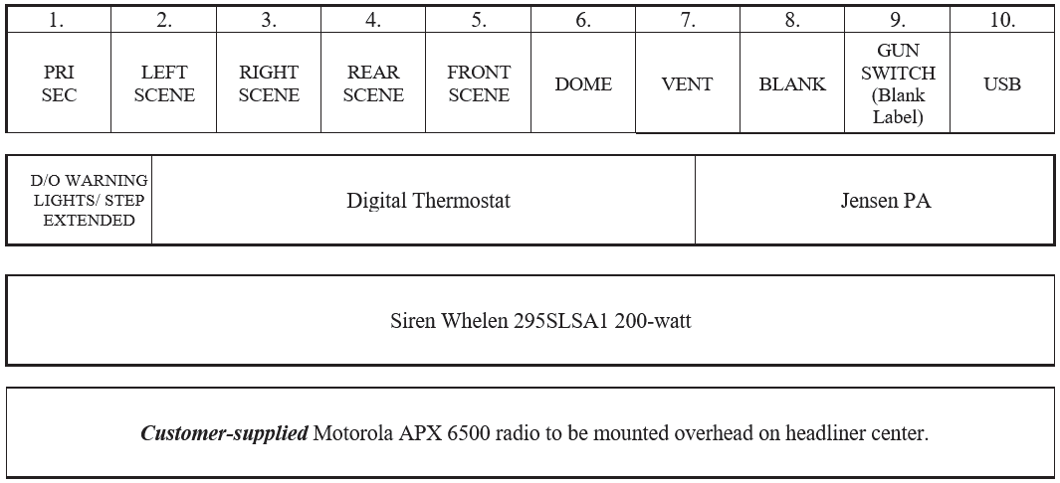

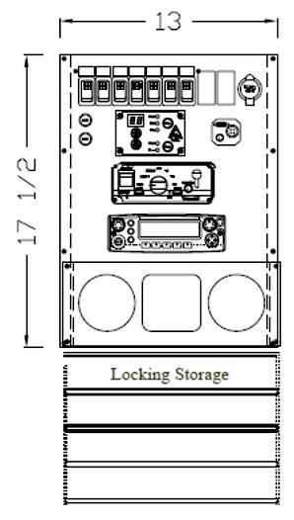 |  | COMPLY: YES NO
1.06.08 | SWITCHES  Switches installed in the driver's console shall be rocker-type and permanently marked by function. A spare switch shall be provided. | COMPLY:  YES NO
1.06.09 | DOOR AJAR WARNING LIGHT  A flashing LED light with a red lens shall be provided on the driver's console to warn the driver of an open module passage door, compartment door or emergency egress hatch. Light shall provide door open indication when the rotary door latch is not fully latched in the second latch position.  A flashing LED light with an amber lens shall be provided on the driver’s console to warn the driver of an extended electric step. Light shall provide extended step indication if the step is extended when the parking brake is released.  The lights shall flash only if the ignition is on.  Both lights shall have engraved labels indicating function.  A buzzer shall sound if the vehicle is placed in gear while doors are open or step is extended. | COMPLY: YES NO

1.06.10 | MODULE INTERIOR LIGHTING  Shall be designed to keep vehicle height to a minimum without interfering with the structural integrity of the roof. Module interior lighting shall consist of Seven Intertek VER2 #ZY-757W-LED-G2 dual intensity LED recessed lights in the roof, installed with tamper-proof rings with rivets, one light shall be installed in each seating area. The lights shall be activated by an on/off switch labeled ″DOME″ on the driver’s console, or by the exterior doors. | COMPLY: YES NO
1.06.11 | GUN RACK  Install Agency Provided AR Gun Rack with Push Button unlock switch in discreet location. | COMPLY:  YES NO
1.06.12 | BASIC EXTERIOR LIGHTING  Basic lighting shall include headlights, parking lights, directional signal lights, tail and stop lights, license plate light, back-up lights, hazard lights, identification lights, clearance lights, and side marker lights as required by FMVSS 108.  Module identification lights, clearance lights, and side marker lights, unless included on a lightbar, shall be Truck-Lite LED Model 36.  Rear and side reflex reflectors shall be installed in accordance with FMVSS 108 requirements.  Rear stop/tail, turn and back-up lights shall be Truck-Lite Model 45 series LED lights, installed in the rear kick panel, pattern from outboard in: red stop/tail light, amber turn signal, and clear back-up light. The back-up lights shall activate automatically when the vehicle is placed in reverse.  Two Whelen #70BTT LED stop/tail lights shall be installed on the rear of the module, one centered on each outboard side.  Two Whelen #70A00TAR LED turn arrows shall be installed on the rear of the module, just below #70BTT lights.  Side marker lights shall be wired to blink with the turn signals.  Light Bar Strip LED RED Light Vertical in the back of module on the Sides – Allow operator visual when driving into RCD (Black Vehicle/Black Walls) | COMPLY: YES NO

1.06.13 | COMMUNICATIONS EQUIPMENT  The customer shall be responsible for powering up and tuning of any radio equipment.  Item #1  Description: One customer-supplied Motorola APX 6500 radio transceiver with one remote head, speaker, and mic. Mounted overhead on center of headliner with Magnetic Mic clip.  Location: Transceiver shall be installed under curbside back seat in cab, one remote head, speaker and mic on the driver's console and antenna on the cab roof. Remote head shall be installed in the headliner and a magnetic mic with microphone shall be installed on the driver’s side adjacent to the radio head.  Additional Instructions: All connections shall be made, including antenna, antenna cable, battery power and/or ignition power, and grounds. Prior to powering up of the module, all in-line fuses of radio equipment shall be removed and secured to their fuse holders. | COMPLY: YES NO
1.06.14 | ANTENNA MOUNTS AND CABLES  One NMO universal antenna mount with KHFUD/RG58UD cable, Larsen HyPermaster universal connector and mini-UHF adapter shall be installed on the cab roof. Antenna base access shall be through the dome light openings, and the cables shall be connected to the transceiver located under the driver’s seat. A WIFI antenna shall be installed on the roof in the forward streetside corner of the module, and connect to the provision Camera System | COMPLY: YES NO
1.06.15 | BATTERY GROUNDS  In addition to OEM chassis grounds, the following ground circuits shall be added to reduce RF interference:  -A minimum 4 ga. ground cable from the power component panel to the chassis frame.  -Two braided ground straps with soldered ends from the module body to the chassis frame. | COMPLY: YES NO
1.06.16 | BATTERY MODIFICATIONS  Chassis batteries shall be utilized in existing locations. | COMPLY:  YES NO

1.06.17 | USB CHARGING PORTS  One USB A/C dual charging ports shall be installed in the driver’s console, and shall be powered continuously. | COMPLY:  YES NO
1.06.18 | COMPARTMENT LIGHTING  LED strip lighting shall be installed in each outside compartment, and shall be activated by the respective compartment door switch. | COMPLY:  YES NO
1.06.19 | EXTERIOR DOOR SWITCHES  Shall be 1/2″ mechanical door switches. | COMPLY:  YES NO
7. EMERGENCY WARNING SYSTEMS
1.07.01 | EMERGENCY WARNING SYSTEMS  Primary – All flashers will turn on Secondary – Only rear flashers will turn on  Audible Ticking Sound when lights are activated | COMPLY: YES NO
1.07.02 | FLASHERS  Two Whelen 70R02FRR Clear lens Red LED flashers with black housings shall be installed on the aft sides of the module, one each on the curbside and streetside of the module in the upper corners.  Two Whelen 70B02FBR Clear lens Blue LED flashers with black housings shall be installed on the forward sides of the module, one each on the curbside and streetside of the module in the upper corners.  Two Whelen 70B02FBR Clear lens Blue LED flashers with black housings shall be installed, one each on the front and rear of the module curbside in the upper corners.  Two Whelen 70R02FRR Clear lens Red LED flashers with black housings shall be installed, one each on the front and rear of the module streetside in the upper corners.  All flashers shall activate when the switch on the console is in PRIMARY mode, and only the rear flashers shall activate when switch is in SECONDARY mode. | COMPLY: YES NO

1.07.03 | SCENE LIGHTS  Four Pioneer PFH2 LED 12VDC scene lights with black housing shall be installed on the module:  - One on the curbside, centered above Cell #1 and Cell #2 doors and forward of Cell #3 door.  - One on the streetside, inboard of the flashers  - One on the rear, upper centered  - One on Front, upper centered on Condenser Bracket  The lights shall be flush-mounted and have internal optics to deflect the light down at 8–32-degree angles.  The scene lights shall be controlled by the “LEFT SCENE, “RIGHT SCENE”, “FRONT SCENE” and “REAR SCENE” switches on the driver’s console, any open cell door, or when the vehicle is placed in reverse. | COMPLY: YES NO
1.07.04 | GRILLE LIGHTS  Two Whelen WIONS flashers with chrome housing shall be installed. One #WIONSMR Clear lens Red Super-LED steady red flasher shall be installed on the curbside, and one #WIONSMB Clear lens Blue Super-LED flasher shall be installed on the streetside.  The grille lights shall turn on with the PRIMARY switch, and turn off with the SECONDARY switch or when the switch is off in the driver’s console. | COMPLY: YES NO
1.07.05 | SIREN  A Whelen 295SLSA1, 200-watt siren shall be installed. Siren options to include radio, horn, manual, wail, yelp, and phaser. The siren’s hands-free function shall operate through the OEM horn ring circuit when the siren’s rotary selector is in the HF position and the PRIMARY switch position #1 is on. | COMPLY: YES NO
1.07.06 | SIREN SPEAKERS  Model SA315P 200-watt siren speakers shall be installed behind the OEM grille. | COMPLY:  YES NO

1.07.07 | MODULE SPEAKERS  Three speakers shall be installed to provide one-way communication from the cab to the module in the following locations:  - One behind the punched grille on upper closeout above the Cell #1 entry door  - One behind the punched grille on upper closeout above the Cell #2 entry door  - One in the curbside portion of the ceiling nearest the Cell #3 entry door, aft of the vent fan  Speakers shall be connected for use with the cab radio via and REI 750407 amplifier head on the driver’s console. The REI head shall allow voice commands via the microphone , or signal input from cab radio. | COMPLY: YES NO
1.07.08 | BACK-UP CAMERA  Item #1  Description: A Voyager back-up camera system shall be installed, including a #VOM73MM 7″ color monitor and a #VOM140 surface-mounted camera Location: Camera on the rear of the module, centered below drip rail.  Monitor centered on chassis windshield, upper. Additional Instructions: Camera shall always be on. | COMPLY: YES NO

1.07.09 | AUDIO/VIDEO/RECORDING EQUIPMENT  Item #1  Description: A Pro Vision security camera system shall be installed, including seven recess pocket-mounted 39AHD interior cameras, recorder with storage, and one 15" PC monitor mounted on Center Console  Location: One interior camera in each section of Cells #1, #2, and #3, 4, 5, 6, and 7 and touchscreen video monitor on the driver’s console.  Additional Instructions: Touchscreen video monitor shall be installed in the cab facing the passenger for monitoring passenger compartments. The cameras shall activate with ignition.  6 Exterior Cameras – 4 on sides, 1 on front, 1 on rear of module = 13 Cameras Total  DVR – 3 DVR’s going into one combiner via HDMI. HDMI to monitor. WI-FI External Cable antenna – Place on top of module in front.  NOTE: ProVision Camera System to include the Back-up Camera. Contact Pro-Vision for more details, gear requirements, and technical advice for this configuration. | COMPLY: YES NO
1.07.10 | Air Horn System  Dual Air Horn System in Addition to factory electric horn, that will deliver high decibel sound notifications - At least 145db | COMPLY: YES NO
8. SUPPORTING DOCUMENTATION

1.08.01 | OWNERS MANUAL  Shall be provided with vehicle and consists of the following items:  - Manufacturer Contact Information  - Table of Contents  - Manufacturers’ Labels  - Electrical Load Test/Payload/Paint Stickers  - Manufacturer Warranties  - Lifetime module warranty  - Seven-year/75,000-mile limited electrical warranty  - Two-year/30,000-mile conversion warranty  - Five-year paint warranty  - Chemical De-Icer Statement  - Service and Operations manual  - Electrical  - Wire charts and plug pinouts  - Harness layout  - Schematics  - Parts list  - Paint information  - Products and Information  - Second OEM chassis key + 3 more Sets = 5 Total 12: Keys for Storage + Compartment Locks = 10 Total | COMPLY: YES NO
9. SUPPORTING DOCUMENTATION
1.09.01 | LOOSE EQUIPMENT  The following equipment shall be shipped loose with the vehicle:  1. Touch-up paint, one bottle each:  - To match Oxford White (#GLV-11291704)  - To match Dark Blue Jean  - White (G2-33631 Alt 2)  - Light Gray (GLV-51748)  - Twenty-Four Schlage keys (56434)  - Fire Extinguishers (2) 15lb Units – Installed in Compartments 1 & 5 | COMPLY: YES NO

1.09.02 | CUSTOMER SUPPLIED EQUIPMENT  The customer shall provide the following equipment and have delivered to Manufacturer within 30 days of the preconstruction meeting:  - Motorola APX 6500 radio and antenna plus speaker  - Halligan Tool w/ Mounting Bracket – Installed in Compartment 2  - Gun Rack w/ Release Button for A.R (Satina dual rail plus universal XL lock).  - Padlocks for roof  - Magnetic mic mount (3) | COMPLY: YES NO

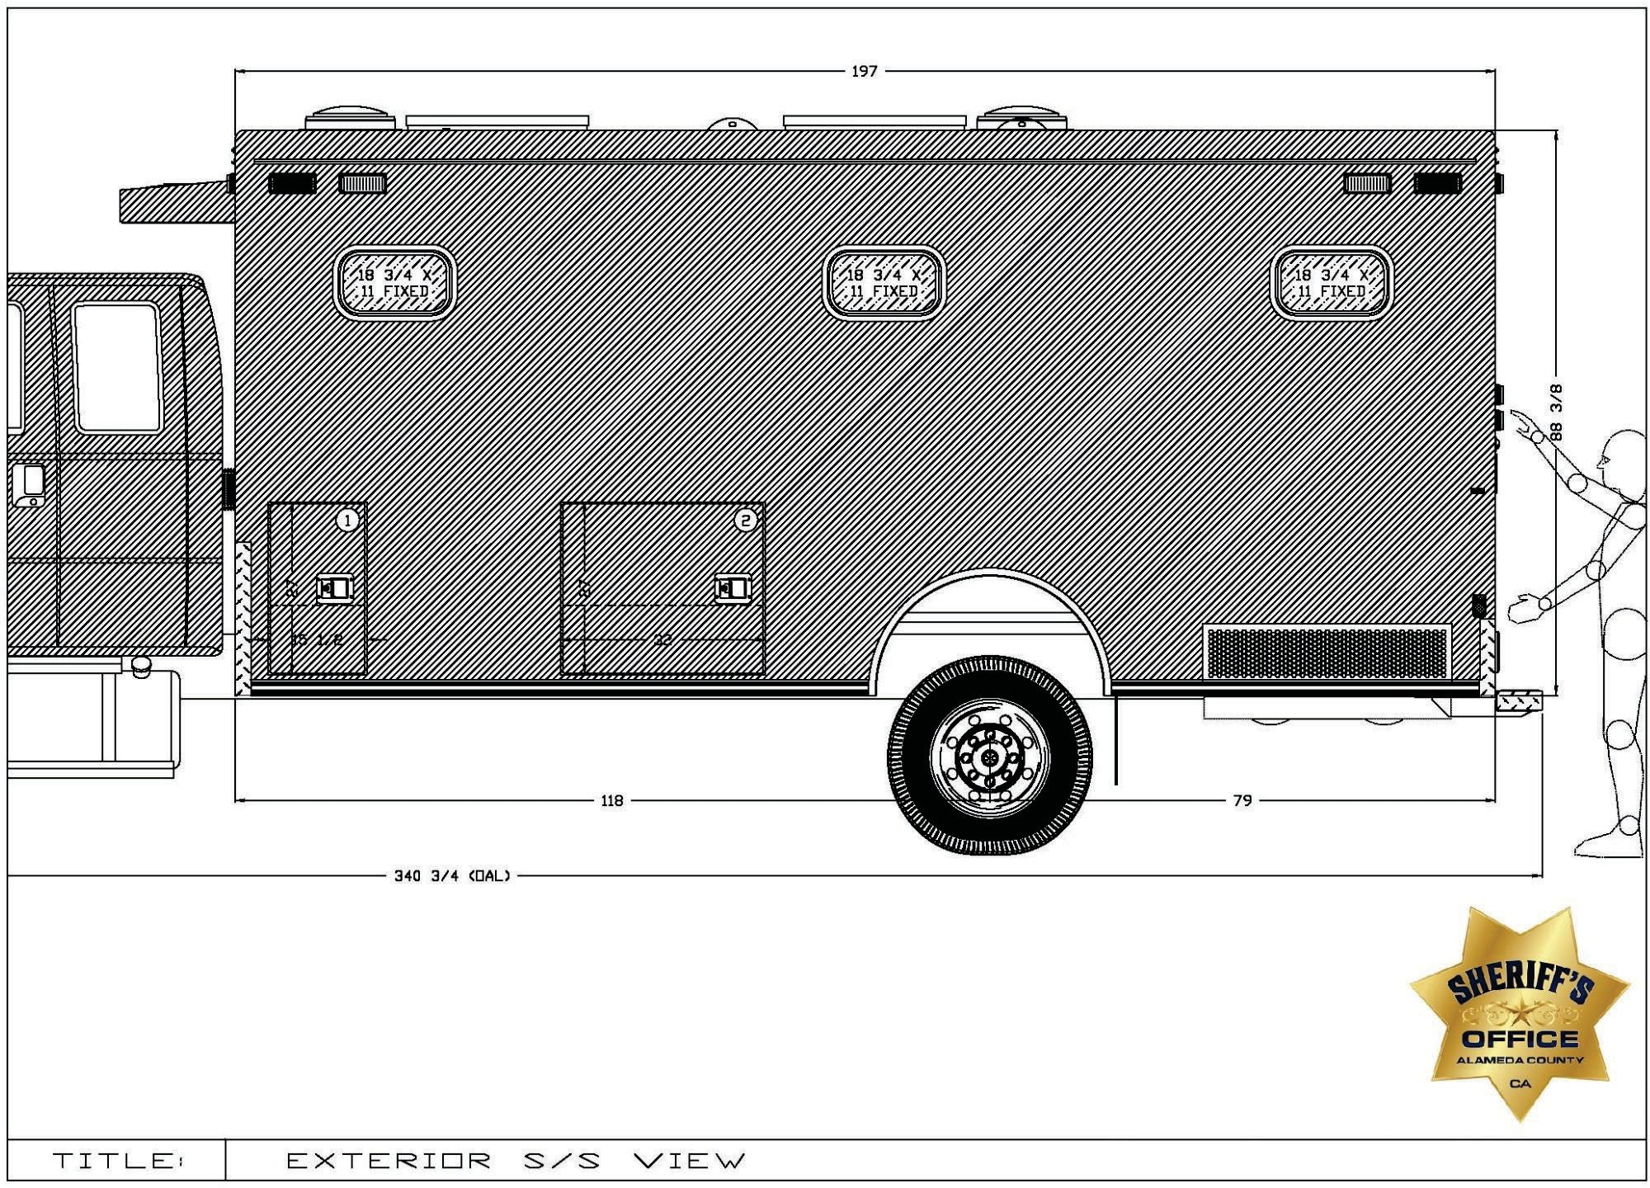

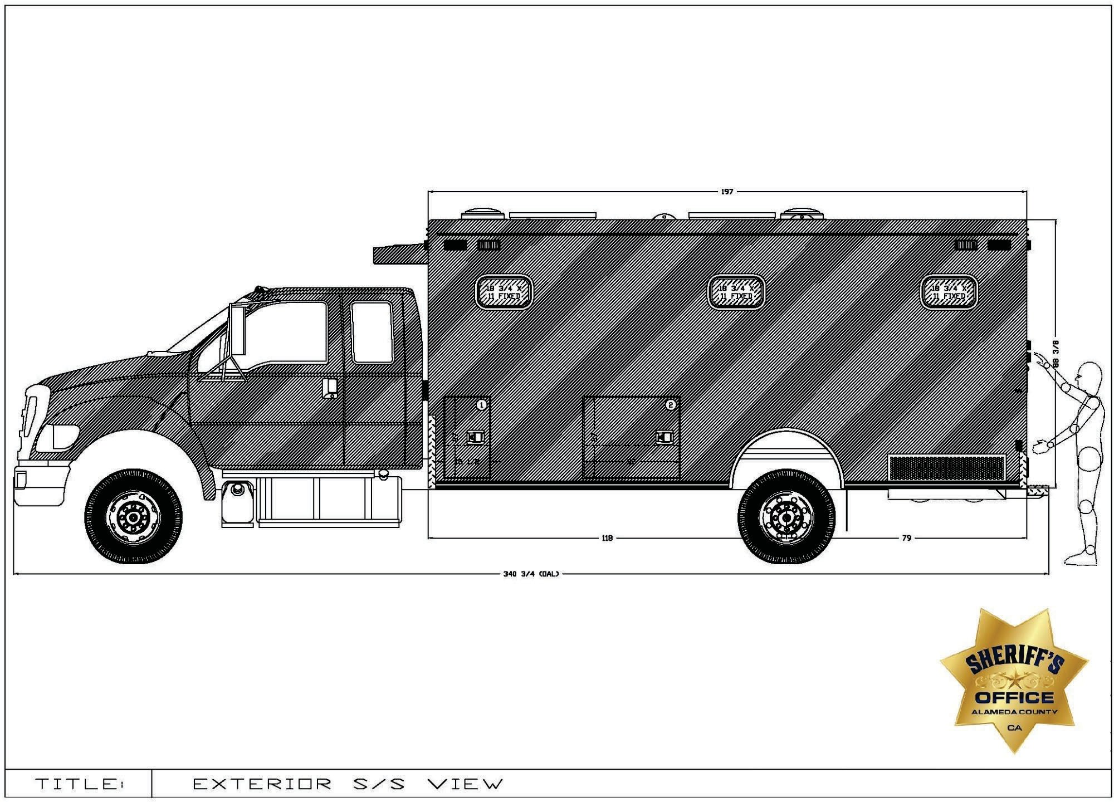

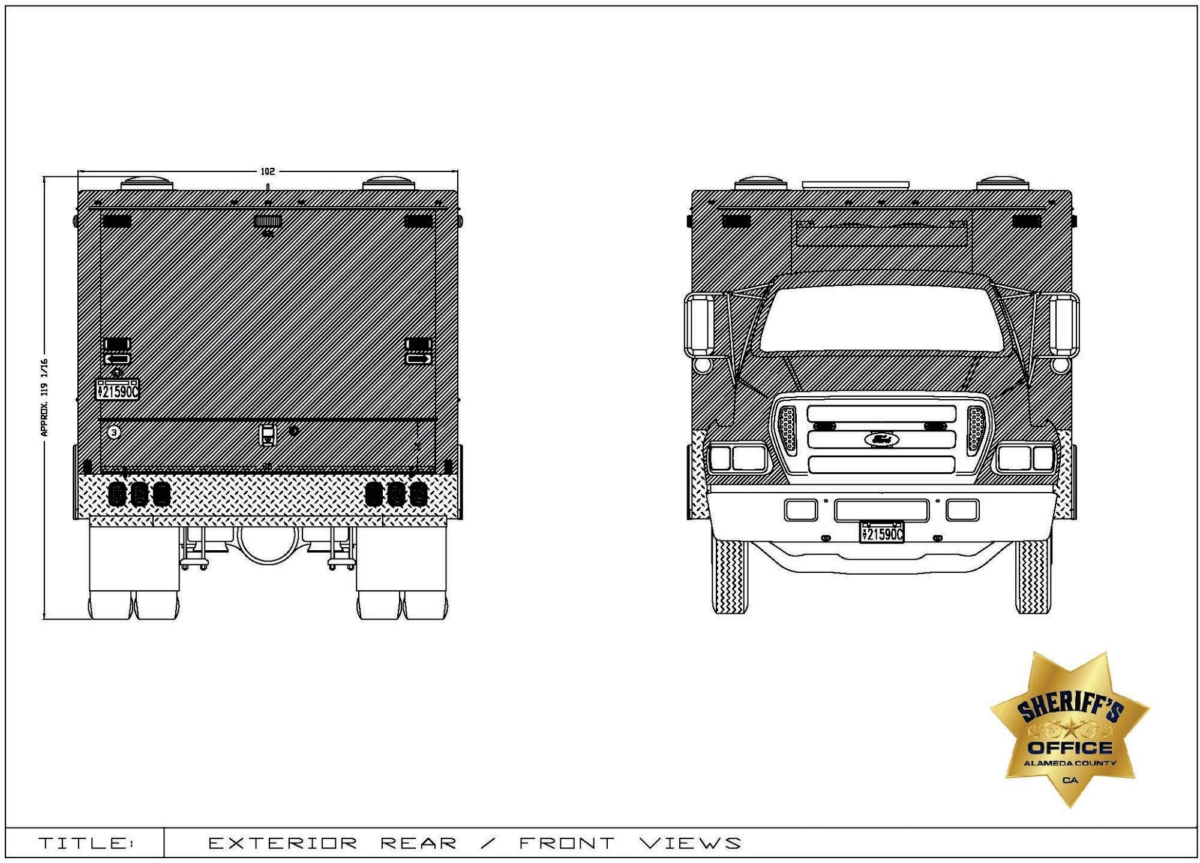

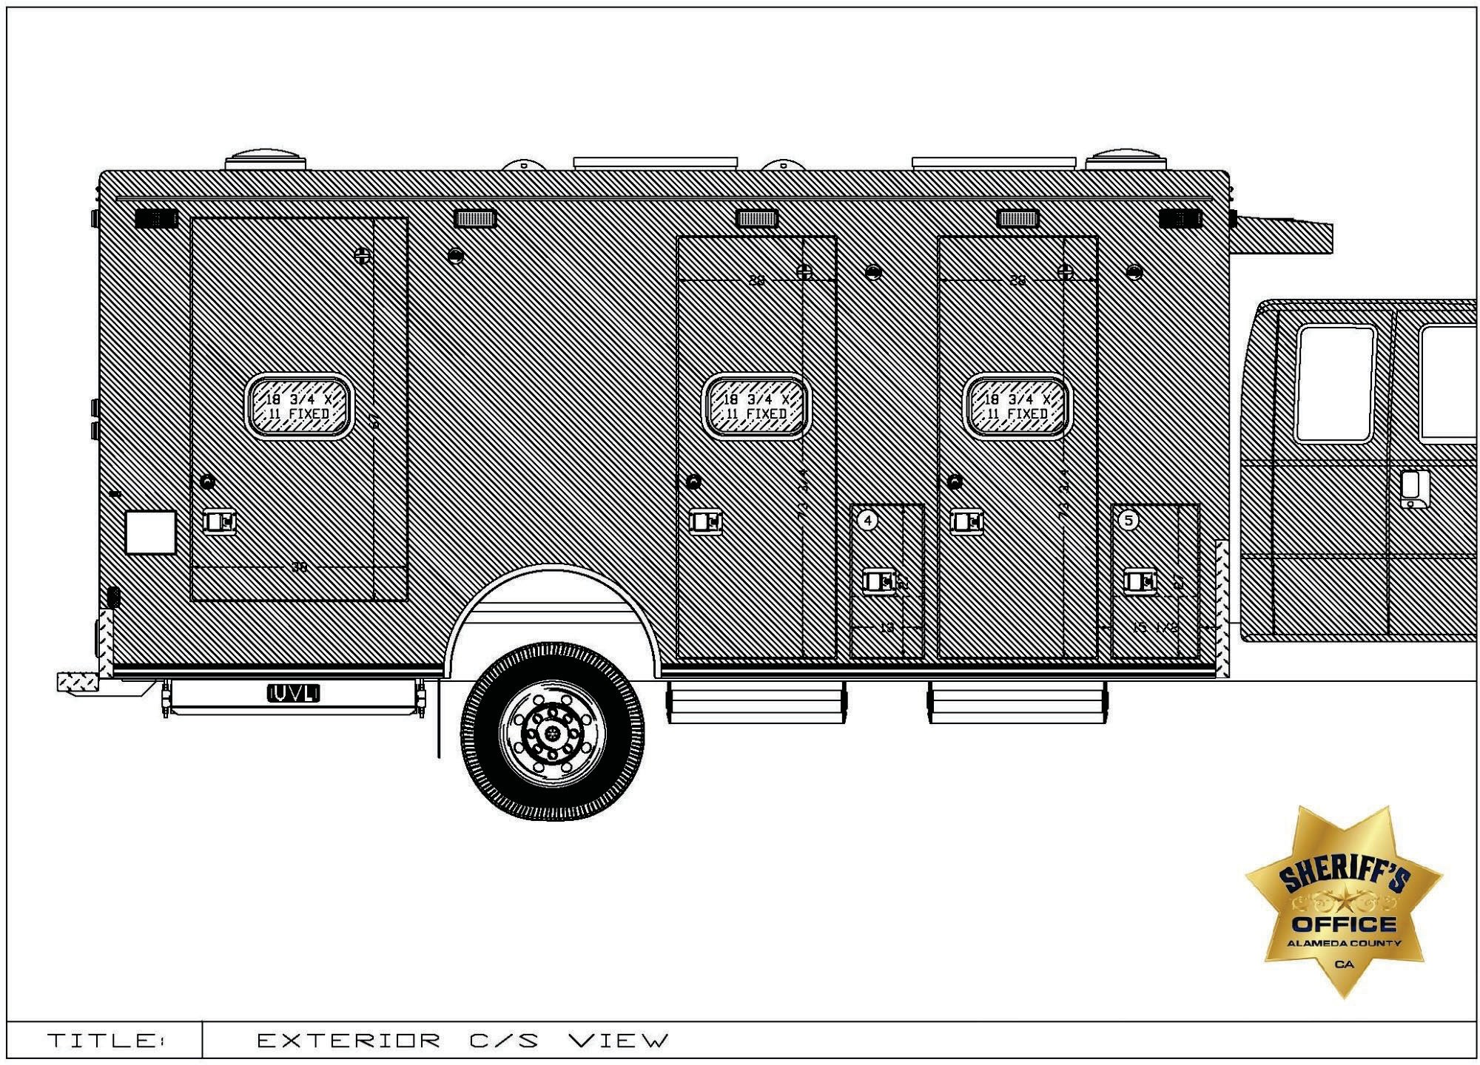

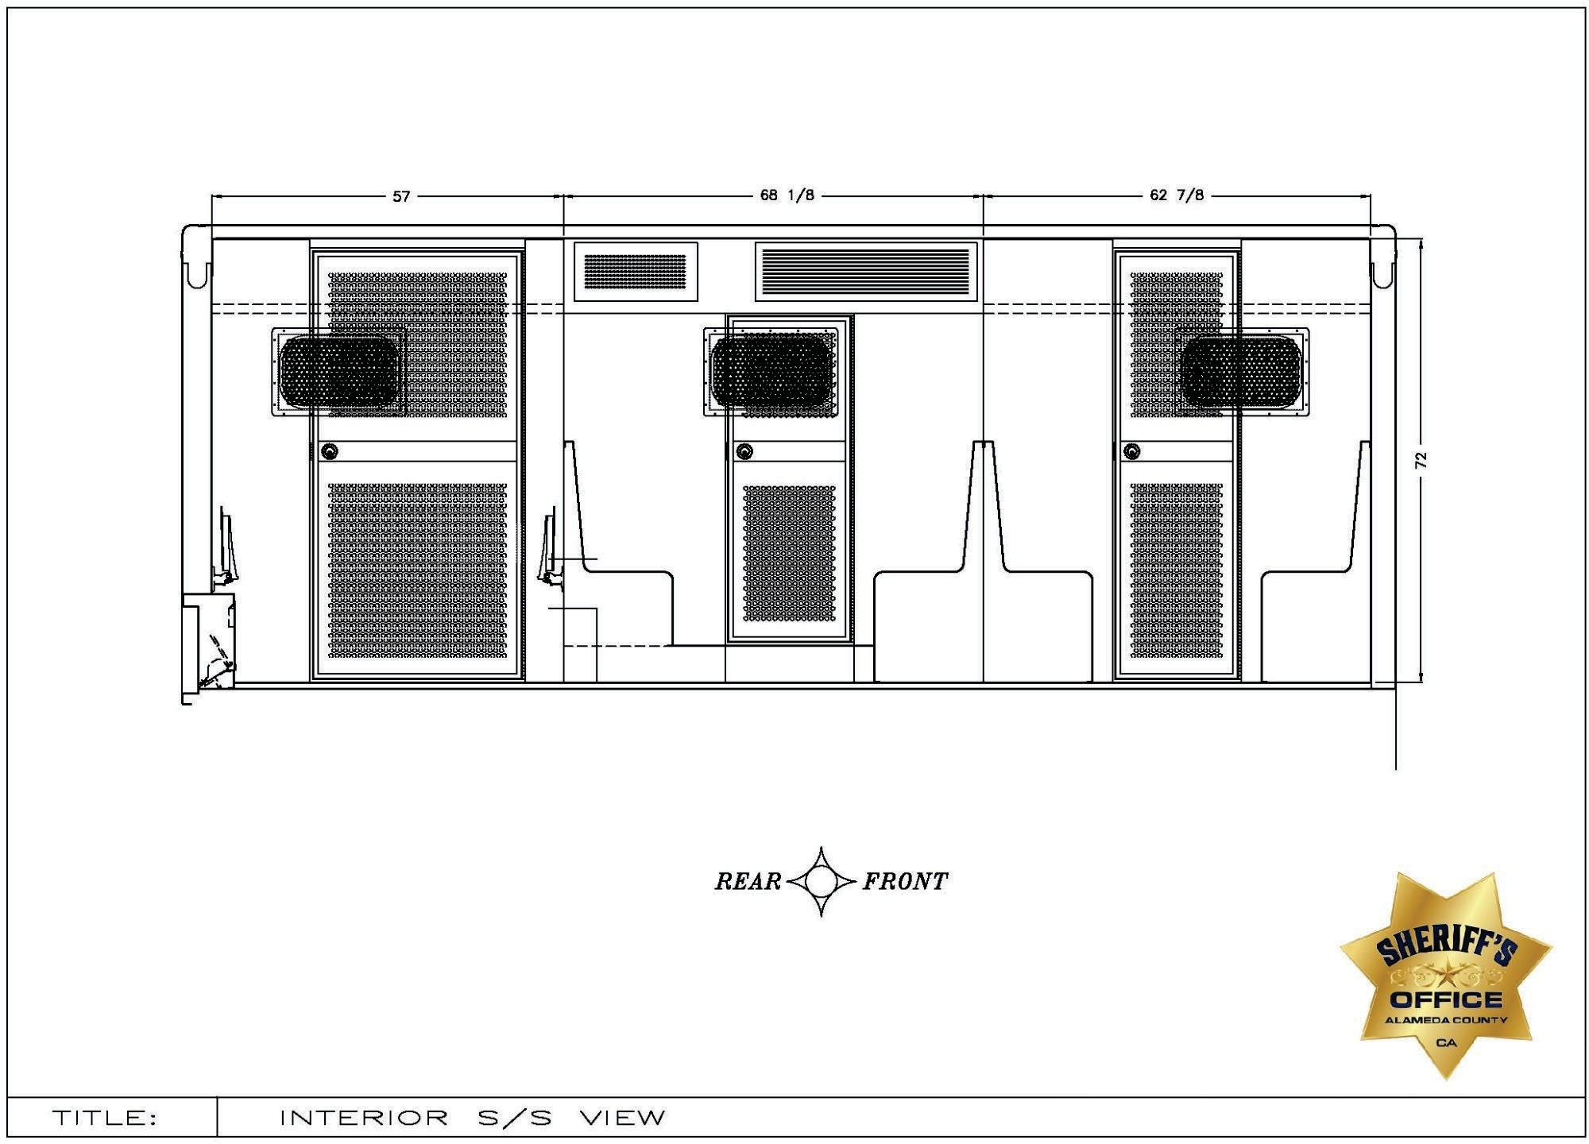

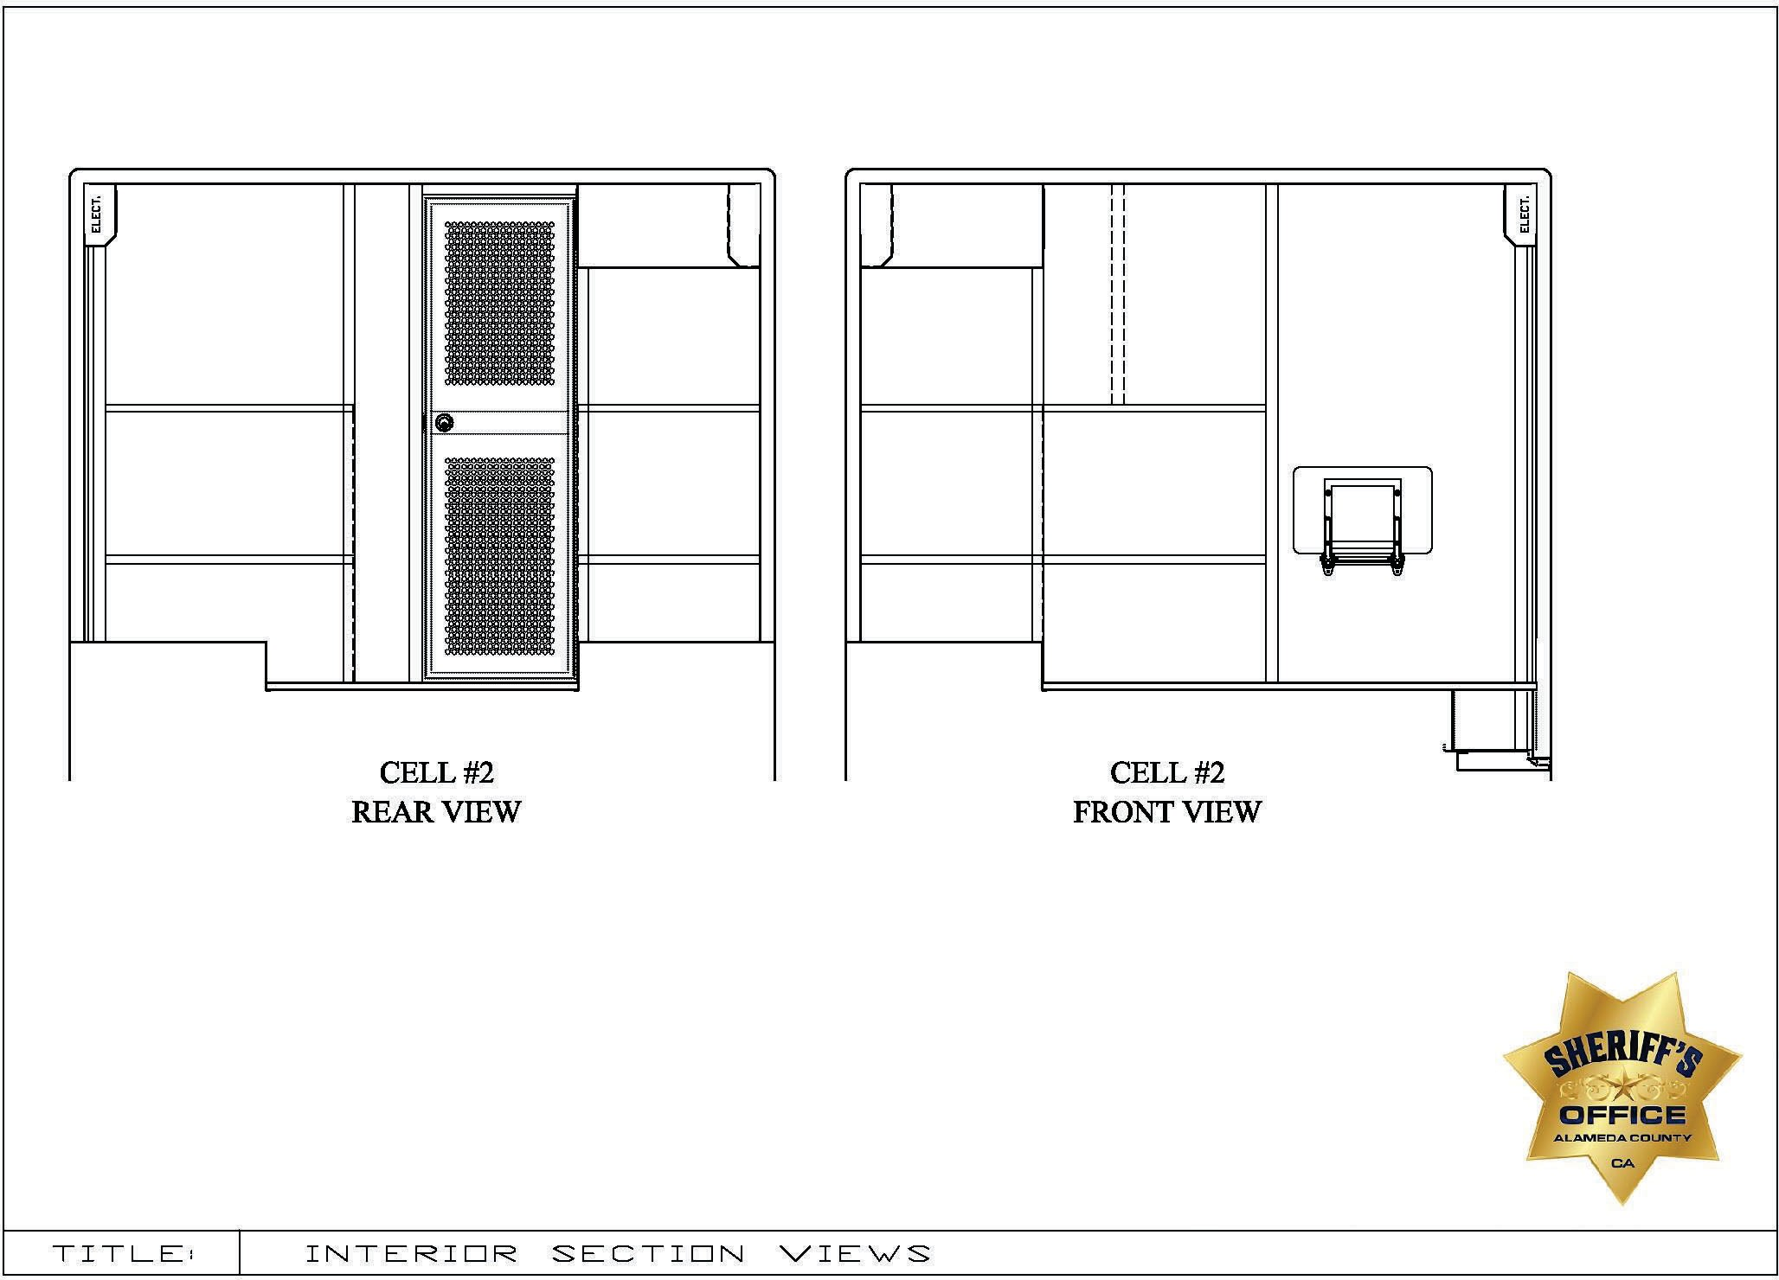

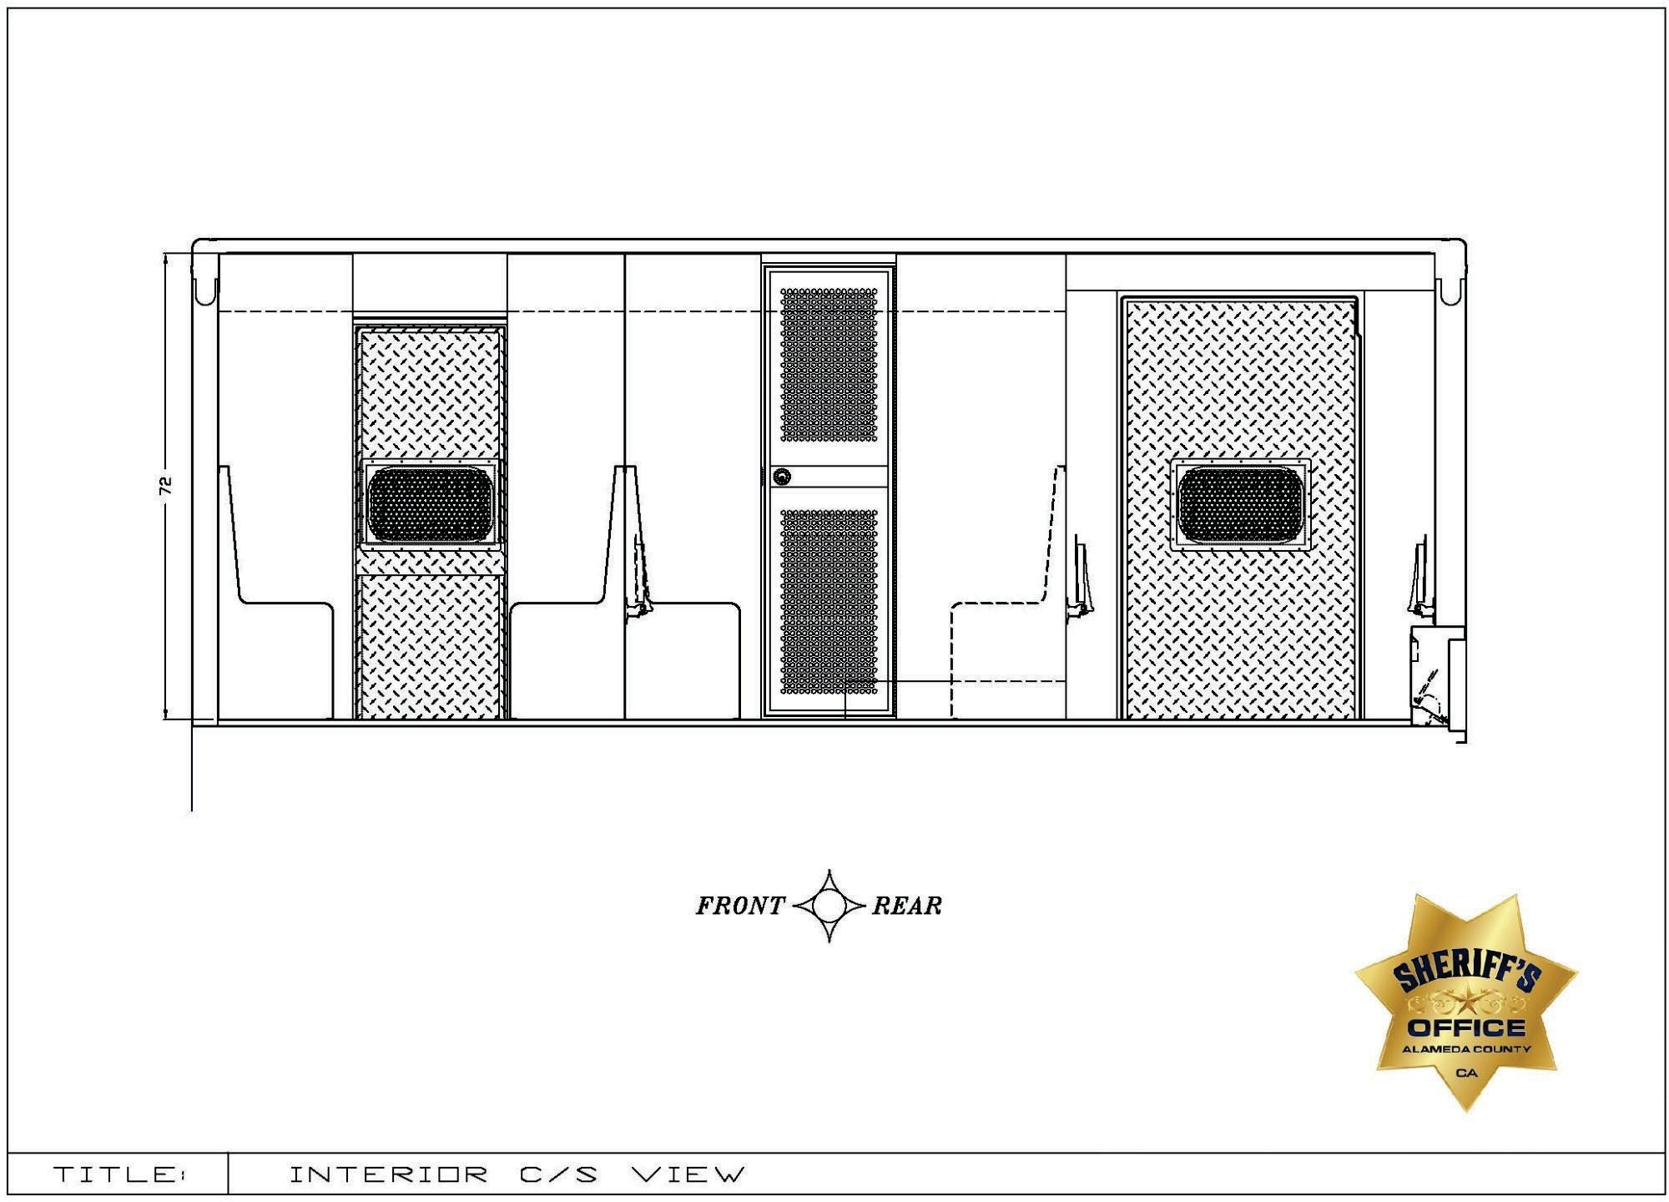

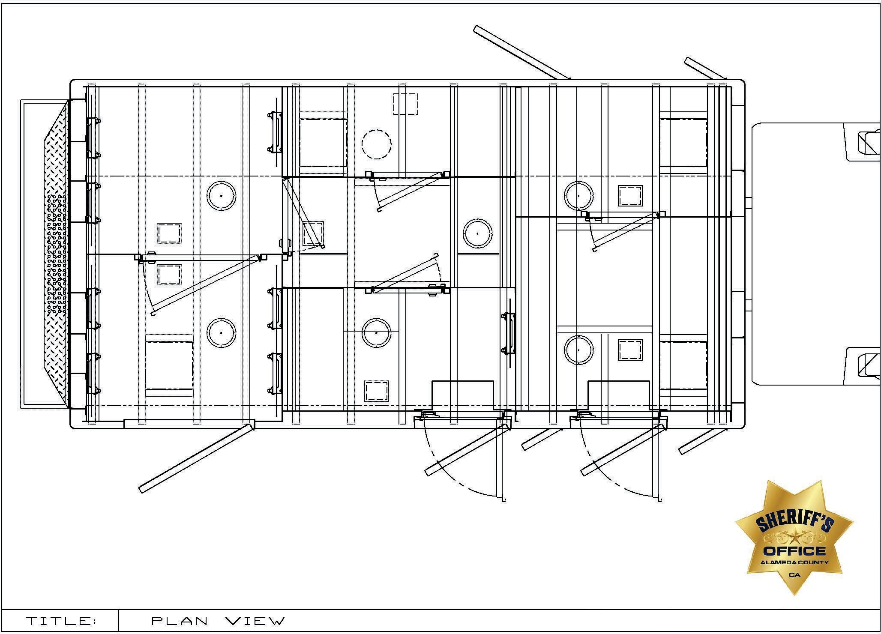

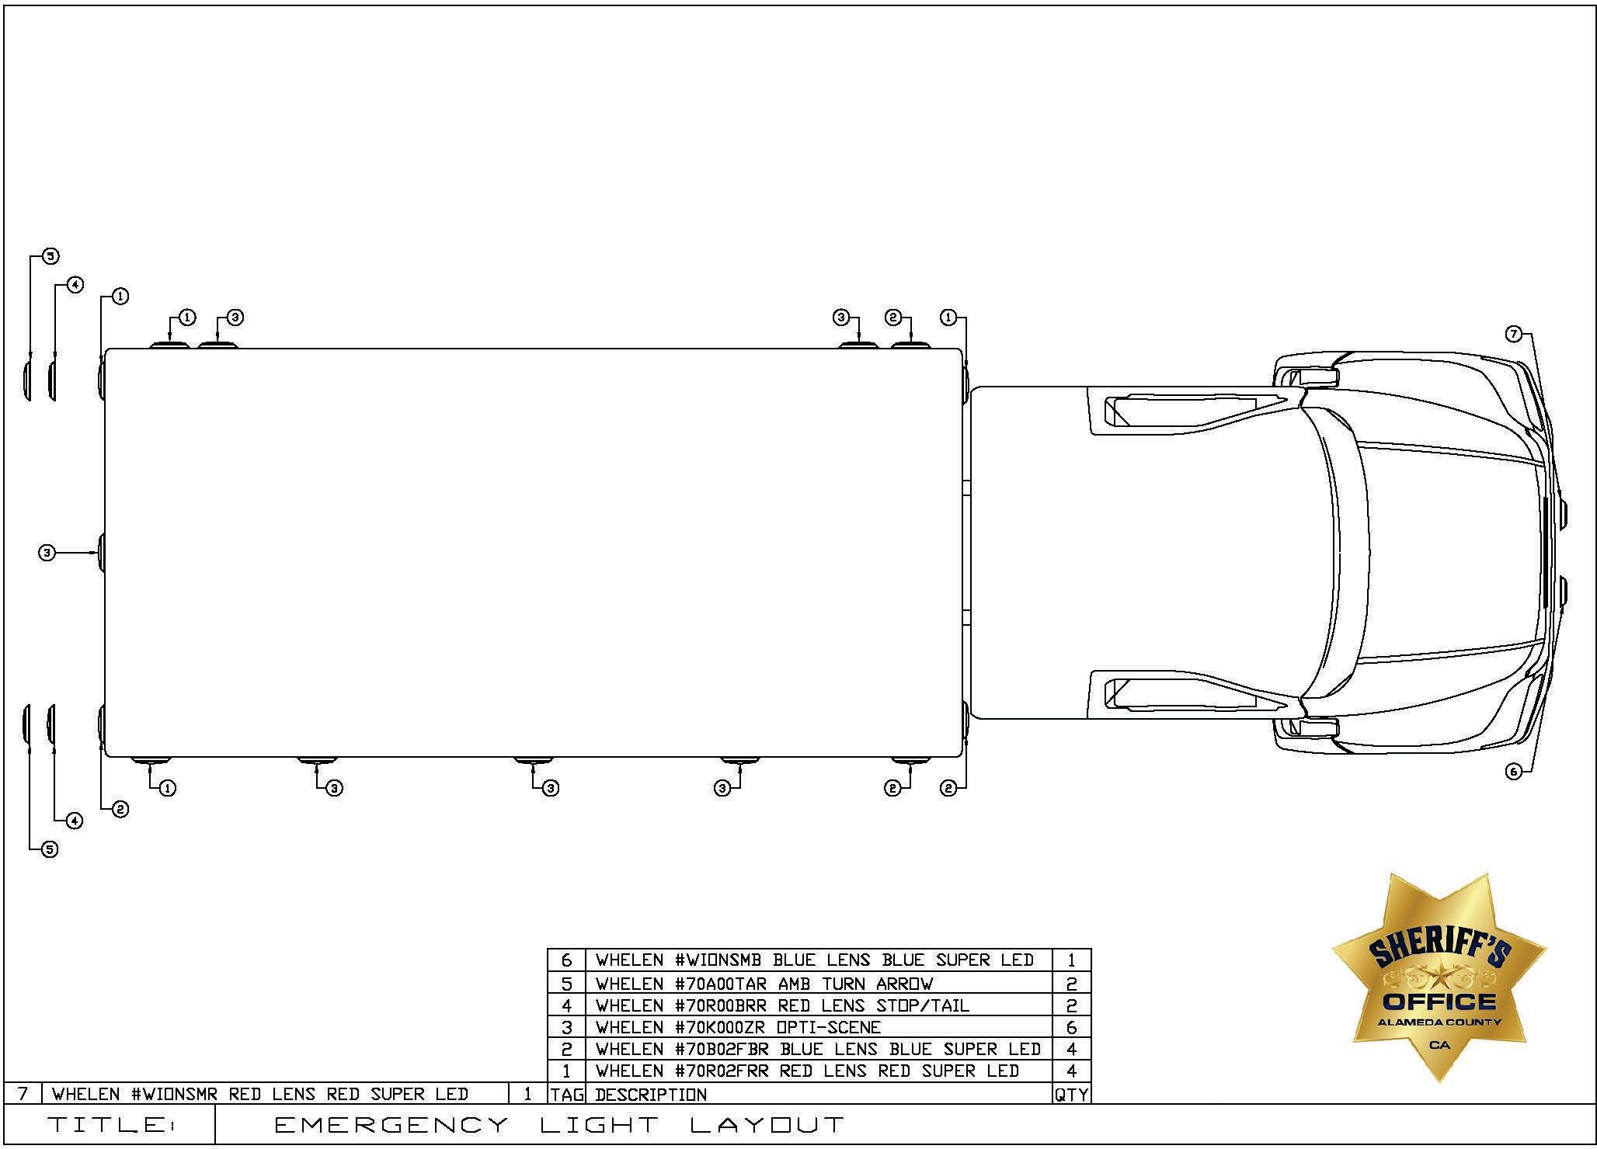

EXHIBIT C
INMATE TRANSPORT VAN – AMBULATORY CAPABLE SPECIFICATIONS RESPONSE
INSTRUCTIONS: Bidders must submit, with their bid, a fully completed Exhibit C – Inmate Transport Van – Ambulatory Capable Specifications Response for Inmate Transportation Vehicles. Bids which are submitted without Exhibit C will be disqualified.
A “Yes” response to a requirement in the “Comply” column will mean that the bidder intends to comply with the exact specification, as described in Exhibit C. If the bidder is able to comply with the specification stated, and states “Yes” in the “Comply” column, no further action is required. A “No” response to a specification sentence in the “Comply” column will mean that the bidder is unable to comply with the specification provided by the County.

If a bidder is unable to comply with specific requirements listed in Exhibit C – Inmate Transport Van – Ambulatory Capable Specifications Response, the bidder is to state “No” in the “Comply” column, and provide a brief explanation in the “Explanation” column. All exceptions, clarifications, and amendments pertaining to Exhibit C shall be described in full, using additional pages, as necessary, to provide complete descriptions. Bidder must clearly reference each exception, clarification, or amendment by its corresponding item number (e.g., Item 1.a. – Specific Ratings, Rear Axle Ration: 5.22 ratio). The County, at its sole discretion, shall have the right to deem acceptable any exceptions, clarifications or amendments stated by the bidder.

A response of “N/A” or no response to any specification column will mean that the bidder is unable to comply with the specification provided by the County.

In Exhibit C, references to specific brand names are intended to describe components that have been determined to best meet operational, performance, or reliability standards of the County, thereby incorporating these standards by reference within the specifications. These specifications are not meant to limit the vendor; they are guidelines to minimum qualifications. The bidder shall indicate their compliance or non-compliance for each line of the Exhibit C section. An “equivalent or better” may be offered by the bidder, subject to evaluation and acceptance by the County. It is the bidder’s responsibility to provide, at bidder’s expense samples, test data, or other documentation, which the County may require to fully evaluate and determine acceptability of an offered substitute. The County reserves the sole right to reject a substituted component that will not meet or exceed County standards. Please refer to Page 20 of this RFP, BRAND NAMES AND APPROVED EQUIVALENTS, for further information on brand names and approved equivalents.

EXCEPTIONS, CLARIFICATIONS, AMENDMENTS TO SPECIFICATIONS: Any and all deviations, exceptions, or alternatives to Exhibit C must be clearly stated, as described below, or the proposal may be considered non-responsive.

- Inmate Transport Van – Ambulatory Capable Specifications  Specification Response  - CHASSIS |  |  | Explanation
2.01.00 | OEM CHASSIS  2024 Ford E-350  - 3 year/36,000 mile ″Bumper to Bumper″ warranty  - 5 year/60,000 mile warranty  - Dual rear wheels  - Twelve Frame Pucks (559)  - Provided by Vendor | COMPLY: YES NO
2.01.01 | SPECIFIC RATINGS  - Drive – 4 x 2  - G.V.W.R. – 11,500 lb  - Front Axle – 4,600 lb  - Rear Axle – 7,800 lb  - Wheelbase – 138″  - Cab to Axle – 80″  - Rear Differential – 4.10 ratio, limited slip | COMPLY: YES NO

2.01.02 | POWER TRAIN  - Engine – Gasoline  - 7.3L V8 Premium (99N)  - Engine block heater  - Heavy duty dry type air cleaner with flow restriction indicator  - Engine Cooling System  - Heavy duty, closed-air, free-liquid state type  - Coolant recovery system  - 50/50 solution Permanent type antifreeze to –40 degrees F  - Transmission  - 6-speed automatic transmission with tow/haul mode w/overdrive  - Auxiliary transmission oil cooler  - Exhaust System  - System complies with Federal Motor Carrier Safety Regulations, Part 393.83  - Suspended using three hangers, excluding manifold attachment  - Discharge at right rear side of module  - Tailpipe shall not terminate within twelve inches of the vertical axis of the fuel tank filler opening.  - Two exhaust heat shields mounted in mid-chassis, right-hand side for upfitter installed frame pucks | COMPLY: YES NO
2.01.03 | STEERING  - Power assisted  - Tilt and telescoping steering wheel | COMPLY:  YES NO
2.01.04 | SHOCK ABSORBERS/STABILIZER BARS  - Heavy-duty shock absorbers front and rear  - OEM front and rear stabilizer bar | COMPLY:  YES NO
2.01.05 | BRAKES  - Four Wheel Disc with Traction Control  - Hill Start Assist  - Traction Control  - Electronic Stability Control (ESC) | COMPLY: YES NO

2.01.06 | TIRES AND WHEELS  - Seven OEM LT 225-75R16E all-season steel belted radials  - Seven OEM 16″ steel wheels, Chrome/Black  - Steel valve stems  - Spare tire and wheel included  - Jack and Tire changing tools | COMPLY: YES NO
2.01.07 | ELECTRICAL  - Alternators – OEM dual heavy-duty, 397 amps total (63N)  - Batteries – OEM dual heavy-duty, 78 amp-HR batteries (634) | COMPLY:  YES NO
2.01.08 | INSTRUMENT PANEL AND CONTROLS  - Gauges  - Speedometer  - Tachometer  - Coolant Temperature  - Oil Pressure  - Fuel Level  - Odometer/Trip Odometer  - Cruise Control  - Instrument Panel Message Center  - Audio – Bluetooth-capable AM/FM stereo w/clock display, USB input and 2 Speakers  - Four Speakers | COMPLY: YES NO

2.01.09 | CAB EXTERIOR  - Exterior Upgrade Package  - Bumper – Front, Chrome  - Grille – Chrome  - License Plate Bracket – Front  - Horn – OEM dual electric  - Windshield wipers – Interval  - Telescopic Trailer Tow Mirrors with manual adjustments  - Two black, below eye level, manually telescoping trailer tow  - Power adjusted upper glass  - Lights  - Headlamps with Autolamp  - Dual sealed-beam with fixed lens  - Fuel tank – OEM 40 Gallons  - Auxiliary Fuel Port (945) | COMPLY: YES NO

2.01.10 | CAB INTERIOR  - Seats – OEM  - Cloth covered bucket seats (211)  - Combination lap and shoulder harness  - Retractable arms on inside, side door armrest  - Climate Control – OEM  - A/C Front Only (572)  - Heavy duty, fresh air, high-capacity heater/defroster  - Dehumidifying air conditioning system  - Ambulance Prep Package (47Z)  - Airbags  - Driver and right-front passenger front  - Interior  - Vinyl headliner  - High-series door trim panels  - Flooring – Black vinyl  - Power door locks & windows  - Vinyl sun visors  - Lights and Convenience Group  - Courtesy light switches on all doors  - Warning chimes  - Headlight-on audible alert  - Illuminated entry  - Dual air bags  - Two 12 Volt Power Points  - Day/Night Interior Rear-view Mirror | COMPLY: YES NO
2.01.11 | COATINGS  - Exterior – Dark Blue  - Interior – Medium Flint Gray | COMPLY:  YES NO
2.01.12 | CHASSIS MODIFICATIONS  The following modifications will be made to the chassis by Vendor | COMPLY:  YES NO

2.01.13 | EXHAUST HEAT SHIELDS  Shall be formed from 20 ga. galvanized sheet metal with stamped reinforcements and formed edges. Access openings shall be provided for shock absorber, mounting bolts, etc. Heat shields shall be bolted to chassis frame and extend from back of cab to the frame cross member just behind the rear axle. | COMPLY: YES NO
2.01.14 | RUNNING BOARDS  Running boards made of 0.125″ bright aluminum diamond plate with front splash guards shall be installed on both sides of the cab, flared towards the front corners of the module, and securely mounted with stainless steel 1/4″-20 truss head bolts. | COMPLY: YES NO
2.01.15 | MUD FLAPS  Black mud flaps shall be installed behind each rear wheel. | COMPLY:  YES NO
2.01.16 | CHASSIS ANTI-THEFT  A Secure Idle #S1340U or equal to system shall be installed, allowing the key to be removed from the ignition with the engine idling. The Secure Idle system shall be activated by a rocker switch labeled ″ANTI-THEFT″ with integral indicating light installed on the dash, left of the steering wheel. When activated, indicator light will light up and the system will allow the vehicle engine to continue running after the ignition key has been removed but will not allow the vehicle to move until the key is reinserted. Details to be confirmed at preconstruction meeting. | COMPLY: YES NO
2.01.17 | DRIVE LINE GUARD  A U-bolt driveline guard shall be installed. | COMPLY:  YES NO
2.01.18 | AUXILIARY COMPRESSOR  A TM-21 auxiliary air conditioning compressor kit shall be added to the OEM engine | COMPLY:  YES NO

2.01.19 | WEAPONS STORAGE  A locking hand-gun stand-alone storage box with a hinged lid door with a controlled open gas shock, a Schlage deadbolt lock, and a Hyskore four gun modular pistol rack shall be provided and installed on the floor, aft of driver's console (keyed same as module deadbolt locks).  A pre-wire shall be installed on back wall, center of cab for a customer-supplied-and- installed Blac Rac double T-Rail locking vertical long gun storage system. An unlock switch to active shall be installed in a discreet location, to be determined at preconstruction meeting. | COMPLY: YES NO
2.01.20 | MISCELLANEOUS ELECTRICAL CONNECTION  An Anderson SB350 jump start terminal with red cap shall be installed in the OEM bumper cut-out, curbside. | COMPLY: YES NO
2.01.21 | MODULE-TO-CHASSIS MOUNTING SYSTEM
2.01.22 | OVERVIEW OF MODULE MOUNTING SYSTEM  Module mounting system shall be designed and used as supplied by chassis manufacturer. It shall consist of twelve rubber puck mounts secured with chassis manufacturer-supplied 0.50″ hardened bolts. | COMPLY: YES NO
2.01.23 | CAB-TO-MODULE ATTACHMENT  The module shall be attached to the cab by twenty 5/16″ Grade 5 plated steel bolts with nylon insert locking nuts. Access plates shall be provided in the bulkhead wall for the servicing of cab-to-module bolts or for remounting of the body. | COMPLY: YES NO
2.01.24 | CAB-TO-MODULE GASKET  A closed-cell, neoprene, weatherproof gasket shall be installed between the cab and module to minimize electrolytic corrosion. | COMPLY: YES NO
2. MODULAR CONSTRUCTION

2.02.00 | MODULE CONSTRUCTION  All material utilized shall be of the correct type, alloy, and thickness to withstand the intended usage and provide protection against cracking, corrosion, or metal fatigue. All materials utilized shall be of open stock origin, commonly available through local sources, for rapid and economical repair or modification of the body. Any use of proprietary parts or materials in the construction of the body is unacceptable, due to potential delays or difficulties in future repairs or service. NO EXCEPTIONS TO BE TAKEN IN THIS AREA. This specification has been designed and written to fill specific needs of this agency. Where brand name, make, or model of equipment has been specified, no exceptions shall be allowed. Where compartment and cabinet sizes have been specified, bidder must bid substantially (plus or minus 1″) the size specified. | COMPLY: YES NO
2.02.01 | MODULE WARRANTY  The module shall have a transferable lifetime structural warranty. | COMPLY:  YES NO
2.02.02 | MATERIAL  EXTRUSIONS SIZE ALLOY  Structural Tubing 1ʺ x 2ʺ x 0.125ʺ sq 6063-T52  Structural Tubing 2ʺ x 2ʺ x 0.125ʺ sq 6063-T52 Structural Angle Cross Members 3ʺ x 3ʺ x 0.375ʺ 6061-T6 Structural Channel Cross Members 1.5ʺ x 3ʺ x 0.25ʺ 6061-T6  FORMED SHEETING SIZE ALLOY  Skin/Roof/Compartments/Subfloors/Doors 0.125ʺ 5052-H32 Interior Cabinets 0.090ʺ 5052-H32  Diamond Plate 0.125ʺ /0.08ʺ 3003-H22  Stainless Steel 16 ga., 20 ga 304 # 4B | COMPLY: YES NO

2.02.03 | MODULE DIMENSIONS  Final dimensions to be confirmed at preconstruction meeting.  Overall Vehicle Dimensions (Specifications are listed as minimums) Length: 21' and 1.5" = 253.50"  Width (Excluding Mirrors): 7' and 10" = 94.00"  Height (Approximate): 7' and 9.25" = 93.25"  Exterior Module Dimensions (Specifications are listed as minimums) Length: 11' and 11" = 143.00"  Width: 7' and 10" = 94.00"  Height: 6' and 1.375" = 73.38"  Interior Module Dimensions (Specifications are listed as minimums) Length: Forward Wall to Rear Wall = 133.00"  Width: Left Wall to Right Wall = 89.00" Height: Floor to Ceiling = 57.00"  Module Electric Step Height 6.50” to 8.50” range to clear the RCD Tunnel Curb Height | COMPLY: YES NO
2.02.04 | STRUCTURAL FRAMING  Side wall and rear wall construction shall consist of 2″ x 2″ x 0.125″ aluminum square tubing extensions welded together with a maximum of 14″ centers. 1″ x 2″ x 0.125″ aluminum tubing may be utilized in addition to 2″ x 2″ tubing to accommodate custom compartment sizes. The bottom of the wall structure shall be sealed with a welded 2″ x 2″ tube, a 2″ x 2″ angle, or a 0.125″ plate depending upon location. The wall structure shall be capped with a 2″ x 4″ x 0.125″ header upon which a 2″ x 2″ x 0.125″ roof structure is welded. This process provides a unitized roll cage structure for greater occupant safety. The front wall structure shall be constructed of formed aluminum channels to allow ample space for wiring raceways, heater hoses, and A/C hoses. | COMPLY: YES NO

2.02.05 | FOUNDATION SYSTEM  The foundation system shall consist of a 0.125″ aluminum sheet subfloor with foundation members securely welded under the subfloor. Transverse members (laterals) shall consist of 3″ x 3″ x 0.375″ structural angles. 0.25″ x 1.5″ aluminum stringers shall span longitudinally between the laterals. | COMPLY: YES NO
2.02.06 | MODULE SEAMS  All body and compartment seams at or below floor level shall be full-seam-welded. The entire perimeter of the subfloor shall be completely sealed with a caulking material, creating a watertight seam. | COMPLY: YES NO
2.02.07 | EXTERIOR SKIN  A Norton NORBOND closed-cell, polyurethane foam tape with high-performance acrylic adhesive shall be utilized full length on all front and rear wall and roof frame members. A polyurethane adhesive sealant shall be applied to the edges of framing members that are bonded with NORBOND tape. An advanced two-part methacrylate structural adhesive shall be used to bond all side wall tubes to the exterior skin and door frames.  The module shall be constructed utilizing full-size sheet construction to minimize body seams. There shall be no corner or mid-body seams. | COMPLY: YES NO
2.02.08 | MODULE ROOF  In order to improve module strength and minimize exposed seams, the roof shall be seamed transversely, shall have a 1.5″ radius along the edges, and shall be welded to 2″ x 4″ wall header tubes 4.75″ below the roof line. The roof shall be supported by positive contact between sidewall framing and roof framing. All seams on the roof surface shall be continuously welded and body-worked on the outside. In order to avoid the possibility of paint and/or weld cracking, no extrusions shall be used in the exterior construction of the roof or corners of the module.  A contoured, 3/8″ aluminum plate, painted to match the module, shall be welded to the roof structure and project through the center of the roof to serve as anchorage for personal fall arrest equipment. The anchorage is designed and rated for a single person only. | COMPLY: YES NO

2.02.09 | MODULE EXTERIOR COMPARTMENTS  All compartments shall be constructed from formed 0.125″ aluminum, securely welded to the subfloor and structural framing. A baffled drain hole shall be provided in all exterior compartment bottoms that extend below the floor line. All exterior adjustable shelves shall be mounted on heavy-duty aluminum track, which is securely welded to compartment interiors. Each shelf shall support at least 300 lb. of equipment.  Final dimensions to be confirmed at preconstruction meeting.  All door latches and compartments to be keyed to code - 56434 to match fleet. | COMPLY: YES NO
2.02.10 | COMPARTMENT #1  Interior Dimensions – 16.25ʺ W x 52.5ʺ H x 17.5″D (upper and lower) Doorway Dimensions – 16.25ʺ W x 52.5ʺ H  Location – Streetside, forward Shelving – Two adjustable Door(s) – Single  Additional Instructions –  - The middle portion of compartment shall be transverse to Compartment #3 and used for wheelchair ramp storage.  - The electrical panel shall be installed on the back wall, in the upper portion; door panel shall be ABS and held in place with Velcro.  - A Pro-Vision Hybrid 4G HD DVR and solid-state driver shall be installed in this Cab.  - Install 15 lb. Fire Extinguisher  - Install Halligan Tool Mount | COMPLY: YES NO

2.02.11 | COMPARTMENT #2  Interior Dimensions – 35.375ʺ W x 27ʺ H x 17.5″D Doorway Dimensions – 35.375ʺ W x 27ʺ H Location – Curbside, aft  Shelving – None Door(s) – Single  Additional Instructions –  - An aluminum mounting plate for the OEM spare tire shall be installed on the back wall with the spare tire mounted in the compartment.  - The bottom of compartment shall be recessed to accommodate a spare tire. | COMPLY: YES NO
2.02.12 | COMPARTMENT #3  Interior Dimensions – 16.25ʺ W x 27ʺ H x 17.5ʺ D Doorway Dimensions – 16.25ʺ W x 27ʺ H Location – Curbside, forward  Shelving – None Door(s) – Single  Additional Instructions –  - This compartment shall be transverse with Compartment #1.  - Install 15 lb. Fire Extinguisher | COMPLY: YES NO
2.02.13 | MODULE DOORS  The doors shall be box-pan-formed with a total thickness of 2″.  Two interior painted hex-punched 0.125″ formed aluminum security doors with a solid perimeter, with 0.1875" clear polycarbonate installed as spit guards behind the hex-punching on the top half of doors, horizontal latch stile, non-locking paddle latch, and 3 deadbolt locks shall be installed inside Cell #1 and Cell #2 exterior doors.  One security door with a solid perimeter, with 0.1875" clear polycarbonate installed as spit guards behind the hex-punching on top half of door and three deadbolt locks shall be installed on the divider between Cell #1 and Cell #2.  One double wide folding interior painted hex-punched 0.125″ formed aluminum security door with a solid perimeter, with 0.1875" clear polycarbonate installed as spit guards behind the hex-punching on top half of door, horizontal latch stile, non- locking paddle latch, and three deadbolt locks shall be installed inside Cell #3 exterior doors. | COMPLY: YES NO

2.02.14 | DOOR FRAME AND SEAL  Each door frame shall have a flange for the installation of an air cell hollow core 360- degree compression door seal. This seal creates watertight, dust-free compartment integrity. Door seal shall be knock-on type. Door frames shall be bonded to the adjacent tubes such that no exterior flange is required. | COMPLY: YES NO
2.02.15 | DOOR HINGES  Compartment and passage doors shall have full-length, piano-type, 2.5″W stainless steel hinges, positioned with 0.25″ rivets at each end. The hinges shall be attached with #12 x 0.75″ stainless steel truss head screws spaced 4″ apart, sealed with Sikaflex. All curbside and streetside side-hinged doors shall be hinged on the forward sides, and all rear side-hinged doors shall be hinged on the outboard sides. | COMPLY: YES NO
2.02.16 | DOOR LATCHES  Exterior door handles shall be semi-flush, chrome-plated Eberhard E Grabber #21100. All exterior doors shall have rotary latches and striker posts that meet FMVSS 206 requirements. Striker posts shall be adjustable and be secured with a nut from behind the door frame. The striker washer shall not be removed. Guards shall be added to the top of the striker posts at the bottom of double passage door openings to reduce the risk of snagging clothing or leg chains when exiting. Doors greater than 45″ tall shall have double rotary latches activated by stainless steel rods. Once final adjustments have been made, threads shall have Loctite or equivalent applied. All double-door compartments shall have an exterior E Grabber handle and rotary latches on each door. Doors shall latch to doorframe-mounted striker posts only and not to one another.  All door latches and compartments to be keyed to code - 56434 to match fleet. | COMPLY: YES NO

2.02.17 | COMPARTMENT DOOR CONTROL  A heavy-duty, double-spring door control capable of holding the door open at approximately a 90-degree angle on any road surface shall be installed at the top of each compartment door.  All door latches and compartments to be keyed to code - 56434 to match fleet. | COMPLY: YES NO
2.02.18 | CURBSIDE/STREETSIDE DOOR CONTROL  A heavy-duty, double spring door check capable of holding the door open at approximately a 90-degree angle on any road surface shall be installed at the top of the curbside passage door and streetside passage door. | COMPLY: YES NO
2.02.19 | REAR DOOR CONTROL  Rear door control shall be two grabber-type hold-open devices with replaceable rubber catches on each door. | COMPLY:  YES NO
2.02.20 | COMPARTMENT DOOR SKINS  Each compartment door skin shall be made of 0.080″ bright aluminum diamond plate, shall be removable, and have a latch service opening with a 2.25″ x 4.5″ diamond plate Cover for lubrication and service. Door skins shall be secured with #8 pan head screws and Sikaflex. | COMPLY: YES NO
2.02.21 | ENTRANCE DOOR SKINS  Shall be 0.080″ bright aluminum diamond plate and be removable to service door hardware. A diamond plate cover shall be installed over the latch access hole with #8 pan head screws and Sikaflex. | COMPLY: YES NO
2.02.22 | ENTRANCE DOORWAYS  Three module entrance doors shall be provided. The curbside and streetside doorway dimensions shall be 32″W x 58.75″H and the rear doorway dimensions shall be  49.75″W x 54.5″H. | COMPLY: YES NO

2.02.23 | THRESHOLDS  All compartment and module access door frames shall have full-width-formed stainless- steel threshold plates to protect the lower edge of frame. | COMPLY:  YES NO
2.02.24 | INTERIOR CELLS  Shall be formed of 0.090″ aluminum and shall be securely welded or mounted to the structural framing. Interior 0.125″ formed aluminum perforated partitions, with a  2.5″ solid border, shall be installed to provide divisions in the seating areas of the module. All walls of the isolation area shall be solid. Deadbolts shall be Schlage cylinder, commercial grade, and keyed alike. All cell exterior doorways shall be  ″Sweep Out″ design.  Final dimensions to be confirmed at preconstruction meeting. | COMPLY: YES NO
2.02.25 | CELL #1 – 1 COMPARTMENT  Capacity: 1 Inmate  Interior Dimensions: 72.25ʺ W x 57ʺ H x 20ʺ D Doorway Exterior Door: 32″W x 58.75″H Location: Streetside, forward  Seating: One bench seat Additional Instructions –  - Benches shall be full-depth with seating for one person.  - A camera in a recessed pocket, shall be installed above the exterior door in this cell.  - This cell shall provide isolation one person and be accessible from the streetside exterior door or through a formed aluminum door installed between this cell and Cell #2. The 25.125"W interior locking partition door shall be 0.125" formed aluminum with textured gray polyurea thermoplastic elastomer finish, with a single-sided Schlage deadbolt (X3). The bottom of the door shall be hex punched for ventilation. | COMPLY: YES NO

2.02.26 | CELL #2 - 1 COMPARTMENT  Capacity: 6 Inmates  Interior Dimensions: 72.25ʺ W x 57ʺ H x 62.25ʺ D Doorway Exterior Door: 32″W x 58.75″H Location: Curbside, forward  Seating: Two bench seats, facing each other Additional Instructions –  - Two top-hinged emergency egress doors shall be installed between Cell #2 and the rear cell #3; each egress door shall have a double sided Schlage deadbolt lock (X3).  - The HVAC unit shall be housed under the aft bench. Bench face shall have a precision punched aluminum panel a minimum of 4″ off the floor to circulate air.  - Benches shall be full-depth with seating for three persons each.  - One speaker shall be installed, location to be determined at preconstruction meeting.  - A camera in a recessed pocket, shall be installed above the exterior door in this cell.  - The partition and emergency egress doors shall be punched to allow return air flow to the HVAC unit and shall be filled with MERV 8 filter media to obscure visibility though the doors.  - A partition door to the isolation area shall be located at the end of this cell (Cell #1 related). | COMPLY: YES NO

2.02.27 | CELL #3 - 1 COMPARTMENT  Capacity: 6 Inmates  Interior Dimensions – 89ʺ W x 57ʺ H x 58.5ʺ D Doorway Exterior Door – 49.75″W x 54.5″H Location – Rear  Seating – Two bench seats, facing each other Additional Instructions –  - Two top hinged emergency egress doors shall be installed between the rear cell and Cell #2.  - Bracing shall be added in the floor for installation of a QStraint wheelchair restraint system.  - A QStraint #Q-8100-AT-SC QRT Deluxe Kit with lap and shoulder belt restraint shall be installed in this compartment, details to be confirmed at preconstruction meeting.  - Back wall shall have two precision punched panels set a minimum of 4″ off the floor to circulate air.  - Benches shall be full-depth with seating for three persons each and accessible from rear doors.  - One speaker shall be installed, location to be determined at preconstruction meeting.  - Two cameras in recessed pockets shall be installed, one in forward upper corner, on streetside and one in forward upper corner, on curbside.  - A removable wall, painted to match the cell interior, shall be installed down the centerline of cell, aligned with the rear doors so that each area can be accessed independently. | COMPLY: YES NO
2.02.28 | SIDE DOORSTEP  Streetside and curbside doorsteps shall be provided which are 10.5″D x 15″W. Step wells shall be ″Sweep Out″ design. Polished aluminum diamond plate kick panel will be installed on the sides and face of doorstep. | COMPLY: YES NO
2.02.29 | FRONT MODULE WALL RECESS  Shall be recessed 6″ into the module body to provide for maximum adjustment of cab seats. | COMPLY:  YES NO

2.02.30 | ELECTROLYSIS PREVENTION  All external materials and fasteners shall be selected to prevent electrolysis and corrosion due to dissimilar materials and exposure to the elements. The module shall be painted before any exterior items (hinges, latches, door hold opens, etc.) are installed to provide an isolating film between dissimilar materials. Exterior fasteners used for direct connection to painted aluminum surfaces shall be coated with a corrosion inhibitor. | COMPLY: YES NO
3. COATING AND FINISHES
2.03.00 | MODULE FINISH PREPARATION  The module shall be seam sealed and all imperfections on aluminum surfaces of module shall be sanded smooth. The entire exterior shall be mechanically etched and washed with wax-and-grease-remover to ensure proper primer/sealant adhesion. | COMPLY: YES NO
2.03.01 | MODULE PRIMER  Module shall be sealed with a two-component, low VOC, direct-to-metal epoxy primer/sealant prior to applying the finish coat of acrylic urethane paint. | COMPLY: YES NO
2.03.02 | PAINT TYPE  Shall be Sherwin Williams acrylic urethane. | COMPLY:  YES NO
2.03.03 | COLOR SCHEME  Base color: to match Dark Blue Jean Metallic  Stripe #1: Color: Oxford White (YZ)  Material: Paint  Location: Module roof, inset 4″ from the edge | COMPLY: YES NO
2.03.04 | CHASSIS COLOR  Chassis shall be painted to match the module. Dark Blue Jean Metallic Door jambs shall be painted to match the chassis.  Under-hood shall be painted to match the chassis. | COMPLY: YES NO

2.03.05 | COMPARTMENT FINISH  All compartments, shelves, and trays shall be sanded, etched, washed, primed, and coated with textured gray polyurea thermoplastic elastomer finish. | COMPLY:  YES NO
2.03.06 | INTERIOR CELL FINISH  All interior cell areas shall be sanded, etched, washed, primed, and coated with textured gray polyurea thermoplastic elastomer finish. | COMPLY: YES NO
2.03.07 | MODULE FLOORING MATERIAL  An insulated floor shall be installed over the 0.125″ aluminum subfloor and shall be comprised of 0.75″ thick polyiso insulation between 0.75″ x 0.75″ x 0.063″ square tubing, covered with a 0.125″ polished aluminum diamond plate. | COMPLY: YES NO
2.03.08 | COMPARTMENT LINING  Compartment floors shall be lined with light gray Matéflex floor tile and all shelves with mat. | COMPLY: YES NO
2.03.09 | SURFACES AND FINISHES  All interior cell surfaces and finishes shall be impervious to soap, disinfectants, and water, to permit washing and sanitizing. | COMPLY: YES NO
4. MODULAR EXTERIOR

2.04.00 | STEP/BUMPER  The rear bumper shall be a welded construction of 3″ x 3″ x 0.375″ aluminum angle and 1.5″ x 0.25″ flat bar and shall be covered by 0.125″ bright aluminum diamond plate. The center section, below the doors, shall have a hex-punched open flow design to prevent accumulation of water and snow and provide a 10″ step. Both outermost ends shall be angled to prevent dragging of corners in high angle of departure areas. Diamond plate shall be formed on front and rear edges for channel- type strength, and a formed 0.090″ aluminum closeout shall be welded to the underside of the bumper. The bumper shall be bolted directly to the chassis frame using high strength Grade 5 bolts. Bumper shall be easily removable and replaceable in case of damage. Bumper to be designed to accommodate a one-person-stile cot. An aluminum diamond plate hinged step shall be installed to fold up and over the bumper when not in use. | COMPLY: YES NO
2.04.01 | RUB RAILS  Bright finished extruded aluminum rub rails of a double channel design shall be installed along the lower streetside and curbside edges of the module. Rub rails shall be 2.5″H x 0.75″W x 0.125″D with a 0.5″H black conspicuity reflective tape installed in the insert area. | COMPLY: YES NO
2.04.02 | FENDER RINGS  Bright polished aluminum fender rings with a rounded outer edge shall be installed on the module, following the full contour of the wheel well opening. | COMPLY:  YES NO
2.04.03 | DRIP RAIL  Extruded, anodized aluminum drip rails shall be installed the full length of the module front, rear, and sides near the roof. Drip rails shall be installed with bonding tape and mechanical fasteners on each end that shall withstand exposure to the elements.  They shall be finished with 45-degree angled ends to avoid hooking materials which brush against the vehicle causing damage. | COMPLY: YES NO

2.04.04 | ROCK GUARDS  Bright aluminum diamond plate rock guards shall cover the front module corners, 24″ up from bottom of module, 2.5″ wrapped around the sides of module, and meet the cab at the front of the module. | COMPLY: YES NO
2.04.05 | REAR KICK PANEL  A bright aluminum diamond plate rear kick panel shall extend from the bottom edge of the module up to the bottom of the rear doors, full-width formed and wrapped  2.5″ around the sides of the module. Panel shall be precision punched for ventilation. | COMPLY: YES NO
2.04.06 | FUEL FILL  A polished cast aluminum fill well shall be installed on the streetside of the module and be properly vented. Fill and vent hoses shall be installed and protected in accordance with the chassis bodybuilder recommendations. | COMPLY: YES NO
2.04.07 | MODULE WINDOWS  All module windows shall have black anodized aluminum frames, rubber gaskets, be dark-tinted and shall be attached with screws for ease of replacement. All module windows shall be dark tinted with fixed glass. The streetside, curbside, side door, and the rear door windows shall be 18.75″ x 11.25″. | COMPLY: YES NO
2.04.08 | FUEL SPLASH GUARD  A stainless-steel fuel splash guard shall be installed below the fuel fill. | COMPLY:  YES NO
2.04.09 | REAR LICENSE PLATE  A rear license plate holder and an incandescent light shall be installed on the rear of the module, streetside lower above the kick panel. | COMPLY:  YES NO
2.04.10 | ELECTRIC STEP  Kwikee double electric steps shall be installed under the streetside and curbside passage doors. Each step shall be wired to automatically open and close with the respective door. A step-down warning light shall be installed in the console. | COMPLY: YES NO

2.04.11 | SPARE TIRE MOUNT  An aluminum mounting plate for the OEM spare tire shall be installed in Compartment #2. The bottom of compartment shall be recessed to accommodate the OEM spare tire, which shall be mounted on the bracket. | COMPLY: YES NO
2.04.12 | RAMPS  Two manually-operated telescoping wheelchair ramps shall be provided and stored in the transverse area of Compartments #1 and #3. The ramp surface shall be designed for maximum traction and shall extend from the body to the ground. When deployed, the ramps shall be secured to the rear threshold by two clevis pins. | COMPLY: YES NO
2.04.13 | EMEGENCY EGRESS  Two top-hinged emergency egress doors shall be installed between Cell #2 and the rear cell (#3); each egress door shall have a double sided Schlage deadbolt lock. | COMPLY:  YES NO
2.04.14 | AUTOMOTIVE UNDERCOATING SEAL  The chassis and module underbodies (excluding the area above the fuel tank, driveline, and exhaust lines, per manufacturer’s specifications) shall be sprayed with undercoating for reduced corrosion and added sound deadening. | COMPLY: YES NO
5. MODULE INTERIOR
2.05.00 | MODULE INTERIOR OVERVIEW  All interior hangers, supports, fasteners, latches, and hinges shall be of a near flush type design when not in use. The inmate transport compartment shall be free of sharp projections. Exposed edges and corners shall be broken with a radius or chamfer.  The entire interior shall be sealed to allow for intense ʺ hose-outʺ cleaning. | COMPLY: YES NO
2.05.01 | UPPER WALL COVERING  All interior walls shall be constructed of 0.125" aluminum which is sanded, etched, washed, primed, and coated with textured gray polyurea thermoplastic elastomer. | COMPLY: YES NO

2.05.02 | HEADLINER  The headliner shall be constructed of 0.125" aluminum which is sanded, etched, washed, primed, and coated with textured gray polyurea thermoplastic elastomer. | COMPLY:  YES NO
2.05.03 | SEAT BELT/WHEELCHAIR  A QStraint #Q-8100-AT-SC QRT Deluxe Kit with lap and shoulder belt restraint shall be installed in Cell #3, exact location to be determined at preconstruction meeting, to include the following:  - Four QRT Deluxe retractors  - Four Slide-N-Click bottom anchorages  - One lap belt  - One shoulder belt with L-track  - One shoulder belt mounting bracket | COMPLY: YES NO
2.05.04 | INSULATION  The module side, ends, roof, doors, and floor shall be insulated to enhance the interior environment and to restrict heat, cold, and external noise from entering the module. The insulation shall be a non-settling foam plank material of 1.5″, or 0.75″ thickness depending upon location and available space.  Roof, doors, wall, and floor insulation shall be polyisocyanurate.  A 3″ wide, 60-mil, closed cell polyethylene foam tape shall be used as a thermal break on the inside surface of the wall tubes. | COMPLY: YES NO

2.05.05 | MODULE CLIMATE CONTROL SYSTEM  The module HVAC system shall incorporate a combination heating/air conditioning unit with 60,000 BTU/hr. heating and 53,000 BTU/hr. cooling capacity. The unit shall have a 1,200 CFM fan and have controls independent of the cab system. The module system shall be controllable from the cab via a digital thermostat located on the driver's console. A skirt-mounted auxiliary dual fan condenser with 83,000 BTU/hr. capacity shall be installed. A 12 VDC booster pump shall be installed to optimize the heating capacity in the module. A return air path with open area equal to at least twice the blower outlet area shall be incorporated into the evaporator closeout.  The heater/AC unit shall be located under the bench in the center of the module. Separate conditioned air supply ducts shall be provided for the front and rear cells. Precision punched vents shall be installed in seat bases 4″ up from floor to accommodate hosing out of cells. Forward discharge vents in Cells #1 and #2 shall contain radius bends at discharge point. All bypass paths shall be sealed.  A polyester filter shall be installed on the inside of the return air grille and shall be removable for cleaning. Cover shall be installed with security screws.  A TM21 auxiliary air conditioning compressor and bracket shall be added to the OEM engine. | COMPLY: YES NO
2.05.06 | AIR RETURN  Perforated air return grilles with integral mesh filters shall be designed into the evaporator closeout. The grilles shall be installed with security screws to resist tampering while providing access for periodic filter cleaning. | COMPLY: YES NO
2.05.07 | MODULE INTERIOR SEATING  Bench seats shall be formed from 0.125" aluminum. A 0.375" backer plate shall be installed behind each bench back for future use of bolting down tethers or two-point seatbelts. | COMPLY: YES NO
6. ELECTRICAL

2.06.00 | ELECTRICAL OVERVIEW  All added body and chassis electrical equipment shall be served by circuits separate and distinct from the vehicle chassis circuits. All vehicle wiring shall be copper and conform to all SAE J1128 requirements. The wiring shall be colored, numbered, or function coded every 3″ for permanent identification and correspond with the vehicle schematics. Solderless, insulated connectors shall be used. Slotted Panduit-style wiring duct shall be used in electrical component module to ensure air circulation throughout power component wiring. The wiring shall be routed in conduit or looms and wiring shall be secured to the underbody or frame with insulated metal cable straps. All power distribution cabling shall be covered with a protective split loom.  Where wiring passes over the exhaust, a heat shield shall be installed. The electrical component module shall be equipped with positive locking plugs to provide easy disconnect for remount or repair of body. All wiring devices, switches, outlets, etc., except circuit breakers, shall be rated to carry 125% of the maximum ampere load for which the circuit is protected.  The vehicle electrical system shall be tested and certified to AMD 005 requirements. | COMPLY: YES NO
2.06.01 | ELECTRICAL LOAD DEVICES  Body electrical wiring shall utilize overload protective devices of the automotive-type circuit breaker. In addition, one single pole, 20-amp circuit breaker shall be provided for future use. The circuit breakers, relays, and other electrical items shall be located in the enclosed electrical component module located behind a removable ABS cover at the back of Compartment #1, upper.  A Havis Charge Guard (BNW 59601), supplied from a fuse on the battery hot bus, shall control power feed to the DVR and USB Charge Ports. Timer for power TBD at pre-build meeting. | COMPLY: YES NO
2.06.02 | IGNITION CONTROL  Chassis electrical circuits shall be controlled by the ignition switch as provided by the OEM chassis manufacturer. The auxiliary chassis-related functions shall be powered by one 100-amp continuous duty solenoid, triggered by the chassis ignition. | COMPLY: YES NO

2.06.03 | MODULE POWER  Module power shall be controlled by the chassis ignition which activates an InPower #SSC42-275 solid state contactor. An ignition interlock shall disconnect module power 15 minutes after the vehicle's ignition is turned off. The interlock shall also allow module power to be reactivated independently for 15 minutes by cycling the ignition switch. | COMPLY: YES NO
2.06.04 | WIRING ACCESS  All cabinets and compartments shall have removable panels as needed to access wiring harnesses and hoses. | COMPLY:  YES NO
2.06.05 | BACK-UP ALARM  An SAE J994-compliant self-adjusting back-up alarm shall be installed, without a disable switch. | COMPLY:  YES NO
2.06.06 | SERVICE LOOP  A 6″ service loop of wire or harness shall be provided at all electrical components, terminals, and connection points. | COMPLY:  YES NO
2.06.07 | DRIVER'S CONSOLE  An engine cover driver’s console made of black-powder-coated formed aluminum shall be mounted to the OEM interior engine cowling between the seats.  It shall have:  - Monitor/stand and event marker button, exact location to be determined at preconstruction meeting.  - A custom faceplate with the layout to be determined at preconstruction meeting.  - Passage Compt. D/O Lights  - CenCom Core C  - Digital Thermostat  - PTT Button  - Customer-supplied radio | COMPLY: YES NO

2.06.08 | SWITCHES  Switches installed in the driver's console shall be rocker-type and permanently marked by function, except for the gun rack switch. | COMPLY:  YES NO
2.06.09 | DOOR AJAR WARNING LIGHT  Two warning lights shall be provided and installed in the driver’s console.  - One flashing LED light with a red lens shall warn driver of open exterior passenger access door, and/or exterior compartment door.  - One flashing LED light with an amber lens shall warn driver electric step is in/out position  All lights shall have engraved labels indicating function. | COMPLY: YES NO
2.06.10 | MODULE INTERIOR LIGHTING  Shall be designed to keep vehicle height to a minimum without interfering with the structural integrity of the roof. Module interior lighting shall consist of four Vista Manufacturing Cygnus #470268 dual intensity LED recessed lights spaced evenly in the roof, installed with security screws: one in Cell #1, one in Cell #2, and two in Cell #3. The lights shall be activated by an on/off switch in the CenCom Core-C on the driver’s console, or by the exterior doors. | COMPLY: YES NO
2.06.11 | BASIC EXTERIOR LIGHTING  Basic lighting shall include headlights, parking lights, directional signal lights, tail and stop lights, license plate light, back-up lights, hazard lights, identification lights, clearance lights, and side marker lights as required by FMVSS 108.  Module identification lights, clearance lights, and side marker lights, unless included on a lightbar, shall be Truck-Lite LED Model 36.  Rear and side reflex reflectors shall be installed in accordance with FMVSS 108 requirements.  Rear stop/tail, turn and back-up lights shall be Truck-Lite Model 45 series LED lights, stacked vertically on the rear of the module, outboard above the rear kick panel, pattern from top to bottom: red stop/tail light, amber turn light, and clear back-up light. | COMPLY: YES NO

2.06.12 | COMMUNICATIONS EQUIPMENT  The customer shall be responsible for powering up and tuning of any radio equipment.  Item #1  Description: Prewire, including 10 ga. power and 10 ga. ground, for future customer- supplied-and-installed equipment.  Location: From the power component module to driver's console  Additional Instructions: Prewiring to be capped and labeled at both ends. Wiring shall be installed at the power component module behind the Panduit cover.  Item #2  Description: One customer-supplied radio transceiver with remote head, auxiliary speaker, mic, and antenna, make/model to be determined at preconstruction meeting.  Locations:  - Transceiver, location to be determined at preconstruction meeting.  - One Magnetic Mic Mount  - One remote head, aux. speaker and mic on the cab headliner  - One antenna on the module roof.  Additional Instructions: All connections shall be made, including antenna, antenna cable(s), battery power and/or ignition power, and grounds. Prior to powering up of the module, all in-line fuses of radio equipment shall be removed and secured to their fuse holders. | COMPLY: YES NO
2.06.13 | ANTENNA MOUNTS AND CABLES  Two NMO universal antenna mounts with KHFUD/RG58UD cables, Larsen HyPermaster universal connectors and mini-UHF adapters shall be installed on the module roof. Antenna base access shall be through the dome light openings, and the cables shall terminate in cab, behind driver’s seat.  One GPS antenna shall be installed on the module for the Pro-Vision security camera system, cable to terminate in location, determined at preconstruction meeting.  One WiFI antenna will be installed on the forward streetside of the module roof, and  connect to the ProVision Cameras System. | COMPLY: YES NO

2.06.14 | BLOCK HEATER  The OEM block heater connection shall not be modified. | COMPLY:  YES NO
2.06.15 | BATTERY GROUNDS  In addition to OEM chassis grounds, the following ground circuits shall be added to reduce RF interference:  - A minimum 4 ga. ground cable from the power component panel to the chassis frame.  - Two braided ground straps with soldered ends from the module body to the chassis frame. | COMPLY: YES NO
2.06.16 | BATTERY MODIFICATIONS  Chassis batteries shall be utilized in existing locations.  An Anderson SB350 jump start terminal with red cap shall be installed in the OEM bumper cut-out, curbside. | COMPLY: YES NO
2.06.17 | EXTERIOR DOOR SWITCHES  Shall be 1/2″ mechanical door switches. | COMPLY:  YES NO
2.06.18 | EMERGENCY WARNING SYSTEMS  A Whelen CORE-C control head shall be installed in the driver's console to control all lighting. Details of light programming to be determined at the preconstruction meeting. When emergency flashers are on, it shall trigger a ʺ tickingʺ noise to give indication to the driver, to be discussed at prebuild meeting. | COMPLY: YES NO
2.06.19 | FLASHERS  Two Whelen #M7AC Clear Lens Red/Blue LED flashers with chrome housings shall be installed on the rear of the module, one each on the curbside and streetside of the module in the upper corners. Lights shall be controlled by the Core-C on driver's console. | COMPLY: YES NO

2.06.20 | FLOOD LIGHTS  Three Whelen #M7ZC LED flood lights shall be flush mounted in the following locations:  - One centered streetside  - One centered curbside  - One on the rear, above the rear doors  The flood lights shall be activated by the Core-C on the driver's console. | COMPLY: YES NO
2.06.21 | GRILLE LIGHTS  Two Whelen #WIONSMCA Clear Lens Red/Blue flashers with chrome housings shall be installed on the OEM grille. Lights shall be controlled by the Core-C on the driver's console. | COMPLY: YES NO
2.06.22 | SIREN  A prewire shall be terminate in the driver's console for future installation of a siren. Prewire shall also include hand's free function. | COMPLY:  YES NO
2.06.23 | SIREN SPEAKERS  A prewire shall terminate in the OEM grille area for future installation of a siren speaker. | COMPLY:  YES NO
2.06.24 | MODULE SPEAKERS  Two speakers shall be installed in the upper closeouts in the module with perforated covers and be connected for use with the cab radio via an amplifier head in the driver's console (REI 750407). The intercom shall allow voice commands via a BTT button, mounted in driver's console. Details to be confirmed at preconstruction meeting.  Speaker Locations:  - One in Cell #2  - One in Cell #3 | COMPLY: YES NO

2.06.25 | AUDIO/VIDEO RECORDING EQUIPMENT  Description: A Pro-Vision audio/video security system shall be installed, Includes the following items:  - Six AHD forward facing cameras  - Two AHD side cameras  - One Hybrid 4G HD DVR  - One 256GB SDXC card  - Lockable cage  - One GPS Antenna  - One Event Marked Button  - One AHD Heavy duty camera/bracket  - One 1TB Solid-State Drive  - One Solid-State Drive Reader Cable  - Eight video splitter cables  - Eight 30ft HD Extension Camera Cables  - One viewing monitor with stand, details to be determined at preconstruction meeting | COMPLY: YES NO
2.06.26 | LOCATIONS FOR PROVISION CAMERAS: (8 Cameras Total)  - One Camera in Cell #1  - One Camera in Cell #2  - Two Cameras in Cell #3  - One exterior camera, streetside upper aft corner, side facing  - One exterior camera, rear, above rear doors, forward facing  - One exterior camera, curbside upper aft corner, side facing  - One exterior camera, front, forward facing  - One GPS antenna on module roof  - One Hybrid 4G HD DVR and solid-state driver in Compartment #1  - Monitor/stand and event marker button on driverʹs console, make/model to be determined at preconstruction meeting  Additional Instructions: The system shall record for a set amount of minutes after vehicle ignition is turned off, to be determined at the preconstruction meeting. | COMPLY: YES NO

2.06.27 | BACKUP CAMERA SYSTEM  Description: A Rostra #250-8309-W back-up camera system shall be installed, including a surface-mounted camera and a rear-view mirror/monitor with a 4.3″ screen.  Location: Camera on the rear of the module, centered above the rear passage doors. Rearview mirror/monitor centered on chassis windshield, upper.  Additional Instructions: Camera shall automatically display on monitor when the vehicle is placed in reverse. The programming remote shall be shipped loose. | COMPLY: YES NO
2.06.28 | USB CHARGING PORTS  One USB A/C dual charging ports shall be installed in the driver’s console, and shall be powered continuously. | COMPLY: YES NO
2.06.29 | Air Horn System  Dual Air Horn System in Addition to factory electric horn, that will deliver high decibel sound notifications - At least 145db | COMPLY: YES NO
7. SUPPORTING DOCUMENTATION

2.07.00 | DOCUMENTATION  - OWNERS MANUAL  Shall be provided with the vehicle and shall include the following items:  - Vendor Contact Information  - Warranties  - Service and Operations Manual  - Electrical Drawings  - Parts list  - Specifications and Drawings  - Certifications  - AMD 005 Low Voltage Electrical System Test  - Product Manuals  - Second OEM chassis key (6 Keys Total) | COMPLY: YES NO
2.07.01 | LABELS  Vendor Paint Label LOCATION: Inside of the electrical cabinet door  FMVSS Certification Label. LOCATION: Adjacent to the chassis OEM stickers, typically on the B pillar (or inside of the electrical cabinet door if there is not room on the B pillar)  Tire and Loading Information Label (for under 10k GVWR only), LOCATION: Adjacent to the chassis OEM stickers, typically on the B pillar (or inside of the electrical cabinet door if there is not room on the B pillar)  Overall Height and GVWR. LOCATION: Visible to the driver while seated | COMPLY: YES NO
8. MISCELLANEOUS EQUIPMENT

2.08.00 | LOOSE EQUIPMENT  The following equipment shall be shipped loose with the vehicle:  - Touch-up paint, one bottle each:  - To match Dark Blue  - White (G2-33631 Alt 2)  - Light Gray (GLV-51748)  - OEM Tire Changing tools  - Two compartment keys, keyed to code - 56434  - Two spare deadbolt keys  - One antenna coax end  - Rearview camera programming remote  - 15lb Fire Extinguisher (2)  - Reflector Triangles | COMPLY: YES NO
2.08.01 | CUSTOMER SUPPLIED EQUIPMENT  The customer shall provide the following equipment and have delivered to Vendor within 30 days of the preconstruction meeting:  - One radio transceiver w/remote head, auxiliary speaker and mic, make/model to be determined  - Halligan Tool Mount & Mount Brackets (Compartment TBD PreBuild) – Driver Side Compartment #1  - AR Gun Rack Mount Kit & Release Switch (Compartment TBD PreBuild) | COMPLY: YES NO

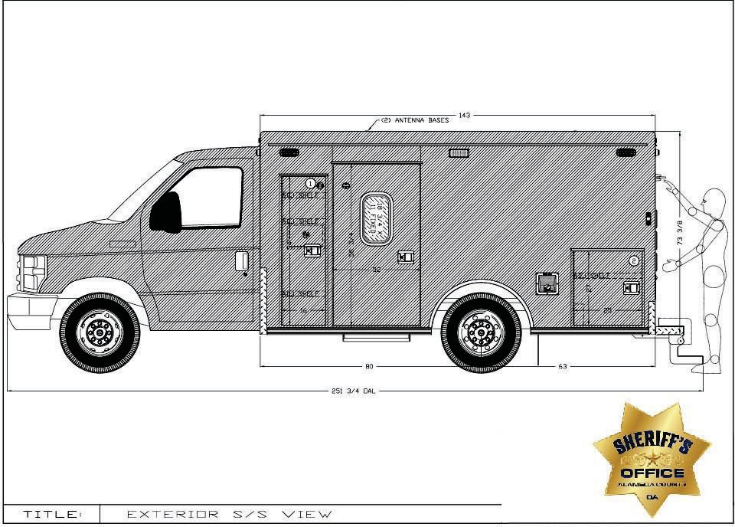

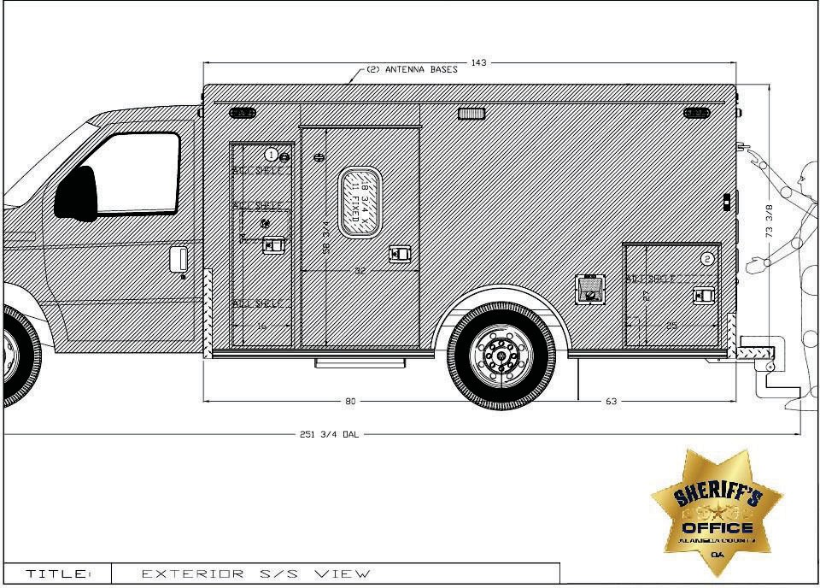

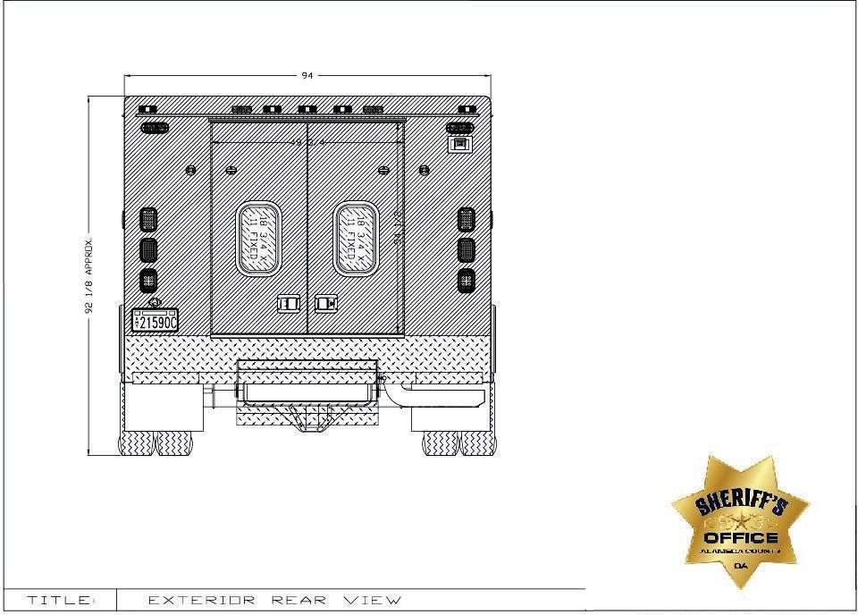

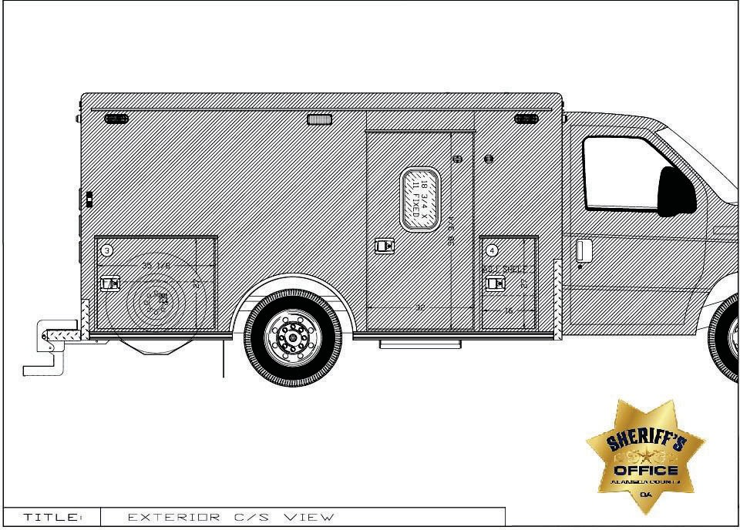

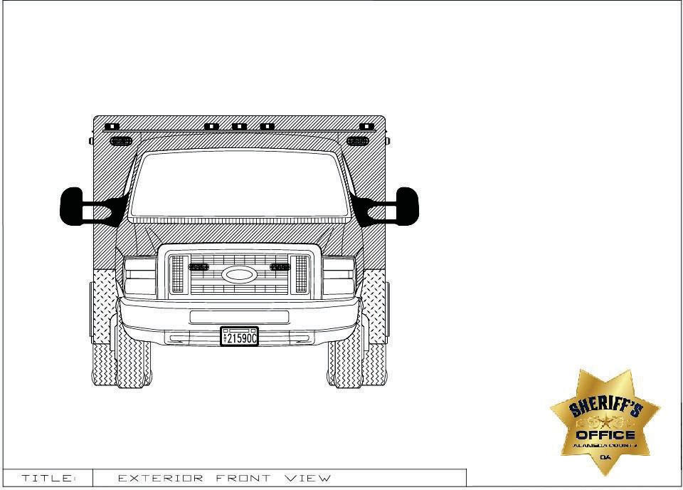

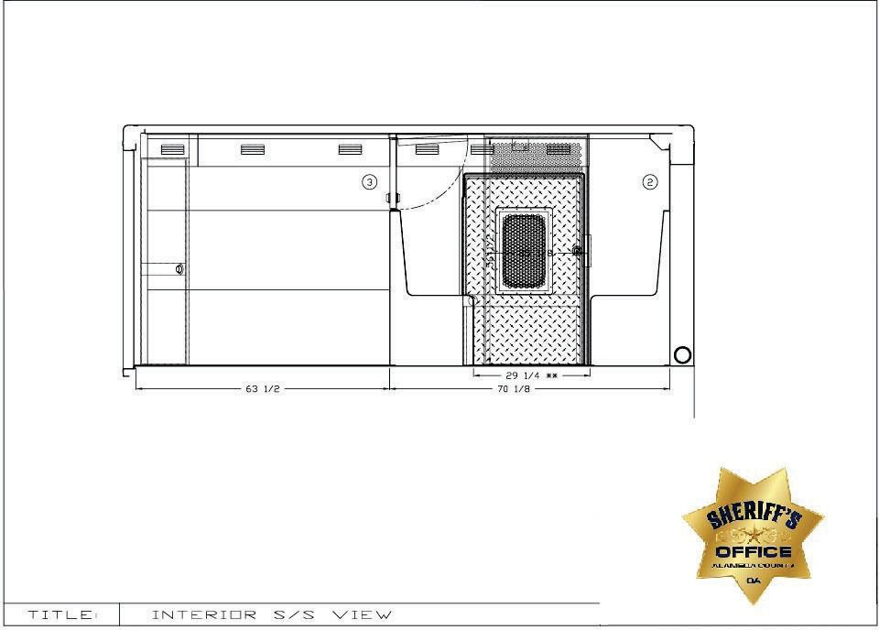

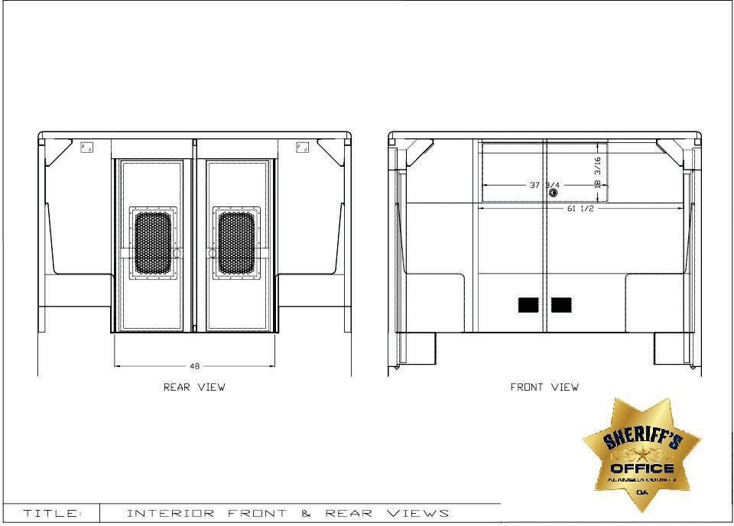

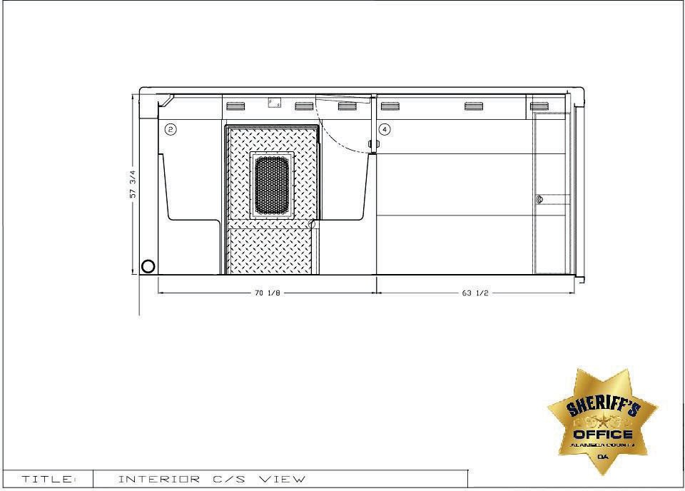

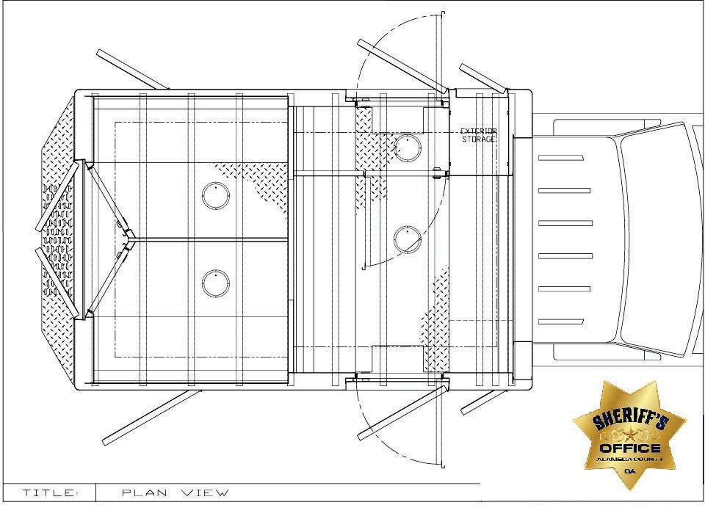

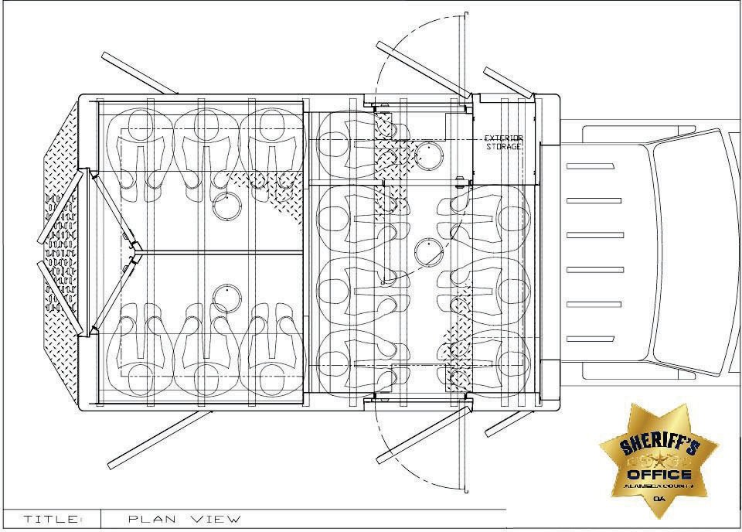
EXHIBIT D
LARGE TRUCK WITHOUT BATHROOM SPECIFICATIONS RESPONSE

INSTRUCTIONS: Bidders must submit, with their bid, a fully completed Exhibit D – Large Truck Without Bathroom Specifications Response for Inmate Transportation Vehicles. Bids which are submitted without Exhibit D will be disqualified.
A “Yes” response to a requirement in the “Comply” column will mean that the bidder intends to comply with the exact specification, as described in Exhibit D. If the bidder is able to comply with the specification stated, and states “Yes” in the “Comply” column, no further action is required. A “No” response to a specification sentence in the “Comply” column will mean that the bidder is unable to comply with the specification provided by the County.

If a bidder is unable to comply with specific requirements listed in Exhibit D, the bidder is to state “No” in the “Comply” column, and provide a brief explanation in the “Explanation” column. All exceptions, clarifications, and amendments pertaining to Exhibit D shall be described in full, using additional pages, as necessary, to provide complete descriptions. Bidder must clearly reference each exception, clarification, or amendment by its corresponding item number (e.g., Item 1.a. – Specific Ratings, Rear Axle Ration: 5.22 ratio). The County, at its sole discretion, shall have the right to deem acceptable any exceptions, clarifications or amendments stated by the bidder.

A response of “N/A” or no response to any specification column will mean that the bidder is unable to comply with the specification provided by the County.

In Exhibit D, references to specific brand names are intended to describe components that have been determined to best meet operational, performance, or reliability standards of the County, thereby incorporating these standards by reference within the specifications. These specifications are not meant to limit the vendor; they are guidelines to minimum qualifications. The bidder shall indicate their compliance or non-compliance for each line of the Exhibit D section. An “equivalent or better” may be offered by the bidder, subject to evaluation and acceptance by the County. It is the bidder’s responsibility to provide, at bidder’s expense samples, test data, or other documentation, which the County may require to fully evaluate and determine acceptability of an offered substitute. The County reserves the sole right to reject a substituted component that will not meet or exceed County standards. Please refer to Page 20 of this RFP, BRAND NAMES AND APPROVED EQUIVALENTS, for further information on brand names and approved equivalents.

EXCEPTIONS, CLARIFICATIONS, AMENDMENTS TO SPECIFICATIONS: Any and all deviations, exceptions, or alternatives to Exhibit D must be clearly stated, as described below, or the proposal may be considered non-responsive.

- LARGE TRUCK WITHOUT BATHROOM Specifications
Specification Response Explanation
  - CHASSIS
3.01.00 | OEM CHASSIS  - 2024 Freightliner M2 106 Plus Conventional  - Rescue & Emergency Service  - Medium Truck Warranty  - Extended Cummins Engine Warranty, 5 years/150,000 miles  - Allison Transmission Warranty, Five years  - Provided by Vendor | COMPLY: YES NO
3.01.01 | SPECIFIC RATINGS  - Drive – 4 x 2  - G.V.W.R Capacity – 37,320 lb  - Wheelbase – 294ʺ  - Rear Axle Ratio – 4.89 | COMPLY: YES NO

3.01.02 | POWER TRAIN  - Engine  – Cummins L9 360EV @ 2200 RPM, 2200 Gov, 1150 LB/FT @ 1200 RPM  - Heavy duty onboard diagnostics interface connector located below LH dash  - 2008 Carb Emission Certification – Clean idle label on forward corner of driver door (6 ʺ x 4 ʺ label)  - Cummins Turbocharged 18.7 CFM air compressor  - Electric Grid Air Intake Warmer  - Cummins exhaust brake integral with variable geometry turbo with on/off dash switch with brake lights  - Block heater  - Transmission  - Allison 3000 EVS automatic with PTO provision  - Water to Oil, transmission cooler, in radiator end tank  - Push button electronic shift control, dash mounted  - Engine Cooling System  - 1100 Sq. In. Radiator  - Exhaust  - Horizontal tailpipe, exit rear of the vehicle aft of the rear wheels, streetside  - Driveline guard (393-001) | COMPLY: YES NO
3.01.03 | STEERING  - Power – TRW TAS-85  - 4-spoke Steering Wheel – 18ʺ  - Steering column – Adjustable tilt and telescoping | COMPLY: YES NO
3.01.04 | AXLES AND SUSPENSION  - Front Axle – 14,700 lb capacity  - Front Suspension – Taper leaf 14,600 lb -- Maintenance free rubber bushings  - Rear Axle – 23,000 Capacity  - Rear Suspension – Hendrickson HAS-230 23,000 lb with 6ʺ ride height  - Ignition controlled electric dump switch for air suspension with state retention and gauge  - Front and rear shock absorbers | COMPLY: YES NO

3.01.05 | BRAKING SYSTEM  - Air Brake Package  - Front – Bendix ADB22X-V Air Disc  - Rear – Air drum brakes  - Wabco 4S/4M ABS with traction control  - BW AD-IS (DRM) brake line air dryer with shield, heater, and integral reservoir  - Brake Lining – Non-Asbestos  - One dash mounted valve parking brake system with warning indicator (882-009)  - Factory-installed Bendix next gen SmarTire tire pressure monitoring system with wheel rim mounted next gen sensors and integrated in dash | COMPLY: YES NO
3.01.06 | TIRES AND WHEELS  - Front Tires – Two Michelin X Line Energy Z 295/60R22.5 18 ply radial  - Rear Tires– Two Michelin X Line Energy Z 295/60R22.5 18 ply radial  - Wheels – Seven OEM Alcoa Aluminum 22.5ʺ , 10 hubs  - Spare tire and wheel included | COMPLY: YES NO
3.01.07 | ELECTRICAL  - Alternator – 320-amp 4962PGH Pad Mount  - Batteries – Four DTNA genuine, flooded starting, min 4000cca, 740rc, threaded stud batteries  - Progressive low voltage disconnect at 12.3 VDC for designated circuits  - Positive and negative posts for jumpstart located on frame next to starter | COMPLY: YES NO

3.01.08 | INSTRUMENT PANEL AND CONTROLS  - Gauges  - Fuel Gauge  - Oil Pressure  - Transmission Oil Temperature  - Engine Coolant Temperature  - Hour Meter and Trip Meter (integral with driver display)  - Speedometer – Electronic w/ mph, kph scale  - Tachometer 3000 rpm  - Voltage (integral with driver display)  - Air restriction gauge without graduations  - Air Pressure, primary and secondary  - Warning system – Lights and Buzzer  - Low air pressure  - Park Brake  - Control – Electronic cruise control with controls on steering wheel spokes  - Audio – AM/FM/WB world tuner radio with Bluetooth, USB and auxiliary inputs | COMPLY: YES NO

3.01.09 | CAB EXTERIOR  - Hood – Fiberglass  - Grille – Chromed Plastic  - 106ʺ Flat Roof aluminum conventional cab  - Air cab mounting  - Bumper – Three-Piece 14ʺ Chromed steel with collapsible ends  - Mirrors (motorized retracting mirrors)  - Door mounted dual bright West Coast, 102ʺ equipment width  - 8ʺ convex, bright finish, mounted under primary mirrors  - Remote, heated  - Windshield wipers – two-speed, with intermittent  - Windows  - One-piece solar green glass windshield  - Tinted door glass LH and RH with tinted non-operating wing windows  - 63ʺ x 14ʺ H tinted rear window  - Lighting  - LED headlight assembly & incandescent marker/turn lamp with chrome bezel  - Alternating Flashing headlamp system with body builder-controlled engagement  - LED aerodynamic marker lights  - Daytime running lights  - Rectangular clear fog lights mounted under bumper  - Dual electric horns | COMPLY: YES NO
3.01.10 | CAB EXTERIOR (Continued)  - Dual Fuel Tanks – 50 Gallon rectangular aluminum, LH, 50-gallon RH. – Detroit fuel/water separator with water in fuel sensor Polished  aluminum with painted bands  - 6 Gallon DEF tank  - Grab Handles – Exterior right and left sides with single rubber inserts | COMPLY: YES NO

3.01.11 | CAB INTERIOR  - Interior – Gray and Carbon (Rugged)  - Premium Insulation  - Interior sun visors – driver and passenger  - Flooring – Black vinyl with insulation  - Driver and passenger seats – Premium high back air suspension, with two air lumbar  - Black Mordura cloth seat covers  - Dual Seat Armrests  - Three-point seatbelts  - Climate Control  - Heater/ Defroster/AC  - Main HVAC controls with recirculation switch  - Standard heater plumbing  - Electric door locks and windows  - Roof mounted console  - Cup holders in dash  - One dash mounted 12 VDC power outlet  - One dash mounted dual 2.1-amp USB-C charger  - Aluminum LH and RH kickplates (693-035)  - Eight OEM keys (78G-008) | COMPLY: YES NO
3.01.12 | COATINGS/PAINT  - Exterior – Blue Jean Metallic (N1)  - Interior – Gray/Carbon | COMPLY:  YES NO
3.01.13 | CHASSIS MODIFICATIONS  The following modifications shall be made to the chassis by Vendor. | COMPLY:  YES NO
3.01.14 | RUBBER MUD FLAPS  Black mud flaps shall be installed behind each rear wheel. | COMPLY:  YES NO
3.01.15 | AIR SUSPENSION  If necessary to abide by customerʹs vertical height restrictions, chassis ride height shall be adjusted ½″ down from normal, as allowed by the chassis manufacturer, in order to improve module vertical clearance. | COMPLY: YES NO

3.01.16 | CHASSIS ANTI-THEFT  A hidden toggle switch under dash shall be provided to disable the chassis transmission selector. | COMPLY:  YES NO
3.01.17 | CHASSIS LIGHTING  A Whelen 3ʺ Red Lens Red LED flasher shall be centered on the cab headliner, to give warning to the cab occupants in regards to the module smoke/carbon monoxide detectors. | COMPLY: YES NO
3.01.18 | AUXILIARY COMPRESSORS  Two TM-21 auxiliary air conditioning compressor kits shall be added to the OEM engine. | COMPLY:  YES NO
3.01.19 | WEAPONS STORAGE  A customer-supplied Blac-Rac dual long-gun storage system designed for a customer-supplied-and-installed AR-15 rifle and shotgun shall be installed on the cab ceiling, exact model to be determined at the preconstruction meeting. A hidden unlock switch shall be installed, location to be determined at the preconstruction meeting. Switch shall only be active when the key is in the chassis ignition.  Locking handgun storage shall be provided in the rear of the driverʹs console. | COMPLY: YES NO
3.01.20 | CHASSIS MISCELLANOUS  One 15lb ABC fire extinguisher with bracket shall be installed in cab (exact location to be determined at preconstruction meeting).  Three Hybrid 4G HDDVRʹs shall be installed in cab (Exact location to be determined at preconstruction meeting). | COMPLY: YES NO
3.01.21 | CAB CONDUIT  A 5.5″ cab conduit shall be installed between the cab and module located behind the driverʹs seat. The driverʹs console harness shall be routed through the conduit. | COMPLY: YES NO

3.01.22 | OVERVIEW OF MODULE MOUNTING SYSTEM  The module shall be bolted to the chassis frame in no fewer than twelve locations. Each mounting location shall include a hard rubber isolation pad between the chassis frame and the module lateral. The rearmost lateral(s) shall be connected to the frame extensions with 5/8″ grade 8 bolts. All remaining laterals shall be connected with vertical 3/4″ grade B7 eye bolts fastened to the frame rails with horizontal 3/4″ grade 8 hex bolts. All bolts shall be secured with locking nuts.  Modules 176″L or longer shall have soft rubber washers added above the forward and rear laterals to accommodate chassis frame torsion. | COMPLY: YES NO
2. MODULAR CONSTRUCTION
3.02.00 | MODULE CONSTRUCTION  All material utilized shall be of the correct type, alloy, and thickness to withstand the intended usage and provide protection against cracking, corrosion, or metal fatigue. All materials utilized shall be of open stock origin, commonly available through local sources, for rapid and economical repair or modification of the body. Any use of proprietary parts or materials in the construction of the body is unacceptable, due to potential delays or difficulties in future repairs or service. NO EXCEPTIONS TO BE TAKEN IN THIS AREA. This specification has been designed and written to fill specific needs of this agency. Where brand name, make, or model of equipment has been specified, no exceptions shall be allowed. Where compartment and cabinet sizes have been specified, bidder must bid substantially (plus or minus 1″) the size specified. | COMPLY: YES NO
3.02.01 | MODULE WARRANTY  The module shall have a transferable lifetime structural warranty. | COMPLY:  YES NO

3.02.02 | MATERIAL  EXTRUSIONS SIZE ALLOY  Structural Tubing 1″ x 2″ x 0.125″ sq. 6063-T52  Structural Tubing 2″ x 2″ x 0.125″ sq. 6063-T52 Structural Angle Cross Members 3″ x 3″ x 0.375″ 6061-T6  Structural Channel Cross Members 1.5″ x 0.25″ 6061-T6
 |  | COMPLY:
 | FORMED SHEETING SIZE ALLOY  Skin/Roof/Compartments/Subfloors/Doors 0.125″ 5052-H32 Interior Cabinets 0.090″ 5052-H32  Diamond Plate 0.125″/0.08″ 3003-H22  Stainless Steel 16 ga., 20 ga. 304 # 4B | YES NO

3.02.03 | MODULE DIMENSIONS  Drop Skirt, from rear curbside door forward 8.00"  Final dimensions to be confirmed at preconstruction meeting.  Overall Vehicle Dimensions (Specifications are listed as minimums) Length: 39' and 2" = 470.00"  Width (Excluding Mirrors): 8' and 6" = 102.00"  Height (Approximate): 9' and 9.38" = 117.38"  - Vehicle Maximum Height TBD at Preconstruction Meeting. Exterior Module Dimensions (Specifications are listed as minimums) Length: 29' and 3" = 351.00"  Width: 8' and 6" = 102.00"  Height (Front of Module): 8' and 2.375" = 98.38"  Height (Rear of Module): 7' and 6.375" = 90.38"  Interior Module Dimensions (Specifications are listed as minimums) Length: Forward Wall to Rear Wall = 342.00"  Width: Aisle = 26.00"  Module Electric Step Height 6.50” to 8.50” range to clear the RCD Tunnel Curb Height | COMPLY: YES NO

3.02.04 | STRUCTURAL FRAMING  Side wall and rear wall construction shall consist of 2″ x 2″ x 0.125″ aluminum square tubing extensions welded together with a maximum of 14″ centers. 1″ x 2″ x 0.125″ aluminum tubing may be utilized in addition to 2″ x 2″ tubing to accommodate custom compartment sizes. The bottom of the wall structure shall be sealed with a welded 2″ x 2″ tube, a 2″ x 2″ angle, or a 0.125″ plate depending upon location. The wall structure shall be capped with a 2″ x 4″ x 0.125″ header upon which a 2″ x 2″ x 0.125″ roof structure is welded. This process provides a unitized roll cage structure for greater occupant safety. The front wall structure shall be constructed of formed aluminum channels to allow ample space for wiring raceways, heater hoses, and A/C hoses. | COMPLY: YES NO
3.02.05 | FOUNDATION SYSTEM  The foundation system shall consist of a 0.125″ aluminum sheet subfloor with foundation members securely welded under the subfloor. Transverse members (laterals) shall consist of 3″ x 3″ x 0.375″ structural angles. 0.25″ x 1.5″ aluminum stringers shall span longitudinally between the laterals. | COMPLY: YES NO
3.02.06 | MODULE SEAMS  All body and compartment seams at or below floor level shall be full- seam-welded. The entire perimeter of the subfloor shall be completely sealed with a caulking material, creating a watertight seam. | COMPLY: YES NO
3.02.07 | EXTERIOR SKIN  A Norton NORBOND closed-cell, polyurethane foam tape with high- performance acrylic adhesive shall be utilized full length on all front and rear wall and roof frame members. A polyurethane adhesive sealant shall be applied to the edges of framing members that are bonded with NORBOND tape. An advanced two-part methacrylate structural adhesive shall be used to bond all side wall tubes to the exterior skin and door frames.  The module shall be constructed utilizing full-size sheet construction to minimize body seams. There shall be no corner or mid-body seams. | COMPLY: YES NO

3.02.08 | MODULE ROOF  In order to improve module strength and minimize exposed seams, the roof shall be seamed transversely, shall have a 1.5″ radius along the edges, and shall be welded to 2″ x 4″ wall header tubes 4.75″ below the roof line. The roof shall be supported by positive contact between sidewall framing and roof framing. All seams on the roof surface shall be continuously welded and body-worked on the outside. In order to avoid the possibility of paint and/or weld cracking, no extrusions shall be used in the exterior construction of the roof or corners of the module.  Three contoured, 3/8″ aluminum plates, painted to match the module, shall be welded to the roof structure and project through the center of the roof to serve as anchorages for personal fall arrest equipment. Each anchorage is designed and rated for a single person only.  The three plates shall be completely removed from the roof surface and be touched up before delivery. | COMPLY: YES NO
3.02.09 | MODULE EXTERIOR COMPARTMENTS  All compartments shall be constructed from formed 0.125″ aluminum, securely welded to the subfloor and structural framing. A baffled drain hole shall be provided in all exterior compartment bottoms that extend below the floor line. All exterior adjustable shelves shall be mounted on heavy-duty aluminum track, which is securely welded to compartment interiors. Each shelf shall support at least 300 lb of equipment. | COMPLY: YES NO

3.02.10 | COMPARTMENT #1 - RADIOS AND SECURITY  Interior Dimensions – 34ʺ W x 17.625ʺ H x 26ʺ D Doorway Dimensions – 34ʺ W x 17.625ʺ H Location – Streetside, forward, lower  Shelving – None  Door(s) – Single, bottom-hinged door with a black 1.5ʺ diameter rubber bumper  Light(s) – One horizontal LED strip light Additional Instructions –  1. Access shall be provided between this compartment and the cab via a  5.5ʺ conduit.  - An enclosed electrical component module shall be enclosed in this compartment.  - A customer-supplied Motorola APX 6500 transceiver shall be installed on the floor of this compartment, aft.  - A Blue Sea #5032 ST Blade fuse block with twelve circuits shall be installed behind the transceiver.  - An 80-amp battery charger shall be installed in this compartment.  - A Samlex #PST-300-12 300-watt inverter shall be installed in this compartment, exact location to be discussed at preconstruction meeting.  - A vent with MERV 8 polyester filter media and a hex-punched stainless- steel cover shall be installed on the forward wall. | COMPLY: YES NO

3.02.11 | COMPARTMENT #2 - SAFETY  Interior Dimensions – 30ʺ W x 16ʺ H x 34ʺ D Doorway Dimensions – 30ʺ W x 16ʺ H Location – Streetside, forward, upper Shelving – None  Door(s) – Single, bottom-hinged door with a black 1.5ʺ diameter rubber bumper  Light(s) – One horizontal LED strip light Additional Instructions –  - One ABC 15 lb fire extinguisher with an Amerex #809 SAE-J3043 compliant bracket shall be installed on the aft wall, exact location to be determined at preconstruction meeting.  - Install a customer-supplied Halligan bracket and tool on the forward wall, exact location to be determined at preconstruction meeting.  - A punched painted aluminum vent shall be installed on the back wall. | COMPLY: YES NO

3.02.12 | COMPARTMENT #3 - ELECTRICAL  Interior Dimensions – 64ʺ W x 17.625ʺ H x 26ʺ D Doorway Dimensions – 64ʺ W x 17.625ʺ H Location – Streetside, forward, lower  Shelving – None  Door(s) – Single, bottom-hinged door with two black 1.5ʺ diameter rubber bumpers  Light(s) – One horizontal LED strip light. Additional Instructions –  - The 12VDC electrical panel shall be installed on the back wall of this compartment. An aluminum cover with ʺ ELECTRICAL PANEL ACCESSʺ label with electrical warning symbol below shall be installed on the front of the 12VDC electrical panel. A wiring access hole shall be provided in the front wall, between the electrical panel and Compartment #1.  - The aft end of the compartment shall be separated from the front of the compartment, by a fixed vertical divider with door gasket.  - The aft portion of this compartment shall have a 300 lb capacity battery tray with a locking left slide. The area shall be vented to the outside and sealed to prevent battery vapors from entering the cells of the prisoner transport. Three aftermarket DTNA genuine, flooded starting, min 4000cca, 740rc, threaded stud batteries shall be installed on the tray. | COMPLY: YES NO

3.02.13 | COMPARTMENT #4  Interior Dimensions – 64ʺ W x 17.625ʺ H x 26ʺ D Doorway Dimensions – 64ʺ W x 17.625ʺ H  Location – Streetside, forward of wheel wells, lower Shelving – None  Door(s) – Single, bottom-hinged door with two black 1.5ʺ diameter rubber bumpers  Light(s) – One horizontal LED strip light. Additional Instructions –  - A vent with MERV 8 polyester filter media and a hex-punched stainless- steel cover shall be installed on the aft wall.  - A 62ʺ W x 25ʺ D reinforced mill finish aluminum roll-out tray with 3″ lips with black knock-on trim and Gray Matéflex floor tile shall be installed on locking, 1000 lb-capacity, 100% extension steel SlideMaster slides. A 14ʺ H mill finish single-wall framed punched aluminum vertical tool board shall be provided as the back wall of the slide-out tray for customer- supplier-and-installed items. Precision punched holes, sized for 5/16ʺ carriage bolts, shall be provided along the full width and height of the vertical tool board. | COMPLY: YES NO
3.02.14 | COMPARTMENT #5  Interior Dimensions – 30ʺ W x 16ʺ H x 34ʺ D Doorway Dimensions – 30ʺ W x 16ʺ H Location – Streetside, forward of wheel wells Shelving – None  Door(s) – Single, bottom-hinged door with one 1.5ʺ diameter rubber bumper  Light(s) – One horizontal LED strip light. Additional Instructions –  - A punched painted aluminum vent shall be installed on the back wall. | COMPLY: YES NO

3.02.15 | COMPARTMENT #6  Interior Dimensions – 90ʺ W x 14ʺ H x 5.5ʺ D Doorway Dimensions – 90ʺ W x 14ʺ H Location – Rear of module  Shelving – None  Door(s) – Single, bottom-hinged door with two black 1.5ʺ diameter rubber bumpers (different than shown in drawings) and deadbolt lock Light(s) – One horizontal LED strip light  Additional Instructions –  - This compartment shall provide access to the wheelchair restraint system in Cell #8. A bottom-hinged diamond plate door, with stainless hinge shall open up to the interior of the unit.  - Three sets of interior wheelchairs restraints shall be installed in this area.  - Drip Rail above compartment #6 | COMPLY: YES NO
3.02.16 | COMPARTMENT #7  Interior Dimensions – 35ʺ W x 17.625ʺ H x 26ʺ D Doorway Dimensions – 32ʺ W x 17.625ʺ H Location – Curbside, aft  Shelving – None  Door(s) – Single, bottom-hinged door with one 1.5ʺ diameter rubber bumper  Light(s) – One horizontal LED strip light. Additional Instructions –  - The back-up manual hydraulic unit for the wheelchair lift shall be located in this compartment. | COMPLY: YES NO

3.02.17 | COMPARTMENT #8  Interior Dimensions – 70ʺ W x 17.625ʺ H x 26ʺ D Doorway Dimensions – 70ʺ W x 17.625ʺ H Location – Curbside, center, lower  Shelving – None  Door(s) – Single, bottom-hinged door with two black 1.5ʺ diameter rubber bumpers,  Light(s) – One horizontal LED strip light Additional Instructions –  - A 68ʺ W x 25ʺ D reinforced mill finish aluminum roll-out tray with 3″ lips with black knock-on trim and Gray Matéflex floor tile shall be installed on locking, 1000 lb-capacity, 100% extension steel SlideMaster slides. A 14ʺ H mill finish framed punched aluminum tool board shall be provided as the back wall of the slide-out tray, for customer-supplied-and-installed items. Precision punched holes, sized for 5/16ʺ carriage bolts, shall be provided along the full width and height of the vertical tool board.  - A vent with MERV 8 polyester filter media and a hex-punched stainless- steel cover shall be installed on the forward wall. | COMPLY: YES NO
3.02.18 | COMPARTMENT #9  Interior Dimensions – 32ʺ W x 16ʺ H x 34ʺ D Doorway Dimensions – 32ʺ W x 16ʺ H Location – Curbside, center, upper Shelving – None  Door(s) – Single, bottom-hinged door with one 1.5ʺ diameter rubber bumper  Light(s) – One horizontal LED strip light. Additional Instructions –  - One ABC 15 lb fire extinguisher with an Amerex #809 SAE-J3043 compliant bracket shall be installed on the forward wall, exact location to be determined at preconstruction meeting.  - A punched painted aluminum vent shall be installed on the back wall. | COMPLY: YES NO

3.02.19 | MODULE DOORS  The doors shall be box pan formed with a total thickness of 2ʺ .  Three interior painted hex-punched 0.125″ formed aluminum security doors, each with a solid perimeter, horizontal latch stile, non-locking paddle latch, and a deadbolt lock shall be installed, just inside the curbside and streetside passage doors and the wheelchair access door. Clear 0.25ʺ polycarbonate shall be installed on the inside surface of the security door for the wheelchair access door, only. | COMPLY: YES NO
3.02.20 | DOOR SEAL  Each door frame shall have a flange for the installation of an air cell hollow core 360-degree compression door seal. This seal creates watertight, dust-free compartment integrity. Door seal shall be knock-on type. Door frames shall be bonded to the adjacent tubes such that no exterior flange is required. | COMPLY: YES NO
3.02.21 | DOOR HINGES  Compartment and passage doors shall have full-length, piano-type, 2.5″W stainless steel hinges, positioned with 0.25″ rivets at each end. The hinges shall be attached with #12 x 0.75″ stainless steel truss head screws spaced 4″ apart, sealed with Sikaflex. All curbside and streetside side-hinged single doors shall be hinged on the forward sides. | COMPLY: YES NO

3.02.22 | DOOR LATCHES  Exterior door handles shall be semi-flush, chrome-plated Eberhard E Grabber #21100. All exterior doors shall have rotary latches and striker posts that meet FMVSS 206 requirements. Striker posts shall be adjustable and be secured with a nut from behind the door frame. The striker washer shall not be removed. Guards shall be added to the top of the striker posts at the bottom of double passage door openings to reduce the risk of snagging clothing or leg chains when exiting. Doors greater than 45″ tall shall have double rotary latches activated by stainless steel rods. Once final adjustments have been made, threads shall have Loctite or equivalent applied. All double-door compartments shall have an exterior E Grabber handle and rotary latches on each door. Doors shall latch to doorframe-mounted striker posts only and not to one another. All locks shall be keyed J236.  The passage doors, wheelchair access door, and cell doors shall each have a single sided dead bolt lock. All dead bolts and pad locks shall be keyed 56434.  Any exposed screws shall be sealed to prevent vandalism. | COMPLY: YES NO
3.02.23 | COMPARTMENT DOOR CONTROL  1.5ʺ diameter black rubber bumper shall be installed for all compartment doors. Compartments #3, 4, 6 and 8 shall have two bumpers. | COMPLY: YES NO
3.02.24 | PASSAGE DOOR CONTROLS  All passage doors shall have low profile grabber type hold-open devices (Cast Products DH0016 &-A) with replacement rubber catches. | COMPLY:  YES NO

3.02.25 | COMPARTMENT DOOR SKINS  Each compartment door skin shall be made of 0.080″ bright aluminum diamond plate, shall be removable, and have a latch service opening with a 2.25″ x 4.5″ diamond plate Cover for lubrication and service all compartment doors except Compartment #6. Door skins shall be secured with #8 pan head screws and Sikaflex.  A diamond plate cover shall be installed over the latch access hole with #8 pan head screws and Sikaflex for Compartment #6.  The 1ʺ perimeter of the inside surface of the diamond plate door skins shall be masked off, and the inside surface of the door skin shall be covered with Advanced Coating Solutions CIC 4.0 composite ceramic insulating coating. A 1ʺ wide x 0.125ʺ thick foam tape shall be then be adhered to the perimeter of the inside surface of the diamond plate door skin, as a thermal barrier. The tape backing on the non-adhered side shall be left in place, to allow the door skin to be removed for future maintenance. | COMPLY: YES NO
3.02.26 | ENTRANCE DOOR SKINS  Shall be 0.080″ bright aluminum diamond plate and be removable to service door hardware. A diamond plate cover shall be installed over the latch access hole with #8 pan head screws and Sikaflex.  The 1ʺ perimeter of the inside surface of the diamond plate door skins shall be masked off, and the inside surface of the door skin shall be covered with Advanced Coating Solutions CIC 4.0 composite ceramic insulating coating. A 1ʺ wide x 0.125ʺ thick foam tape shall be then be adhered to the perimeter of the inside surface of the diamond plate door skin, as a thermal barrier. The tape backing on the non-adhered side shall be left in place, to allow the door skin to be removed for future maintenance. | COMPLY: YES NO
3.02.27 | ENTRANCE DOORWAYS & EMERGENCY EGRESS DOORS  Two module entrance doors shall be provided; one on the streetside and one on the curbside. The doorway dimensions shall be 31ʺ W x 81.75ʺ H. A 40ʺ W x 69ʺ H wheelchair access door shall be installed on the curbside, aft of the wheel well. | COMPLY: YES NO

3.02.28 | INTERIOR COMPARTMENTS  Each cell door shall have an upper and lower Schlage single-sided deadbolt, keyed 56434. Any exposed screws shall be security type and sealed to prevent vandalism.  All cell doors shall be aft-hinged, allowing the doors to always be between the prisoner and officer.  Note: Cells #4, 5, 11, and 12 shall be reduced in height to accommodate relocation of HVAC blower units to the middle of the module. | COMPLY: YES NO
3.02.29 | FORWARD GROUP CELL #1  Capacity: 9 Inmates  Interior Dimensions – 97ʺ W x 74ʺ H x 52.25ʺ D Location – Forward  Door(s) – One 0.125ʺ streetside-hinged aluminum cell door shall be installed. The door shall have four hex punched sections; two stacked above the center stile, and two stacked below the center stile. 0.25ʺ clear polycarbonate shall cover the upper two hex-punched sections. Additional polycarbonate covers and cell ventilation to be determined at the preconstruction meeting. The door shall have a stainless-steel piano hinge and two single-sided Schlage deadbolt locks, one upper and one lower.  Seating – Three formed aluminum benches shall be provided: a five- person bench against the forward wall, and two two-person benches on the aft cell wall, one on each side of the aisle.  Additional Instructions –  - Two 18.625″W x 11.125″H dual pane windows with hex-punched stainless-steel covers riveted in place over the inside surface shall be installed, one each on the streetside and curbside walls.  - A security camera shall be installed on the streetside wall, upper forward, positioned to capture the entire cell. | COMPLY: YES NO

3.02.30 | STREETSIDE CELL #2  Capacity: 2 Inmates  Interior Dimensions – 32.5ʺ W x 74ʺ H x 35.75ʺ D Location – Streetside, forward  Door(s) – One 0.125ʺ aluminum aft-hinged cell door shall be installed. The door shall have four hex punched sections; two stacked above the center stile, and two stacked below the center stile. 0.25ʺ clear polycarbonate shall cover the upper two hex-punched sections. Additional polycarbonate covers and cell ventilation to be determined at the preconstruction meeting. The door to have a stainless-steel piano hinge and two single- sided Schlage deadbolt locks, one upper and one lower.  Seating – One formed aluminum two-person bench Additional Instructions –  - Two 18.625″W x 11.125″H dual pane windows with hex-punched stainless-steel covers riveted in place over the inside surface shall be installed.  - A security camera shall be installed on the upper wall, facing the bench. | COMPLY: YES NO

3.02.31 | STREETSIDE CELL #3  Capacity: 2 Inmates  Interior Dimensions – 33.375ʺ W x 74ʺ H x 35.75ʺ D Location – Streetside, forward  Door(s) – One 0.125ʺ aluminum aft-hinged cell door shall be installed. The door shall have four hex punched sections; two stacked above the center stile, and two stacked below the center stile. 0.25ʺ clear polycarbonate shall cover the upper two hex-punched sections. Additional polycarbonate covers and cell ventilation to be determined at the preconstruction meeting. The door to have a stainless-steel piano hinge and two single- sided Schlage deadbolt locks, one upper and one lower.  Seating – One formed aluminum two-person bench Additional Instructions –  - A 18.625″W x 11.125″H dual pane window with hex-punched stainless- steel cover riveted in place over the inside surface shall be installed.  - A security camera shall be installed on the upper wall, facing the bench. | COMPLY: YES NO

3.02.32 | STREETSIDE CELL #4  Capacity: 2 Inmates  Interior Dimensions – 33.375ʺ W x TBDʺ H x 35.75ʺ D Location – Streetside, middle  Door(s) – One 0.125ʺ aluminum aft-hinged cell door shall be installed. The door shall have four hex punched sections; two stacked above the center stile, and two stacked below the center stile. 0.25ʺ clear polycarbonate shall cover the upper two hex-punched sections. Additional polycarbonate covers and cell ventilation to be determined at the preconstruction meeting. The door to have a stainless-steel piano hinge and two single- sided Schlage deadbolt locks, one upper and one lower.  Seating – One formed aluminum two-person bench, facing aft. Additional Instructions –  - A 18.625″W x 11.125″H dual pane window with hex-punched stainless- steel cover riveted in place over the inside surface shall be installed.  - A security camera shall be installed on the upper wall, facing the bench. | COMPLY: YES NO

3.02.33 | STREETSIDE CELL #5  Capacity: 2 Inmates  Interior Dimensions – 33.375ʺ W x TBDʺ H x 35.75ʺ D Location – Streetside, middle  Door(s) – One 0.125ʺ aluminum aft-hinged cell door shall be installed. The door shall have four hex punched sections; two stacked above the center stile, and two stacked below the center stile. 0.25ʺ clear polycarbonate shall cover the upper two hex-punched sections. Additional polycarbonate covers and cell ventilation to be determined at the preconstruction meeting. The door to have a stainless-steel piano hinge and two single- sided Schlage deadbolt locks, one upper and one lower.  Seating – One formed aluminum two-person bench Additional Instructions –  - A 18.625″W x 11.125″H dual pane window with hex-punched stainless- steel cover riveted in place over the inside surface shall be installed.  - A security camera shall be installed on the upper wall, facing the bench. | COMPLY: YES NO

3.02.34 | STREETSIDE CELL #6  Capacity: 2 Inmates  Interior Dimensions – 33.375ʺ W x 74ʺ H x 35.75ʺ D Location – Streetside, middle  Door(s) – One 0.125ʺ aluminum aft-hinged cell door shall be installed. The door shall have four hex punched sections; two stacked above the center stile, and two stacked below the center stile. 0.25ʺ clear polycarbonate shall cover the upper two hex-punched sections. Additional polycarbonate covers and cell ventilation to be determined at the preconstruction meeting. The door to have a stainless-steel piano hinge and two single- sided Schlage deadbolt locks, one upper and one lower.  Seating – One formed aluminum two-person bench Additional Instructions –  - A 18.625″W x 11.125″H dual pane window with hex-punched stainless- steel cover riveted in place over the inside surface shall be installed.  - A security camera shall be installed on the upper wall, facing the bench. | COMPLY: YES NO

3.02.35 | STREETSIDE CELL #7  Capacity: 2 Inmates  Interior Dimensions – 34.25ʺ W x 74ʺ H x 35.75ʺ D Location – Streetside, middle  Door(s) – One 0.125ʺ aluminum aft-hinged cell door shall be installed. The door shall have four hex punched sections; two stacked above the center stile, and two stacked below the center stile. 0.25ʺ clear polycarbonate shall cover the upper two hex-punched sections. Additional polycarbonate covers and cell ventilation to be determined at the preconstruction meeting. The door to have a stainless-steel piano hinge and two single- sided Schlage deadbolt locks, one upper and one lower.  Seating – One formed aluminum two-person bench Additional Instructions –  - A 18.625″W x 11.125″H dual pane window with hex-punched stainless- steel cover riveted in place over the inside surface shall be installed.  - A security camera shall be installed on the upper wall, facing the bench. | COMPLY: YES NO

3.02.36 | REAR CELL #8  Capacity: 9 Inmates or 3 Wheelchair Inmates Interior Dimensions – 52.25ʺ W x 74ʺ H x 97ʺ D Location – Rear  Door(s) – One interior 0.125ʺ aluminum curbside-hinged cell door shall be installed. The door shall have four hex punched sections; two stacked above the center stile, and two stacked below the center stile. 0.25ʺ clear polycarbonate shall cover the upper two hex-punched sections. Additional polycarbonate covers and cell ventilation to be determined at the preconstruction meeting. The door to have a stainless-steel piano hinge and two single-sided Schlage deadbolt locks, one upper and one lower.  One exterior wheelchair access door with deadbolt lock shall be installed, along with an inner security door with deadbolt.  Seating – Five 10″D flip-up aluminum benches with 1″ frames, painted to match the interior shall be installed, three on the rear wall, and two on the front wall. The benches shall each have a minimum of two spring- loaded seat irons to keep the bench in the upright position except during use. Walls shall be reinforced to support flip-up benches. | COMPLY: YES NO

3.02.37 | REAR CELL #8 (ADDITIONAL INSTRUCTIONS)  - A 18.625″W x 11.125″H dual pane window with hex-punched stainless- steel cover riveted in place over the inside surface shall be installed on the streetside wall.  - Three positions for wheelchairs shall be provided against the rear wall.  - Three Sure-Lok #AL7275-4C wheelchair restraint kits #AL7275-4C with auto-tensioning retractor assemblies and S-hooks shall be installed at floor level along the aft wall. Restraints shall be accessible from the exterior Compartment #6.  - Each wheelchair position shall have a three-point seatbelt harness provided and padlocked in place. Padlock shall be keyed to match the deadbolt keys.  - A security camera shall be installed on the upper wall, facing the bench, exact location to be determined at preconstruction meeting. | COMPLY: YES NO

3.02.38 | CURBSIDE CELL #9  Capacity: 2 Inmates  Interior Dimensions – 32.5ʺ W x 74ʺ H x 35.75ʺ D Location – Curbside, rear  Door(s) – One 0.125ʺ aluminum aft-hinged cell door shall be installed. The door shall have four hex punched sections; two stacked above the center stile, and two stacked below the center stile. 0.25ʺ clear polycarbonate shall cover the upper two hex-punched sections. Additional polycarbonate covers and cell ventilation to be determined at the preconstruction meeting. The door to have a stainless-steel piano hinge and two single- sided Schlage deadbolt locks, one upper and one lower.  Seating – One formed aluminum two-person bench Additional Instructions –  - A 18.625″W x 11.125″H dual pane window with hex-punched stainless- steel cover riveted in place over the inside surface shall be installed.  - A security camera shall be installed on the upper wall, facing the bench. | COMPLY: YES NO

3.02.39 | CURBSIDE CELL #10  Capacity: 2 Inmates  Interior Dimensions – 33.375ʺ W x 74ʺ H x 35.75ʺ D Location – Curbside, rear  Door(s) – One 0.125ʺ aluminum aft-hinged cell door shall be installed. The door shall have four hex punched sections; two stacked above the center stile, and two stacked below the center stile. 0.25ʺ clear polycarbonate shall cover the upper two hex-punched sections. Additional polycarbonate covers and cell ventilation to be determined at the preconstruction meeting. The door to have a stainless-steel piano hinge and two single- sided Schlage deadbolt locks, one upper and one lower.  Seating – One formed aluminum two-person bench Additional Instructions –  - A 18.625″W x 11.125″H dual pane window with hex-punched stainless- steel cover riveted in place over the inside surface shall be installed.  - A security camera shall be installed on the upper wall, facing the bench. | COMPLY: YES NO

3.02.40 | CURBSIDE CELL #11  Capacity: 2 Inmates  Interior Dimensions – 33.375ʺ W x TBDʺ H x 35.75ʺ D Location – Curbside, middle  Door(s) – One 0.125ʺ aluminum aft-hinged cell door shall be installed. The door shall have four hex punched sections; two stacked above the center stile, and two stacked below the center stile. 0.25ʺ clear polycarbonate shall cover the upper two hex-punched sections. Additional polycarbonate covers and cell ventilation to be determined at the preconstruction meeting. The door to have a stainless-steel piano hinge and two single- sided Schlage deadbolt locks, one upper and one lower.  Seating – One formed aluminum two-person bench Additional Instructions –  - A 18.625″W x 11.125″H dual pane window with hex-punched stainless- steel cover riveted in place over the inside surface shall be installed.  - A security camera shall be installed on the upper wall, facing the bench. | COMPLY: YES NO

3.02.41 | CURBSIDE CELL #12  Capacity: 2 Inmates  Interior Dimensions – 33.375ʺ W x TBDʺ H x 35.75ʺ D Location – Curbside  Door(s) – One 0.125ʺ aluminum aft-hinged cell door shall be installed. The door shall have four hex punched sections; two stacked above the center stile, and two stacked below the center stile. 0.25ʺ clear polycarbonate shall cover the upper two hex-punched sections. Additional polycarbonate covers and cell ventilation to be determined at the preconstruction meeting. The door to have a stainless-steel piano hinge and two single- sided Schlage deadbolt locks, one upper and one lower.  Seating – One formed aluminum two-person bench Additional Instructions –  - A 18.625″W x 11.125″H dual pane window with hex-punched stainless- steel cover riveted in place over the inside surface shall be installed.  - A security camera shall be installed on the upper wall, facing the bench. | COMPLY: YES NO

3.02.42 | CURBSIDE CELL #13  Capacity: 2 Inmates  Interior Dimensions – 33.375ʺ W x 74ʺ H x 35.75ʺ D Location – Curbside, forward  Door(s) – One 0.125ʺ aluminum aft-hinged cell door shall be installed. The door shall have four hex punched sections; two stacked above the center stile, and two stacked below the center stile. 0.25ʺ clear polycarbonate shall cover the upper two hex-punched sections. Additional polycarbonate covers and cell ventilation to be determined at the preconstruction meeting. The door to have a stainless-steel piano hinge and two single- sided Schlage deadbolt locks, one upper and one lower.  Seating – One formed aluminum two-person bench Additional Instructions –  - A 18.625″W x 11.125″H dual pane window with hex-punched stainless- steel cover riveted in place over the inside surface shall be installed.  - A security camera shall be installed on the upper wall, facing the bench. | COMPLY: YES NO

3.02.43 | CURBSIDE CELL #14  Capacity: 2 Inmates  Interior Dimensions – 34.25ʺ W x 74ʺ H x 35.75ʺ D Location – Curbside, forward  Door(s) – One 0.125ʺ aluminum aft-hinged cell door shall be installed. The door shall have four hex punched sections; two stacked above the center stile, and two stacked below the center stile. 0.25ʺ clear polycarbonate shall cover the upper two hex-punched sections. Additional polycarbonate covers and cell ventilation to be determined at the preconstruction meeting. The door to have a stainless-steel piano hinge and two single- sided Schlage deadbolt locks, one upper and one lower.  Seating – One formed aluminum two-person bench Additional Instructions –  - A 18.625″W x 11.125″H dual pane window with hex-punched stainless- steel cover riveted in place over the inside surface shall be installed.  - A security camera shall be installed on the upper wall, facing the bench. | COMPLY: YES NO
3.02.44 | CURBSIDE AND STREETSIDE DOORSTEPS  Two 31ʺ W x 20ʺ D recessed double doorsteps shall be provided, one each on the streetside and curbside. There shall be a drain hole and an open grate step plate for each step which is removable for cleaning purposes. Polished aluminum diamond plate kick panels shall be installed on the side and face of the doorstep.  Two 18ʺ L x 1.250″D stainless-steel diagonal grab bars shall be installed aft of each stairwell to be used as an entry/exit assist rail. | COMPLY: YES NO
3. COATING AND FINISHES

3.03.00 | MODULE FINISH PREPARATION  The module shall be seam sealed and all imperfections on aluminum surfaces of module shall be sanded smooth. The entire exterior shall be mechanically etched and washed with wax and grease remover to ensure proper primer and paint adhesion. | COMPLY: YES NO
3.03.01 | MODULE PRIMER  Module shall be sealed with a two-component, low VOC, direct-to-metal epoxy primer/sealant prior to applying the finish coat of acrylic urethane paint. | COMPLY: YES NO
3.03.02 | PAINT TYPE  Shall be ʺ Sherwin Williamsʺ acrylic urethane. | COMPLY:  YES NO
3.03.03 | COLOR SCHEME  Base color: To match Blue Jean Metallic (B7-101173619).  Note: Color match to be confirmed by spray-out before painting of module.  Stripe #1 Color: Oxford White (GLV-11291704) Material: Paint  Location: Entire module roof, inset 4ʺ from the edge | COMPLY: YES NO
3.03.04 | CHASSIS COLOR  Chassis shall be OEM Blue Jean Metallic (N1). | COMPLY:  YES NO
3.03.05 | VEHICLE WINDOW TINTING  SunTek Evolve 70 ceramic tint shall be added to the OEM window tint on the side and rear windows of the cab.  SunTek Evolve 70 ceramic tint shall be added to each module window. | COMPLY: YES NO
3.03.06 | COMPARTMENT FINISH  All compartments shall be sanded, etched, washed, primed, and coated with textured gray polyurea thermoplastic elastomer finish.  Shelves and trays shall be mill-finished aluminum. | COMPLY: YES NO

3.03.07 | INTERIOR FINISH  All interior cell areas shall be sanded, etched, washed, primed, and coated with textured gray polyurea thermoplastic elastomer finish. | COMPLY:  YES NO
3.03.08 | MODULE FLOORING MATERIAL  An insulated floor shall be installed over the 0.125″ aluminum subfloor and shall be comprised of 0.75″ thick polyiso insulation between 0.75″ x 0.75″ x 0.063″ square tubing, covered with a 0.125″ polished aluminum diamond plate floor.  The floors of the two-person isolation cells shall be slightly sloped to allow water to drain to the center aisle during cleaning. Three duck-bill drains shall be installed in the center hallway, and one duck-bill drain shall be installed in the Rear Cell #8. | COMPLY: YES NO
3.03.09 | COMPARTMENT LINING  Compartment floors shall be lined with light gray Matéflex floor tile and all shelves with mat. | COMPLY:  YES NO
3.03.10 | SURFACES AND FINISHES  All surfaces and finishes shall be impervious to soap, disinfectants, and water, to permit washing and sanitizing. | COMPLY:  YES NO
4. MODULAR EXTERIOR

3.04.00 | STEP/BUMPER  The rear bumper shall be a welded construction of 3″ x 3″ x 0.375″ aluminum angle and 1.5″ x 0.25″ flat bar and shall be covered by 0.125″ bright aluminum diamond plate. The center section, below the doors, shall have a hex-punched open flow design to prevent accumulation of water and snow and provide a 10″ step. Both outermost ends shall be angled to prevent dragging of corners in high angle of departure areas. Diamond plate shall be formed on front and rear edges for channel-type strength, and a formed 0.090″ aluminum closeout shall be welded to the underside of the bumper. The bumper shall be bolted directly to the chassis frame using high strength Grade 5 bolts. Bumper shall be easily removable and replaceable in case of damage.  Four Rosco flush-mount back-up sensors shall be installed on the rear face of the bumper. | COMPLY: YES NO
3.04.01 | RUB RAILS  Bright finished extruded aluminum rub rails of a double channel design shall be installed along the lower streetside and curbside edges of the module. Rub rails shall be 2.5″H x 0.75″W x 0.125″D, with a 0.5″H black conspicuity reflective tape installed in the insert area. | COMPLY: YES NO
3.04.02 | FENDER RINGS  High grade weather-resistant industrial rubber fender rings with a rounded outer edge shall be installed on the module, following the full contour of the wheel well opening and projecting 2.5″ from the module body. | COMPLY: YES NO

3.04.03 | DRIP RAIL  Extruded, anodized aluminum drip rails shall be installed the full length of the module front, rear, and sides near the roof, and over each exterior passage door. Drip rails shall be installed with bonding tape and mechanical fasteners on each end that shall withstand exposure to the elements. They shall be finished with 45-degree angled ends to avoid hooking materials which brush against the vehicle causing damage.  Add Drip Rail above Compartment #6 | COMPLY: YES NO
3.04.04 | ROCK GUARDS  Bright aluminum diamond plate rock guards shall cover the front module corners, 24″ up from bottom of module, 2.5″ wrapped around the sides of module, and 15″ across the front of the module. | COMPLY: YES NO
3.04.05 | REAR STEP GUARD  A bright aluminum diamond plate rear kick panel shall extend from the bottom edge of the module up to the bottom of the rear doors, full-width formed and wrapped 2.5″ around the sides of the module. | COMPLY: YES NO
3.04.06 | MODULE WINDOWS  All module windows shall be dual pane, have black anodized aluminum frames, rubber gaskets, be dark-tinted and shall be attached with screws for ease of replacement.  The side door windows shall be 18.75ʺ x 18.75ʺ with fixed glass. Fifteen 18.625″W x 11.125″H windows shall be installed: eight on the streetside and seven on the curbside.  Module windows shall have 14-gauge hex-punched stainless-steel covers riveted in place over the inside surface, sealed with Sikaflex around the edges. Each Cell Should Have Access To A Window View | COMPLY: YES NO

3.04.07 | ELECTRIC STEPS  Kwikee double electric steps shall be installed under the streetside and curbside passage doors. Each step shall be wired to automatically open and close with the respective door. A step-down warning light shall be installed in the console.  Note: Step height from ground to bottom step shall range from 6.50″ to 8.50″ to clear the RCD Tunnel curb height. | COMPLY: YES NO
3.04.08 | WHEELCHAIR LIFT  A BraunAbility #NUVL855R 12 VDC wheelchair lift shall be installed below the wheelchair access door on the curbside aft of the wheel well. Lift shall be rated at 750 lb, have a transmission interlock/transmission disable to prevent operation while the vehicle is in motion, and disable transmission when the wheelchair lift is deployed. Lift shall be capable of manual operation in case of electrical difficulty. A control panel shall be installed on the curbside rear of the module. The panel shall have a Cast Products access door keyed for a J236 lock. Panel to be installed halfway of the height of the door (around 6’ from the ground – allows easy access from inside compartment and from the ground by operator) | COMPLY: YES NO
3.04.09 | EXTERIOR FIRE SUPPRESSION  Two ABC 15 lb fire extinguishers with a Amerex #809 SAE-J3043 compliant brackets shall be installed: one each in Compartments #2 and #9. | COMPLY:  YES NO
3.04.10 | BELOW FLOOR INSULATION  To further enhance thermal and anti-condensation insulating properties of the floor system, a composite ceramic insulating coating shall be applied to the entire bottom surface of the module, including wheel well liners. | COMPLY: YES NO
5. MODULE INTERIOR

3.05.00 | MODULE INTERIOR OVERVIEW  All interior hangers, supports, fasteners, latches, and hinges shall be of a near flush type design when not in use. The inmate transport compartment shall be free of sharp projections. Exposed edges and corners shall be broken with a radius or chamfer.  The entire interior shall be sealed to allow for intense ʺ hose-outʺ cleaning. | COMPLY: YES NO
3.05.01 | UPPER WALL COVERING  All interior walls shall be constructed of 0.125″ aluminum which is sanded, etched, washed, primed, and coated with textured gray polyurea thermoplastic elastomer. | COMPLY: YES NO
3.05.02 | HEADLINER  The headliner shall be constructed of 0.125″ aluminum which is sanded, etched, washed, primed, and coated with textured gray polyurea thermoplastic elastomer. | COMPLY: YES NO
3.05.03 | ACCESS DOOR GRAB RAILS  Two 18ʺ L x 1.250″D stainless-steel grab bars shall be installed diagonally aft of each stairwell to be used as an entry/exit assist rails, streetside door and curbside forward door. | COMPLY: YES NO
3.05.04 | SEATBELTS  Three Sure-Lok #AL7275-4C wheelchair restraint kits #AL7275-4C with auto-tensioning retractor assemblies and S-hooks shall be installed at floor level for the Rear Cell #8. Restraints shall be accessible from the exterior Compartment #6.  Three removable three-point belt assemblies shall be padlocked in place, one for each wheelchair occupant. Six semi-rigid cable buckle ends shall be bolted to the floor, two for each wheelchair position. Padlocks shall be keyed the same as the deadbolt locks.  Backing plates shall be installed behind each formed aluminum bench seat, for future seatbelts. | COMPLY: YES NO

3.05.05 | INSULATION  The module side, ends, roof, doors, and floor shall be insulated to enhance the interior environment and to restrict heat, cold, and external noise from entering the module. The insulation shall be a non-settling foam plank material of 1.5″, or 0.75″ thickness depending upon location and available space.  Roof, doors, wall, and floor insulation shall be polyisocyanurate.  A 1″ wide, 45-mil, closed cell polyethylene foam tape shall be used as a thermal break on the inside surface of the wall tubes.  The inside surface of the module exterior skin (side walls and roof) shall be coated with an Advanced Coating Solutions CIC 4.0 composite white ceramic insulating coating. | COMPLY: YES NO

3.05.06 | MODULE CLIMATE CONTROL SYSTEM  The module HVAC system shall incorporate two combination heating/air conditioning units, each with 60,000 BTU/hr. heating and 53,000 BTU/hr. cooling capacity. Each unit shall have a 1,200 CFM fan. Units shall be installed at mid-point of the module, and be accessible from the main aisle via access panels secured with security screws.  The module system shall be controllable from the cab via a digital thermostat located on the driver's console.  Conditioned air ducts shall be installed down both the streetside and curbside of the module, in the upper closeout. Turning vanes shall be installed at 90-degree bends and at each discharge point.  A booster fan shall be provided behind a removable punched vent panel at the AC discharge point in each of the two-person isolation cells. Panels shall be removable for service, and attached with security screws.  Two auxiliary dual fan skirt-mounted condensers, each with 83,000 BTU/hr. capacity shall be installed.  A 12 VDC booster pump shall be installed to optimize the heating capacity in the module. A return air path with open area equal to at least twice the blower outlet area shall be incorporated into the evaporator closeout.  Two TM-21 auxiliary air conditioning compressor kits shall be added to the OEM engine. | COMPLY: YES NO

3.05.07 | EXTERNAL AIR INTAKE  To supplement heated or cooled air with fresh air, an axial fan shall be installed beneath the curbside forward seat in the forward cell with an opening in the exterior wall of the module. Moisture-separating louvers shall be installed inboard of the hex-punched, painted aluminum cover on the exterior wall. The air shall enter the module through a punched closeout on the face of the bench. Washable filter media shall be installed on the inside of the interior punched closeout.  The fan shall be controlled by a single rocker switch in the driver's console labeled ʺ VENTʺ , shared with the exhaust axial fan. The switch shall be active when module power is on. | COMPLY: YES NO
3.05.08 | AIR RETURN  Perforated air return grilles with integral mesh filters shall be designed into the evaporator closeout. The grilles shall be installed with security screws to resist tampering while providing access for periodic filter cleaning. | COMPLY: YES NO
3.05.09 | EXHAUST VENTS  A second axial fan shall be installed beneath the aft-most curbside bench to discharge air through the exterior wall. A hex-punched, painted aluminum cover shall be screwed to the exterior wall. The fan shall be bolted to the exterior cover. The air shall exit the module through a punched closeout beneath the curbside forward jump seats in the rear cell. Washable filter media shall be installed on the inside of the closeout. A false floor shall be added beneath the bench to ensure that water entering through the exterior hex-punched cover shall flow back out through the cover.  The fan shall be controlled by a single rocker switch in the driver's console labeled ʺ VENTʺ , shared with the fresh air axial fan. The switch shall be active when module power is on. | COMPLY: YES NO

3.05.10 | MODULE INTERIOR SEATING  Bench seats shall be formed from 0.125″ aluminum. A 0.375″ backer plate shall be installed behind the bench back for future use of bolting down tethers or two-point seat belts.  Five 10″D flip-up aluminum benches with 1″ frames, painted to match the interior shall be installed in Rear Cell #8. Each bench shall have a minimum of two spring-loaded seat irons to keep the bench in the upright position except during use, with reinforced walls behind the seats. | COMPLY: YES NO
3.05.11 | SMOKE/CARBON MONOXIDE DETECTORS  A SafeTAlert 62 Series Marine Flush mount mini carbon monoxide alarm with relay and a Shield Tech Security wired 12 VDC smoke detector shall be installed behind a punched closeout above the center of the hallway. Both alarms shall be wired to a Whelen #3SR00FRR Red Lens Red LED flasher on the cab headliner, labeled. ʺ MODULE SMOKE/CARBON ALARMʺ . – Warning flasher with a label in the chassis cab headliner. | COMPLY: YES NO
6. ELECTRICAL

3.06.00 | ELECTRICAL OVERVIEW  All added body and chassis electrical equipment shall be served by circuits separate and distinct from the vehicle chassis circuits. All vehicle wiring shall be copper and conform to all SAE J1128 requirements. The wiring shall be colored, numbered, or function coded every 3″ for permanent identification and correspond with the vehicle schematics. Solderless, insulated connectors shall be used. Slotted Panduit-style wiring duct shall be used in electrical component module to ensure air circulation throughout power component wiring. The wiring shall be routed in conduit or looms and wiring shall be secured to the underbody or frame with insulated metal cable straps. All power distribution cabling shall be covered with a protective split loom. Where wiring passes over the exhaust, a heat shield shall be installed. The electrical component module shall be equipped with positive locking plugs to provide easy disconnect for remount or repair of body. All wiring devices, switches, outlets, etc., except circuit breakers, shall be rated to carry 125% of the maximum ampere load for which the circuit is protected. The vehicle electrical system shall be tested and certified to AMD 005 requirements. The electrical panel shall be installed in Compartment #3, with an aluminum cover held in place with Velcro. On the aluminum cover, there shall be a label stating: ʺ ELECTRICAL PANEL ACCESSʺ with an electrical warning symbol below it. A black label with white letters shall be placed on the driverʹs console denoting the location of the electrical panel | COMPLY: YES NO
3.06.01 | ELECTRICAL LOAD DEVICES  Body electrical wiring shall utilize overload protective devices of the automotive-type circuit breaker. In addition, one single pole, 20-amp circuit breaker shall be provided for future use. The circuit breakers, relays, and other electrical devices shall be included as part of the enclosed electrical component module in Compartment #1.  The circuit breaker for the Wheelchair Lift, along with an adjacent printed tape label, shall be installed above the disconnect switch and shall be powered from the battery side of the disconnect to ensure wheelchair lift  interlock functionality whether the disconnect switch is on or off. | COMPLY: YES NO

3.06.02 | IGNITION CONTROL  Chassis electrical circuits shall be controlled by the ignition switch as provided by the OEM chassis manufacturer. The auxiliary chassis-related functions shall be powered by one 100-amp continuous duty solenoid, triggered by the chassis ignition. | COMPLY: YES NO
3.06.03 | MODULE POWER/BATTERY DISCONNECT  Module power shall be controlled by a Cole Hersee master disconnect switch that shall be mounted on the cab floor, outboard side of the driverʹs seat. The Cole Hersee #30101 master disconnect switch shall activate a 100-amp continuous duty solenoid which works in conjunction with the Havis Charge Guard. A Havis Charge Guard BNW 59601 supplied from a fuse on the battery hot bus, shall control power feed to the DVRS, vent fan motorized covers, and USB Charge Port. The charge guard shall supply continuous power to the DVR’s, fan covers, and USB Charge Port for 18 hours or until battery voltage falls below 11.0 VDC for 15 min. | COMPLY: YES NO
3.06.04 | BACK-UP ALARM  An SAE J994-compliant self-adjusting back-up alarm shall be installed, without a disable switch. | COMPLY:  YES NO
3.06.05 | SERVICE LOOP  A 6ʺ service loop of wire or harness shall be provided at all electrical components, terminals, and connection points. | COMPLY:  YES NO

3.06.06 | DRIVER'S CONSOLE  A Type 1 driver's console made of black-powder-coated formed aluminum shall be installed between the seats. It shall have:  - 7ʺ HD display screen shall be in the console for FRC SNB100-C00-MH0 system, details to be determined at preconstruction meeting.  - A custom console floor base  - A cup holder plate with center pocket  - Aft locking handgun storage with an aft-hinged door with controlled open gas shock, deadbolt lock, and a Hyskore four-gun modular pistol rack.  - A custom faceplate with the layout to be determined at preconstruction meeting, with following items:  - Passage Compt. D/O Lights  - Whelan Core-S Siren System  - FRC - "View" "Overlay" & Event Buttons  - Digital Thermostat  - Switch - Vent and Steady Red  - PTT Buttons (14 Total)  - Customer-supplied radio (Motorola) – Mounted Overhead Cab  - Dual USB Ports (Charging)  - PTT Button for ALL CELLS Additional Items:  An auxiliary speaker shall be installed on the front of the console. Pro-Vision monitor/stand and event marker button, locations TBD at prebuild. | COMPLY: YES NO
3.06.07 | SWITCHES  Switches installed in the driver's console shall be rocker-type and permanently marked by function. Gun Rack switch will not be marked by function. | COMPLY:  YES NO

3.06.08 | DOOR AJAR WARNING LIGHTS/BUZZER  Two warning lights shall be provided and installed in the driverʹs console.  - One flashing LED light with a red lens shall warn driver of open exterior passenger access door, and/or exterior compartment door.  - One flashing LED light with an amber lens shall warn driver electric step is in/out position  All lights shall have engraved labels indicating function.  A buzzer shall sound with the respective light if the vehicle is placed in gear while doors are open, or step is out. | COMPLY: YES NO
3.06.09 | MODULE INTERIOR LIGHTING  Shall be designed to keep vehicle height to a minimum without interfering with the structural integrity of the roof. Module interior lighting shall consist of twenty-one Vista Manufacturing Cygnus #470268 dual intensity LED recessed lights spaced evenly in the roof, installed with security screws: There shall be sixteen in the cell areas, and Five in the aisle.  The lights shall be activated by two on/off switches on the Whelen Core-S siren: the ʺ CENTER DOMEʺ switch shall control the hallway lights, and the  ʺ REAR DOME HI-OFF-LOʺ switch shall control the cell lights. | COMPLY: YES NO

3.06.10 | BASIC EXTERIOR LIGHTING  Basic lighting shall include headlights, parking lights, directional signal lights, tail and stop lights, license plate light, back-up lights, hazard lights, identification lights, clearance lights, and side marker lights as required by FMVSS 108.  Module identification lights, clearance lights, and side marker lights, unless included on a lightbar, shall be Truck-Lite LED Model 36.  Rear and side reflex reflectors shall be installed in accordance with FMVSS 108 requirements.  Two LED Whelen #704BTT stop/tail lights shall be installed on the rear of the module, at mid height.  Two LED Whelen #704T turn arrows shall be installed on the rear of the module, at mid height.  The two Truck-Lite LED Model 36 amber marker lights above the module wheel wells shall blink with the respective turn signal.  There shall be two Whelen #PSR01FCR Solo steady Red LED lights on the back of module, one on each side, with momentary latching switch labeled ʺ STEADY REDʺ in driverʹs console. This is to allow operator visual when driving into RCD Tunnel.  Side marker lights shall be wired to blink with the turn signals. | COMPLY: YES NO

3.06.11 | COMMUNICATIONS EQUIPMENT  Item #1 :  Description: One customer-supplied Motorola APX6500 radio transceiver with one E5 remote hand and auxiliary speaker shall be installed by Vendor. – Install Magnetic Mic Clip overhead headliner center.  Location: Transceiver in Compartment #1, remote head on the driverʹs console, and auxiliary speaker on front of the driver's console.  Remote Head should be installed overhead on headliner Center Additional Instructions: All connections shall be made, including antenna, antenna cable(s), battery power, ignition power, and grounds. Prior to powering up of the module, all in-line fuses of radio equipment shall be removed and secured to their fuse holders.  Item #2 :  Description: One Blue Sea #5032 split bus fuse block shall be installed, for future customer-supplied-and-installed equipment.  Location: Compartment #1  Additional Instructions: At electrical panel and fuse block, circuit shall be properly labeled and functionally wired. One 30-amp automatic reset breaker wired ignition hot, and one 40-amp automatic reset breaker wired battery hot, shall be installed. Power shall be supplied via a 10-ga. wire, and ground for fuse block shall be an 8-ga. wire. | COMPLY: YES NO

3.06.12 | ANTENNA MOUNTS AND CABLES  One NMO universal antenna mount with a KUDPL25 cable shall be centered on the cab roof. Approximately 18″ of extra cable shall be provided at antenna base, and at least 36ʺ in Compartment #2, with a PL- 259 connector soldered to the cable end. Antenna shall terminate in Compartment #1 at the customer-supplied Motorola APX6500 transceiver.  One GPS antenna shall be installed in the driver's cab for the Pro-Vision security camera system, cable to terminate in the cab, exact locations to be determined at preconstruction meeting. Antenna installed outside top of module  One GPS antenna shall be installed in the driver's cab for the FRC SNB100- C00-MH0 security camera system, cable to terminate in the cab, exact locations to be determined at preconstruction meeting.  Install WIFI antenna outside on Roof of Module (Front) | COMPLY: YES NO
3.06.13 | BATTERY GROUNDS  In addition to OEM chassis grounds, the following ground circuits shall be added to reduce RF interference:  -A minimum 4 ga. ground cable from the power component panel to the chassis frame.  -Two braided ground straps with soldered ends from the module body to the chassis frame. | COMPLY: YES NO
3.06.14 | BATTERY CHARGER  An 80-amp minimum battery charger/conditioner shall be installed in Compartment #1 and wired to shoreline. The charger shall have a totally filtered output voltage, locked at a maximum 13.6VDC. The charger shall be designed for long term charger and converter operation without damage to batteries. | COMPLY: YES NO

3.06.15 | BATTERY MODIFICATIONS  Chassis batteries shall be utilized in existing locations.  In addition to the OEM batteries located on the chassis, three additional DTNA genuine, flooded starting, min 4000cca, 740rc, threaded stud batteries shall be installed in the curbside forward exterior Compartment #3 and interconnected to provide maximum cold cranking amps and reserve capacity at all times. | COMPLY: YES NO
3.06.16 | 12VDC POWER SUPPLY  One Blue Sea switch-insert-style dual USB charger shall be installed in driver's console. Charger shall be wired ignition hot. | COMPLY:  YES NO
3.06.17 | COMPARTMENT LIGHTING  LED strip lighting shall be installed in each outside compartment, and shall be activated by the respective compartment door switch. | COMPLY:  YES NO
3.06.18 | EXTERIOR DOOR SWITCHES  Shall be 1/2ʺ mechanical door switches. | COMPLY:  YES NO
3.06.19 | EMERGENCY WARNING SYSTEMS  All emergency lighting shall be controlled by the Whelen Core-S siren on the driver's console. Lighting shall operate in two modes  Primary Mode: All flashers shall turn on. Secondary Mode: Only rear flashers shall turn on.  When emergency flashers are on, siren shall be programmed to emit a  ʺ tickingʺ noise to give indication to the driver. | COMPLY: YES NO

3.06.20 | FLASHERS  Eight Whelen 700 Series LED flashers shall be installed in the upper corners of the module, layout as follows:  - #70B02FCR Clear Lens Blue Super LED flasher, streetside forward  - #70R02FCR Clear Lens Red Super LED flasher, streetside aft  - #70R02FCR Clear Lens Red Super LED flasher, rear of module, streetside  - #70B02FCR Clear Lens Blue Super LED flasher, rear of module, curbside  - #70R02FCR Clear Lens Red Super LED flasher, curbside aft  - #70B02FCR Clear Lens Blue Super LED flasher, curbside forward  - #70B02FCR Clear Lens Blue Super LED flasher, front of module, curbside  - #70R02FCR Clear Lens Red Super LED flasher, front of module, streetside  All flashers shall activate when the ʺ PRI/SECʺ switch on the Whelen Core- S is in Primary mode, and only the rear flasher shall activate when the switch is in Secondary mode. | COMPLY: YES NO
3.06.21 | SCENELIGHTS  4 Pioneer PFH2 LED scene lights LED scene lights shall be installed – One each on the curbside and streetside of the module in the upper Center, inboard of the flashers and one each on the front and rear of module, centered. The curbside passage door shall activate the curbside scene lights. The scene lights shall also be controlled by the respective switches on the Whelen Core-S siren. | COMPLY: YES NO
3.06.22 | FLASHING HEADLIGHTS  OEM flashing headlights shall be enabled by Vendor and shall be activated by a switch labeled "HEADLIGHT FLASHER″ on the Whelen Core-S siren. | COMPLY: YES NO

3.06.23 | GRILLE LIGHTS  Two Whelen WION flashers with chrome housings shall be installed, one Whelen #WIONSMCR Clear Lens Red Super-LED steady red light on the streetside, and one Whelen #WIONSMCB Clear Lens Blue Super-LED flasher on the curbside  The grille lights shall turn on with the ʺ PRI/SECʺ switch in the Primary position on the Whelen Core-S siren, and turn off in Secondary mode or if the switch is in the off position on the Whelen Core-S siren. | COMPLY: YES NO
3.06.24 | SIREN  A Whelen CORE-S siren shall be installed in the driver's console to control all lighting and to power siren speakers. Details of siren programming to be determined at the preconstruction meeting. When emergency flashers are on, siren shall emit a ʺ tickingʺ noise to give indication to the driver. | COMPLY: YES NO
3.06.25 | SIREN SPEAKER  Two Federal Signal BP200-EF 200-watt speakers with North Star stainless- steel grilles shall be installed in the OEM bumper, outboard. | COMPLY:  YES NO
3.06.26 | INVERTER  A Samlex #PST-300-12 300-watt inverter shall be installed in Compartment #1 with a perforated aluminum surround. The inverter shall be configured to turn on and off with ignition (to be confirmed at preconstruction meeting). | COMPLY: YES NO

3.06.27 | MODULE SPEAKERS  Fourteen speakers with perforated covers shall be installed in the upper closeouts in the module with perforated covers, and be connected for use with intercom system. Fifteen individually labeled PTT switches (labeled  ʺ FRONTʺ , ʺ D1ʺ through ʺ D6ʺ , ʺ REARʺ , ʺ P6ʺ through ʺ P1ʺ and ʺ ALL CELLSʺ ) shall be installed on a panel in the driver's console, accessible from the passenger seat.  All speakers shall be connected to an aftermarket AM/FM radio with volume control installed in the driverʹs console.  Intercom shall include a ʺ auto-duckingʺ feature to automatically reduce AM/FM radio volume level when any PTT intercom button is depressed. | COMPLY: YES NO
3.06.28 | USB CHARGING PORTS  A Kussmaul combination USB-A/USB-C switch insert style charging port shall be installed in the driver’s console, and shall be powered via Havis Charge Guard. An inPower LVD20-100 SPC540 low voltage disconnect shall deliver power to the ausxiliary bus only when the supply voltage to the vehicle batteries is at or above 13.0 VDC. | COMPLY: YES NO

3.06.29 | AUDIO/VIDEO/RECORDING EQUIPMENT (Item #1)  Description: An FRC SNB100-C00-MH0 360-degree camera system with 7" HD display screen shall be installed, including the following:  - One – 7" HD Monitor  - One – Cable Harness  - One – ECU with Lock-Removable front cove  - Four – Camera Modules 2.9 MP  - Four – Camera Cable extensions  - One 8m for front camera  - Two 12m for the side cameras  - One 15m for the back camera  - One – Y-Splitter  - One – Remote control  - One – 4P-to-RCA adapter Cables  - One – External IR Sensor Receiver, mounted in Driverʹs Console  - One – Event Button Cable Harness  - One – Driver Button cable harness  - One – View Select signal cable harness  - One – Ethernet adapter  - One – GPS antenna  - Four – 256 GB SD cards  - Three – Push buttons (green=driver/view button, red=event button, black=outrigger button) | COMPLY: YES NO

3.06.30 | AUDIO/VIDEO/RECORDING EQUIPMENT (Location For Item #1)  - Four cameras as follows.  - One camera above the rear doors  - One camera in the OEM grille  - One camera on the curbside above the side passage door  - One camera on the streetside, just aft of forward scene light  - 7ʺ HD display screen with mount shall be installed on the driverʹs console, exact location to be determined at preconstruction meeting.  - Wi-Fi Antenna to be installed on roof of module (Location TBD)  - The GPS antenna shall be installed inside the cab, exact location to be determined at preconstruction meeting.  - The three push-buttons (ʺ VIEWʺ , ʺ OVERLAYʺ , and ʺ EVENTʺ shall be installed in the driverʹs console..  Additional Instructions: The system shall record for a set amount of minutes after vehicle ignition is turned off, to be determined at the preconstruction meeting. | COMPLY: YES NO

3.06.31 | AUDIO/VIDEO/RECORDING EQUIPMENT (Item #2)  Description: A Pro-Vision audio/video security system shall be installed, including the following components:  - Sixteen AHD forward-facing cameras  - Four AHD side camera  - Two AHD Ultra-wide low-profile cameras  - Two Ranger 1080p HD hybrid DVR base kits with no camera, including  - Two Flush mounts for DVR-923  - One AHD heavy duty camera/bracket  - Three Hybrid 4G HD DVRs with 256 GB SDX cards  - Three 1TB solid state drives with reader cables  - Twenty-four video splitter cables  - Twenty-seven 30 ft HD extension cables  - One GPS antenna  - One Event marker button  - One viewing monitor with stand, details to be determined at the preconstruction meeting. | COMPLY: YES NO
3.06.32 | AUDIO/VIDEO/RECORDING EQUIPMENT (Location For Item #2)  - Cameras:  - One camera each in Cells #1-14  - Four side-facing cameras, two each on the streetside and curbside of the module in the upper corners (two near the rear of the module facing forward, and two near the front of the module facing aft)  - GPS antenna location to be determined at preconstruction meeting  - DVRʹs/ in driverʹs cab, exact location to be determined at preconstruction meeting  - Monitor/stand and event marker button in the driverʹs console. Additional Instructions: The system shall record for a set amount of minutes after vehicle ignition is turned off, to be determined at the preconstruction meeting. | COMPLY: YES NO

3.06.33 | BACK-UP SENSORS  A Rosco #BSSK4000 hardwired back-up sensor kit shall be installed, including four black flush-mount sensors in the rear bumper (two roof sensors to be discussed at preconstruction meeting). A display unit shall be installed on the cab dash, near the A-pillar on the left side. | COMPLY: YES NO
3.06.34 | Air Horn System  Dual Air Horn System in Addition to factory electric horn, that will deliver high decibel sound notifications - At least 145db | COMPLY: YES NO
7. SUPPORTING DOCUMENTATION
3.07.00 | OWNER'S MANUAL  Shall be provided with the vehicle and shall include the following items:  - Vendor Contact Information  - Warranties  - Service and Operations Manual  - Electrical Drawings  - Parts list  - Specifications and Drawings  - Certifications  a. AMD 005 Low Voltage Electrical System Test  - Product Manuals  - Seven OEM chassis keys | COMPLY: YES NO

3.07.01 | LABELS  Label Description Location  Vendor Paint Label Inside of the electrical cabinet door FMVSS Certification Label B Pillar (Next to Chassis OEM Labels)  Tire & Loading Info. Label B Pillar (Next to Chassis OEM Labels) (for under 10k GVWR only)  Overall Height and GVWR Visible to the driver while seated | COMPLY: YES NO
8. MISCELLANEOUS EQUIPMENT
3.08.00 | LOOSE EQUIPMENT  The following equipment shall be shipped loose with the vehicle:  - Touch-up paint, one bottle each:  - Blue Jean Metallic (B7-101173619)  - Lt Gray (GLV-51748)  - Spare tire and wheel  - Twenty-four Schlage keys – Key code – 56434  - Fire Extinguisher (3) 15lb units (one in cab, one on each side of module compartment) | COMPLY: YES NO
3.08.01 | CUSTOMER-SUPPLIED EQUIPMENT  The customer shall provide the following equipment and have delivered to Vendor within 30 days of the preconstruction meeting:  - One Motorola APX6500 transceiver with one remote head and one auxiliary speaker  - Motorola #HAF4016A antenna with mount and cable  - Gun Rack w/ Release Button for A.R. Setina Dual T-Rail and Universal XL Lock  - Halligan tool with mounting bracket  - Magnetic Mics (3 Units) | COMPLY: YES NO

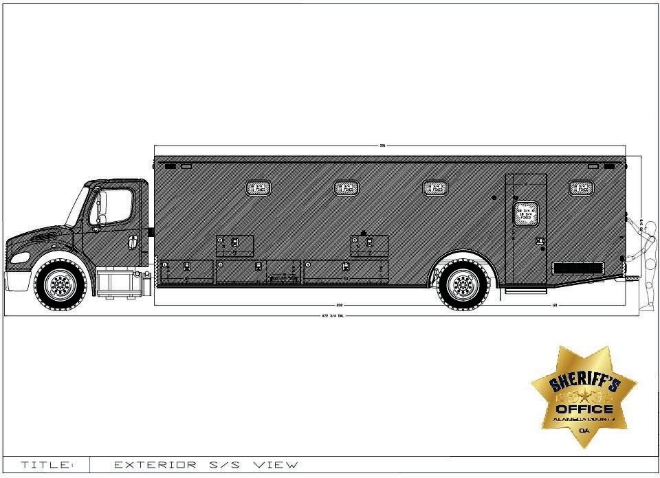

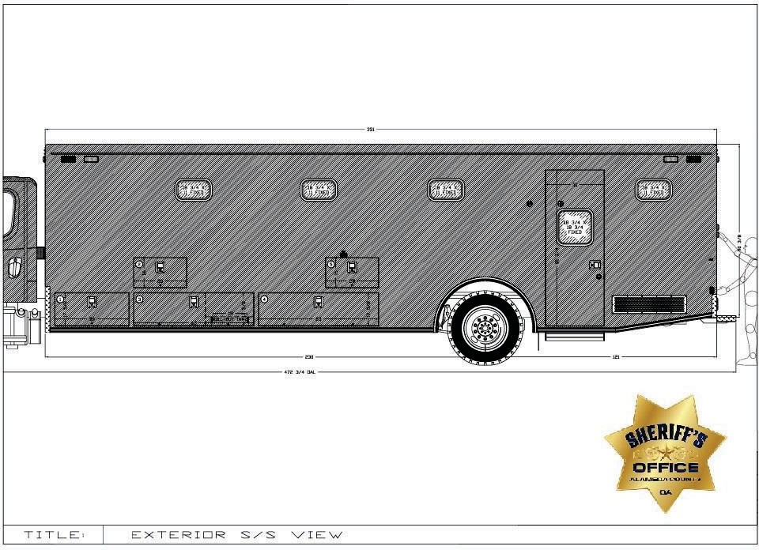

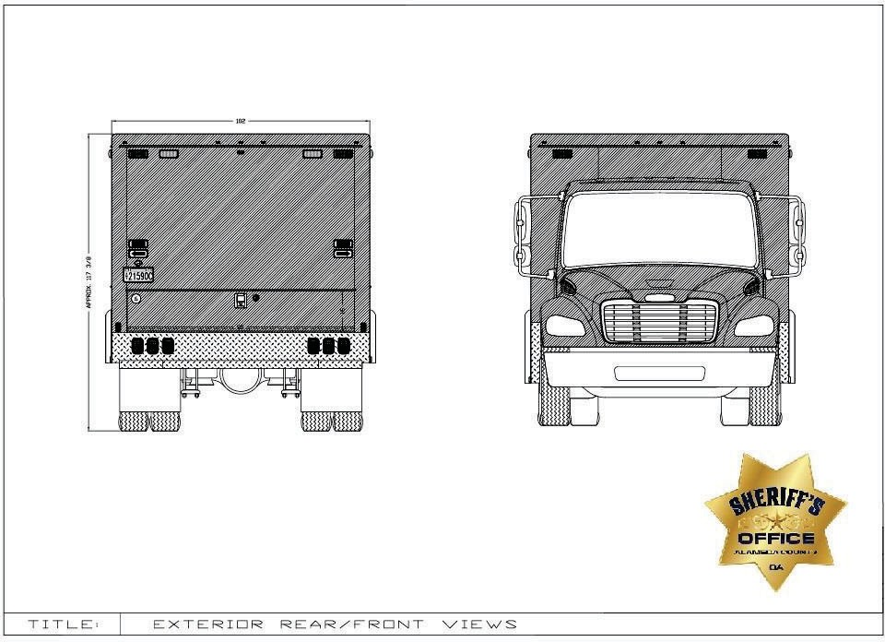

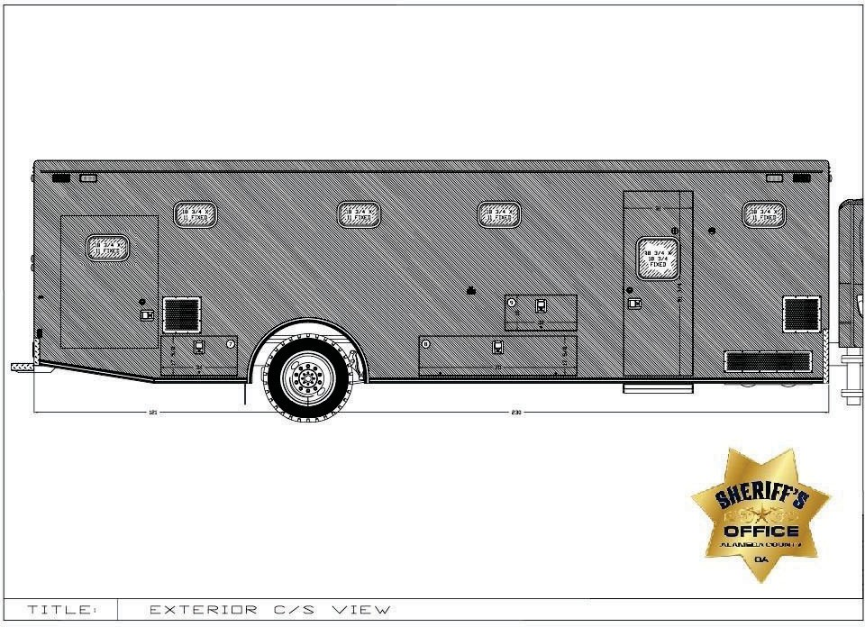

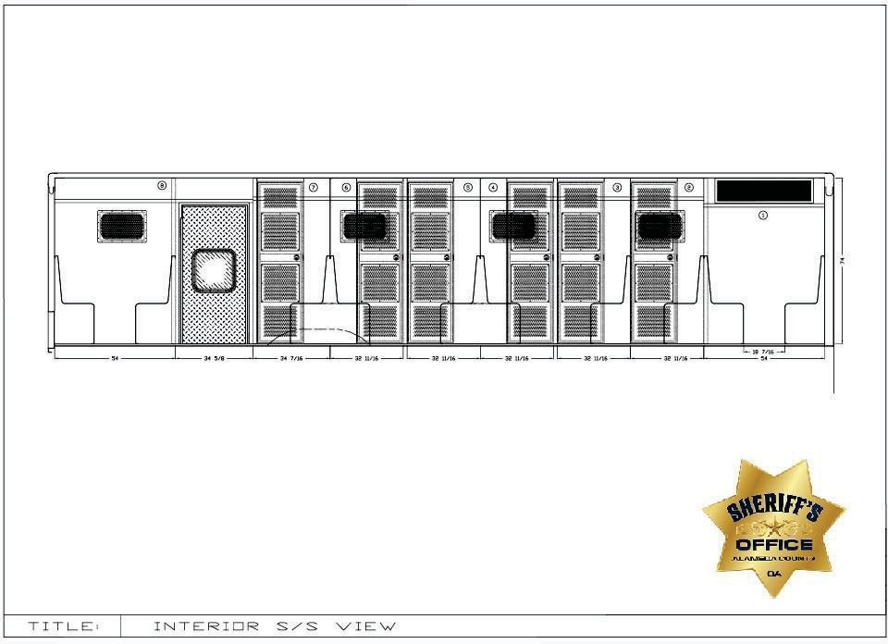

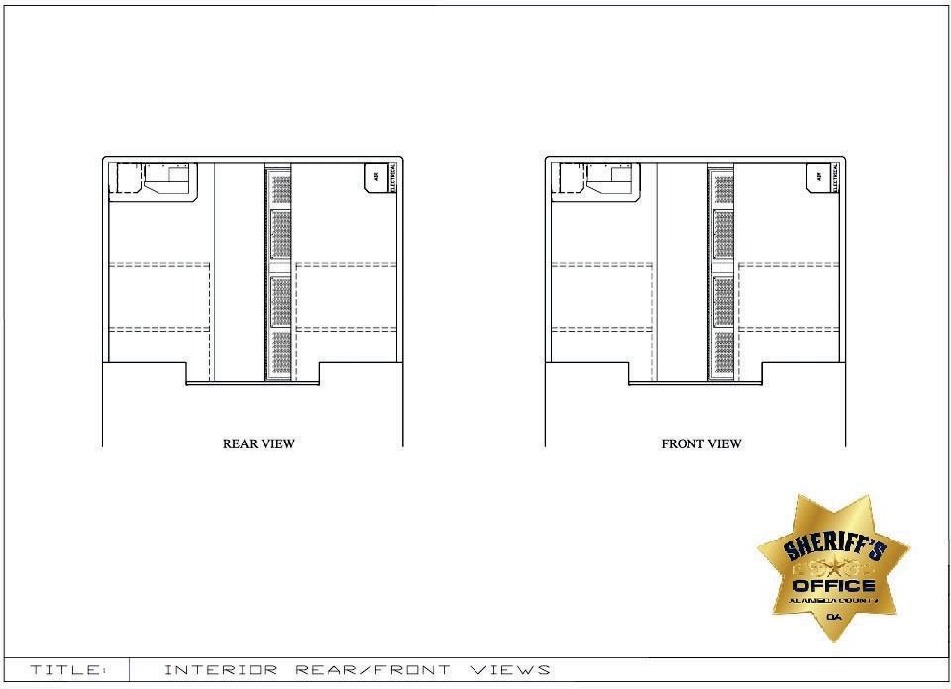

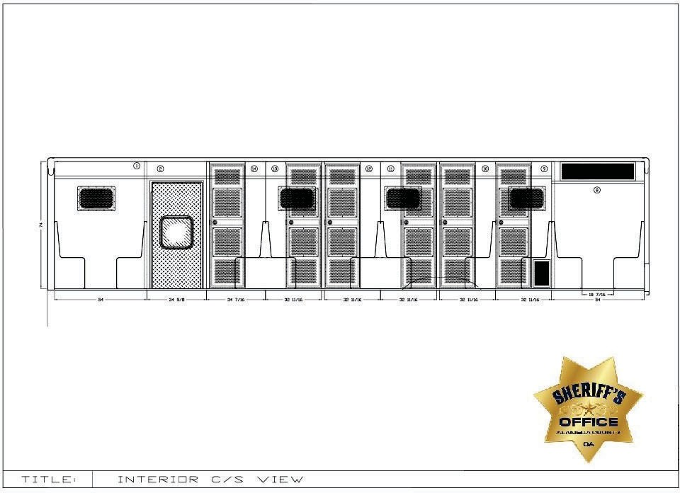

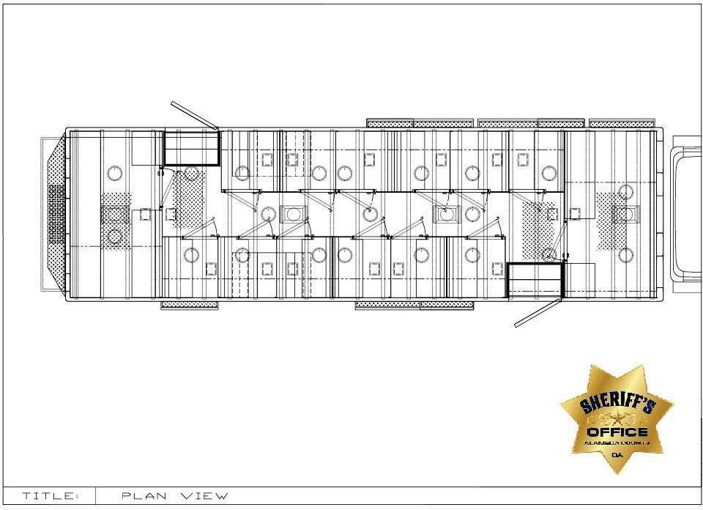

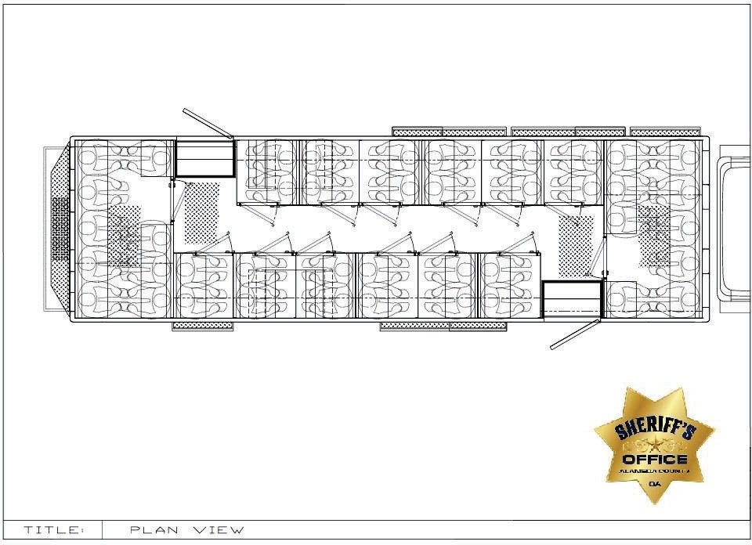

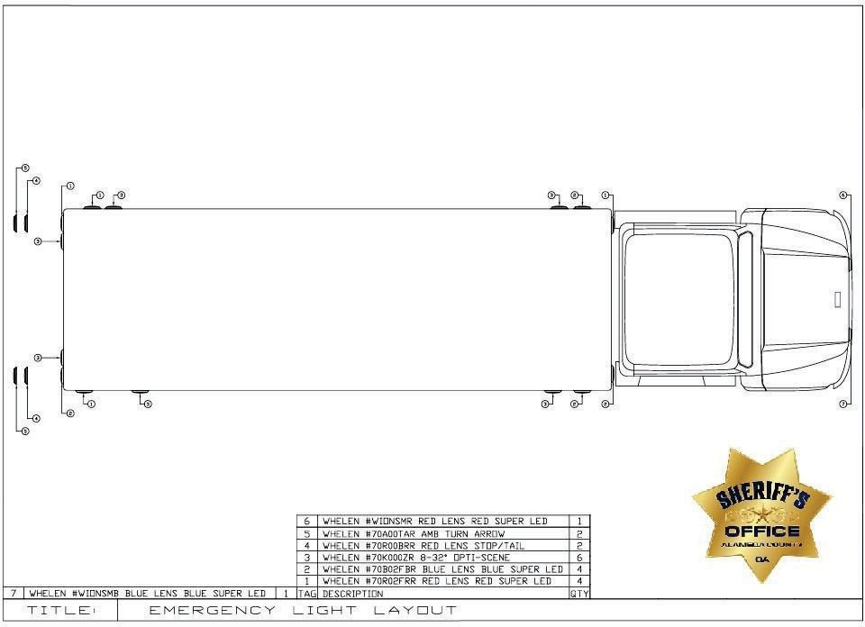

EXHIBIT E
LARGE TRUCK WITH BATHROOM SPECIFICATIONS RESPONSE

INSTRUCTIONS: Bidders must submit, with their bid, a fully completed Exhibit E – Large Truck with Bathroom Specifications Response for Inmate Transportation Vehicles. Bids which are submitted without Exhibit E will be disqualified.
A “Yes” response to a requirement in the “Comply” column will mean that the bidder intends to comply with the exact specification, as described in Exhibit E. If the bidder is able to comply with the specification stated, and states “Yes” in the “Comply” column, no further action is required. A “No” response to a specification sentence in the “Comply” column will mean that the bidder is unable to comply with the specification provided by the County.

If a bidder is unable to comply with specific requirements listed in Exhibit E – Large Truck with Bathroom Specifications Response, the bidder is to state “No” in the “Comply” column, and provide a brief explanation in the “Explanation” column. All exceptions, clarifications, and amendments pertaining to Exhibit E shall be described in full, using additional pages, as necessary, to provide complete descriptions. Bidder must clearly reference each exception, clarification, or amendment by its corresponding item number (e.g., Item 1.a. – Specific Ratings, Rear Axle Ration: 5.22 ratio). The County, at its sole discretion, shall have the right to deem acceptable any exceptions, clarifications or amendments stated by the bidder.

A response of “N/A” or no response to any specification column will mean that the bidder is unable to comply with the specification provided by the County.

In Exhibit E, references to specific brand names are intended to describe components that have been determined to best meet operational, performance, or reliability standards of the County, thereby incorporating these standards by reference within the specifications. These specifications are not meant to limit the vendor; they are guidelines to minimum qualifications. The bidder shall indicate their compliance or non-compliance for each line of the Exhibit E section. An “equivalent or better” may be offered by the bidder, subject to evaluation and acceptance by the County. It is the bidder’s responsibility to provide, at bidder’s expense samples, test data, or other documentation, which the County may require to fully evaluate and determine acceptability of an offered substitute. The County reserves the sole right to reject a substituted component that will not meet or exceed County standards. Please refer to Page 20 of this RFP, BRAND NAMES AND APPROVED EQUIVALENTS, for further information on brand names and approved equivalents.

EXCEPTIONS, CLARIFICATIONS, AMENDMENTS TO SPECIFICATIONS: Any and all deviations, exceptions, or alternatives to Exhibit E must be clearly stated, as described below, or the proposal may be considered non-responsive.

- LARGE TRUCK WITH BATHROOM Specifications
Specification Response Explanation
  - CHASSIS
4.01.00 | OEM CHASSIS  - 2024 Freightliner M2 106 Plus Conventional  - Rescue & Emergency Service  - Medium Truck Warranty  - Extended Cummins Engine Warranty, 5 years/150,000 miles  - Allison Transmission Warranty, Five years  - Provided by Vendor | COMPLY: YES NO
4.01.01 | SPECIFIC RATINGS  - Drive – 4 x 2  - G.V.W.R Capacity – 37,320 lb  - Wheelbase – 294ʺ  - Rear Axle Ratio – 4.89 | COMPLY: YES NO

4.01.02 | POWER TRAIN  - Engine  – Cummins L9 360EV @ 2200 RPM, 2200 Gov, 1150 LB/FT @ 1200 RPM  - Heavy duty onboard diagnostics interface connector located below LH dash  - 2008 Carb Emission Certification – Clean idle label on forward corner of driver door (6 ʺ x 4 ʺ label)  - Cummins Turbocharged 18.7 CFM air compressor  - Electric Grid Air Intake Warmer  - Cummins exhaust brake integral with variable geometry turbo with on/off dash switch with brake lights  - Block heater  - Transmission  - Allison 3000 EVS automatic with PTO provision  - Water to Oil, transmission cooler, in radiator end tank  - Push button electronic shift control, dash mounted  - Engine Cooling System  - 1100 Sq. In. Radiator  - Exhaust  - Horizontal tailpipe, exit rear of the vehicle aft of the rear wheels, streetside  - Driveline guard (393-001) | COMPLY: YES NO
4.01.03 | STEERING  - Power – TRW TAS-85  - 4-spoke Steering Wheel – 18ʺ  - Steering column – Adjustable tilt and telescoping | COMPLY: YES NO
4.01.04 | AXLES AND SUSPENSION  - Front Axle – 14,700 lb capacity  - Front Suspension – Taper leaf 14,600 lb -- Maintenance free rubber bushings  - Rear Axle – 23,000 Capacity  - Rear Suspension – Hendrickson HAS-230 23,000 lb with 6ʺ ride height  - Ignition controlled electric dump switch for air suspension with state retention and gauge  - Front and rear shock absorbers | COMPLY: YES NO

4.01.05 | BRAKING SYSTEM  - Air Brake Package  - Front – Bendix ADB22X-V Air Disc  - Rear – Air drum brakes  - Wabco 4S/4M ABS with traction control  - BW AD-IS (DRM) brake line air dryer with shield, heater, and integral reservoir  - Brake Lining – Non-Asbestos  - One dash mounted valve parking brake system with warning indicator (882-009)  - Factory-installed Bendix next gen SmarTire tire pressure monitoring system with wheel rim mounted next gen sensors and integrated in dash | COMPLY: YES NO
4.01.06 | TIRES AND WHEELS  - Front Tires – Two Michelin X Line Energy Z 295/60R22.5 18 ply radial  - Rear Tires– Two Michelin X Line Energy Z 295/60R22.5 18 ply radial  - Wheels – Seven OEM Alcoa Aluminum 22.5ʺ , 10 hubs  - Spare tire and wheel included | COMPLY: YES NO
4.01.07 | ELECTRICAL  - Alternator – 320-amp 4962PGH Pad Mount  - Batteries – Four DTNA genuine, flooded starting, min 4000cca, 740rc, threaded stud batteries  - Progressive low voltage disconnect at 12.3 VDC for designated circuits  - Positive and negative posts for jumpstart located on frame next to starter | COMPLY: YES NO

4.01.08 | INSTRUMENT PANEL AND CONTROLS  - Gauges  - Fuel Gauge  - Oil Pressure  - Transmission Oil Temperature  - Engine Coolant Temperature  - Hour Meter and Trip Meter (integral with driver display)  - Speedometer – Electronic w/ mph, kph scale  - Tachometer 3000 rpm  - Voltage (integral with driver display)  - Air restriction gauge without graduations  - Air Pressure, primary and secondary  - Warning system – Lights and Buzzer  - Low air pressure  - Park Brake  - Control – Electronic cruise control with controls on steering wheel spokes  - Audio – AM/FM/WB world tuner radio with Bluetooth, USB and auxiliary inputs | COMPLY: YES NO

4.01.09 | CAB EXTERIOR  - Hood – Fiberglass  - Grille – Chromed Plastic  - 106ʺ Flat Roof aluminum conventional cab  - Air cab mounting  - Bumper – Three-Piece 14ʺ Chromed steel with collapsible ends  - Mirrors (motorized retracting mirrors)  - Door mounted dual bright West Coast, 102ʺ equipment width  - 8ʺ convex, bright finish, mounted under primary mirrors  - Remote, heated  - Windshield wipers – two-speed, with intermittent  - Windows  - One-piece solar green glass windshield  - Tinted door glass LH and RH with tinted non-operating wing windows  - 63ʺ x 14ʺ H tinted rear window  - Lighting  - LED headlight assembly & incandescent marker/turn lamp with chrome bezel  - Alternating Flashing headlamp system with body builder-controlled engagement  - LED aerodynamic marker lights  - Daytime running lights  - Rectangular clear fog lights mounted under bumper  - Dual electric horns | COMPLY: YES NO

4.01.10 | CAB EXTERIOR (Continued)  - Dual Fuel Tanks – 50 Gallon rectangular aluminum, LH, 50-gallon RH. – Detroit fuel/water separator with water in fuel sensor Polished  aluminum with painted bands  - 6 Gallon DEF tank  - Grab Handles – Exterior right and left sides with single rubber inserts | COMPLY: YES NO
4.01.11 | CAB INTERIOR  - Interior – Gray and Carbon (Rugged)  - Premium Insulation  - Interior sun visors – driver and passenger  - Flooring – Black vinyl with insulation  - Driver and passenger seats – Premium high back air suspension, with two air lumbar  - Black Mordura cloth seat covers  - Dual Seat Armrests  - Three-point seatbelts  - Climate Control  - Heater/ Defroster/AC  - Main HVAC controls with recirculation switch  - Standard heater plumbing  - Electric door locks and windows  - Roof mounted console  - Cup holders in dash  - One dash mounted 12 VDC power outlet  - One dash mounted dual 2.1-amp USB-C charger  - Aluminum LH and RH kickplates (693-035)  - Eight OEM keys (78G-008) | COMPLY: YES NO
4.01.12 | COATINGS/PAINT  - Exterior – Blue Jean Metallic (N1)  - Interior – Gray/Carbon | COMPLY:  YES NO

4.01.13 | CHASSIS MODIFICATIONS  The following modifications shall be made to the chassis by Vendor. | COMPLY:  YES NO
4.01.14 | RUBBER MUD FLAPS  Black mud flaps shall be installed behind each rear wheel. | COMPLY:  YES NO
4.01.15 | AIR SUSPENSION  If necessary to abide by customerʹs vertical height restrictions, chassis ride height shall be adjusted ½″ down from normal, as allowed by the chassis manufacturer, in order to improve module vertical clearance. | COMPLY: YES NO
4.01.16 | CHASSIS ANTI-THEFT  A hidden toggle switch under dash shall be provided to disable the chassis transmission selector. | COMPLY:  YES NO
4.01.17 | CHASSIS LIGHTING  A Whelen 3ʺ Red Lens Red LED flasher shall be centered on the cab headliner, to give warning to the cab occupants in regards to the module smoke/carbon monoxide detectors. | COMPLY: YES NO
4.01.18 | AUXILIARY COMPRESSORS  Two TM-21 auxiliary air conditioning compressor kits shall be added to the OEM engine. | COMPLY:  YES NO
4.01.19 | WEAPONS STORAGE  A customer-supplied Blac-Rac dual long-gun storage system designed for a customer-supplied-and-installed AR-15 rifle and shotgun shall be installed on the cab ceiling, exact model to be determined at the preconstruction meeting. A hidden unlock switch shall be installed, location to be determined at the preconstruction meeting. Switch shall only be active when the key is in the chassis ignition.  Locking handgun storage shall be provided in the rear of the driverʹs console. | COMPLY: YES NO

4.01.20 | CHASSIS MISCELLANOUS  One 15lb ABC fire extinguisher with bracket shall be installed in cab (exact location to be determined at preconstruction meeting).  Three Hybrid 4G HDDVRʹs shall be installed in cab (Exact location to be determined at preconstruction meeting). | COMPLY: YES NO
4.01.21 | CAB CONDUIT  A 5.5″ cab conduit shall be installed between the cab and module located behind the driverʹs seat. The driverʹs console harness shall be routed through the conduit. | COMPLY: YES NO
4.01.22 | OVERVIEW OF MODULE MOUNTING SYSTEM  The module shall be bolted to the chassis frame in no fewer than twelve locations. Each mounting location shall include a hard rubber isolation pad between the chassis frame and the module lateral. The rearmost lateral(s) shall be connected to the frame extensions with 5/8″ grade 8 bolts. All remaining laterals shall be connected with vertical 3/4″ grade B7 eye bolts fastened to the frame rails with horizontal 3/4″ grade 8 hex bolts. All bolts shall be secured with locking nuts.  Modules 176″L or longer shall have soft rubber washers added above the forward and rear laterals to accommodate chassis frame torsion. | COMPLY: YES NO
2. MODULAR CONSTRUCTION

4.02.00 | MODULE CONSTRUCTION  All material utilized shall be of the correct type, alloy, and thickness to withstand the intended usage and provide protection against cracking, corrosion, or metal fatigue. All materials utilized shall be of open stock origin, commonly available through local sources, for rapid and economical repair or modification of the body. Any use of proprietary parts or materials in the construction of the body is unacceptable, due to potential delays or difficulties in future repairs or service. NO EXCEPTIONS TO BE TAKEN IN THIS AREA. This specification has been designed and written to fill specific needs of this agency. Where brand name, make, or model of equipment has been specified, no exceptions shall be allowed. Where compartment and cabinet sizes have been specified, bidder must bid substantially (plus or minus 1″) the size specified. | COMPLY: YES NO
4.02.01 | MODULE WARRANTY  The module shall have a transferable lifetime structural warranty. | COMPLY:  YES NO
4.02.02 | MATERIAL  EXTRUSIONS SIZE ALLOY  Structural Tubing 1″ x 2″ x 0.125″ sq. 6063-T52  Structural Tubing 2″ x 2″ x 0.125″ sq. 6063-T52 Structural Angle Cross Members 3″ x 3″ x 0.375″ 6061-T6 Structural Channel Cross Members 1.5″ x 0.25″ 6061-T6  FORMED SHEETING SIZE ALLOY  Skin/Roof/Compartments/Subfloors/Doors 0.125″ 5052-H32 Interior Cabinets 0.090″ 5052-H32  Diamond Plate 0.125″/0.08″ 3003-H22  Stainless Steel 16 ga., 20 ga. 304 # 4B | COMPLY: YES NO

4.02.03 | MODULE DIMENSIONS  Drop Skirt, from rear curbside door forward 8.00"  Final dimensions to be confirmed at preconstruction meeting.  Overall Vehicle Dimensions (Specifications are listed as minimums) Length: 39' and 4.75" = 472.75"  Width (Excluding Mirrors): 8' and 6" = 102.00"  Height (Approximate): 9' and 9.38" = 117.38"  - Vehicle Maximum Height TBD at Preconstruction Meeting. Exterior Module Dimensions (Specifications are listed as minimums) Length: 29' and 3" = 351.00"  Width: 8' and 6" = 102.00"  Height (Front of Module): 8' and 2.375" = 98.38"  Height (Rear of Module): 7' and 6.375" = 90.38"  Interior Module Dimensions (Specifications are listed as minimums) Length: Forward Wall to Rear Wall = 342.00"  Width: Aisle = 26.00"  Module Electric Step Height 6.50” to 8.50” range to clear the RCD Tunnel Curb Height | COMPLY: YES NO

4.02.04 | STRUCTURAL FRAMING  Side wall and rear wall construction shall consist of 2″ x 2″ x 0.125″ aluminum square tubing extensions welded together with a maximum of 14″ centers. 1″ x 2″ x 0.125″ aluminum tubing may be utilized in addition to 2″ x 2″ tubing to accommodate custom compartment sizes. The bottom of the wall structure shall be sealed with a welded 2″ x 2″ tube, a 2″ x 2″ angle, or a 0.125″ plate depending upon location. The wall structure shall be capped with a 2″ x 4″ x 0.125″ header upon which a 2″ x 2″ x 0.125″ roof structure is welded. This process provides a unitized roll cage structure for greater occupant safety. The front wall structure shall be constructed of formed aluminum channels to allow ample space for wiring raceways, heater hoses, and A/C hoses. | COMPLY: YES NO
4.02.05 | FOUNDATION SYSTEM  The foundation system shall consist of a 0.125″ aluminum sheet subfloor with foundation members securely welded under the subfloor. Transverse members (laterals) shall consist of 3″ x 3″ x 0.375″ structural angles. 0.25″ x 1.5″ aluminum stringers shall span longitudinally between the laterals. | COMPLY: YES NO
4.02.06 | MODULE SEAMS  All body and compartment seams at or below floor level shall be full- seam-welded. The entire perimeter of the subfloor shall be completely sealed with a caulking material, creating a watertight seam. | COMPLY: YES NO
4.02.07 | EXTERIOR SKIN  A Norton NORBOND closed-cell, polyurethane foam tape with high- performance acrylic adhesive shall be utilized full length on all front and rear wall and roof frame members. A polyurethane adhesive sealant shall be applied to the edges of framing members that are bonded with NORBOND tape. An advanced two-part methacrylate structural adhesive shall be used to bond all side wall tubes to the exterior skin and door frames.  The module shall be constructed utilizing full-size sheet construction to minimize body seams. There shall be no corner or mid-body seams. | COMPLY: YES NO

4.02.08 | MODULE ROOF  In order to improve module strength and minimize exposed seams, the roof shall be seamed transversely, shall have a 1.5″ radius along the edges, and shall be welded to 2″ x 4″ wall header tubes 4.75″ below the roof line. The roof shall be supported by positive contact between sidewall framing and roof framing. All seams on the roof surface shall be continuously welded and body-worked on the outside. In order to avoid the possibility of paint and/or weld cracking, no extrusions shall be used in the exterior construction of the roof or corners of the module.  Three contoured, 3/8″ aluminum plates, painted to match the module, shall be welded to the roof structure and project through the center of the roof to serve as anchorages for personal fall arrest equipment. Each anchorage is designed and rated for a single person only.  The three plates shall be completely removed from the roof surface and be touched up before delivery. | COMPLY: YES NO
4.02.09 | MODULE EXTERIOR COMPARTMENTS  All compartments shall be constructed from formed 0.125″ aluminum, securely welded to the subfloor and structural framing. A baffled drain hole shall be provided in all exterior compartment bottoms that extend below the floor line. All exterior adjustable shelves shall be mounted on heavy-duty aluminum track, which is securely welded to compartment interiors. Each shelf shall support at least 300 lb of equipment. | COMPLY: YES NO

4.02.10 | COMPARTMENT #1 - SAFETY  Interior Dimensions – 30ʺ W x 16ʺ H x 34ʺ D Doorway Dimensions – 30ʺ W x 16ʺ H Location – Streetside, forward, upper Shelving – None  Door(s) – Single, bottom-hinged door with a black 1.5ʺ diameter rubber bumper  Light(s) – One horizontal LED strip light Additional Instructions –  - One ABC 15 lb fire extinguisher with an Amerex #809 SAE-J3043 compliant bracket shall be installed on the aft wall, exact location to be determined at preconstruction meeting.  - An enclosed electrical component module shall be enclosed in this compartment.  - Install a customer-supplied Halligan bracket and tool on the forward wall, exact location to be determined at preconstruction meeting.  - A punched painted aluminum vent shall be installed on the back wall. | COMPLY: YES NO

4.02.11 | COMPARTMENT #2 - ELECTRICAL  Interior Dimensions – 64ʺ W x 17.625ʺ H x 26ʺ D Doorway Dimensions – 64ʺ W x 17.625ʺ H Location – Streetside, forward, lower  Shelving – None  Door(s) – Single, bottom-hinged door with two black 1.5ʺ diameter rubber bumpers  Light(s) – One horizontal LED strip light. Additional Instructions –  - A vent with MERV 8 polyester filter media and a hex-punched stainless-steel cover shall be installed on the forward wall.  - Access shall be provided between this compartment and the cab via a  5.5ʺ conduit.  - A customer-supplied Motorola APX 6500 transceiver shall be installed on the floor of this compartment, forward.).  - A Blue Sea #5032 ST Blade fuse block with twelve circuits shall be installed behind the transceiver.  - A 80-amp battery charger shall be installed in this compartment.  - A Samlex #PST-300-12 300-watt inverter shall be installed in this compartment. | COMPLY: YES NO

4.02.12 | COMPARTMENT #2 - ELECTRICAL (Continued)  - The 12VDC electrical panel shall be installed on the back wall of this compartment. An aluminum cover with ʺ ELECTRICAL PANEL ACCESSʺ label with electrical warning symbol below shall be installed on the front of the 12VDC electrical panel. A wiring access hole shall be provided in the front wall, between the electrical panel and Compartment #1.  - The aft end of the compartment shall be separated from the front of the compartment, by a fixed vertical divider with door gasket.  - The aft portion of this compartment shall have a 300 lb capacity battery tray with a locking left slide. The area shall be vented to the outside and sealed to prevent battery vapors from entering the cells of the prisoner transport. Three aftermarket DTNA genuine, flooded starting, min 4000cca, 740rc, threaded stud batteries shall be installed on the tray.

4.02.13 | COMPARTMENT #3  Interior Dimensions – 64ʺ W x 17.625ʺ H x 26ʺ D Doorway Dimensions – 64ʺ W x 17.625ʺ H  Location – Streetside, forward of wheel wells, lower Shelving – None  Door(s) – Single, bottom-hinged door with two black 1.5ʺ diameter rubber bumpers  Light(s) – One horizontal LED strip light. Additional Instructions –  - A vent with MERV 8 polyester filter media and a hex-punched stainless-steel cover shall be installed on the aft wall.  - A 62ʺ W x 25ʺ D reinforced mill finish aluminum roll-out tray with 3″ lips with black knock-on trim and Gray Matéflex floor tile shall be installed 7on locking, 1000 lb-capacity, 100% extension steel SlideMaster slides. A 14ʺ H mill finish single-wall framed punched aluminum vertical tool board shall be provided as the back wall of the slide-out tray for customer- supplier-and-installed items. Precision punched holes, sized for 5/16ʺ carriage bolts, shall be provided along the full width and height of the vertical tool board. | COMPLY: YES NO
4.02.14 | COMPARTMENT #4  Interior Dimensions – 30ʺ W x 16ʺ H x 34ʺ D Doorway Dimensions – 30ʺ W x 16ʺ H Location – Streetside, forward of wheel wells Shelving – None  Door(s) – Single, bottom-hinged door with one 1.5ʺ diameter rubber bumper  Light(s) – One horizontal LED strip light. Additional Instructions –  - A punched painted aluminum vent shall be installed on the back wall. | COMPLY: YES NO

4.02.15 | COMPARTMENT #5  Interior Dimensions – 32ʺ W x 14ʺ H x 5.5ʺ D Doorway Dimensions – 32ʺ W x 14ʺ H Location – Rear of module, curbside Shelving – None  Door(s) – Single, bottom-hinged door with one black 1.5ʺ diameter rubber bumper and deadbolt lock  Light(s) – One horizontal LED strip light Additional Instructions –  - This compartment shall provide access to the wheelchair restraint system in Cell #9. A bottom-hinged diamond plate door, with stainless hinge shall open up to the interior of the unit.  - One interior wheelchair restraint shall be installed in this area.  - Drip Rail above compartment #5 | COMPLY: YES NO
4.02.16 | COMPARTMENT #6  Interior Dimensions – 35ʺ W x 17.625ʺ H x 26ʺ D Doorway Dimensions – 32ʺ W x 17.625ʺ H Location – Curbside, aft  Shelving – None  Door(s) – Single, bottom-hinged door with one 1.5ʺ diameter rubber bumper  Light(s) – One horizontal LED strip light. Additional Instructions –  - The back-up manual hydraulic unit for the wheelchair lift shall be located in this compartment. | COMPLY: YES NO

4.02.17 | COMPARTMENT #7  Interior Dimensions – 70ʺ W x 17.625ʺ H x 26ʺ D Doorway Dimensions – 70ʺ W x 17.625ʺ H Location – Curbside, center, lower  Shelving – None  Door(s) – Single, bottom-hinged door with two black 1.5ʺ diameter rubber bumpers  Light(s) – One horizontal LED strip light Additional Instructions –  - A 68ʺ W x 25ʺ D reinforced mill finish aluminum roll-out tray with 3″ lips with black knock-on trim and Gray Matéflex floor tile shall be installed on locking, 1000 lb-capacity, 100% extension steel SlideMaster slides. A 14ʺ H mill finish framed punched aluminum tool board shall be provided as the back wall of the slide-out tray, for customer-supplied-and-installed items. Precision punched holes, sized for 5/16ʺ carriage bolts, shall be provided along the full width and height of the vertical tool board.  - One ABC 15 lb fire extinguisher with an Amerex #809 SAE-J3043 compliant bracket shall be installed on the aft wall, exact location to be determined at preconstruction meeting.  - A vent with MERV 8 polyester filter media and a hex-punched stainless-steel cover shall be installed on the forward wall. | COMPLY: YES NO
4.02.18 | COMPARTMENT #8  Interior Dimensions – 32ʺ W x 16ʺ H x 34ʺ D Doorway Dimensions – 32ʺ W x 16ʺ H Location – Curbside, center, upper Shelving – None  Door(s) – Single, bottom-hinged door with one 1.5ʺ diameter rubber bumper  Light(s) – One horizontal LED strip light. Additional Instructions –  - A punched painted aluminum vent shall be installed on the back wall. | COMPLY: YES NO

4.02.19 | MODULE DOORS  The doors shall be box pan formed with a total thickness of 2ʺ .  Three interior painted hex-punched 0.125″ formed aluminum security doors, each with a solid perimeter, horizontal latch stile, non-locking paddle latch, and a deadbolt lock shall be installed, just inside the curbside and streetside passage doors and the wheelchair access door. Clear 0.25ʺ polycarbonate shall be installed on the inside surface of the security door for the wheelchair access door, only. | COMPLY: YES NO
4.02.20 | DOOR SEAL  Each door frame shall have a flange for the installation of an air cell hollow core 360-degree compression door seal. This seal creates watertight, dust-free compartment integrity. Door seal shall be knock-on type. Door frames shall be bonded to the adjacent tubes such that no exterior flange is required. | COMPLY: YES NO
4.02.21 | DOOR HINGES  Compartment and passage doors shall have full-length, piano-type, 2.5″W stainless steel hinges, positioned with 0.25″ rivets at each end. The hinges shall be attached with #12 x 0.75″ stainless steel truss head screws spaced 4″ apart, sealed with Sikaflex. All curbside and streetside side-hinged single doors shall be hinged on the forward sides. | COMPLY: YES NO

4.02.22 | DOOR LATCHES  Exterior door handles shall be semi-flush, chrome-plated Eberhard E Grabber #21100. All exterior doors shall have rotary latches and striker posts that meet FMVSS 206 requirements. Striker posts shall be adjustable and be secured with a nut from behind the door frame. The striker washer shall not be removed. Guards shall be added to the top of the striker posts at the bottom of double passage door openings to reduce the risk of snagging clothing or leg chains when exiting. Doors greater than 45″ tall shall have double rotary latches activated by stainless steel rods. Once final adjustments have been made, threads shall have Loctite or equivalent applied. All double-door compartments shall have an exterior E Grabber handle and rotary latches on each door. Doors shall latch to doorframe-mounted striker posts only and not to one another. All locks shall be keyed J236.  The passage doors, wheelchair access door, and cell doors shall each have a single sided dead bolt lock. All dead bolts and pad locks shall be keyed 56434.  Any exposed screws shall be sealed to prevent vandalism. | COMPLY: YES NO
4.02.23 | COMPARTMENT DOOR CONTROL  1.5ʺ diameter black rubber bumper shall be installed for all compartment doors. Compartments #2, 3, and 7 shall have two bumpers. | COMPLY:  YES NO
4.02.24 | PASSAGE DOOR CONTROLS  All passage doors shall have low profile grabber type hold-open devices (Cast Products DH0016 &-A) with replacement rubber catches. | COMPLY:  YES NO

4.02.25 | COMPARTMENT DOOR SKINS  Each compartment door skin shall be made of 0.080″ bright aluminum diamond plate, shall be removable, and have a latch service opening with a 2.25″ x 4.5″ diamond plate Cover for lubrication and service all compartment doors except Compartment #5. Door skins shall be secured with #8 pan head screws and Sikaflex.  A diamond plate cover shall be installed over the latch access hole with #8 pan head screws and Sikaflex for Compartment #5.  The 1ʺ perimeter of the inside surface of the diamond plate door skins shall be masked off, and the inside surface of the door skin shall be covered with Advanced Coating Solutions CIC 4.0 composite ceramic insulating coating. A 1ʺ wide x 0.125ʺ thick foam tape shall be then be adhered to the perimeter of the inside surface of the diamond plate door skin, as a thermal barrier. The tape backing on the non-adhered side shall be left in place, to allow the door skin to be removed for future maintenance. | COMPLY: YES NO
4.02.26 | ENTRANCE DOOR SKINS  Shall be 0.080″ bright aluminum diamond plate and be removable to service door hardware. A diamond plate cover shall be installed over the latch access hole with #8 pan head screws and Sikaflex.  The 1ʺ perimeter of the inside surface of the diamond plate door skins shall be masked off, and the inside surface of the door skin shall be covered with Advanced Coating Solutions CIC 4.0 composite ceramic insulating coating. A 1ʺ wide x 0.125ʺ thick foam tape shall be then be adhered to the perimeter of the inside surface of the diamond plate door skin, as a thermal barrier. The tape backing on the non-adhered side shall be left in place, to allow the door skin to be removed for future maintenance. | COMPLY: YES NO
4.02.27 | ENTRANCE DOORWAYS & EMERGENCY EGRESS DOORS  Two module entrance doors shall be provided; one on the streetside and one on the curbside. The doorway dimensions shall be 31ʺ W x 81.75ʺ H. A 40ʺ W x 69ʺ H wheelchair access door shall be installed on the curbside, aft of the wheel well. | COMPLY: YES NO

4.02.28 | INTERIOR COMPARTMENTS  Each cell door shall have an upper and lower Schlage single-sided deadbolt, keyed 56434. Any exposed screws shall be security type and sealed to prevent vandalism.  All cell doors shall be aft-hinged, allowing the doors to always be between the prisoner and officer.  Note: Cells #4, 5, 11, and 12 shall be reduced in height to accommodate relocation of HVAC blower units to the middle of the module. | COMPLY: YES NO
4.02.29 | FORWARD GROUP CELL #1  Capacity: 9 Inmates  Interior Dimensions – 97ʺ W x 74ʺ H x 52.25ʺ D Location – Forward  Door(s) – One 0.125ʺ streetside-hinged aluminum cell door shall be installed. The door shall have four hex punched sections; two stacked above the center stile, and two stacked below the center stile. 0.25ʺ clear polycarbonate shall cover the upper two hex-punched sections. Additional polycarbonate covers and cell ventilation to be determined at the preconstruction meeting. The door shall have a stainless-steel piano hinge and two single-sided Schlage deadbolt locks, one upper and one lower.  Seating – Three formed aluminum benches shall be provided: a five- person bench against the forward wall, and two two-person benches on the aft cell wall, one on each side of the aisle.  Additional Instructions –  - Two 18.625″W x 11.125″H dual pane windows with hex-punched stainless-steel covers riveted in place over the inside surface shall be installed, one each on the streetside and curbside walls.  - A security camera shall be installed on the streetside wall, upper forward, positioned to capture the entire cell. | COMPLY: YES NO

4.02.30 | STREETSIDE CELL #2  Capacity: 2 Inmates  Interior Dimensions – 32.5ʺ W x 74ʺ H x 35.75ʺ D Location – Streetside, forward  Door(s) – One 0.125ʺ aluminum aft-hinged cell door shall be installed. The door shall have four hex punched sections; two stacked above the center stile, and two stacked below the center stile. 0.25ʺ clear polycarbonate shall cover the upper two hex-punched sections. Additional polycarbonate covers and cell ventilation to be determined at the preconstruction meeting. The door to have a stainless-steel piano hinge and two single- sided Schlage deadbolt locks, one upper and one lower.  Seating – One formed aluminum two-person bench Additional Instructions –  - Two 18.625″W x 11.125″H dual pane windows with hex-punched stainless-steel covers riveted in place over the inside surface shall be installed.  - A security camera shall be installed on the upper wall, facing the bench. | COMPLY: YES NO

4.02.31 | STREETSIDE CELL #3  Capacity: 2 Inmates  Interior Dimensions – 33.375ʺ W x 74ʺ H x 35.75ʺ D Location – Streetside, forward  Door(s) – One 0.125ʺ aluminum aft-hinged cell door shall be installed. The door shall have four hex punched sections; two stacked above the center stile, and two stacked below the center stile. 0.25ʺ clear polycarbonate shall cover the upper two hex-punched sections. Additional polycarbonate covers and cell ventilation to be determined at the preconstruction meeting. The door to have a stainless-steel piano hinge and two single- sided Schlage deadbolt locks, one upper and one lower.  Seating – One formed aluminum two-person bench Additional Instructions –  - A 18.625″W x 11.125″H dual pane window with hex-punched stainless- steel cover riveted in place over the inside surface shall be installed.  - A security camera shall be installed on the upper wall, facing the bench. | COMPLY: YES NO

4.02.32 | STREETSIDE CELL #4  Capacity: 2 Inmates  Interior Dimensions – 33.375ʺ W x TBDʺ H x 35.75ʺ D Location – Streetside, middle  Door(s) – One 0.125ʺ aluminum aft-hinged cell door shall be installed. The door shall have four hex punched sections; two stacked above the center stile, and two stacked below the center stile. 0.25ʺ clear polycarbonate shall cover the upper two hex-punched sections. Additional polycarbonate covers and cell ventilation to be determined at the preconstruction meeting. The door to have a stainless-steel piano hinge and two single- sided Schlage deadbolt locks, one upper and one lower.  Seating – One formed aluminum two-person bench, facing aft. Additional Instructions –  - A 18.625″W x 11.125″H dual pane window with hex-punched stainless- steel cover riveted in place over the inside surface shall be installed.  - A security camera shall be installed on the upper wall, facing the bench. | COMPLY: YES NO

4.02.33 | STREETSIDE CELL #5  Capacity: 2 Inmates  Interior Dimensions – 33.375ʺ W x TBDʺ H x 35.75ʺ D Location – Streetside, middle  Door(s) – One 0.125ʺ aluminum aft-hinged cell door shall be installed. The door shall have four hex punched sections; two stacked above the center stile, and two stacked below the center stile. 0.25ʺ clear polycarbonate shall cover the upper two hex-punched sections. Additional polycarbonate covers and cell ventilation to be determined at the preconstruction meeting. The door to have a stainless-steel piano hinge and two single- sided Schlage deadbolt locks, one upper and one lower.  Seating – One formed aluminum two-person bench Additional Instructions –  - A 18.625″W x 11.125″H dual pane window with hex-punched stainless- steel cover riveted in place over the inside surface shall be installed.  - A security camera shall be installed on the upper wall, facing the bench. | COMPLY: YES NO

4.02.34 | STREETSIDE CELL #6  Capacity: 2 Inmates  Interior Dimensions – 33.375ʺ W x 74ʺ H x 35.75ʺ D Location – Streetside, middle  Door(s) – One 0.125ʺ aluminum aft-hinged cell door shall be installed. The door shall have four hex punched sections; two stacked above the center stile, and two stacked below the center stile. 0.25ʺ clear polycarbonate shall cover the upper two hex-punched sections. Additional polycarbonate covers and cell ventilation to be determined at the preconstruction meeting. The door to have a stainless-steel piano hinge and two single- sided Schlage deadbolt locks, one upper and one lower.  Seating – One formed aluminum two-person bench Additional Instructions –  - A 18.625″W x 11.125″H dual pane window with hex-punched stainless- steel cover riveted in place over the inside surface shall be installed.  - A security camera shall be installed on the upper wall, facing the bench. | COMPLY: YES NO

4.02.35 | STREETSIDE CELL #7  Capacity: 2 Inmates  Interior Dimensions – 34.25ʺ W x 74ʺ H x 35.75ʺ D Location – Streetside, middle  Door(s) – One 0.125ʺ aluminum aft-hinged cell door shall be installed. The door shall have four hex punched sections; two stacked above the center stile, and two stacked below the center stile. 0.25ʺ clear polycarbonate shall cover the upper two hex-punched sections. Additional polycarbonate covers and cell ventilation to be determined at the preconstruction meeting. The door to have a stainless-steel piano hinge and two single- sided Schlage deadbolt locks, one upper and one lower.  Seating – One formed aluminum two-person bench Additional Instructions –  - A 18.625″W x 11.125″H dual pane window with hex-punched stainless- steel cover riveted in place over the inside surface shall be installed.  - A security camera shall be installed on the upper wall, facing the bench. | COMPLY: YES NO

4.02.36 | REAR CELL #8 - LAVATORY  Capacity: 1 Person Bathroom  Interior Dimensions – 40.5ʺ W (exclude water tank) x 78ʺ H x 35.75ʺ D Location – Streetside, aft  Door(s) – One 0.125ʺ aluminum aft-hinged cell door shall be installed. The door shall have four hex punched sections; two stacked above the center stile, and two stacked below the center stile. 0.25ʺ clear polycarbonate shall cover the upper two hex-punched sections. Additional polycarbonate covers and cell ventilation to be determined at the preconstruction meeting. The door to have a stainless-steel piano hinge and two single-sided Schlage deadbolt locks, one upper and one lower.  - A 18.625″W x 11.125″H dual pane window with hex-punched stainless-steel cover riveted in place over the inside surface shall be installed.  - Exhaust fan shall be installed in this cell, w/ interior security cover.  - A stainless-steel toilet with push button flush shall be installed at forward end.  - A drain installed on the floor to allow for ease of cleaning.  - A Kingsway Group #KG23 ligature-resistant two roll surface mounted toilet paper dispenser installed on the streetside wall.  - A security camera shall be installed on the upper wall, details and location to be determined at the preconstruction meeting.  - Walls and floor shall be lined with stainless steel panels. | COMPLY: YES NO

4.02.37 | WHEELCHAIR CELL #9  Capacity: 4 Inmates or 1 Inmate Wheelchair Dimensions – 55.5ʺ W x 74ʺ H x 35.75ʺ D Location – Rear, Curbside  Door(s) – One interior 0.125ʺ aluminum curbside-hinged cell door shall be installed. The door shall have four hex punched sections; two stacked above the center stile, and two stacked below the center stile. 0.25ʺ clear polycarbonate shall cover the upper two hex-punched sections. Additional polycarbonate covers and cell ventilation to be determined at the preconstruction meeting. The door to have a stainless-steel piano hinge and two single-sided Schlage deadbolt locks, one upper and one lower.  One exterior wheelchair access door with deadbolt lock and 18.625″W x 11.125″H dual pane window with hex-punched stainless-steel cover riveted in place over the inside surface shall be installed, along with an inner security door with deadbolt.  Seating – Two 10″D flip-up aluminum benches with 1″ frames, painted to match the interior shall be installed, one each on the front and rear walls. The benches shall each have a minimum of two spring-loaded seat irons to keep bench in the upright position except during use. Walls reinforced to support flip-up benches.  - One position for a wheelchair against the rear wall.  - A Sure-Lok #AL7275-4C wheelchair restraint kit with auto-tensioning retractor assemblies and S-hooks installed at floor level along the aft wall. Restraints accessible at Ext. Compartment #5.  - A three-point seatbelt harness shall be provided and padlocked in place. Padlock shall be keyed to match the deadbolt keys. | COMPLY: YES NO

4.02.38 | CURBSIDE CELL #10  Capacity: 2 Inmates  Interior Dimensions – 32.5ʺ W x 74ʺ H x 35.75ʺ D Location – Curbside, rear  Door(s) – One 0.125ʺ aluminum aft-hinged cell door shall be installed. The door shall have four hex punched sections; two stacked above the center stile, and two stacked below the center stile. 0.25ʺ clear polycarbonate shall cover the upper two hex-punched sections. Additional polycarbonate covers and cell ventilation to be determined at the preconstruction meeting. The door to have a stainless-steel piano hinge and two single- sided Schlage deadbolt locks, one upper and one lower.  Seating – One formed aluminum two-person bench Additional Instructions –  - A 18.625″W x 11.125″H dual pane window with hex-punched stainless- steel cover riveted in place over the inside surface shall be installed.  - A security camera shall be installed on the upper wall, facing the bench. | COMPLY: YES NO

4.02.39 | CURBSIDE CELL #11  Capacity: 2 Inmates  Interior Dimensions – 33.375ʺ W x 74ʺ H x 35.75ʺ D Location – Curbside, rear  Door(s) – One 0.125ʺ aluminum aft-hinged cell door shall be installed. The door shall have four hex punched sections; two stacked above the center stile, and two stacked below the center stile. 0.25ʺ clear polycarbonate shall cover the upper two hex-punched sections. Additional polycarbonate covers and cell ventilation to be determined at the preconstruction meeting. The door to have a stainless-steel piano hinge and two single- sided Schlage deadbolt locks, one upper and one lower.  Seating – One formed aluminum two-person bench Additional Instructions –  - A 18.625″W x 11.125″H dual pane window with hex-punched stainless- steel cover riveted in place over the inside surface shall be installed.  - A security camera shall be installed on the upper wall, facing the bench. | COMPLY: YES NO

4.02.40 | CURBSIDE CELL #12  Capacity: 2 Inmates  Interior Dimensions – 33.375ʺ W x TBDʺ H x 35.75ʺ D Location – Curbside, middle  Door(s) – One 0.125ʺ aluminum aft-hinged cell door shall be installed. The door shall have four hex punched sections; two stacked above the center stile, and two stacked below the center stile. 0.25ʺ clear polycarbonate shall cover the upper two hex-punched sections. Additional polycarbonate covers and cell ventilation to be determined at the preconstruction meeting. The door to have a stainless-steel piano hinge and two single- sided Schlage deadbolt locks, one upper and one lower.  Seating – One formed aluminum two-person bench Additional Instructions –  - A 18.625″W x 11.125″H dual pane window with hex-punched stainless- steel cover riveted in place over the inside surface shall be installed.  - A security camera shall be installed on the upper wall, facing the bench. | COMPLY: YES NO

4.02.41 | CURBSIDE CELL #13  Capacity: 2 Inmates  Interior Dimensions – 33.375ʺ W x TBDʺ H x 35.75ʺ D Location – Curbside  Door(s) – One 0.125ʺ aluminum aft-hinged cell door shall be installed. The door shall have four hex punched sections; two stacked above the center stile, and two stacked below the center stile. 0.25ʺ clear polycarbonate shall cover the upper two hex-punched sections. Additional polycarbonate covers and cell ventilation to be determined at the preconstruction meeting. The door to have a stainless-steel piano hinge and two single- sided Schlage deadbolt locks, one upper and one lower.  Seating – One formed aluminum two-person bench Additional Instructions –  - A 18.625″W x 11.125″H dual pane window with hex-punched stainless- steel cover riveted in place over the inside surface shall be installed.  - A security camera shall be installed on the upper wall, facing the bench. | COMPLY: YES NO

4.02.42 | CURBSIDE CELL #14  Capacity: 2 Inmates  Interior Dimensions – 33.375ʺ W x 74ʺ H x 35.75ʺ D Location – Curbside, forward  Door(s) – One 0.125ʺ aluminum aft-hinged cell door shall be installed. The door shall have four hex punched sections; two stacked above the center stile, and two stacked below the center stile. 0.25ʺ clear polycarbonate shall cover the upper two hex-punched sections. Additional polycarbonate covers and cell ventilation to be determined at the preconstruction meeting. The door to have a stainless-steel piano hinge and two single- sided Schlage deadbolt locks, one upper and one lower.  Seating – One formed aluminum two-person bench Additional Instructions –  - A 18.625″W x 11.125″H dual pane window with hex-punched stainless- steel cover riveted in place over the inside surface shall be installed.  - A security camera shall be installed on the upper wall, facing the bench. | COMPLY: YES NO

4.02.43 | CURBSIDE CELL #15  Capacity: 2 Inmates  Interior Dimensions – 34.25ʺ W x 74ʺ H x 35.75ʺ D Location – Curbside, forward  Door(s) – One 0.125ʺ aluminum aft-hinged cell door shall be installed. The door shall have four hex punched sections; two stacked above the center stile, and two stacked below the center stile. 0.25ʺ clear polycarbonate shall cover the upper two hex-punched sections. Additional polycarbonate covers and cell ventilation to be determined at the preconstruction meeting. The door to have a stainless-steel piano hinge and two single- sided Schlage deadbolt locks, one upper and one lower.  Seating – One formed aluminum two-person bench Additional Instructions –  - A 18.625″W x 11.125″H dual pane window with hex-punched stainless- steel cover riveted in place over the inside surface shall be installed.  - A security camera shall be installed on the upper wall, facing the bench. | COMPLY: YES NO
4.02.44 | CURBSIDE AND STREETSIDE DOORSTEPS  Two 31ʺ W x 20ʺ D recessed double doorsteps shall be provided, one each on the streetside and curbside. There shall be a drain hole and an open grate step plate for each step which is removable for cleaning purposes. Polished aluminum diamond plate kick panels shall be installed on the side and face of the doorstep.  Two 18ʺ L x 1.250″D stainless-steel diagonal grab bars shall be installed aft of each stairwell to be used as an entry/exit assist rail. | COMPLY: YES NO
3. COATING AND FINISHES

4.03.00 | MODULE FINISH PREPARATION  The module shall be seam sealed and all imperfections on aluminum surfaces of module shall be sanded smooth. The entire exterior shall be mechanically etched and washed with wax and grease remover to ensure proper primer and paint adhesion. | COMPLY: YES NO
4.03.01 | MODULE PRIMER  Module shall be sealed with a two-component, low VOC, direct-to-metal epoxy primer/sealant prior to applying the finish coat of acrylic urethane paint. | COMPLY: YES NO
4.03.02 | PAINT TYPE  Shall be ʺ Sherwin Williamsʺ acrylic urethane. | COMPLY:  YES NO
4.03.03 | COLOR SCHEME  Base color: To match Blue Jean Metallic (B7-101173619).  Note: Color match to be confirmed by spray-out before painting of module.  Stripe #1 Color: Oxford White (GLV-11291704) Material: Paint  Location: Entire module roof, inset 4ʺ from the edge | COMPLY: YES NO
4.03.04 | CHASSIS COLOR  Chassis shall be OEM Blue Jean Metallic (N1). | COMPLY:  YES NO
4.03.05 | VEHICLE WINDOW TINTING  SunTek Evolve 70 ceramic tint shall be added to the OEM window tint on the side and rear windows of the cab.  SunTek Evolve 70 ceramic tint shall be added to each module window. | COMPLY: YES NO
4.03.06 | COMPARTMENT FINISH  All compartments shall be sanded, etched, washed, primed, and coated with textured gray polyurea thermoplastic elastomer finish.  Shelves and trays shall be mill-finished aluminum. | COMPLY: YES NO

4.03.07 | INTERIOR FINISH  All interior cell areas shall be sanded, etched, washed, primed, and coated with textured gray polyurea thermoplastic elastomer finish. | COMPLY:  YES NO
4.03.08 | MODULE FLOORING MATERIAL  An insulated floor shall be installed over the 0.125″ aluminum subfloor and shall be comprised of 0.75″ thick polyiso insulation between 0.75″ x 0.75″ x 0.063″ square tubing, covered with a 0.125″ polished aluminum diamond plate floor.  The floors of the two-person isolation cells shall be slightly sloped to allow water to drain to the center aisle during cleaning. Three duck-bill drains shall be installed in the center hallway, and one duck-bill drain each shall be installed in the Rear Cell #8 Lavatory and Cell #9 Wheelchair Area. | COMPLY: YES NO
4.03.09 | COMPARTMENT LINING  Compartment floors shall be lined with light gray Matéflex floor tile and all shelves with mat. | COMPLY:  YES NO
4.03.10 | SURFACES AND FINISHES  All surfaces and finishes shall be impervious to soap, disinfectants, and water, to permit washing and sanitizing. | COMPLY:  YES NO
4. MODULAR EXTERIOR

4.04.00 | STEP/BUMPER  The rear bumper shall be a welded construction of 3″ x 3″ x 0.375″ aluminum angle and 1.5″ x 0.25″ flat bar and shall be covered by 0.125″ bright aluminum diamond plate. The center section, below the doors, shall have a hex-punched open flow design to prevent accumulation of water and snow and provide a 10″ step. Both outermost ends shall be angled to prevent dragging of corners in high angle of departure areas. Diamond plate shall be formed on front and rear edges for channel-type strength, and a formed 0.090″ aluminum closeout shall be welded to the underside of the bumper. The bumper shall be bolted directly to the chassis frame using high strength Grade 5 bolts. Bumper shall be easily removable and replaceable in case of damage.  Four Rosco flush-mount back-up sensors shall be installed on the rear face of the bumper. | COMPLY: YES NO
4.04.01 | RUB RAILS  Bright finished extruded aluminum rub rails of a double channel design shall be installed along the lower streetside and curbside edges of the module. Rub rails shall be 2.5″H x 0.75″W x 0.125″D, with a 0.5″H black conspicuity reflective tape installed in the insert area. | COMPLY: YES NO
4.04.02 | FENDER RINGS  High grade weather-resistant industrial rubber fender rings with a rounded outer edge shall be installed on the module, following the full contour of the wheel well opening and projecting 2.5″ from the module body. | COMPLY: YES NO
4.04.03 | DRIP RAIL  Extruded, anodized aluminum drip rails shall be installed the full length of the module front, rear, and sides near the roof, and over each exterior passage door. Drip rails shall be installed with bonding tape and mechanical fasteners on each end that shall withstand exposure to the elements. They shall be finished with 45-degree angled ends to avoid hooking materials which brush against the vehicle causing damage.  Add Drip Rail above Compartment #5 | COMPLY: YES NO

4.04.04 | ROCK GUARDS  Bright aluminum diamond plate rock guards shall cover the front module corners, 24″ up from bottom of module, 2.5″ wrapped around the sides of module, and 15″ across the front of the module. | COMPLY: YES NO
4.04.05 | REAR STEP GUARD  A bright aluminum diamond plate rear kick panel shall extend from the bottom edge of the module up to the bottom of the rear doors, full-width formed and wrapped 2.5″ around the sides of the module. | COMPLY: YES NO
4.04.06 | MODULE WINDOWS  All module windows shall be dual pane, have black anodized aluminum frames, rubber gaskets, be dark-tinted and shall be attached with screws for ease of replacement.  The side door windows shall be 18.75ʺ x 18.75ʺ with fixed glass. Fifteen 18.625″W x 11.125″H windows shall be installed: eight on the streetside and seven on the curbside.  Module windows shall have 14-gauge hex-punched stainless-steel covers riveted in place over the inside surface, sealed with Sikaflex around the edges. Each Cell Should Have Access To A Window View | COMPLY: YES NO
4.04.07 | ELECTRIC STEPS  Kwikee double electric steps shall be installed under the streetside and curbside passage doors. Each step shall be wired to automatically open and close with the respective door. A step-down warning light shall be installed in the console.  Note: Step height from ground to bottom step shall range from 6.50″ to 8.50″ to clear the RCD Tunnel curb height. | COMPLY: YES NO

4.04.08 | WHEELCHAIR LIFT  A BraunAbility #NUVL855R 12 VDC wheelchair lift shall be installed below the wheelchair access door on the curbside aft of the wheel well. Lift shall be rated at 750 lb, have a transmission interlock/transmission disable to prevent operation while the vehicle is in motion, and disable transmission when the wheelchair lift is deployed. Lift shall be capable of manual operation in case of electrical difficulty. A control panel shall be installed on the curbside rear of the module. The panel shall have a Cast Products access door keyed for a J236 lock. Panel to be installed halfway of the height of the door (around 6’ from the ground – allows easy access from inside compartment and from the ground by operator) | COMPLY: YES NO
4.04.09 | EXTERIOR FIRE SUPPRESSION  Two ABC 15 lb fire extinguishers with a Amerex #809 SAE-J3043 compliant brackets shall be installed: one each in Compartments #1 and #7. | COMPLY: YES NO
4.04.10 | BELOW FLOOR INSULATION  To further enhance thermal and anti-condensation insulating properties of the floor system, a composite ceramic insulating coating shall be applied to the entire bottom surface of the module, including wheel well liners. | COMPLY: YES NO
4.04.11 | EXTERIOR WATER TANK  An Icon 25-gallon black water tank shall be located below the curbside frame rail, streetside, for the toilet. The tank shall be plumbed to an RV- style discharge outlet, exact location to be determined at the preconstruction meeting. | COMPLY: YES NO
5. MODULE INTERIOR

4.05.00 | MODULE INTERIOR OVERVIEW  All interior hangers, supports, fasteners, latches, and hinges shall be of a near flush type design when not in use. The inmate transport compartment shall be free of sharp projections. Exposed edges and corners shall be broken with a radius or chamfer.  The entire interior shall be sealed to allow for intense ʺ hose-outʺ cleaning. | COMPLY: YES NO
4.05.01 | UPPER WALL COVERING  All interior walls shall be constructed of 0.125″ aluminum which is sanded, etched, washed, primed, and coated with textured gray polyurea thermoplastic elastomer. | COMPLY: YES NO
4.05.02 | HEADLINER  The headliner shall be constructed of 0.125″ aluminum which is sanded, etched, washed, primed, and coated with textured gray polyurea thermoplastic elastomer. | COMPLY: YES NO
4.05.03 | ACCESS DOOR GRAB RAILS  Two 18ʺ L x 1.250″D stainless-steel grab bars shall be installed diagonally aft of each stairwell to be used as an entry/exit assist rails, streetside door and curbside forward door. | COMPLY: YES NO
4.05.04 | SEATBELTS  A Sure-Lok #AL7275-4C wheelchair restraint kit with auto-tensioning retractor assemblies and S-hooks shall be installed at floor level for the Wheelchair Cell #9. Restraints shall be accessible from the exterior Compartment #5.  A removable three-point belt assembly shall be padlocked in place for the wheelchair occupant. Two semi-rigid cable buckle ends shall be bolted to the floor. Padlock shall be keyed the same as the deadbolt locks.  Backing plates shall be installed behind each formed aluminum bench seat, for future seatbelts. | COMPLY: YES NO

4.05.05 | INSULATION  The module side, ends, roof, doors, and floor shall be insulated to enhance the interior environment and to restrict heat, cold, and external noise from entering the module. The insulation shall be a non-settling foam plank material of 1.5″, or 0.75″ thickness depending upon location and available space.  Roof, doors, wall, and floor insulation shall be polyisocyanurate.  A 1″ wide, 45-mil, closed cell polyethylene foam tape shall be used as a thermal break on the inside surface of the wall tubes.  The inside surface of the module exterior skin (side walls and roof) shall be coated with an Advanced Coating Solutions CIC 4.0 composite white ceramic insulating coating. | COMPLY: YES NO

4.05.06 | MODULE CLIMATE CONTROL SYSTEM  The module HVAC system shall incorporate two combination heating/air conditioning units, each with 60,000 BTU/hr. heating and 53,000 BTU/hr. cooling capacity. Each unit shall have a 1,200 CFM fan. Units shall be installed at mid-point of the module, and be accessible from the main aisle via access panels secured with security screws.  The module system shall be controllable from the cab via a digital thermostat located on the driver's console.  Conditioned air ducts shall be installed down both the streetside and curbside of the module, in the upper closeout. Turning vanes shall be installed at 90-degree bends and at each discharge point.  A booster fan shall be provided behind a removable punched vent panel at the AC discharge point in each of the two-person isolation cells. Panels shall be removable for service, and attached with security screws.  Two auxiliary dual fan skirt-mounted condensers, each with 83,000 BTU/hr. capacity shall be installed.  A 12 VDC booster pump shall be installed to optimize the heating capacity in the module. A return air path with open area equal to at least twice the blower outlet area shall be incorporated into the evaporator closeout.  Two TM-21 auxiliary air conditioning compressor kits shall be added to the OEM engine. | COMPLY: YES NO

4.05.07 | EXTERNAL AIR INTAKE  To supplement heated or cooled air with fresh air, an axial fan shall be installed beneath the curbside forward seat in the forward cell with an opening in the exterior wall of the module. Moisture-separating louvers shall be installed inboard of the hex-punched, painted aluminum cover on the exterior wall. The air shall enter the module through a punched closeout on the face of the bench. Washable filter media shall be installed on the inside of the interior punched closeout.  The fan shall be controlled by a single rocker switch in the driver's console labeled ʺ VENTʺ , shared with the exhaust axial fan. The switch shall be active when module power is on. | COMPLY: YES NO
4.05.08 | AIR RETURN  Perforated air return grilles with integral mesh filters shall be designed into the evaporator closeout. The grilles shall be installed with security screws to resist tampering while providing access for periodic filter cleaning. | COMPLY: YES NO
4.05.09 | EXHAUST VENTS  A second axial fan shall be installed beneath the aft-most curbside bench to discharge air through the exterior wall. A hex-punched, painted aluminum cover shall be screwed to the exterior wall. The fan shall be bolted to the exterior cover. The air shall exit the module through a punched closeout beneath the curbside forward jump seats in the rear cell. Washable filter media shall be installed on the inside of the closeout. A false floor shall be added beneath the bench to ensure that water entering through the exterior hex-punched cover shall flow back out through the cover.  The fan shall be controlled by a single rocker switch in the driver's console labeled ʺ VENT", shared with the fresh air axial fan. The switch shall be active when module power is on.  A motor-powered exhaust vent with a chrome Perko cover shall be located in the streetside rear corner of the module, for Cell #8 Lavatory. Fan shall be controlled by a switch labeled ʺ EXHAUST FANʺ on the driverʹs console. | COMPLY: YES NO

4.05.10 | MODULE INTERIOR SEATING  Bench seats shall be formed from 0.125″ aluminum. A 0.375″ backer plate shall be installed behind the bench back for future use of bolting down tethers or two-point seat belts.  Two 10″D flip-up aluminum benches with 1″ frames, painted to match the interior shall be installed in Wheelchair Cell #9. Each bench shall have a minimum of two spring-loaded seat irons to keep the bench in the upright position except during use, with reinforced walls behind the seats. | COMPLY: YES NO
4.05.11 | SMOKE/CARBON MONOXIDE DETECTORS  A SafeTAlert 62 Series Marine Flush mount mini carbon monoxide alarm with relay and a Shield Tech Security wired 12 VDC smoke detector shall be installed behind a punched closeout above the center of the hallway. Both alarms shall be wired to a Whelen #3SR00FRR Red Lens Red LED flasher on the cab headliner, labeled. ʺ MODULE SMOKE/CARBON ALARMʺ . label in the chassis cab headliner. | COMPLY: YES NO
4.05.12 | TOILET  A Microphor #LF-320 12VDC stainless steel toilet with push button flush shall be installed in the lavatory, Cell #8. The floor of the lavatory shall be stainless steel and extend three feet up the walls. A Kingsway Group #KG23 ligature-resistant two roll surface mounted toilet paper dispenser shall be installed on the streetside wall. An Icon 20-gallon fresh water tank shall be installed in a secure closeout behind the toilet, with locking fresh water inlet port on the exterior of the module, curbside upper aft. An Icon 25-gallon black water tank shall be installed below the lavatory floor, with an exterior RV-style waste outlet connection accessible through an exterior door. A floor drain shall be provided with maximum drain opening for ease of cleaning. The floor shall be tapered to allow the flow of fluids towards the drain. A duck bill drain valve shall be installed below the vehicle to prevent exhaust fumes from entering the module through the drain.  Kingsway #KG23 TP holder. | COMPLY: YES NO
6. ELECTRICAL

4.06.00 | ELECTRICAL OVERVIEW  All added body and chassis electrical equipment shall be served by circuits separate and distinct from the vehicle chassis circuits. All vehicle wiring shall be copper and conform to all SAE J1128 requirements. The wiring shall be colored, numbered, or function coded every 3″ for permanent identification and correspond with the vehicle schematics. Solderless, insulated connectors shall be used. Slotted Panduit-style wiring duct shall be used in electrical component module to ensure air circulation throughout power component wiring. The wiring shall be routed in conduit or looms and wiring shall be secured to the underbody or frame with insulated metal cable straps. All power distribution cabling shall be covered with a protective split loom. Where wiring passes over the exhaust, a heat shield shall be installed. The electrical component module shall be equipped with positive locking plugs to provide easy disconnect for remount or repair of body. All wiring devices, switches, outlets, etc., except circuit breakers, shall be rated to carry 125% of the maximum ampere load for which the circuit is protected. The vehicle electrical system shall be tested and certified to AMD 005 requirements. The electrical panel shall be installed in Compartment #2, with an aluminum cover held in place with Velcro. On the aluminum cover, there shall be a label stating: ʺ ELECTRICAL PANEL ACCESSʺ with an electrical warning symbol below it. A black label with white letters shall be placed on the driverʹs console denoting the location of the electrical panel | COMPLY: YES NO
4.06.01 | ELECTRICAL LOAD DEVICES  Body electrical wiring shall utilize overload protective devices of the automotive-type circuit breaker. In addition, one single pole, 20-amp circuit breaker shall be provided for future use. The circuit breakers, relays, and other electrical devices shall be included as part of the enclosed electrical component module in Compartment #1. The circuit breaker for the Wheelchair Lift, along with an adjacent printed tape label, shall be installed above the disconnect switch and shall be powered from the battery side of the disconnect to ensure wheelchair lift interlock functionality whether the disconnect switch is on or off. | COMPLY: YES NO

4.06.02 | IGNITION CONTROL  Chassis electrical circuits shall be controlled by the ignition switch as provided by the OEM chassis manufacturer. The auxiliary chassis-related functions shall be powered by one 100-amp continuous duty solenoid, triggered by the chassis ignition. | COMPLY: YES NO
4.06.03 | MODULE POWER/BATTERY DISCONNECT  Module power shall be controlled by a Cole Hersee master disconnect switch that shall be mounted on the cab floor, outboard side of the driverʹs seat. The Cole Hersee #30101 master disconnect switch shall activate a 100-amp continuous duty solenoid which works in conjunction with the Havis Charge Guard. A Havis Charge Guard BNW 59601 supplied from a fuse on the battery hot bus, shall control power feed to the DVRS, vent fan motorized covers, and USB Charge Port. The charge guard shall supply continuous power to the DVR’s, fan covers, and USB Charge Port for 18 hours or until battery voltage falls below 11.0 VDC for 15 min. | COMPLY: YES NO
4.06.04 | BACK-UP ALARM  An SAE J994-compliant self-adjusting back-up alarm shall be installed, without a disable switch. | COMPLY:  YES NO
4.06.05 | SERVICE LOOP  A 6ʺ service loop of wire or harness shall be provided at all electrical components, terminals, and connection points. | COMPLY:  YES NO

4.06.06 | DRIVER'S CONSOLE  A Type 1 driver's console made of black-powder-coated formed aluminum shall be installed between the seats. It shall have:  - 7ʺ HD display screen shall be in the console for FRC SNB100-C00-MH0 system, details to be determined at preconstruction meeting.  - A custom console floor base  - A cup holder plate with center pocket  - Aft locking handgun storage with an aft-hinged door with controlled open gas shock, deadbolt lock, and a Hyskore four-gun modular pistol rack.  - A custom faceplate with the layout to be determined at preconstruction meeting, with following items:  - Passage Compt. D/O Lights  - Whelan Core-S Siren System  - FRC - "View" "Overlay" & Event Buttons  - Digital Thermostat  - Switch - Vent and Steady Red  - PTT Buttons (15 Total)  - Customer-supplied radio (Motorola) - Mounted Overhead Cab  - Dual USB Ports (Charging)  - PTT Button for ALL CELLS Additional Items:  An auxiliary speaker shall be installed on the front of the console. Pro-Vision monitor/stand and event marker button, locations TBD at prebuild. | COMPLY: YES NO
4.06.07 | SWITCHES  Switches installed in the driver's console shall be rocker-type and permanently marked by function. Gun Rack switch will not be marked by function. | COMPLY: YES NO

4.06.08 | DOOR AJAR WARNING LIGHTS/BUZZER  Two warning lights shall be provided and installed in the driverʹs console.  - One flashing LED light with a red lens shall warn driver of open exterior passenger access door, and/or exterior compartment door.  - One flashing LED light with an amber lens shall warn driver electric step is in/out position  All lights shall have engraved labels indicating function.  A buzzer shall sound with the respective light if the vehicle is placed in gear while doors are open, or step is out. | COMPLY: YES NO
4.06.09 | MODULE INTERIOR LIGHTING  Shall be designed to keep vehicle height to a minimum without interfering with the structural integrity of the roof. Module interior lighting shall consist of twenty-one Vista Manufacturing Cygnus #470268 dual intensity LED recessed lights spaced evenly in the roof, installed with security screws: There shall be sixteen in the cell areas, and Five in the aisle.  The lights shall be activated by two on/off switches on the Whelen Core-S siren: the ʺ CENTER DOMEʺ switch shall control the hallway lights, and the  ʺ REAR DOME HI-OFF-LOʺ switch shall control the cell lights. | COMPLY: YES NO

4.06.10 | BASIC EXTERIOR LIGHTING  Basic lighting shall include headlights, parking lights, directional signal lights, tail and stop lights, license plate light, back-up lights, hazard lights, identification lights, clearance lights, and side marker lights as required by FMVSS 108.  Module identification lights, clearance lights, and side marker lights, unless included on a lightbar, shall be Truck-Lite LED Model 36.  Rear and side reflex reflectors shall be installed in accordance with FMVSS 108 requirements.  Two LED Whelen #704BTT stop/tail lights shall be installed on the rear of the module, at mid height.  Two LED Whelen #704T turn arrows shall be installed on the rear of the module, at mid height.  The two Truck-Lite LED Model 36 amber marker lights above the module wheel wells shall blink with the respective turn signal.  There shall be two Whelen #PSR01FCR Solo steady Red LED lights on the back of module, one on each side, with momentary latching switch labeled ʺ STEADY REDʺ in driverʹs console. This is to allow operator visual when driving into RCD Tunnel.  Side marker lights shall be wired to blink with the turn signals. | COMPLY: YES NO

4.06.11 | COMMUNICATIONS EQUIPMENT  Item #1 :  Description: One customer-supplied Motorola APX6500 radio transceiver with one E5 remote hand and auxiliary speaker shall be installed by Vendor. – Install Magnetic Mic Clip overhead headliner center.  Location: Transceiver in Compartment #2, remote head on the driverʹs console, and auxiliary speaker on front of the driver's console.  Remote Head should be installed overhead on headliner Center Additional Instructions: All connections shall be made, including antenna, antenna cable(s), battery power, ignition power, and grounds. Prior to powering up of the module, all in-line fuses of radio equipment shall be removed and secured to their fuse holders.  Item #2 :  Description: One Blue Sea #5032 split bus fuse block shall be installed, for future customer-supplied-and-installed equipment.  Location: Compartment #2  Additional Instructions: At electrical panel and fuse block, circuit shall be properly labeled and functionally wired. One 30-amp automatic reset breaker wired ignition hot, and one 40-amp automatic reset breaker wired battery hot, shall be installed. Power shall be supplied via a 10-ga. wire, and ground for fuse block shall be an 8-ga. wire. | COMPLY: YES NO

4.06.12 | ANTENNA MOUNTS AND CABLES  One NMO universal antenna mount with a KUDPL25 cable shall be centered on the cab roof. Approximately 18″ of extra cable shall be provided at antenna base, and at least 36ʺ in Compartment #2, with a PL- 259 connector soldered to the cable end. Antenna shall terminate in Compartment #2 at the customer-supplied Motorola APX6500 transceiver.  One GPS antenna shall be installed in the driver's cab for the Pro-Vision security camera system, cable to terminate in the cab, exact locations to be determined at preconstruction meeting. Antenna installed outside top of module  One GPS antenna shall be installed in the driver's cab for the FRC SNB100- C00-MH0 security camera system, cable to terminate in the cab, exact locations to be determined at preconstruction meeting.  Install WIFI antenna outside on Roof of Module (Front) | COMPLY: YES NO
4.06.13 | BATTERY GROUNDS  In addition to OEM chassis grounds, the following ground circuits shall be added to reduce RF interference:  -A minimum 4 ga. ground cable from the power component panel to the chassis frame.  -Two braided ground straps with soldered ends from the module body to the chassis frame. | COMPLY: YES NO
4.06.14 | BATTERY CHARGER  An 80-amp minimum battery charger/conditioner shall be installed in Compartment #2 and wired to shoreline. The charger shall have a totally filtered output voltage, locked at a maximum 13.6VDC. The charger shall be designed for long term charger and converter operation without damage to batteries. | COMPLY: YES NO

4.06.15 | BATTERY MODIFICATIONS  Chassis batteries shall be utilized in existing locations.  In addition to the OEM batteries located on the chassis, three additional DTNA genuine, flooded starting, min 4000cca, 740rc, threaded stud batteries shall be installed in the curbside forward exterior Compartment #2 and interconnected to provide maximum cold cranking amps and reserve capacity at all times. | COMPLY: YES NO
4.06.16 | 12VDC POWER SUPPLY  One Blue Sea switch-insert-style dual USB charger shall be installed in driver's console. Charger shall be wired ignition hot. | COMPLY:  YES NO
4.06.17 | COMPARTMENT LIGHTING  LED strip lighting shall be installed in each outside compartment, and shall be activated by the respective compartment door switch. | COMPLY:  YES NO
4.06.18 | EXTERIOR DOOR SWITCHES  Shall be 1/2ʺ mechanical door switches. | COMPLY:  YES NO
4.06.19 | EMERGENCY WARNING SYSTEMS  All emergency lighting shall be controlled by the Whelen Core-S siren on the driver's console. Lighting shall operate in two modes  Primary Mode: All flashers shall turn on. Secondary Mode: Only rear flashers shall turn on.  When emergency flashers are on, siren shall be programmed to emit a  ʺ tickingʺ noise to give indication to the driver. | COMPLY: YES NO

4.06.20 | FLASHERS  Eight Whelen 700 Series LED flashers shall be installed in the upper corners of the module, layout as follows:  - #70B02FCR Clear Lens Blue Super LED flasher, streetside forward  - #70R02FCR Clear Lens Red Super LED flasher, streetside aft  - #70R02FCR Clear Lens Red Super LED flasher, rear of module, streetside  - #70B02FCR Clear Lens Blue Super LED flasher, rear of module, curbside  - #70R02FCR Clear Lens Red Super LED flasher, curbside aft  - #70B02FCR Clear Lens Blue Super LED flasher, curbside forward  - #70B02FCR Clear Lens Blue Super LED flasher, front of module, curbside  - #70R02FCR Clear Lens Red Super LED flasher, front of module, streetside  All flashers shall activate when the ʺ PRI/SECʺ switch on the Whelen Core- S is in Primary mode, and only the rear flasher shall activate when the switch is in Secondary mode. | COMPLY: YES NO
4.06.21 | SCENELIGHTS  4 Pioneer PFH2 LED scene lights LED scene lights shall be installed – One each on the curbside and streetside of the module in the upper Center, inboard of the flashers and one each on the front and rear of module, centered. The curbside passage door shall activate the curbside scene lights. The scene lights shall also be controlled by the respective switches on the Whelen Core-S siren. | COMPLY: YES NO
4.06.22 | FLASHING HEADLIGHTS  OEM flashing headlights shall be enabled by Vendor and shall be activated by a switch labeled "HEADLIGHT FLASHER″ on the Whelen Core-S siren. | COMPLY: YES NO

4.06.23 | GRILLE LIGHTS  Two Whelen WION flashers with chrome housings shall be installed, one Whelen #WIONSMCR Clear Lens Red Super-LED steady red light on the streetside, and one Whelen #WIONSMCB Clear Lens Blue Super-LED flasher on the curbside  The grille lights shall turn on with the ʺ PRI/SECʺ switch in the Primary position on the Whelen Core-S siren, and turn off in Secondary mode or if the switch is in the off position on the Whelen Core-S siren. | COMPLY: YES NO
4.06.24 | SIREN  A Whelen CORE-S siren shall be installed in the driver's console to control all lighting and to power siren speakers. Details of siren programming to be determined at the preconstruction meeting. When emergency flashers are on, siren shall emit a ʺ tickingʺ noise to give indication to the driver. | COMPLY: YES NO
4.06.25 | SIREN SPEAKER  Two Federal Signal BP200-EF 200-watt speakers with North Star stainless- steel grilles shall be installed in the OEM bumper, outboard. | COMPLY:  YES NO
4.06.26 | INVERTER  A Samlex #PST-300-12 300-watt inverter shall be installed in Compartment #2 with a perforated aluminum surround. The inverter shall be configured to turn on and off with ignition (to be confirmed at preconstruction meeting). | COMPLY: YES NO

4.06.27 | MODULE SPEAKERS  Fourteen speakers with perforated covers shall be installed in the upper closeouts in the module with perforated covers, and be connected for use with intercom system. Sixteen individually labeled PTT switches (labeled  ʺ FRONTʺ , ʺ D1ʺ through ʺ D6ʺ , "Lavatory", "W/C", ʺ P6ʺ through ʺ P1ʺ and  ʺ ALL CELLSʺ ) shall be installed on a panel in the driver's console, accessible from the passenger seat.  All speakers shall be connected to an aftermarket AM/FM radio with volume control installed in the driverʹs console.  Intercom shall include a ʺ auto-duckingʺ feature to automatically reduce AM/FM radio volume level when any PTT intercom button is depressed. | COMPLY: YES NO

4.06.28 | AUDIO/VIDEO/RECORDING EQUIPMENT (Item #1)  Description: An FRC SNB100-C00-MH0 360-degree camera system with 7" HD display screen shall be installed, including the following:  - One – 7" HD Monitor  - One – Cable Harness  - One – ECU with Lock-Removable front cove  - Four – Camera Modules 2.9 MP  - Four – Camera Cable extensions  - One 8m for front camera  - Two 12m for the side cameras  - One 15m for the back camera  - One – Y-Splitter  - One – Remote control  - One – 4P-to-RCA adapter Cables  - One – External IR Sensor Receiver, mounted in Driverʹs Console  - One – Event Button Cable Harness  - One – Driver Button cable harness  - One – View Select signal cable harness  - One – Ethernet adapter  - One – GPS antenna  - Four – 256 GB SD cards  - Three – Push buttons (green=driver/view button, red=event button, black=outrigger button) | COMPLY: YES NO

4.06.29 | AUDIO/VIDEO/RECORDING EQUIPMENT (Location For Item #1)  - Four cameras as follows.  - One camera above the rear doors  - One camera in the OEM grille  - One camera on the curbside above the side passage door  - One camera on the streetside, just aft of forward scene light  - 7ʺ HD display screen with mount shall be installed on the driverʹs console, exact location to be determined at preconstruction meeting.  - Wi-Fi Antenna to be installed on roof of module (Location TBD)  - The GPS antenna shall be installed inside the cab, exact location to be determined at preconstruction meeting.  - The three push-buttons (ʺ VIEWʺ , ʺ OVERLAYʺ , and ʺ EVENTʺ shall be installed in the driverʹs console..  Additional Instructions: The system shall record for a set amount of minutes after vehicle ignition is turned off, to be determined at the preconstruction meeting. | COMPLY: YES NO

4.06.30 | AUDIO/VIDEO/RECORDING EQUIPMENT (Item #2)  Description: A Pro-Vision audio/video security system shall be installed, including the following components:  - Sixteen AHD forward-facing cameras  - Four AHD side camera  - Two AHD Ultra-wide low-profile cameras  - Two Ranger 1080p HD hybrid DVR base kits with no camera, including  - Two Flush mounts for DVR-923  - One AHD heavy duty camera/bracket  - Three Hybrid 4G HD DVRs with 256 GB SDX cards  - Three 1TB solid state drives with reader cables  - Twenty-four video splitter cables  - Twenty-seven 30 ft HD extension cables  - One GPS antenna  - One Event marker button  - One viewing monitor with stand, details to be determined at the preconstruction meeting. | COMPLY: YES NO
4.06.31 | AUDIO/VIDEO/RECORDING EQUIPMENT (Location For Item #2)  - Cameras:  - One camera each in Cells #1-15 - Note: Camera details/position in Cell #8 Lavatory to be discussed at the preconstruction meeting.  - Four side-facing cameras, two each on the streetside and curbside of the module in the upper corners (two near the rear of the module facing forward, and two near the front of the module facing aft)  - GPS antenna location to be determined at preconstruction meeting  - DVRʹs/ in driverʹs cab, exact location to be determined at preconstruction meeting  - Monitor/stand and event marker button in the driverʹs console. Additional Instructions: The system shall record for a set amount of minutes after vehicle ignition is turned off, to be determined at the preconstruction meeting. | COMPLY: YES NO

4.06.32 | BACK-UP SENSORS  A Rosco #BSSK4000 hardwired back-up sensor kit shall be installed, including four black flush-mount sensors in the rear bumper (two roof sensors to be discussed at preconstruction meeting). A display unit shall be installed on the cab dash, near the A-pillar on the left side. | COMPLY: YES NO
4.06.33 | USB CHARGING PORTS  A Kussmaul combination USB-A/USB-C switch insert style charging port shall be installed in the driver’s console, and shall be powered via Havis Charge Guard. An inPower LVD20-100 SPC540 low voltage disconnect shall deliver power to the ausxiliary bus only when the supply voltage to the vehicle batteries is at or above 13.0 VDC. | COMPLY: YES NO
4.06.34 | Air Horn System  Dual Air Horn System in Addition to factory electric horn, that will deliver high decibel sound notifications - At least 145db | COMPLY: YES NO
7. SUPPORTING DOCUMENTATION
4.07.00 | OWNER'S MANUAL  Shall be provided with the vehicle and shall include the following items:  - Vendor Contact Information  - Warranties  - Service and Operations Manual  - Electrical Drawings  - Parts list  - Specifications and Drawings  - Certifications  a. AMD 005 Low Voltage Electrical System Test  - Product Manuals  - Seven OEM chassis keys | COMPLY: YES NO

4.07.01 | LABELS  Label Description Location  Vendor Paint Label Inside of the electrical cabinet door FMVSS Certification Label B Pillar (Next to Chassis OEM Labels)  Tire & Loading Info. Label B Pillar (Next to Chassis OEM Labels) (for under 10k GVWR only)  Overall Height and GVWR Visible to the driver while seated | COMPLY: YES NO
8. MISCELLANEOUS EQUIPMENT
4.08.00 | LOOSE EQUIPMENT  The following equipment shall be shipped loose with the vehicle:  - Touch-up paint, one bottle each:  - Blue Jean Metallic (B7-101173619)  - Lt Gray (GLV-51748)  - Spare tire and wheel  - Twenty-four Schlage keys – Key code – 56434  - Fire Extinguisher (3) 15lb units (one in cab, one on each side of module compartment) | COMPLY: YES NO
4.08.01 | CUSTOMER-SUPPLIED EQUIPMENT  The customer shall provide the following equipment and have delivered to Vendor within 30 days of the preconstruction meeting:  - One Motorola APX6500 transceiver with one remote head and one auxiliary speaker  - Motorola #HAF4016A antenna with mount and cable  - Gun Rack w/ Release Button for A.R. Setina Dual T-Rail and Universal XL Lock  - Halligan tool with mounting bracket  - Magnetic Mics (3 Units) | COMPLY: YES NO

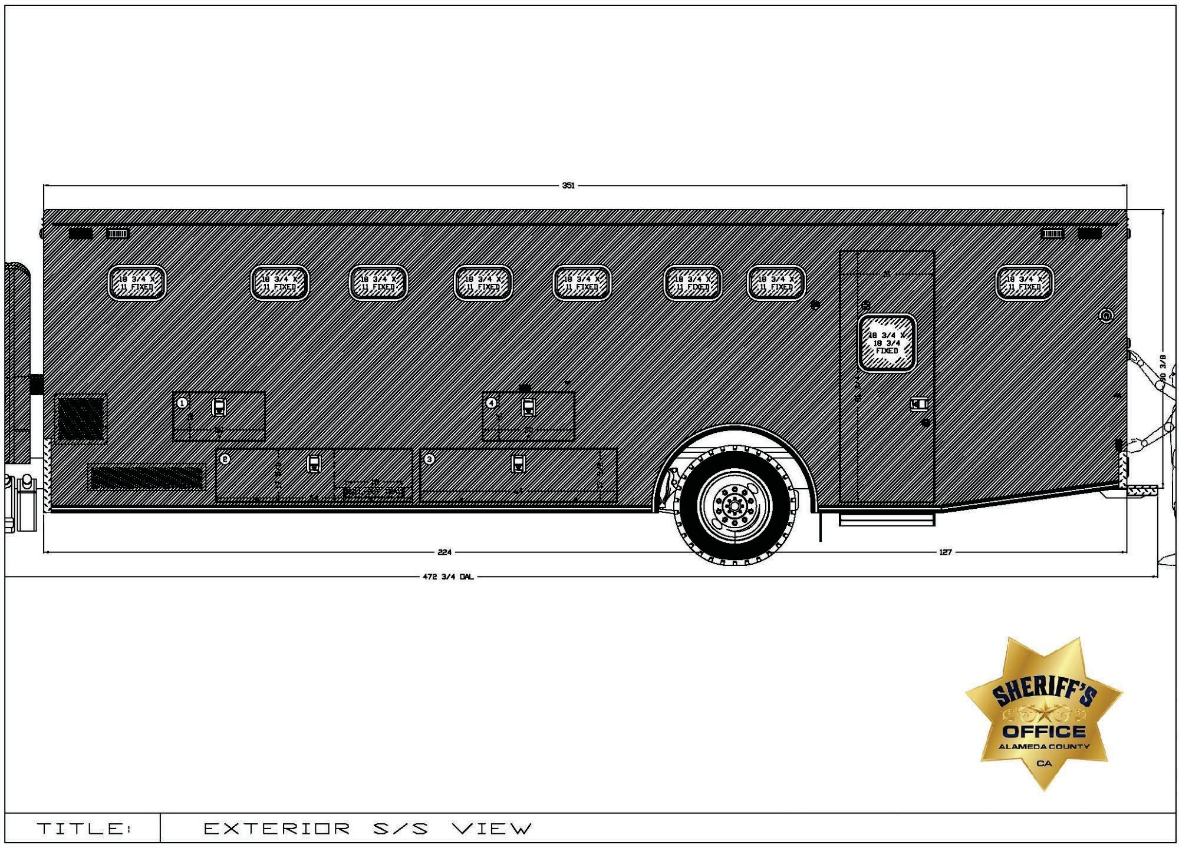

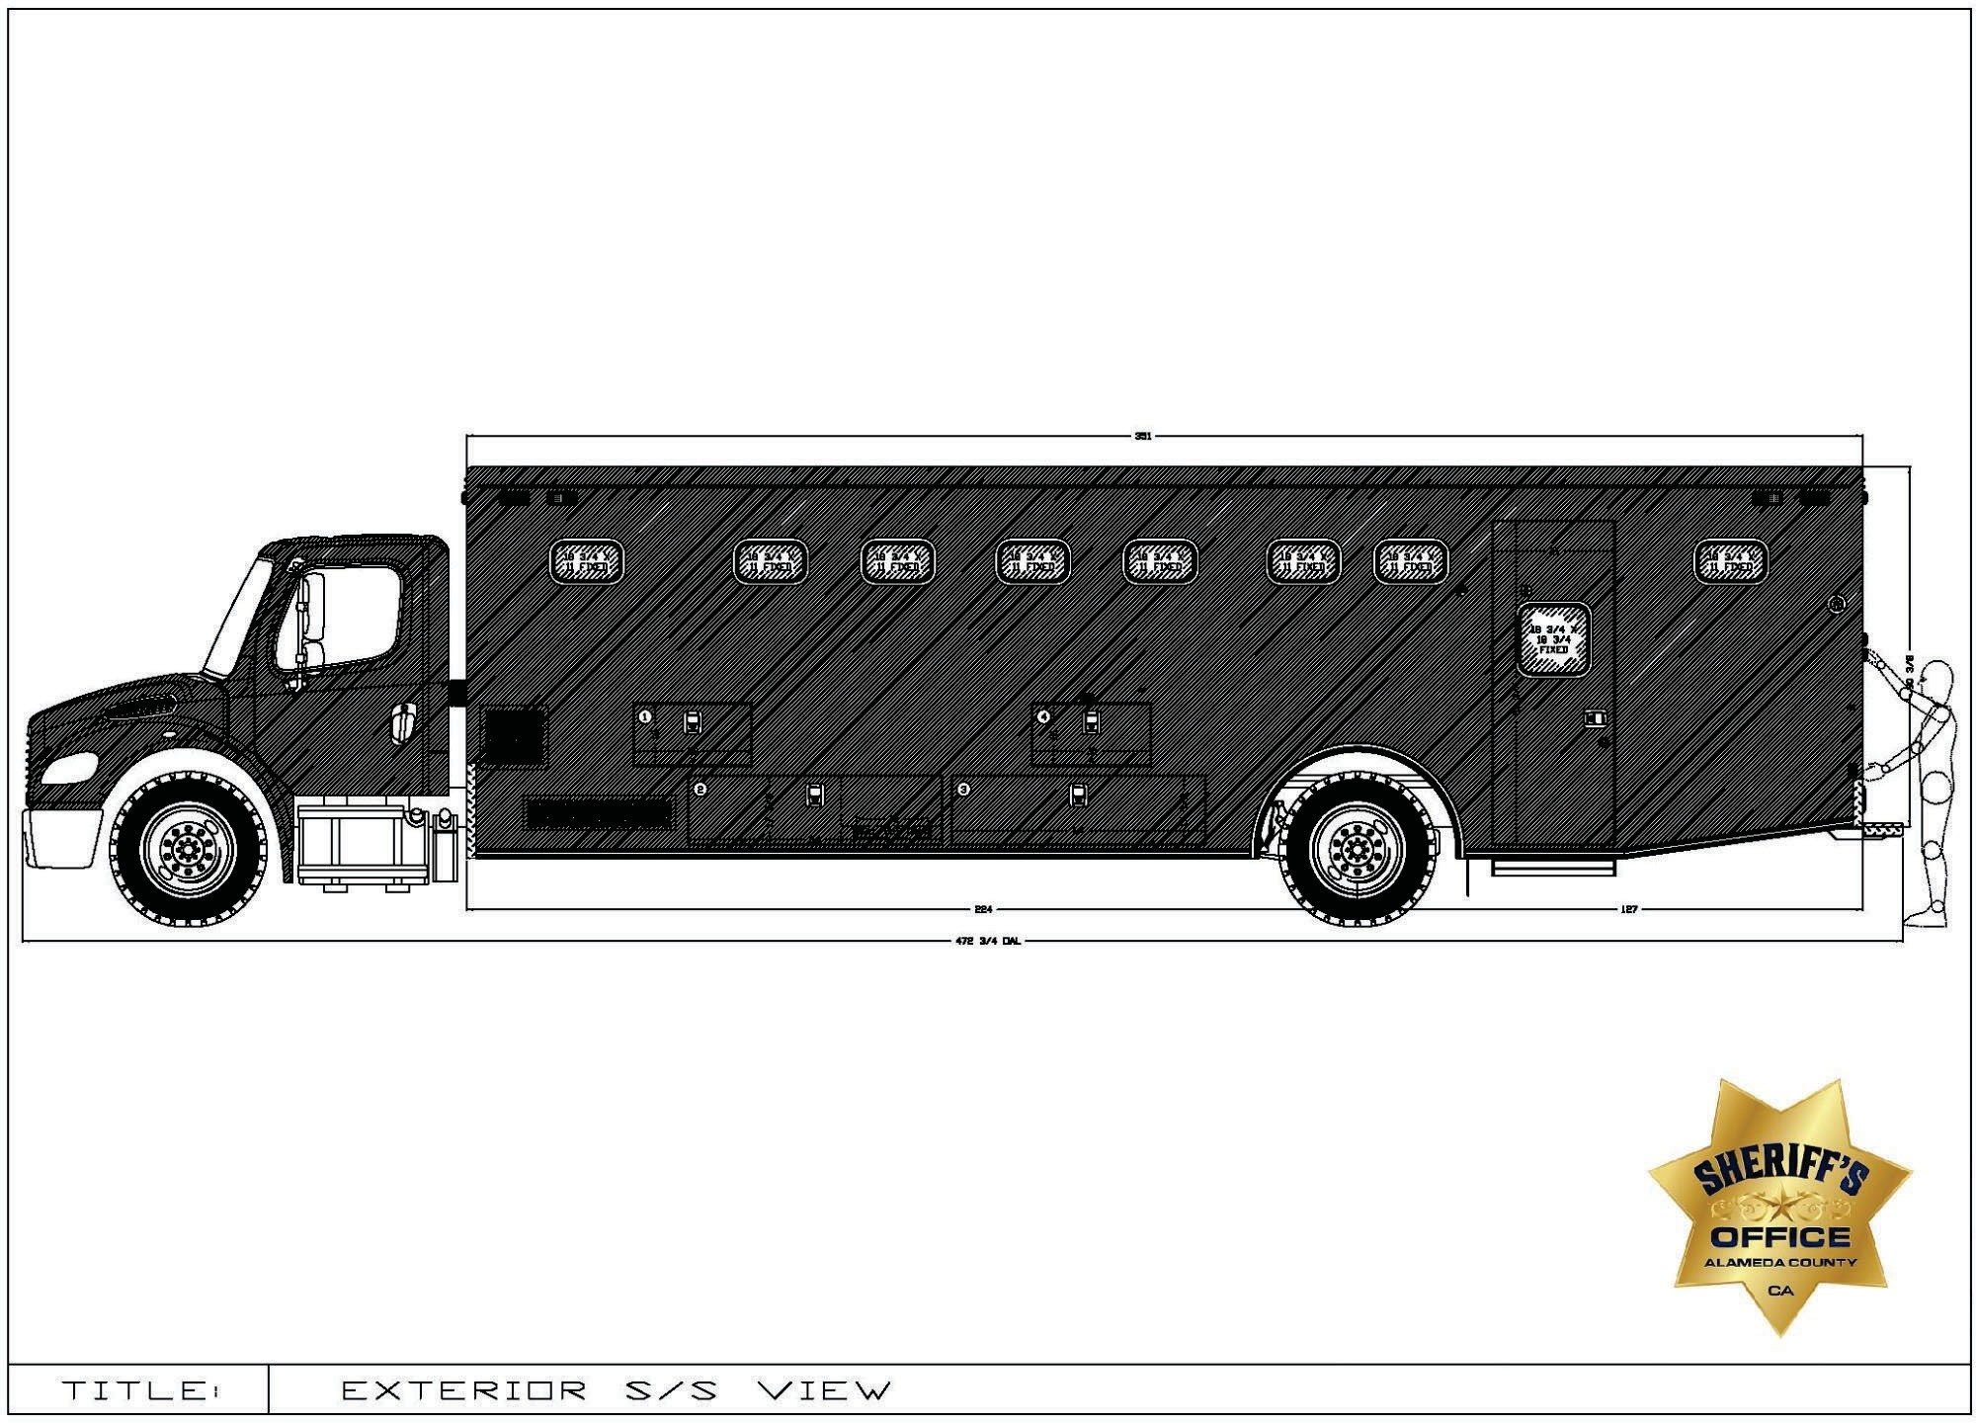

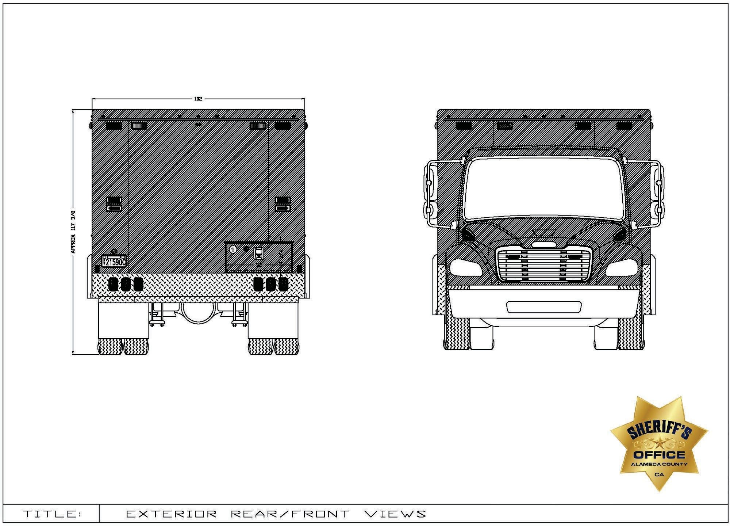

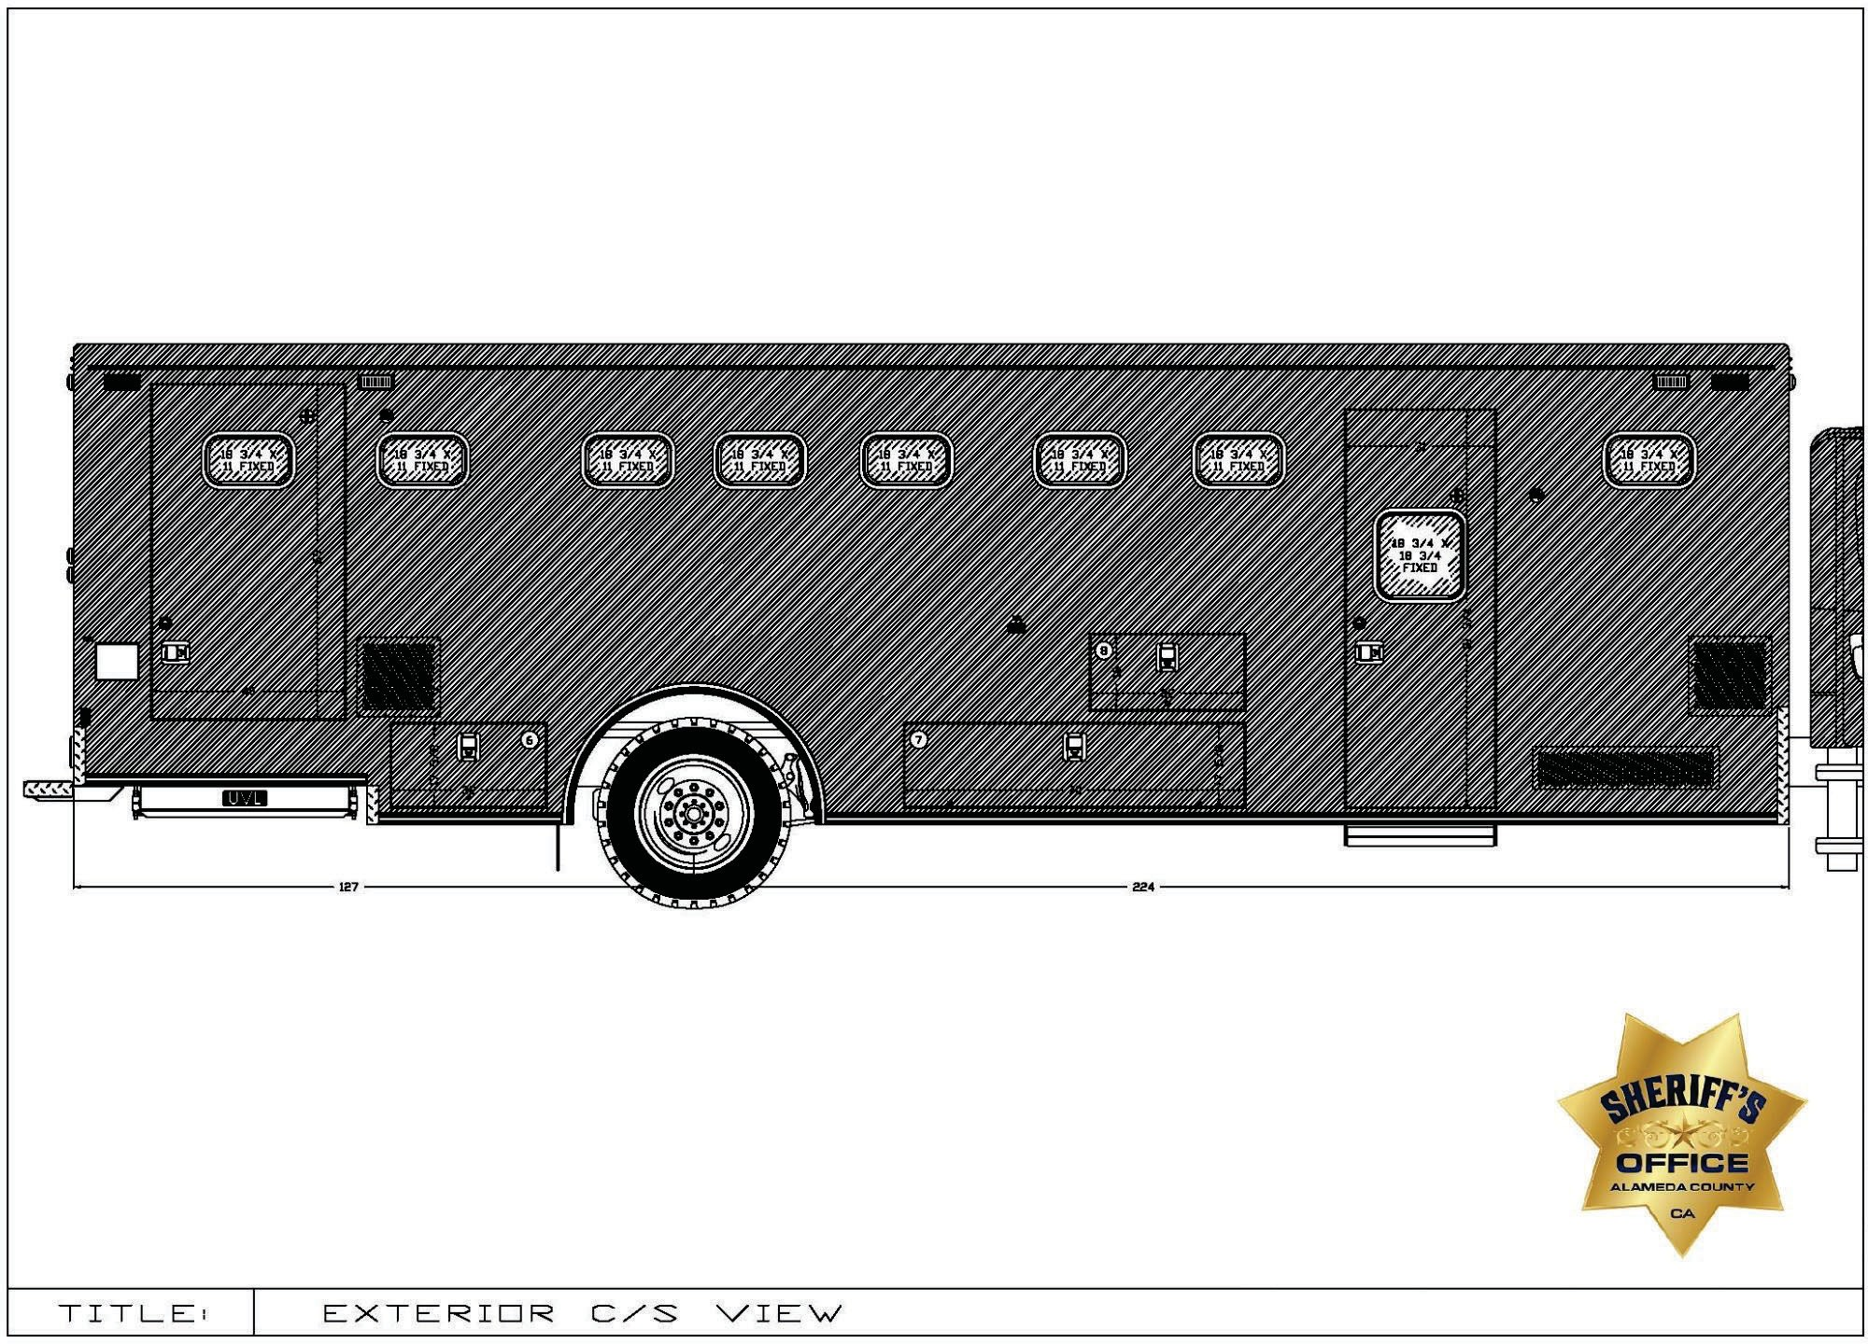

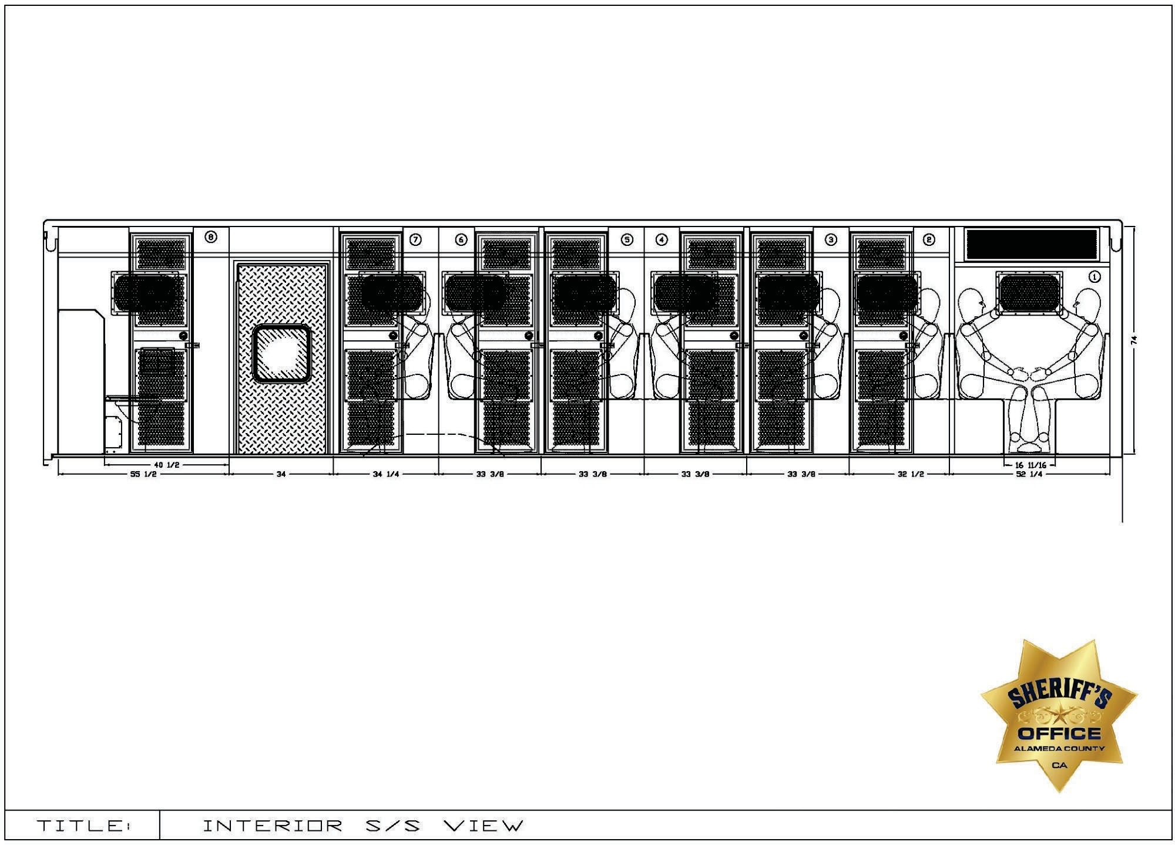

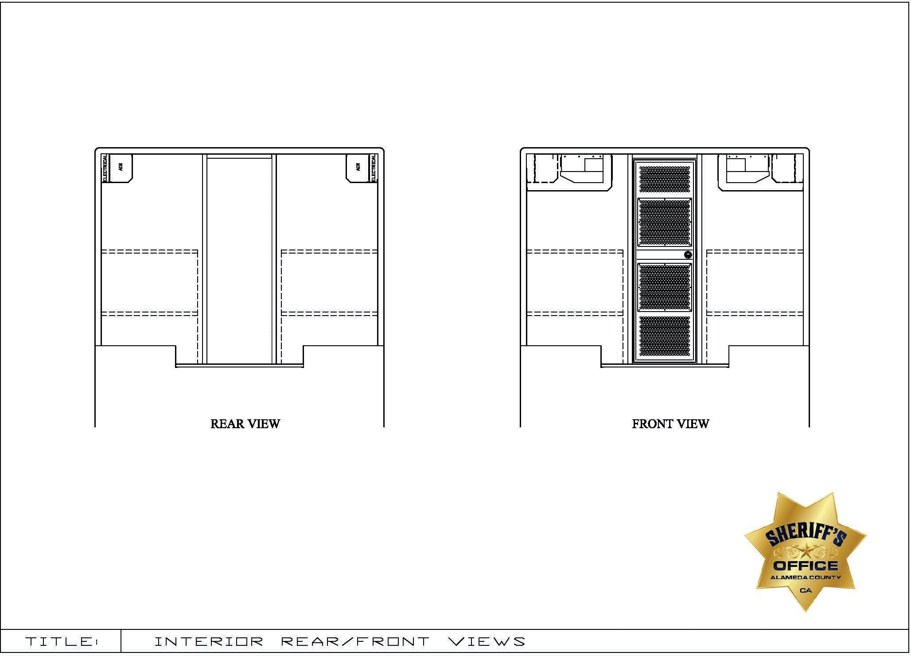

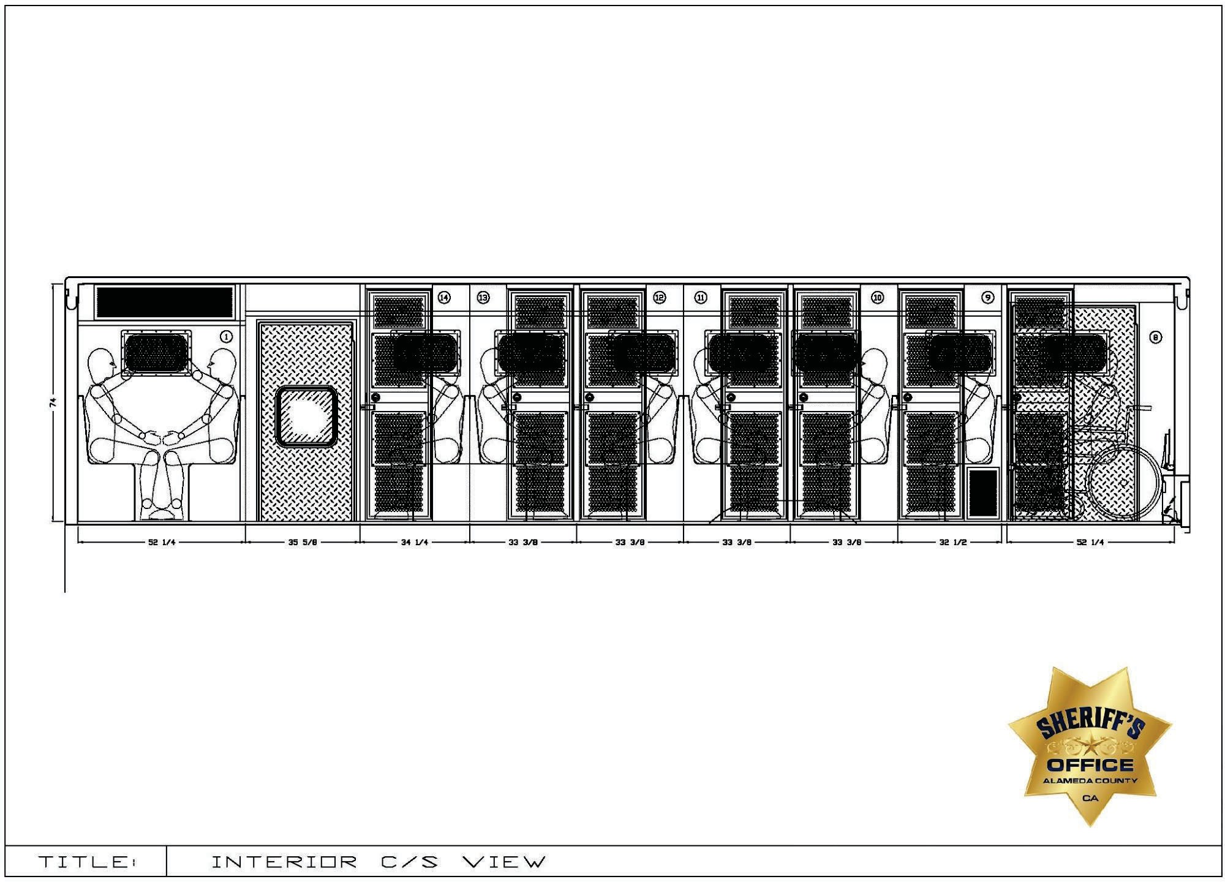

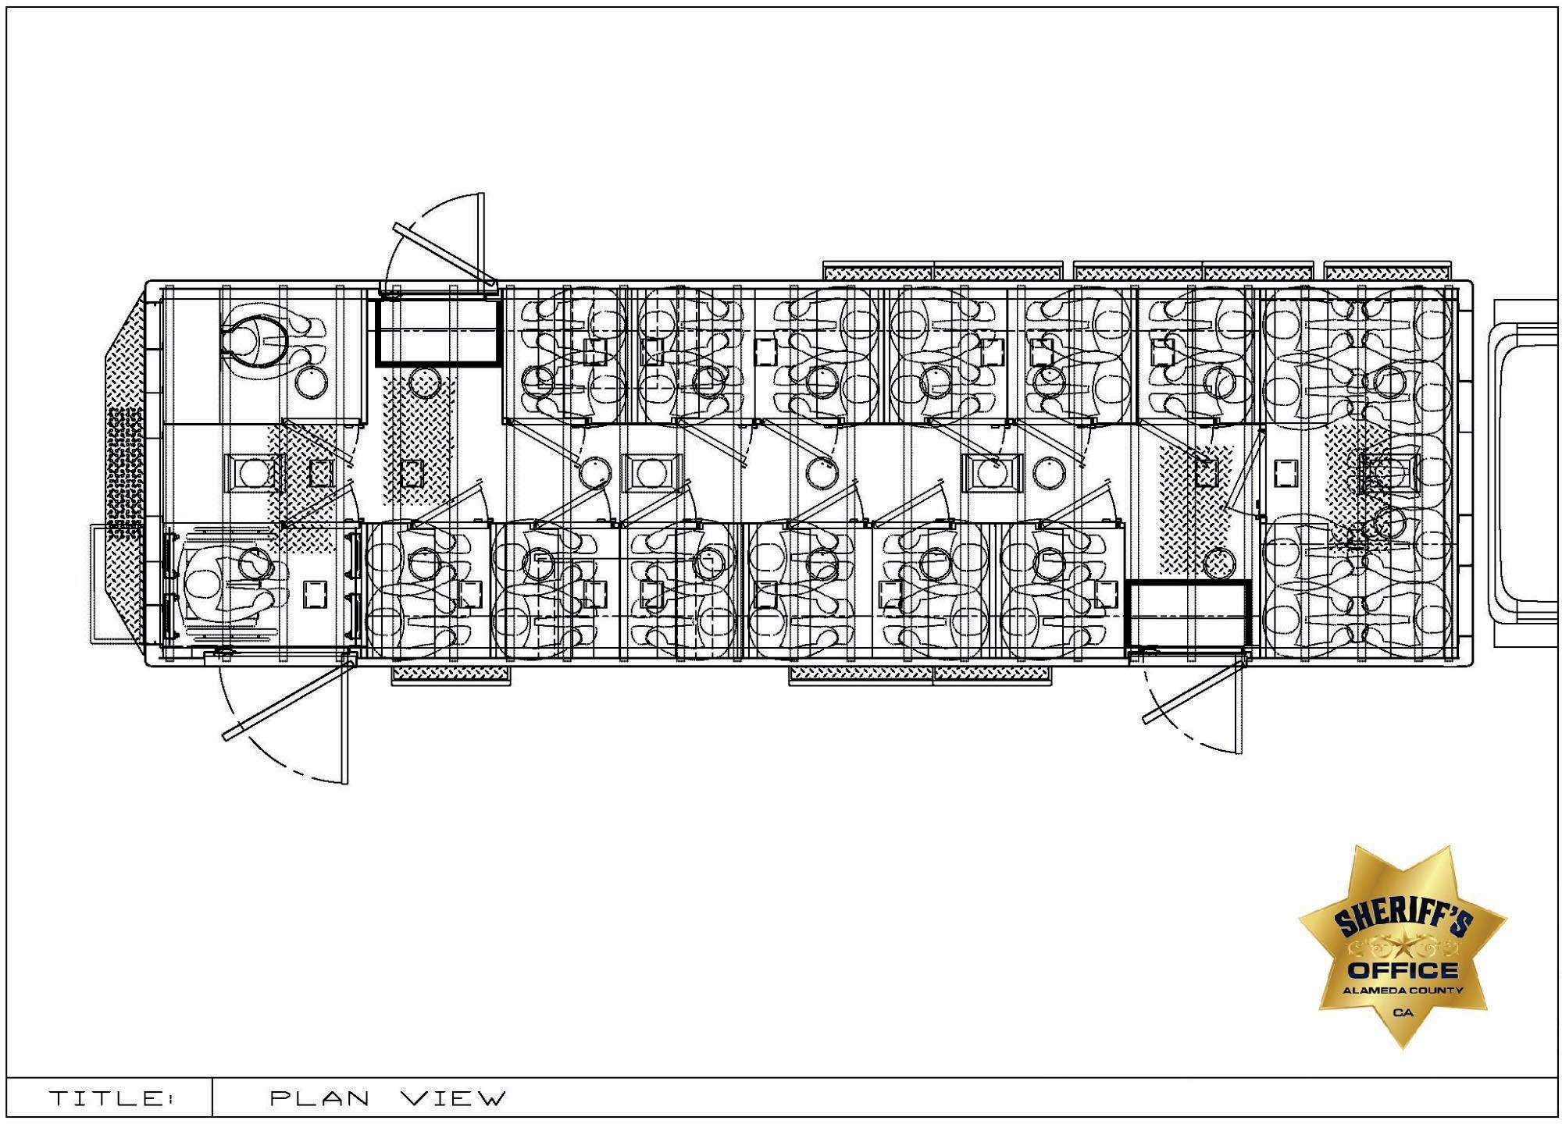

EXHIBIT F
FEDERAL MOTOR VEHICLE SAFETY STANDARD CERTIFICATION

FEDERAL MOTOR VEHICLE SAFETY STANDARD CERTIFICATION

I, , certify on behalf of

, that the vehicles

to be manufactured comply with relevant Federal Motor Vehicle Safety Standards.

BY:

TITLE:

MANUFACTURER:

DATE:__________________________
EXHIBIT G
SALLY PORT DIMENSIONS
