ALAMEDA COUNTY HEALTH

QUESTIONS & ANSWERS
for
RFQ No. ACH-900325
for
Community Care Expansion Preservation Operating Subsidies
& Behavioral Health Bridge Housing Auxiliary Payments

Summary of Q&A Submitted
Networking/Bidders Conferences held on October 16 and 17, 2024

Notice to Bidders
This County of Alameda, HCSA Questions & Answers (Q&A) Document has been electronically issued to potential bidders via e-mail based on the bidders conference sign-in sheets or from other sources. This Q&A Document will also be posted on the General Services Agency (GSA) Contracting Opportunities website located at https://www.acgov.org/gsa_app/gsa/purchasing/bid_content/contractopportunities.jsp

 | QUESTIONS | RESPONSES
 | Why does Alameda County Health (ACH), Housing and Homelessness Services (H&H) require proposals to be submitted via hard copy and USB drive, while other departments only accept online submissions? | As stated in the RFQ on page 22, Section S.1.c, Bidders must submit one original hard copy bid (Exhibit A – Bid Response Packet, including additional required documentation), with original ink signatures and a USB flash drive with an exact copy of the paper proposal in a PDF file, preferably a single file. ACH H&H does not have an online submission system at this time.
 | Can Bidders apply for both Category 1 – Community Care Expansion Preservation Operating Subsidy Payments and Category 2 – Behavioral Health Bridge Housing Auxiliary Payments? | As stated in the RFQ on page 4, Section A. Intent, Bidders may apply to one or both categories.
 | What is an eligible type of reference? Can I use the same references that I used for prior bid responses? | As stated in the RFQ on page 44 (page 17 of the Bid Response Packet), services or goods provided by the Bidder to the reference should have similar scope, volume and requirements to those outlined in these specification, terms and conditions. You may use references that you submitted with previous proposals.
 | Does the County have a list of Homeless Management Information System (HMIS) data entry providers? | The County does not have a list of HMIS data entry providers. As stated in the RFQ on pages 10 and 12, a successful Bidder that is not a licensed HMIS agency will be required to collect all data needed for third party data entry in a format approved by AC Health. AC Health will identify data entry providers.
 | My facility is licensed as an Intermediate Care Facility /Developmental Disability -Habilitative (ICF/DD-H). Does my facility qualify for this funding opportunity? | As identified in the RFQ in Section I.C.1. (page 8), only Bidders who have an existing licensed Adult Residential Facility (“ARF”), as defined in Title 22, section 80001(a)(5) of the California Code of Regulations; Residential Care Facility for the Elderly (“RCFE”), as defined in Title 22, section 87101(r)(5) of the California Code of Regulations; or Residential Care Facility for the Chronically Ill (“RCFCI”), as defined in Title 22, section 87801(r)(5) of the California Code of Regulations are eligible for this funding opportunity.
 | Please explain each category of requested services in layperson’s terms. | The Community Care Expansion Preservation Operating Subsidy Payment program goal is to improve residents’ quality of life and help prevent closure of the facility by funding operations costs (pg. 5-6 of the RFQ) and a one-time subsidy to cover rising insurance costs (pg. 6-7 of the RFQ). The Behavioral Health Bridge Housing Auxiliary Payments program is designed to provide the highest level of support for a limited duration with a focus on transitioning individuals to a lower level of care as they stabilize, gain greater independence, or other suitable housing is secured. This program is to help people experiencing homelessness who have serious behavioral health conditions that prevent them from accessing help and moving out of homelessness (pg. 7 of the RFQ).
 | Where do I locate the Category 1 Excel Workbook and how do I use it? | The Category 1 Excel Workbook can be located on the Alameda County General Services Agency Contracting Opportunities website at https://gsa.acgov.org/do-business-with-us/contracting-opportunities/current-bid/?bidid=2978. Scroll down to the bottom and click on the link titled “2978_RFQ#ACH-900325_BudgetForm.xlsx” (or click HERE). Open the Excel Workbook once it is downloaded. You will see three tabs at the bottom as shown below circled in red  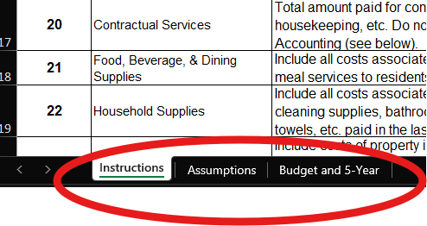  Then click on the second tab “Assumptions” and enter the information requested ONLY IN THE YELLOW SHADED CELLS.  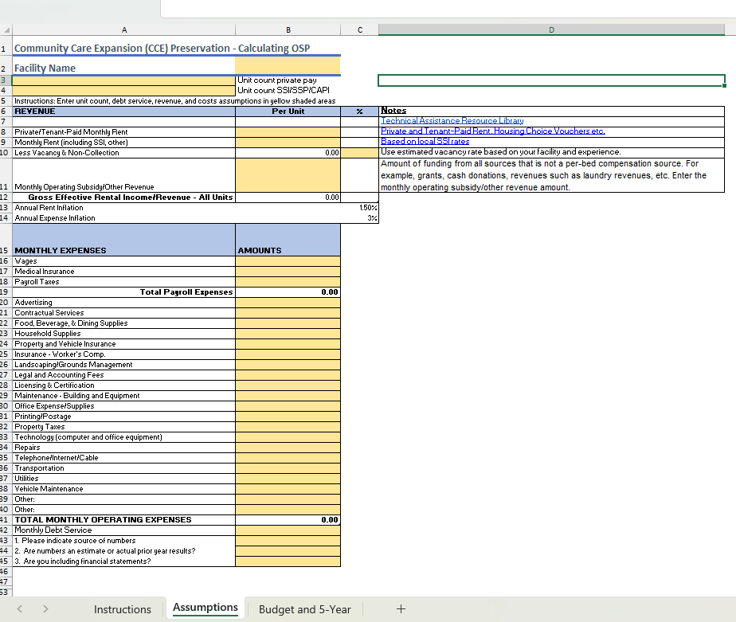  DO NOT ENTER INFORMATION IN TAB 3 “Budget and 5-Year).  Please refer to the first tab (labeled “Instructions”) for guidance regarding definitions and what information should be entered into the “Assumptions” yellow shaded cells.
 | Where do I locate the Exceptions and Clarifications form? | The Exceptions and Clarifications form can be found in the Bid Response Packet on page 19 (page 46 of the RFQ).
 | Do I enter Housing Subsidy Program (HSP) payments in the Category 1 Excel Workbook under Monthly Operating Subsidy/Other Revenue? | Yes, for the Category 1 Excel Workbook, you should add HSP payments received in the Assumptions tab in the yellow shaded cell for the Monthly Operating Subsidy/Other Revenue line item.
 | If I do not have any debt service, should I enter N/A in the Monthly Debt Service field and following fields? | If you have $0 monthly debt service expenses, you should enter $0 in the Monthly Debt Service field. On row 43, please enter the source(s) of the information you entered into the Excel Workbook. On row 44, please enter either the word Estimate or Actual depending on which method you use. On row 45, please enter the word Yes or No, depending on whether you include financial statements with your proposal. If you enter Yes, please be sure to include your financial statements along with your bid proposal.

