COUNTY OF ALAMEDA

Questions & Answers

to

RFP No. 902546

for

Lead Evaluation Consultants
Networking/Bidders Conference Held on January 16, 2025

This County of Alameda, General Services Agency (GSA), RFP Questions & Answers (Q&A) has been electronically issued to potential bidders via email. Email addresses used are those in the County’s Small Local Emerging Business (SLEB) Vendor Database or other sources. If you have registered or are certified as a SLEB, please ensure that the complete and accurate email address is noted and kept updated in the SLEB Vendor Database. This RFP Q&A will also be posted on the GSA Contracting Opportunities website located at Alameda County Current Contracting Opportunities.


Alameda County is committed to reducing environmental impacts across our entire supply chain. If printing this document, please print only what you need, print double-sided, and use recycled-content paper.

Thank you for your participation and interest in the County of Alameda RFP No. 902546– Lead Evaluation Consultants.
All the questions are taken verbatim from written questions received via email. The County of Alameda shall be noted as “County” in the answers to these questions. The Q&A is the final stance of the County. Please consider this document in preparation for your bid response.

Questions and Answers:
- Page 12 – Description of Services
The Description of Proposed Service must describe the overall services. The Bidder must address point-by-point how they will meet or exceed each requirement listed in:
1. Section D (Specific Requirements), Items 1 through 20, including the requirements outlined in Attachment 2, and the attachments of the required copies of certifications/trainings/registration.
Can you provide clarification regarding Section D (Specific Requirements) Items 1 through 20? Section D located on page 6 of the RFP does not list 20 items.
The items listed in Section D (Specific Requirements) are items 1. a. through v. and 2. Please refer to Addendum No. 1.
- Page 12 - Section E (Deliverables/Reports), Items 1 through 4.
Can you provide clarification regarding what is required in this section? Do you want examples of previous reports and/or deliverables?
Bidders are to provide a detailed, point-by-point explanation of how they will meet each specific requirement outlined in Section E (Deliverables/Reports), Items 1 through 4. This means for each requirement listed, Bidders should clearly describe their approach, methods, and any steps they will take to ensure to meet or exceed the specifications. This is not the requirement of Section E (Deliverables/Reports) but Bidders may include any supporting documentation or examples to further demonstrate their capability in meeting the listed requirements.
- Who are the incumbents for the previous contract?
The incumbents for the previous expired contracts are Professional Service Industries, Inc., Oaks Environmental Testing, Inc., and Titan Environmental Solutions, Inc.
- Can you send a copy of the previous expired contract and total dollar amount spent?
Please submit a public records request to healthyhomesadmin@acgov.org to obtain a copy of previous contracts. The estimated spend on the previous expired contract was $230,556.
- Previous fee schedule from incumbent and testing fees?
Testing fees are covered under a separate contract. Please submit a public records request to healthyhomesadmin@acgov.org to obtain testing fees. Previous incumbents' fees were as follows:
Contractor No. 1
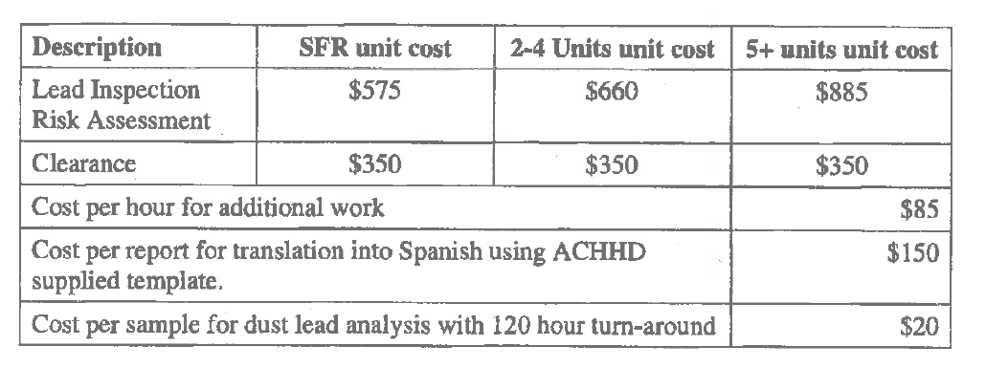
Contractor No. 2
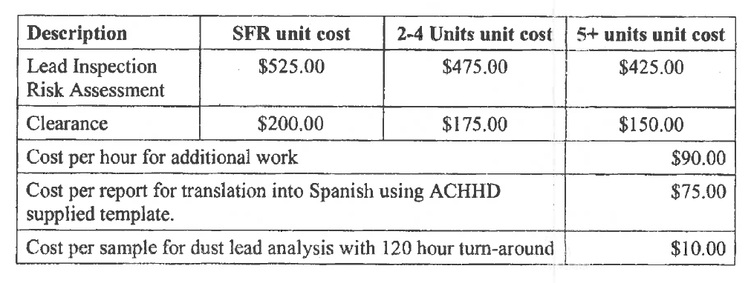
Contractor No. 3
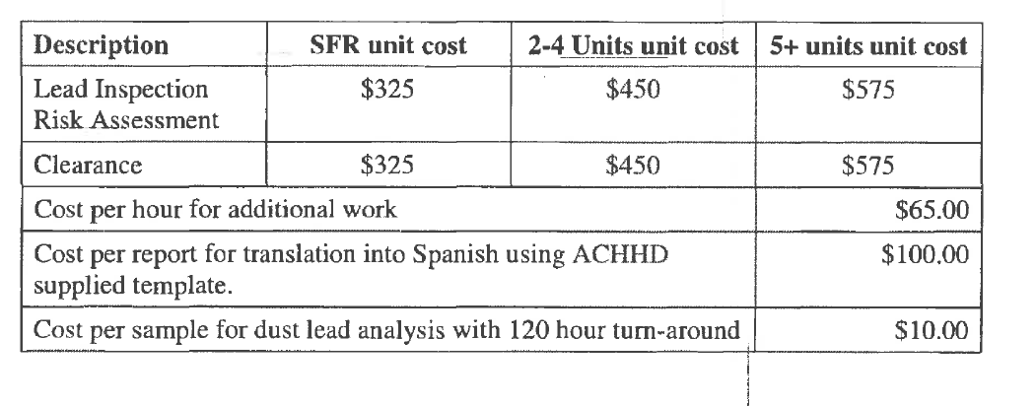
- Previous RFP evaluations from last contract?
Please submit a public records request to healthyhomesadmin@acgov.org to request previous RFP evaluations.
- Does County of Alameda have a list of specific Capital Projects planned for the next 5 years?
At this time, the County of Alameda does not have a finalized list of specific capital projects planned for the next five years.

