**IMPORTANT NOTICE**
ONLINE BIDDING PROCESS

- Bid pricing must be submitted online through Alameda County Strategic Sourcing Supplier Portal.
- The following pages require signatures and must be scanned and uploaded to Alameda County Strategic Sourcing Supplier Portal:
- Exhibit A – Bid Response Packet, Bidder Information and Acceptance page
  - Must be signed by Bidder
- Exhibit A – Bid Response Packet, SLEB Partnering Information Sheet
  - Must be signed by Bidder
  - Must be signed by SLEB Partner if subcontracting to a SLEB

Please read EXHIBIT A – Bid Response Packet carefully, INCOMPLETE BIDS WILL BE REJECTED. Alameda County will not accept submissions or documentation after the bid response due date. Successful uploading of a document does not equal acceptance of the document by Alameda County.

COUNTY OF ALAMEDA

REQUEST FOR PROPOSAL No. 901489

for

Workers’ Compensation Third Party Administration Services

For complete information regarding this project, see RFP posted at http://www.acgov.org/gsa_app/gsa/purchasing/bid_content/contractopportunities.jsp or contact the County representative listed below. Thank you for your interest!

Contact Person: Ariana Figueroa, Procurement & Contracts Specialist

Phone Number: (510) 208-9599

E-mail Address: ariana.figueroa@acgov.org

RESPONSE DUE
by
2:00 p.m.
on
November 2, 2016
through
Alameda County, GSA-Procurement
Strategic Sourcing Supplier Portal
https://ezsourcing.acgov.org/psp/SS/SUPPLIER/ERP/h/?tab=DEFAULT


Alameda County is committed to reducing environmental impacts across our entire supply chain.
If printing this document, please print only what you need, print double-sided, and use recycled-content paper.
COUNTY OF ALAMEDA
REQUEST FOR PROPOSAL No. 901489
SPECIFICATIONS, TERMS & CONDITIONS
for
Workers’ Compensation Third Party Administration Services<

TABLE OF CONTENTS
Page

I. STATEMENT OF WORK 4
A. INTENT 4
B. SCOPE 4
C. BACKGROUND 5
D. OBJECTIVES: 6
E. BIDDER QUALIFICATIONS 6
F. SPECIFIC REQUIREMENTS 7
G. DELIVERABLES / REPORTS 25
II. CALENDAR OF EVENTS 26
H. NETWORKING / BIDDERS CONFERENCES 26
III. COUNTY PROCEDURES, TERMS, AND CONDITIONS 27
I. EVALUATION CRITERIA / SELECTION COMMITTEE 27
J. CONTRACT EVALUATION AND ASSESSMENT 32
K. NOTICE OF RECOMMENDATION TO AWARD 33
L. TERM / TERMINATION / RENEWAL 33
M. BRAND NAMES AND APPROVED EQUIVALENTS 33
N. QUANTITIES 34
O. PRICING 34
P. AWARD 36
Q. METHOD OF ORDERING 37
R. INVOICING 37
S. ACCOUNT MANAGER / SUPPORT STAFF 38
IV. INSTRUCTIONS TO BIDDERS 38
T. COUNTY CONTACTS 38
U. SUBMITTAL OF BIDS 39
V. RESPONSE FORMAT 41

ATTACHMENTS

EXHIBIT A - BID RESPONSE PACKET
EXHIBIT B - INSURANCE REQUIREMENTS - VENDOR BID LIST
EXHIBIT D - PERFORMANCE INCENTIVES
EXHIBIT E - VENDOR BID LIST CLAIMS ADMINISTRATION GUIDELINES
EXHIBIT F - CSAC-EIA EXCESS WORKERS’ COMPENSATION CLAIM REPORTING AND REIMBURSEMENT PROCEDURES
EXHIBIT G - COUNTY’S SELF INSURED RETENTION (SIR)

STATEMENT OF WORK

INTENT
It is the intent of these specifications, terms, and conditions to describe the third party administration services for the County of Alameda Workers’ Compensation Claims Program. The Alameda County Administrator’s Office-Risk Management Unit (RMU) is seeking a qualified Third Party Administrator (TPA) to perform claims administration services as required by law and in accordance with County policy for its self-insured workers’ compensation (WC) program.
The County intends to award a three-year contract (with the option to renew) to the bidder selected as the most responsible bidder whose response conforms to the RFP and meets the County’s requirements.

SCOPE
Approximately 9,025 full-time equivalent employees are covered in the County WC program. Full-time employees and eligible part-time employees are members of the Alameda County Employees Retirement Association (ACERA). Fire Department employees are members of California Public Employees’ Retirement System (Cal/PERS).

There are approximately 2,170 safety employees in the Sheriff’s Office, Fire Department, District Attorney’s Office, and the Probation Department. Public safety personnel are afforded salary continuation benefits under Labor Code §4850.

The County’s total payroll (salaries) for the 2015/2016 fiscal year was approximately $766,163,000.

The County contracts with a TPA for claims review, processing, and payment of benefits for its self-insured WC program. Currently, the County maintains a self-insured retention (SIR) amount of $3,000,000 per incident and is a member of the CSAC Excess Insurance Authority (CSAC-EIA), a Joint Powers Authority which provides excess WC coverage. Other amounts of SIR, coverage, and vendors apply for previous years.

The TPA shall also provide claims administration services for all existing claims, including:

- Claims with dates of injury prior to November 21, 1979.
- Claims with dates of injury from July 1, 1997 to present.

Claims with dates of injury from November 21, 1979 through June 30, 1997 have been re-insured in a loss portfolio transfer and are handled by a different TPA up to the SIR level. However, if they exceed the loss portfolio limits but are below the excess insurance attachment level, they are the responsibility of the County’s TPA.

The new claims experienced in the past five years are:

 | First Aid/Incident Only | Indemnity | Medical | Total
FY 11/12 | 218 | 628 | 196 | 1,042
FY 12/13 | 224 | 575 | 268 | 1,067
FY 13/14 | 243 | 448 | 277 | 968
FY 14/15 | 174 | 384 | 260 | 818
FY 15/16 | 254 | 595 | 223 | 1,072

As of 06/30/2016, the current caseloads of open and re-opened claims are:

First Aid/Incident Only | 2
Medical Only | 62
Indemnity | 917
Future Medical | 526
Total: | 1,507

BACKGROUND
The County’s RMU coordinates all aspects of the WC program between the agencies/departments and the TPA.
The County Agency/Department is responsible for reporting injuries; arranging employee contact; training managers, supervisors, and employees on WC procedures; and the administration of early return to work programs (RTW).
The County’s Auditor-Controller’s Agency is responsible for providing lost time, salary information, audits and issues payment of benefits to injured employees and contracted WC vendors, and issues settlement payments through the County’s revolving fund.
The County has outsourced the following services: managed care; investigations; ergonomic evaluation and equipment; and defense attorney services. The RMU is responsible for vendor compliance with contract and performance standards.

The Contractor shall work with and fully cooperate with the Utilization Review (UR) managed care vendor, bill review vendor(s), and any other WC vendors selected by the County. In addition, the Contractor shall not charge the County, the managed care, UR or bill review vendor(s), or any other WC vendors for setting up and maintaining the interfaces, including, but not limited to, implementation fees, electronic data interface, or scanning fees.
Currently, the County has a pharmacy benefit network (PBN), but does not have a medical provider network (MPN). Should a MPN be implemented, the contractor shall work and fully cooperate with the selected MPN and the current PBN vendors/networks. In addition, the Contractor shall not charge the County or MPN/PBN vendors for setting up and maintaining this relationship including, but not limited to, implementation fees, electronic data interface, or scanning fees.

OBJECTIVES:
The intent of this solicitation and resultant Contract is that the TPA shall efficiently and effectively administer WC claims for all claimants in accordance with the requirements detailed under specific requirements commencing on or before July 1, 2017.
The following should be accomplished prior to the effective date of July 1, 2017:

- WC Claims information including data on current and prior claims shall be converted from the current administrator to the successful Contractor's electronic claims management;

- The hiring and placement of a dedicated staff comprised of qualified and experienced personnel;

- The logistical positioning of a service unit or office to manage and administer the County's WC Claims, with no interruption in services to claimants; and

- The coordination of services with providers.

BIDDER QUALIFICATIONS
    - BIDDER Minimum Qualifications
      - Bidder shall be regularly and continuously engaged in the business of providing WC third party administration services with public agencies that have public safety employees of similar or equal size to the County for at least three years. Experience must be demonstrated by references provided by Bidder at the time of the bid.
      - Bidder shall be licensed with the California Department of Industrial Relations, Self-Insurance Plans. License shall be provided with bid Submittal.
      - Bidder shall possess all permits, licenses and professional credentials necessary to supply product and perform services as specified under this RFP.

SPECIFIC REQUIREMENTS
The Contractor shall administer the County’s claims from an office located within the County of Alameda or as otherwise approved by the County after bid award.
The Contractor shall perform all services required to supervise and administer a self-insured WC program for the County and act as the County’s representative in matters relating to the County’s obligations under the WC laws of the State of California.
In addition, the Contractor shall perform claims administration services in accordance with County specific policies and industry standards. The claims administrative services required shall include, but are not limited to, the following:
    - County Program Requirements
- Ergonomic Services – Contractor shall make ergonomic evaluation referrals for all Repetitive Stress Injury (RSI) claims and those claims with prescriptions for ergonomic evaluations or equipment within one week of receipt of such claims or prescriptions, even if placed on delay status. Contractor shall make referrals to County-approved evaluators. The County shall order the recommended equipment. Contractor shall be responsible for documenting activity in the claims file and for paying all costs in regard to initial and follow-up reports and for equipment purchased and installed associated with the referral. The Contractor shall provide a monthly repetitive strain injury report and provide the results to the County to demonstrate compliance.

All payments for ergonomic evaluation and equipment are to be coded with the proper transaction codes which distinguish between evaluation and equipment costs.

- Subcontractor Approvals – The County reserves the right to request reassignment of subcontractors that are not performing in a manner satisfactory to the County.

- Americans with Disabilities Act-California Fair Employment and Housing Act (ADA-FEHA) Program – Contractor shall provide appropriate disability information to the County to assist with departmental and Countywide ADA-FEHA accommodation efforts. Disability information including specific permanent restrictions and the County Essential Functions Job Analysis (EFJA) completed by WC doctors shall be provided to contacts designated by the County.

- Return-To-Work Program – Contractor shall obtain disability information and temporary restrictions from the primary treating physician and forward them to the County within three days of the provider appointment. Documentation providing for temporary modified duty, including restrictions and duration shall be entered into the claims management system with three days of receipt. Contractor system shall include the ability to track lost work days and modified duty days as part of each Indemnity claim. Contractor shall provide a monthly report to assigned County Agency/Department liaison to track compliance with the County’s temporary modified work policy.

- Cal/PERS and ACERA Disability Retirement Services – Contractor shall cooperate with all inquiries made in relation to disability retirement applications for Alameda County employees. Such cooperation shall include, but is not limited to, responding to verbal and written inquiries by the County, including its attorneys, and providing copies of documents and case notes as requested. Cooperation may include direct contact, and the exchange of information and documents between the RMU, County Counsel, and the assigned WC defense attorney. Contractor shall respond to written inquiries regarding the existence and status of WC claims and provide copies of medical files within two weeks of receipt of a request from the RMU.

- Essential Functions Job Analysis/Essential Functions Form #5 (EFJA/EF5) – Contractor shall obtain, from the County Agency/Department liaisons, the EFJA for the injured employee’s generic or specific job class, should the injured employee be off work or on temporary disability (including 4850) for more than 60 days. If one is not available, Contractor shall refer the request for an EFJA to a qualified RTW vendor within one week. Contractor shall provide the qualified RTW vendor with a County approved EFJA/EF5 form. Contractor shall be responsible for sending the EFJA/EF5 to the Qualified Medical Examiner (QME), Agreed Medical Examiner (AME), and/or the primary treating physician prior to the Permanent and Stationary (P&S) determination. Contractor shall use County specific language in the doctor’s letters regarding the EFJA and obtain the completed form from the evaluator with the medical-legal reports.

Contractor shall provide the County Agency/Department liaison and the County RMU, within 10 days of Contractor’s receipt, the following documents:

- EFJA/EF5s completed by the clinician;
- P&S reports;
- County Notices of Offer of Modified or Alternative Work for all P&S reports ; and
- County RTW Cover Sheet.

- Integration with Auditor-Controller Disability Unit – Contractor shall issue non-cash vouchers and checks as required by the Auditor-Controller Disability Unit and reports for the Alameda County Fire Department. Contractor shall respond timely to requests for verification of temporary disability/Labor Code 4850 in coordination with bi-weekly County pay periods. Contractor shall assist the Auditor-Controller Disability Unit with any request for audit of leaves for medical appointments (W57). Contractor does NOT have any authority to settle any payroll related adjustments.

- County Procedures & Forms – Contractor shall follow County policies and procedures, copy designated County staff on specified correspondence, and use County forms.

- Penalty Reimbursement – In addition to other damages that the County may be able to recover as provided by law, Contractor shall be responsible for all costs and penalties incurred as a result of its errors or delays in the administration of claims. This includes, but is not limited to, penalties as a result of failure to determine compensability or to pay claims timely, self-imposed penalties, and penalties imposed by the Workers’ Compensation Appeals Board (WCAB) or other regulatory agencies. Contractor shall reimburse the County, for any such penalties incurred, on a quarterly basis within 30 days from the end of the quarter.

- Performance Incentives – Contractor shall abide by the performance incentives and penalties located in Exhibit D – Performance Incentives. Contractor shall reimburse the County at the end of each quarter for any penalty incurred.

- Payments through the County’s Revolving Account – The County requires that certain payments made through the revolving account be pre-approved by the Director of Risk Management/designee. This includes all payments to the Contractor for ancillary services. The Contractor shall cooperate with the County in developing a process so that the bills are paid in a timely manner. Contractor shall notify the Auditor-Controller Disability Unit of any one time payment of $10,000 or more.

    - Claims Management
      - Information Technology – Contractor may use its own claims management system. Contractor shall provide training for County representatives, at no cost, in accessing information, creating reports, and downloading information into Microsoft Excel from its claims management system. If information cannot be downloaded into a Microsoft Excel file format, then the Contractor shall provide reports within 24 hours of a request.

Regardless of the type of claims management system used, the Contractor shall provide County with 10 full access and at least 20 limited access licenses. For the full access license, the County representative should have access to, but not be limited to, the following:

- Diary Access;
- Claim Notepad/Status Notes;
- Payments & Reserves;
- All Correspondence;
- Work Status Access; and
- All Reports.

The Contractor shall comply with the requirements of the state Electronic Adjudication Management System (EAMS), at no additional charge to the County.

      - Telephonic Claims Reporting – The RMU desires the capacity to report claims telephonically or electronically without the departments and supervisors needing to complete the Employer’s First Report of Injury Form 5020. The selected TPA must be able to provide this service customized to meet the County’s needs or manage and pay a subcontractor (without additional cost to the County) to provide at a minimum the services outlined below:

        - Provision of a 1-800 number operable 24/7/365 for telephonic reporting of WC claims and triage/first aid services by a registered nurse (RN) applying consistent, recognized, and County of Alameda (COA)-approved medical protocols. (If the call is from a supervisor, then triaging of the injury and referral to a medical care site are not needed).

        - Referral to most appropriate COA-designated employer medical care sites or MPN and provision of self-help services.

        - Documentation of all reported incidents, claims, first aid, and RN self-care reports and ability to generate summary reports by department on a monthly schedule.

        - Electronic data interchange (EDI) transmission of WC claim/incident information same day to TPA and faxed or emailed copies of Form 5020 to the RMU and employee’s departmental WC Liaison for completion of missing personnel, notification of employee’s supervisor and distribution of the DWC-1, Facts brochure and other WC information.

      - Meetings, Audits, Coding, and Training – Contractor shall be responsible for the following:

        - Maintaining a County/Contractor policy and procedure manual. Newly hired employees shall be trained on County policies and procedures prior to handling any County claims.

        - Preparing status reports for and participating in periodic claims review meetings with respective County Agency/Department liaisons and County RMU.

        - Participating in quarterly RMU meetings and as needed.

        - Holding periodic meetings and file reviews on selected cases with RMU and defense attorney.

        - Holding periodic meetings and file reviews on selected cases with RMU and investigative firm.

        - Providing documentation for the monthly check register audit.

        - Responding to Auditor/Controller Disability Unit with any request for audit on leaves from medical appointments.

        - Using and updating, within its claims management system, the County’s agency and department location, coding and occupational coding that correspond with County budget and job classifications, as needed.

        - Utilizing appropriate pay codes for all transactions.

        - Conduct training in WC law and procedures, claims system procedures, and orientation meetings for the County’s personnel involved in the WC program, including supervisors and department liaisons.

      - General Program Administration

        - Contractor shall provide a dedicated claims team and sufficient claims personnel so that no claims adjuster will be required to handle more than 150 open indemnity claims. This caseload shall include future medical cases with every two future medical cases counted as one indemnity case. The claims count shall be reviewed on a quarterly basis. Temporary claims adjusters must be hired to replace staff that are expected to be absent for more than two weeks. Contractor shall provide quarterly report to monitor compliance.

        - Contractor shall have sufficient staff to effectively handle the County’s WC claims. Insurance Code Section 11761 requires the Contractor to certify that their personnel meet minimum standards. Contractor will insure that all claims personnel assigned to the County’s account shall meet the annual requirement for continuing education. In addition, the County requires that all personnel managing claims, contacting the public or employees must fluently speak and correctly write English for the effective administration of this Contract. The County expects that claims staff will meet or exceed the experience and professional qualifications listed below and each must successfully complete a background check.

          - The Claims Manager, Claims Supervisor, and Claims Adjusters shall be state-certified, Self-Insurance Administrators as set forth in Title 8, California Code of Regulations, Section 15452.

          - The Claims Manager and Supervisor shall have a minimum of five years of WC claims experience with a California public agency with public safety employees and at least two years WC claims supervisory experience. Supervisors shall not carry caseloads, but may handle sensitive or conflict claims identified by RMU.

          - A minimum of six Senior Claims Adjusters shall be state-certified and experienced with the competency to handle medical, indemnity, and litigated claims. The Senior Claims Adjuster shall have a minimum of five years of WC claims experience and a minimum of two years’ experience with a California public agency with public safety employees.

          - A minimum of three Claims Adjusters handling future medical and medical-only claims shall be state-certified with a minimum of three years of WC claims handling experience.

          - No trainee shall be allowed to handle County claims.

        - The Contractor shall be responsible for recruitment and selection of all personnel consistent with the position experience levels and professional qualifications outlined above. The County reserves the right to interview all finalists for the Claims Manager, Claims Supervisor and Claims Adjuster positions. The County also reserves the right to request reassignment of Contractor employees that are not performing in a manner satisfactory to the County.

        - Contractor shall provide the County with information on changes or proposed changes in legislation and rules and regulations affecting the County’s self-insured WC program, including but not limited to required postings and notices.

        - Contractor shall identify problem areas and recommended solutions on an on-going basis with County representatives. Contractor shall provide consultation services, as needed, to ensure the success of the program, including cost containment and reduction of losses.

        - Contractor shall provide loss and injury reports for the County, as a whole, and for each County Agency/Department quarterly and prepare annual stewardship reports, SIP, Cal/OSHA, and other reports as requested.

        - Contractor shall have an electronic database capable of producing specialized and ad-hoc reports in addition to those required by the State of California.

        - Management summary as well as detailed claim reports shall be provided to the County upon request. Contractor shall provide all required reports within the timeframes specified by the County. Electronic reports in Microsoft Excel file format are preferred for data analysis by County.

    - General Claims Administration
      - Contractor shall administer claims in accordance with the CSAC-EIA Claims Administration Guidelines (see Exhibit E) and CSAC-EIA Excess Workers’ Compensation Claim Reporting and Reimbursement Procedures (see Exhibit F). In the event that a more stringent requirement is contained in this section, the more stringent requirement shall apply.
      - If paper system, all correspondence is to be date-stamped and distributed to staff within one day of receipt. If paperless, all correspondence received shall be scanned legibly and documented in the paperless system within one day of receipt.
      - Claims are to be reviewed and setup within 24 hours of receipt from any source. The Contractor shall conduct three point contact with the injured employee, supervisor, and physician within 48 hours of receipt. In the event a party is non-responsive, there should be evidence of at least three documented attempts to reach the individual. Medical only claims shall have this three point contact requirement as well.
      - Contractor shall make initial compensability determination (delay, accept or denial) and reasons for determination shall be made and documented in the file within 14 calendar days of the filing of the claim with the employer. Contractor shall provide a copy of all benefit notices to County designee.
      - Contractor shall code claims as first-aid, incident only, medical only, or indemnity and future medical. Contractor shall demonstrate compliance at least annually or upon request by the County.
      - Contractor shall respond to phone calls and emails within one working day and to written inquiries within three working days.
      - Contractor shall send a copy of the 5020 to the County within 48 hours of request.
      - Contractor shall review and timely process all claims for WC benefits in accordance with the California Department of Industrial Relations (DIR) report and notification requirements.
      - Contractor shall request a report from the Index Bureau on all new indemnity claims. Subsequent requests should be made every six to 12 months thereafter or earlier if required. County claims can be reported to the Index Bureau under a contract through the CSAC-EIA. Results shall be documented in claim notes.
      - Contractor shall determine eligibility for and provide timely payments of medical and indemnity benefits and if, warranted schedule QME examinations to determine the compensability of claims. Prior to the initial payment of temporary disability a medical report must be received or the medical provider contacted to establish the nature and extent of injury, causal relation to the alleged incident, treatment plan and estimated RTW date.
      - Contractor shall make disability payments in accordance with the County’s bi-weekly payroll schedule. In the event of continuing disability, the Contractor shall obtain medical documentation and contact the medical provider, as needed, for verification of continuing indemnity payments prior to issuing the temporary disability payment and document all activities in claim notes. Contractor shall work with County’s Auditor-Controller’s Agency when adjustment is needed with disability benefits,
      - Contractor shall set up and maintain appropriate reserves based on CSAC-EIA reserving rule and, according to SIP requirements, using a diary system for regular review of adequacy, but at least every 45 days. Contractor shall establish reserves within two days of receipt of all new claims and re-evaluate them at each diary date. The basis for any changes shall be documented in the file. If there are no adjustments, the file should be documented to show that the review was conducted and that no changes are required. Contractor shall notify the County of any increase in reserves above $500,000.
      - Contractor shall obtain and evaluate medical reports as to the amount of any residual permanent disability to be anticipated, causation for apportionment and subrogation potential. Contractor shall document the claim file of any effort made on apportionment and subrogation.
      - Contractor shall review, compute, and authorize timely payment for mileage and temporary and permanent disability benefits due to injured employees whether paid voluntarily or under Decisions, Orders, Findings & Awards of the WCAB, or Compromise & Release settlements. Payments shall be paid in accordance with the terms of the settlements and awards, Labor Code, or CSAC-EIA Workers’ Compensation Administration Guidelines, whichever provides the timeliest payment to the injured worker.
      - Defense Attorney Referral-Contractor shall assist in the preparation of litigated cases, negotiation of Stipulated Awards, Compromise & Release settlements, and subrogation actions. Contractor shall complete the referral form outlining issues to be handled and not assign attorneys without first obtaining approval from the Claims Supervisor. The Contractor shall utilize County approved defense firms/attorneys. Contractor shall hold periodic meetings and file reviews on selected cases with RMU, and defense attorney.
      - Investigation Referral-Contractor shall evaluate and arrange for the investigation of questionable claims and the disability status of injured employees in order to adjust all claims, minimize disability, and assist in the trial or settlement of claims in a cost effective manner. Outside investigation services shall be employed only when necessary and only with the Claims Supervisor’s authorization. Contractor shall complete the referral form outlining issues and desired outcomes. The Contractor shall utilize County approved investigators. Contractor shall hold periodic meetings and file reviews on selected cases with RMU and investigators.
      - Contractor shall timely report all claims to the excess insurance carrier when the reserves reach 50% of the County’s SIR (see Exhibit G) or as required by the CSAC-EIA Excess Workers’ Compensation Claim Reporting and Reimbursement Procedures (see Exhibit F). Reimbursement should be sent directly to the County. Contractor shall post recovery to the appropriate claim file within 30 days’ notice from the County. Contractor shall provide semi-annual report of cases where reserves reach 50% of the County’s SIR.
      - Contractor shall negotiate State Employment Development Department (EDD) and other liens as appropriate for proper case administration. EDD payments shall be coordinated with the County’s Auditor-Controller’s Agency and not paid directly to EDD unless authorized by the County’s Auditor-Controller’s Agency.
      - Contractor shall code all claims with proper County three-tier location codes and County occupational titles.
      - Each open indemnity claim file shall reflect any significant development in the file and include a plan of action and resolution. Such plan shall be reviewed at 45 days unless there is a compelling reason, as determined by the Claims Supervisor, not to do so (e.g. future medical cases). All such reviews and summaries shall be labeled and documented in the claim notes. The supervisor shall monitor activity on indemnity files at intervals not to exceed 120 calendar days.
      - On all future medical award cases, Contractor shall document the file specific as to the body parts(s) and/or specific condition for which future care has been awarded. Coverage parameters outlined on the P&S report should be stated in file notes and referenced prior to authorization of future medical treatment.
      - Contractor shall initiate action to finalize each claim within 30 days of receipt of the final medical report. If no permanent disability benefits are owed, contractor shall send No permanent disability (PD) letter and review file for closure if no medical treatment required. If the claimant is eligible for permanent disability benefits, the contractor shall inform claimant by letter and review for closure if no medical treatment is required after final PD payment, or transfer to Future Medical clerk for further monitoring.
      - Contractor shall complete and submit error free Annual Report to the Office of Self Insurance Plans (OSIP) by September 1st of each year.
      - Contractor shall subrogate all claims where a third party is the cause of the injury and copy the County on initial notice and final resolution. If legal counsel is required, Contractor shall notify the County of such action. The County shall approve all third party recovery agreements. Reimbursement should be sent directly to the County. Contractor shall post recovery to the appropriate claim file within 30 days’ notice from the County.
      - Contractor does not have any settlement authority. No agreement shall be authorized involving liability, or potential liability without the advance written consent of the County. Contractor shall obtain the County’s authorization on all settlement or stipulations within 30 days of receipt of a ratable medical report, or within 30 days of defense attorney request for settlement authority. For claims that exceed the SIR, no agreement shall be authorized involving liability, or potential liability without the advance written consent of the County and Excess Workers’ Compensation Carrier. Contractor shall obtain settlement authority from the County and provide such authority to defense counsel at least two weeks prior to Mandatory Settlement Conference (MSC) and trial dates.
      - Contractor shall investigate the existence of apportionment and it shall be documented in the claim file. If potential apportionment is identified, all efforts to reduce exposure shall be pursued and documented.
      - Contractor shall maintain complete claim files, including subpoenaed medical records, depositions, defense attorneys’ records, and surveillance and investigation reports.
      - Contractor shall be in compliance with the mandatory reporting requirement per Medicare, Medicaid, and State Children’s Health Insurance Program (SCHIP) Extension Act (MMSEA) Section 111. Contractor shall act as the County’s reporting agent and report claims data to the Center for Medicare and Medicaid Services (CMS) and shall upload all files to the Coordination of Benefits (COB) Secure Website on behalf of the County at no additional cost.
    - Accounting Control
      - Workers’ Compensation Revolving Account
        - The County shall establish a revolving fund checking account in the amount of $250,000 to cover payments and reimbursements applicable to the self-insured WC program. Checks shall be protected with state-of-the-art security measures. The trust fund shall be established in the name of the Contractor as the agent of the County. Deposits shall be made to the account as required to ensure that funds are available for payments of lawful and approved claim benefits, settlements and allocated expenses, including Labor Code Section 132a claims. “Allocated expense” shall include all WCAB costs, legal fees, copy and process service expenses, independent investigation expenses, expert witness fees, and other costs as approved by the County.
        - Contractor shall not draw on the fund for any purposes other than for the payment of lawful expenses. Contractor shall provide the County with a weekly check register in Microsoft Excel file format of all payments from the fund. The register shall include, but not be limited to, the date and check number, transaction purpose, name of claimant, claim number, name of adjuster, name of payee, and amount paid. Appropriate supporting documentation shall be made available upon request from the County. In addition, the Contractor shall provide a monthly check register in Microsoft Excel file format to the County’s Auditor-Controller’s Agency.
        - The County requires that certain payments be pre-approved by the Director of Risk Management/designee. This includes any payments made to the Contractor for ancillary services. The Contractor shall review and submit invoices to the County RMU within 10 days of receipt from the vendor.
        - Contractor shall obtain pre-funding authorization from the County’s Auditor-Controller’s Agency on any one time payment of $5,000 or more.
        - In addition, the Contractor shall reconcile the revolving fund checking account within three working days of the receipt of the bank statement and provide the information to the County.
        - Contractor shall develop, implement, and maintain necessary security procedures to safeguard the checks and the funds from fraud.
        - If the Contractor uses its own bank, the County requires that the bank provide the following:
          - A hard copy of the monthly bank statement and a soft copy of the cashed checks in an Microsoft Excel file format; and
          - An electronic record of the cashed checks showing the front and the back of each check.
    - Medical Administration
      - Contractor shall coordinate with the County to maintain a panel of medical practitioners for the initial treatment of injured employees.
      - Contractor shall work with the managed care provider(s) to assure appropriateness of treatment and follow utilization review procedures, American College of Occupational and Environmental Medicine (ACOEM) guidelines, and Official Disability Guidelines (ODG). Contractor shall manage medical treatment for the $10,000 cap on all delayed claims. Contractor shall authorize medical case management and nurses per agreed upon criteria and monitor their use for necessity and reasonableness.
      - Contractor shall be responsible for handling Independent Medical Review (IMR) request.
      - Contractor shall refer all repetitive stress injuries claims for ergonomic evaluation within one week of receipt. All payments for ergonomic evaluations and equipment are to be coded to the proper accounting codes which distinguish between evaluation and equipment costs. Procedures, coding, vendors, ordering of evaluation, copying and report formats shall be in accordance with County procedures.
      - Contractor shall pay bills in accordance with the California Labor Code. Medical bills shall be reviewed by the Claims Adjuster for relation to injury before being transmitted to the bill review vendor. Prompt and appropriate notice to providers shall be sent regarding any medical charges that are questionable and/or disputed. Uncontested medical bills shall be paid in accordance with the Labor Code. Contractor shall use appropriate pay code when processing bill payments. Contractor shall ensure that a utilization review process in compliance with California Labor Code section 4610 (LC 4610) is in place and that Contractor shall ensure a cost effective efficient bill review process is in place to help minimize medical treatment costs. County reserves the right to un-bundle these services or request a change in subcontractors at its sole discretion.
      - Contractor shall provide complete claims administration and processing of all lifetime medical cases awarded or ordered by WCAB in accordance with current laws and utilization review. Contractor shall document the file specific as to the body parts(s) and/or specific condition for which future care has been awarded. Coverage parameters outlined on the P&S report should be stated in file notes and referenced prior to authorization of future medical treatment.
      - Contractor shall take a proactive role in handling initial medical control including contacting initial treatment providers and/or redirecting care where the injured employee has not initially gone to a designated facility or pre-designated physician.
      - Contractor shall monitor temporary disability and restricted duty cases. Contractor shall contact the primary treating physician every 45 days on claims where employees remain on temporary disability with the goal of returning the employee to temporary modified work or to regular work as soon as possible.
      - Contractor shall monitor all claims where injured employees are on temporary modified work with a goal of returning them to full duty or maximum medical improvement (MMI) as soon as possible. These claims shall be monitored in compliance with County policy which allows a maximum of 90 calendar days of temporary modified duty. The contractor shall coordinate with County Agency/Department liaison and RMU.
      - Subject to the Memoranda of Understanding (MOU) or Administrative Code limitations, injured employees may be paid for actual treatment time and reasonable travel time when required by a physician to undergo diagnostic tests/treatment and therapy that falls within the employee’s normal working hours. Contractor shall respond to quarterly random audit requests to confirm authorization of specific medical appointments (by claim, name, date, and provider) on forms provided by the County. Contractor shall respond within 14 days of receipt.
    - Litigation Management
      - Contractor shall use the County approved panel of defense firms/attorneys. Defense attorney referrals shall be approved by the Claims Supervisor and assignment shall be made in accordance with County criteria. Cases should be assigned to defense firms on an “as-needed” and “tasked” basis as specified by the County.
      - Cases should be assigned to law firms using criteria to be specified by the County. All claims requiring referral to defense counsel shall be accompanied by a referral letter outlining the status of the case, results of investigations, and issues to be handled, obtaining depositions and Agreed Medical Examiner(s) (AMEs), and resolving disputed ratings.
      - Contractor shall monitor performance of all defense attorneys and require them to provide a case summary along with recommendations for resolution and an action plan within 30 days of referral and provide justifications for settlement proposals 30 days before the MSC or trial. The Contractor shall copy the County on correspondence as specified by the County.
      - Contractor shall obtain settlement authority from the County and provide such authority to defense counsel at least two weeks prior to Mandatory Settlement Conference and trial dates.
      - Contractor and defense counsel shall not include language in the settlement agreements addressing the disposition of claims in other venues, such as disability retirement, ADA-FEHA or tort claims unless directed by RMU. Any questions regarding settlement language or payroll issues shall be directed to County.
      - Contractor shall hold periodic meetings and file reviews on selected cases with RMU, and defense attorney.
      - Contractor and defense counsel should coordinate global settlements with County Counsel and County Civil Attorney’s through the RMU. Additional, separate settlement authorization requirements apply to global settlements.
    - Investigation Management
      - Contractor shall use the County approved panel of investigators. Investigation referrals shall be approved by the Claims Supervisor and assignment shall be made in accordance with County criteria.
      - Cases should be assigned to investigators by the Contractor on an “as-needed” basis as specified by the County. All claims requiring referral to investigators shall be accompanied by a referral letter outlining the status of the case and issues to be handled.
      - Contractor shall monitor performance of all investigators and require them to provide a report within 14 days of receipt of assignment. The Contractor shall copy the County on correspondence as specified by the County.
      - Special Investigation Unit (SIU) Management. Contractor shall develop and implement a process to refer potentially fraudulent claims to the County’s SIU. If warranted, the Contractor shall prepare the case and refer it to the County of Alameda District Attorney’s Office SIU for prosecution. Contractor shall provide quarterly reports of these activities, including results of sub-rosa investigations. All potential fraudulent claims shall also be referred to the State Department of Insurance and copies be sent to the County. Contractor shall maintain a toll-free fraud hotline to receive reports of potential WC fraud.
      - Contractor shall hold periodic meetings, promptly provide requested claim information, and monitor prosecution activity of cases referred to the District Attorney’s Office for fraud.
    - Managed Care Cost Containment Services
      - Managed care services are bid separately from the claims TPA. The Contractor shall work with and fully cooperate with the managed care provider(s) Utilization Review (UR) and Bill Review (BR) service vendor. The Contractor shall not charge to the County or the managed care vendor(s) for setting up and maintaining this relationship including, but not limited to, implementation fees, electronic data interface, or scanning fees.
      - Currently, the County does not have a MPN but has a PBN. Should MPN be implemented, the contractor shall work and fully cooperate with the selected MPN. In addition, the Contractor shall not charge the County or MPN vendors for setting up and maintaining this relationship including, but not limited to, implementation fees, electronic data interface, or scanning fees.
    - Audit
      - The County reserves the right to audit files for claims handling and payments. In addition, the County may require periodic claims audits and/or actuarial studies to be conducted by independent auditors or actuaries, at the County’s expense. Contractor shall cooperate fully with audits and/or actuarial studies at their own expense. Additionally, Contractor shall provide County personnel and/or representatives with work space, access to claim system and provide assistance by locating files and invoices for these audits and studies.
      - Contractor shall audit all outside vendor’s billings including, but not limited to, legal, investigation, and UR/managed care invoices for accuracy before approving the payments and shall reconcile payments in claim system on a monthly basis with the County’s payments to the vendors. Contractor shall approve invoices within 10 days of receipt from vendors and forward to RMU.
      - Should Contractor conduct periodic in house audits, a copy of the summary or recap of the audit shall be submitted to the County.
    - Quality Assurance
      - The Contractor shall provide the County with a description of its quality assurance program. The program shall include, but not be limited to, the following areas:
        - Employee Qualification and Training
          - Minimum education and/or work experience requirements for each position;
          - Ongoing training as required by the state;
          - Staff meetings; and
          - Ongoing communication with claim staff regarding County requirements and changes.
        - Claims Handling
          - An acceptable staff to supervisor ratio;
          - Random internal audits;
          - Regularly updated claims processing manual;
          - New claims handling, three-point contacts;
          - Phone monitoring;
          - Diary monitoring;
          - Closing Ratio;
          - Caseload;
          - Reserves;
          - Plan of Action every 45 days;
          - Policy to minimize the number of claims with penalties and amounts of penalty;
          - External random audits by client; and
          - State audits.
        - Supervisor’s Qualification and Training
          - Minimum education and/or work experience;
          - Ongoing training as required by the state;
          - Credentials and continuing education requirements; and
          - Timely supervisor diary and review.

DELIVERABLES / REPORTS
    - Contractor shall provide the County with monthly, quarterly, and annual reports in the format and number requested by the County. Such reports shall include, but not limited to, the following:
      - Claim Summary Report – Monthly
      - Claims Opened and Closed – Monthly
      - Total Incurred Reserves – Quarterly
      - New Claims Opened – Monthly
      - Modified Duty Work Report – Monthly
      - Department Open Claims Log – Quarterly
      - Penalty Report – Quarterly
h. Subrogation Recoveries – Quarterly

CALENDAR OF EVENTS
EVENT | DATE/LOCATION
Request Issued | September 6, 2016
Written Questions Due | by 5:00 p.m. on September 21, 2016
*Networking/Bidders Conference #1 | September 19, 2016 @ 1:30 p.m. | at: Social Services Agency  California Poppy Room  24100 Amador Street  Hayward, CA 94545
*Networking/Bidders Conference #2  (Online conference option enabled for remote participation) | September 21, 2016 @ 10:00 a.m. | at: Law Library Building  3rd Floor, Room 390  125 12th Street  Oakland, CA 94607  OR remotely @ http://gsaalamedacounty.adobeconnect.com/admin/show-event-catalog
Addendum Issued | October 12, 2016
Response Due | November 2, 2016 by 2:00 p.m.
Evaluation Period | November 2, 2016 – December 19, 2016
Vendor Interviews | December 7, 2016
Board Letter Recommending Award Issued | December 21, 2016
Board Consideration Award Date | February 21, 2017
Contract Start Date | June 30, 2017
* Includes a tutorial of how to register and use Online Bid Process.

Note: Award and start dates are approximate.

NETWORKING / BIDDERS CONFERENCES
    - The bidders conference held on September 21, 2016 will have an online conference option enabled for remote participation. Bidders can opt to participate via a computer with a stable internet connection (the recommended Bandwidth is 512Kbps) at http://gsaalamedacounty.adobeconnect.com/admin/show-event-catalog. In order to get the best experience, the County recommends that bidders who participate remotely use equipment with audio output such as speakers, headsets, or a telephone. Bidders may also attend this conference in person.
    - Networking/bidders conferences will be held to:
      - Provide an opportunity for Small Local Emerging Businesses (SLEBs) and large firms to network and develop subcontracting relationships in order to participate in the contract(s) that may result from this RFP.
      - Provide an opportunity for bidders to ask specific questions about the project and request RFP clarification.
      - Provide the County with an opportunity to receive feedback regarding the project and RFP.
      - Provide the bidders with tutorials on how to bid online through Alameda County’s Strategic Sourcing Supplier Portal.
    - All questions will be addressed, and the list of attendees will be included, in an RFP Addendum following the networking/bidders conference(s).
    - Potential bidders are strongly encouraged to attend networking/bidders conference(s) in order to further facilitate subcontracting relationships. Vendors who attend a networking/bidders conference will be added to the Vendor Bid List. Failure to participate in a networking/bidders conference will in no way relieve the Contractor from furnishing goods and/or services required in accordance with these specifications, terms and conditions. Attendance at a networking/bidders conference is highly recommended but is not mandatory.

COUNTY PROCEDURES, TERMS, AND CONDITIONS

EVALUATION CRITERIA / SELECTION COMMITTEE
All proposals that pass the initial Evaluation Criteria which are determined on a pass/fail basis (Completeness of Response, Financial Stability, and Debarment and Suspension) will be evaluated by a County Selection Committee (CSC). The CSC may be composed of County staff and other parties that may have expertise or experience in WC third party administration services. The CSC will score and recommend a Contractor in accordance with the evaluation criteria set forth in this RFP. Other than the initial pass/fail Evaluation Criteria, the evaluation of the proposals shall be within the sole judgment and discretion of the CSC.
All contact during the evaluation phase shall be through the GSA-Procurement department only. Bidders shall neither contact nor lobby evaluators during the evaluation process. Attempts by Bidder to contact and/or influence members of the CSC may result in disqualification of Bidder.
The CSC will evaluate each proposal meeting the qualification requirements set forth in this RFP. Bidders should bear in mind that any proposal that is unrealistic in terms of the technical or schedule commitments, or unrealistically high or low in cost, will be deemed reflective of an inherent lack of technical competence or indicative of a failure to comprehend the complexity and risk of the County’s requirements as set forth in this RFP.
Bidders are advised that in the evaluation of cost it will be assumed that the unit price quoted is correct in the case of a discrepancy between the unit price and an extension.
As a result of this RFP, the County intends to award a contract to the responsible bidder(s) whose response conforms to the RFP and whose bid presents the greatest value to the County, all evaluation criteria considered. The combined weight of the evaluation criteria is greater in importance than cost in determining the greatest value to the County. The goal is to award a contract to the bidder(s) that proposes the County the best quality as determined by the combined weight of the evaluation criteria. The County may award a contract of higher qualitative competence over the lowest priced response.
The basic information that each section should contain is specified below, these specifications should be considered as minimum requirements. Much of the material needed to present a comprehensive proposal can be placed into one of the sections listed. However, other criteria may be added to further support the evaluation process whenever such additional criteria are deemed appropriate in considering the nature of the goods and/or services being solicited.
Each of the Evaluation Criteria below will be used in ranking and determining the quality of bidders’ proposals. Proposals will be evaluated according to each Evaluation Criteria, and scored on the zero to five-point scale outlined below. The scores for all Evaluation Criteria will then be added, according to their assigned weight (below), to arrive at a weighted score for each proposal. A proposal with a high weighted total will be deemed of higher quality than a proposal with a lesser-weighted total. The final maximum score for any project is 550 points, including the possible 50 points for local and small, local and emerging, or local preference points (maximum 10% of final score).
The evaluation process may include a two-stage approach including an initial evaluation of the written proposal and preliminary scoring to develop a short list of bidders that will continue to the final stage of oral presentation and interview and reference checks. The preliminary scoring will be based on the total points, excluding points allocated to references, oral presentation and interview.
If the two-stage approach is used, the five bidders receiving the highest preliminary scores and with at least 200 points will be invited to an oral presentation and interview. Only the bidders meeting the short list criteria will proceed to the next stage. All other bidders will be deemed eliminated from the process. All bidders will be notified of the short list participants; however, the preliminary scores at that time will not be communicated to bidders.
The zero to five-point scale range is defined as follows:
0 | Not Acceptable | Non-responsive, fails to meet RFP specification. The approach has no probability of success. If a mandatory requirement this score will result in disqualification of proposal.
1 | Poor | Below average, falls short of expectations, is substandard to that which is the average or expected norm, has a low probability of success in achieving objectives per RFP.
2 | Fair | Has a reasonable probability of success, however, some objectives may not be met.
3 | Average | Acceptable, achieves all objectives in a reasonable fashion per RFP specification. This will be the baseline score for each item with adjustments based on interpretation of proposal by Evaluation Committee members.
4 | Above Average / Good | Very good probability of success, better than that which is average or expected as the norm. Achieves all objectives per RFP requirements and expectations.
5 | Excellent / Exceptional | Exceeds expectations, very innovative, clearly superior to that which is average or expected as the norm. Excellent probability of success and in achieving all objectives and meeting RFP specification.

The Evaluation Criteria and their respective weights are as follows:
 | Evaluation Criteria | Weight
 | Completeness of Response:  Responses to this RFP must be complete. Responses that do not include the proposal content requirements identified within this RFP and subsequent Addenda and do not address each of the items listed below will be considered incomplete, be rated a Fail in the Evaluation Criteria and will receive no further consideration.  Responses that are rated a Fail and are not considered may be picked up at the delivery location within 14 calendar days of contract award and/or the completion of the competitive process. | Pass/Fail
 | California Department of Industrial Relations License:  Bidders shall be licensed with the California Department of Industrial Relations, Self-Insurance Plans. License shall be provided with bid Submittal. | Pass/Fail
 | Debarment and Suspension:  Bidders, its principal and named subcontractors are not identified on the list of Federally debarred, suspended or other excluded parties located at www.sam.gov. | Pass/Fail
 | Technical Criteria:  Required claims administration services will be evaluated against the RFP specifications and in the following areas:  - Claims Management  - Claims Management Information System (MIS):  - Has Bidder adequately described its MIS capabilities (dashboard, charts, paperless, graphs, reports, trend analysis, etc.)?  - Is the MIS user friendly for County representatives?  - Accounting Control  - Medical Administration  - Litigation Management  - Investigation Management  - Managed Care Cost Containment Services  - Audits  - Quality Assurance | 25 Points
 | Cost:  The points for Cost will be computed by dividing the amount of the lowest responsive bid received by each bidder’s total proposed cost.  While not reflected in the Cost evaluation points, an evaluation may also be made of:  - Reasonableness (i.e., does the proposed pricing accurately reflect the bidder’s effort to meet requirements and objectives?);  - Realism (i.e., is the proposed cost appropriate to the nature of the products and services to be provided?); and  - Affordability (i.e., the ability of the County to finance services).  Consideration of price in terms of overall affordability may be controlling in circumstances where two or more proposals are otherwise adjudged to be equal, or when a superior proposal is at a price that the County cannot afford. | 1515115 Points
 | Implementation Plan and Schedule:  An evaluation will be made of the likelihood that Bidder’s implementation plan and schedule will meet the County’s schedule while also identifying and planning for mitigation of schedule risks which Bidder believes may adversely affect any portion of the County’s schedule. Proposals will be evaluated against the RFP specifications and the strength of the proposal in regards to the below:  - Data transfer procedures (physical and electronic);  - Staffing plan for recruiting, hiring, and training;  - Orientation & Notification of internal & external customers; and  - Bidder’s transition plan. | 20 Points
 | References (See Exhibit A – Bid Response Packet) | 15 Points
 | Customer Service:  Proposals will be evaluated against the RFP specifications and the strength of the proposal in regards to the below:  - What will the turnaround time be for acknowledging an issue?  - Procedure for handling any issues  - Provides professional and courteous customer service | 5 Points
 | Oral Presentation and Interview:  The oral presentation by each bidder shall not exceed 90 minutes in length. The oral interview will consist of standard questions asked of each of the bidders and specific questions regarding the specific proposal. Bidders will also be required to demonstrate their proposed reporting system to the CSC. The proposals may then be re-evaluated and re-scored based on the oral presentation and interview. | 10 Points
 | Understanding of the Project:  Proposals will be evaluated against the RFP specifications and the questions below:  - Has proposer demonstrated a thorough understanding of the purpose and scope of the project?  - Does the proposed online system allow for administrator updates, reports, and description update capability?  - How well has the proposer identified pertinent issues and potential problems related to the project?  - Has the proposer demonstrated that it understands the deliverables the County expects it to provide?  5. Has the proposer demonstrated that it understands the County’s time schedule and can meet it? | 10 Points
SMALL LOCAL EMERGING BUSINESS PREFERENCE
 | Local Preference: Points equaling five percent of bidder’s total score, for the above Evaluation Criteria, will be added. This will be the bidder’s final score for purposes of award evaluation. | 5%
 | Small and Local or Emerging and Local Preference: Points equaling five percent of bidder’s total score, for the above Evaluation Criteria, will be added. This will be the bidder’s final score for purposes of award evaluation. | 5%

CONTRACT EVALUATION AND ASSESSMENT
During the initial 60 day period of any contract, which may be awarded to Contractor, the CSC and/or other persons designated by the County will meet with the Contractor to evaluate the service performance and to identify any issues or potential problems.
The County reserves the right to determine, at its sole discretion, whether:
    - Contractor has complied with all terms of this RFP; and
    - Any problems or potential problems with the proposed services were evidenced which make it unlikely (even with possible modifications) that such system and/or services have met the County requirements.
If, as a result of such determination, the County concludes that it is not satisfied with Contractor, Contractor’s performance under any awarded contract and/or Contractor’s services as contracted for therein, the Contractor will be notified of contract termination effective 45 days following notice. Contractor shall be responsible for returning County facilities to their original state at no charge to the County. The County will have the right to invite the next highest ranked bidder to enter into a contract. The County also reserves the right to re-bid this project if it is determined to be in its best interest to do so.

NOTICE OF RECOMMENDATION TO AWARD
    - At the conclusion of the RFP response evaluation process (“Evaluation Process”), all bidders will be notified in writing by e-mail, fax, or US Postal Service mail, of the contract award recommendation, if any, by GSA-Procurement. The document providing this notification is the Notice of Recommendation to Award.
The Notice of Recommendation to Award will provide the following information:
      - The name of the bidder being recommended for contract award; and
      - The names of all other parties that submitted proposals.
    - At the conclusion of the RFP response evaluation process, debriefings for unsuccessful bidders will be scheduled and provided upon written request and will be restricted to discussion of the unsuccessful offeror’s bid. Under no circumstances will any discussion be conducted with regard to contract negotiations with the successful bidder.
    - The submitted proposals shall be made available upon request no later than five calendar days before approval of the award and contract is scheduled to be heard by the Board of Supervisors.

TERM / TERMINATION / RENEWAL
    - The term of the contract, which may be awarded pursuant to this RFP, will be three years.
    - By mutual agreement, any contract which may be awarded pursuant to this RFP, may be extended for an additional two one-year terms at agreed prices with all other terms and conditions remaining the same.

BRAND NAMES AND APPROVED EQUIVALENTS
    - Any references to manufacturers, trade names, brand names and/or catalog numbers are intended to be descriptive, but not restrictive, unless otherwise stated, and are intended to indicate the quality level desired. Bidders may offer any equivalent product that meets or exceeds the specifications. Bids based on equivalent products must:
      - Clearly describe the alternate offered and indicate how it differs from the product specified; and
      - Include complete descriptive literature and/or specifications as proof that the proposed alternate will be equal to or better than the product named in this bid as PDF attachments to your online bid submission.
    - The County reserves the right to be the sole judge of what is equal and acceptable and may require Bidder to provide additional information and/or samples.
    - If Bidder does not specify otherwise, it is understood that the referenced brand will be supplied.

QUANTITIES
Quantities listed herein are annual estimates based on past usage and are not to be construed as a commitment. No minimum or maximum is guaranteed or implied.

PRICING
    - Prices quoted shall be firm for the first 36 months of any contract that may be awarded pursuant to this RFP.
    - Price escalation for the second and third years of any contract awarded as a result of this RFP shall not exceed the percentage increase stated by Bidder on the Bid Form.
    - All pricing as quoted will remain firm for the term of any contract that may be awarded as a result of this RFP.
    - Unless otherwise stated, Bidder agrees that, in the event of a price decline, the benefit of such lower price shall be extended to the County.
    - All prices are to be F.O.B. destination. Any freight/delivery charges are to be included.
    - Any price increases or decreases for subsequent contract terms may be negotiated between Contractor and County only after completion of the initial term.
    - Taxes and freight charges:
      - The County is soliciting a total price for this project. The price(s) quoted shall be the total cost the County will pay for this project including Sales, Use, or other taxes, and all other charges.
      - No charge for delivery, drayage, express, parcel post packing, cartage, insurance, license fees, permits, costs of bonds, or for any other purpose, except taxes legally payable by County, will be paid by the County unless expressly included and itemized in the bid.
      - Amount paid for transportation of property to the County of Alameda is exempt from Federal Transportation Tax. An exemption certificate is not required where the shipping papers show the consignee as Alameda County; as such papers may be accepted by the carrier as proof of the exempt character of the shipment.
      - Articles sold to the County of Alameda are exempt from certain Federal excise taxes. The County will furnish an exemption certificate.
    - All prices quoted shall be in United States dollars and "whole cent," no cent fractions shall be used. There are no exceptions.
    - Price quotes shall include any and all payment incentives available to the County.
    - Bidders are advised that in the evaluation of cost, if applicable, it will be assumed that the unit price quoted is correct in the case of a discrepancy between the unit price and an extension.
    - Federal and State minimum wage laws apply. The County has no requirements for living wages. The County is not imposing any additional requirements regarding wages.
    - Prevailing Wages: Pursuant to Labor Code Sections 1770 et seq., Contractor shall pay to persons performing labor in and about Work provided for in Contract not less than the general prevailing rate of per diem wages for work of a similar character in the locality in which the Work is performed, and not less than the general prevailing rate of per diem wages for legal holiday and overtime work in said locality, which per diem wages shall not be less than the stipulated rates contained in a schedule thereof which has been ascertained and determined by the Director of the State Department of Industrial Relations to be the general prevailing rate of per diem wages for each craft or type of workman or mechanic needed to execute this contract.

AWARD
    - Proposals will be evaluated by a committee and will be ranked in accordance with the RFP section entitled “Evaluation Criteria/Selection Committee.”
    - The committee will recommend award to the bidder who, in its opinion, has submitted the proposal that best serves the overall interests of the County and attains the highest overall point score. Award may not necessarily be made to the bidder with the lowest price.
    - Small and Emerging Locally Owned Business: The County is vitally interested in promoting the growth of small and emerging local businesses by means of increasing the participation of these businesses in the County’s purchase of goods and services.
As a result of the County’s commitment to advance the economic opportunities of these businesses, Bidders must meet the County’s Small and Emerging Locally Owned Business requirements in order to be considered for the contract award. These requirements can be found online at:
http://acgov.org/auditor/sleb/overview.htm
For purposes of this bid, applicable industries include, but are not limited to, the following NAICS Code(s): 524292.
A small business is defined by the United States Small Business Administration (SBA) as having no more than the number of employees or average annual gross receipts over the last three years required per SBA standards based on the small business's appropriate NAICS code.
An emerging business is defined by the County as having either annual gross receipts of less than one-half that of a small business OR having less than one-half the number of employees AND that has been in business less than five years.
    - The County reserves the right to reject any or all responses that materially differ from any terms contained in this RFP or from any Exhibits attached hereto, to waive informalities and minor irregularities in responses received, and to provide an opportunity for bidders to correct minor and immaterial errors contained in their submissions. The decision as to what constitutes a minor irregularity shall be made solely at the discretion of the County.
    - The County reserves the right to award to a single or multiple Contractors.
    - The County has the right to decline to award this contract or any part thereof for any reason.
    - Board approval to award a contract is required.
    - A contract must be negotiated, finalized, and signed by the recommended awardee prior to Board approval.
    - Final Standard Agreement terms and conditions will be negotiated with the selected bidder. Bidder may access a copy of the Standard Services Agreement template can be found online at:
http://www.acgov.org/gsa/purchasing/standardServicesAgreement.pdf
The template contains minimal Agreement boilerplate language only.
    - The RFP specifications, terms, conditions and Exhibits, RFP Addenda and Bidder’s proposal, may be incorporated into and made a part of any contract that may be awarded as a result of this RFP.

METHOD OF ORDERING
    - A written PO and signed Standard Agreement contract will be issued upon Board approval.
    - POs and Standard Agreements will be faxed, transmitted electronically or mailed and shall be the only authorization for the Contractor to place an order.
    - POs and payments for products and/or services will be issued only in the name of Contractor.
    - Contractor shall adapt to changes to the method of ordering procedures as required by the County during the term of the contract.
    - Change orders shall be agreed upon by Contractor and County and issued as needed in writing by County.

INVOICING
    - Contractor shall invoice the requesting department, unless otherwise advised, upon satisfactory receipt of product and/or performance of services.
    - County will use best efforts to make payment within 30 days following receipt and review of invoice and upon complete satisfactory receipt of product and performance of services.
    - County shall notify Contractor of any adjustments required to invoice.
    - Invoices shall contain County PO number, invoice number, remit to address and itemized products and/or services description and price as quoted and shall be accompanied by acceptable proof of delivery.
    - Contractor shall utilize standardized invoice upon request.
    - Invoices shall only be issued by the Contractor who is awarded a contract.
    - Payments will be issued to and invoices must be received from the same Contractor whose name is specified on the POs.
    - The County will pay Contractor monthly or as agreed upon, not to exceed the total quoted in the bid response.

ACCOUNT MANAGER / SUPPORT STAFF
    - Contractor shall provide a dedicated competent account manager who shall be responsible for the County account/contract. The account manager shall receive all orders from the County and shall be the primary contact for all issues regarding Bidder’s response to this RFP and any contract which may arise pursuant to this RFP.
    - Contractor shall also provide adequate, competent support staff that shall be able to service the County during normal working hours, Monday through Friday. Such representative(s) shall be knowledgeable about the contract, products offered and able to identify and resolve quickly any issues including but not limited to order and invoicing problems.
    - Contractor account manager shall be familiar with County requirements and standards and work with the County to ensure that established standards are adhered to.
    - Contractor account manager shall keep the County Specialist informed of requests from departments as required. 7

INSTRUCTIONS TO BIDDERS

COUNTY CONTACTS
GSA-Procurement is managing the competitive process for this project on behalf of the County. All contact during the competitive process is to be through the GSA-Procurement department only.
The evaluation phase of the competitive process shall begin upon receipt of sealed bids until a contract has been awarded. Bidders shall not contact or lobby evaluators during the evaluation process. Attempts by Bidder to contact evaluators may result in disqualification of bidder.
All questions regarding these specifications, terms and conditions are to be submitted in writing, preferably via e-mail by 5:00 p.m. on September 21, 2016 to:
Ariana Figueroa, Procurement & Contracts Specialist
Alameda County, GSA-Procurement
1401 Lakeside Drive, Suite 907
Oakland, CA 94612
E-Mail: ariana.figueroa@acgov.org
PHONE: (510) 208-9599

The GSA Contracting Opportunities website will be the official notification posting place of all Requests for Interest, Proposals, Quotes and Addenda. Go to http://www.acgov.org/gsa_app/gsa/purchasing/bid_content/contractopportunities.jsp to view current contracting opportunities.

SUBMITTAL OF BIDS
    - All bids must be completed and successfully uploaded through Alameda County Strategic Sourcing Supplier Portal BY 2:00 p.m. on the due date specified in the Calendar of Events. Technical difficulties in downloading/submitting documents through the Alameda County Strategic Sourcing Supplier Portal shall not extend the due date and time.
    - Bidders must also submit an attached electronic copy of their proposal. The electronic copy must be in a single file (PDF with OCR preferred), and shall be an exact scanned image of the original hard copy Exhibit A – Bid Response Packet, including additional required documentation.
    - No email (electronic) or facsimile bids will be considered.
    - All costs required for the preparation and submission of a bid shall be borne by Bidder.
    - Only one bid response will be accepted from any one person, partnership, corporation, or other entity; however, several alternatives may be included in one response. For purposes of this requirement, “partnership” shall mean, and is limited to, a legal partnership formed under one or more of the provisions of the California or other state’s Corporations Code or an equivalent statute.
    - All other information regarding the bid responses will be held as confidential until such time as the CSC has completed its evaluation, a recommended award has been made by the CSC and the contract has been fully negotiated with the intended awardee named in the recommendation to award/non-award notification(s). The submitted proposals shall be made available upon request no later than five calendar days before the recommendation to award and enter into a contract is scheduled to be heard by the Board of Supervisors. All parties submitting proposals, either qualified or unqualified, will be sent recommend to award/non-award notification(s), which will include the name of the bidder to be recommended for award of this project. In addition, award information will be posted on the County’s “Contracting Opportunities” website, mentioned above.
    - Each bid received, with the name of the bidder, shall be entered on a record, and each record with the successful bid indicated thereon shall, after the award of the order or contract, be open to public inspection.
    - California Government Code Section 4552: In submitting a bid to a public purchasing body, the bidder offers and agrees that if the bid is accepted, it will assign to the purchasing body all rights, title, and interest in and to all causes of action it may have under Section 4 of the Clayton Act (15 U.S.C. Sec. 15) or under the Cartwright Act (Chapter 2, commencing with Section 16700, of Part 2 of Division 7 of the Business and Professions Code), arising from purchases of goods, materials, or services by the bidder for sale to the purchasing body pursuant to the bid. Such assignment shall be made and become effective at the time the purchasing body tenders final payment to the bidder.
    - Bidder expressly acknowledges that it is aware that if a false claim is knowingly submitted (as the terms “claim” and “knowingly” are defined in the California False Claims Act, Cal. Gov. Code, §12650 et seq.), County will be entitled to civil remedies set forth in the California False Claim Act. It may also be considered fraud and the Contractor may be subject to criminal prosecution.
    - The undersigned Bidder certifies that it is, at the time of bidding, and shall be throughout the period of the contract, licensed by the State of California to do the type of work required under the terms of the Contract Documents. Bidder further certifies that it is regularly engaged in the general class and type of work called for in the Bid Documents.
    - The undersigned Bidder certifies that it is not, at the time of bidding, on the California Department of General Services (DGS) list of persons determined to be engaged in investment activities in Iran or otherwise in violation of the Iran Contracting Act of 2010 (Public Contract Code Section 2200-2208).
    - It is understood that County reserves the right to reject this bid and that the bid shall remain open to acceptance and is irrevocable for a period of 180 days, unless otherwise specified in the Bid Documents.

RESPONSE FORMAT
    - Bid responses must be submitted online through Alameda County Strategic Sourcing Supplier Portal.
    - Bid responses are to be straightforward, clear, concise and specific to the information requested.
    - In order for bids to be considered complete, Bidder must provide responses to all information requested. See Exhibit A – Bid Response Packet.
    - Bid responses, in whole or in part, are NOT to be marked confidential or proprietary. County may refuse to consider any bid response or part thereof so marked. Bid responses submitted in response to this RFP may be subject to public disclosure. County shall not be liable in any way for disclosure of any such records. Please refer to the County’s website at: http://www.acgov.org/gsa/departments/purchasing/policy/proprietary.htm for more information regarding Proprietary and Confidential Information policies.


EXHIBIT A
BID RESPONSE PACKET

RFP No. 901489 – <Workers’ Compensation Third Party Administration Services

To: The County of Alameda

From:
(Official Name of Bidder)

- AS DESCRIBED IN THE SUBMITTAL OF BIDS SECTION OF THIS RFP, BIDDERS ARE TO SUBMIT ONE ELECTRONIC COPY OF THE BID IN PDF (with OCR preferred). THE ELECTRONIC COPY MUST HAVE ALL APPROPRIATE PAGES SIGNED

- ALL PAGES OF THE BID RESPONSE PACKET (EXHIBIT A) MUST BE SUBMITTED THROUGH STRATEGIC SOURCING SUPPLIER PORTAL AS PDF ATTACHMENT(S) IN TOTAL WITH ALL REQUIRED DOCUMENTS ATTACHED THERETO; ALL INFORMATION REQUESTED MUST BE SUPPLIED; ANY PAGES OF EXHIBIT A (OR ITEMS THEREIN) NOT APPLICABLE TO THE BIDDER MUST STILL BE SUBMITTED AS PART OF A COMPLETE BID RESPONSE, WITH SUCH PAGES OR ITEMS CLEARLY MARKED “N/A”

- BIDDERS SHALL NOT SUBMIT TO THE COUNTY A RE-TYPED, WORD-PROCESSED, OR OTHERWISE RECREATED VERSION OF EXHIBIT A – BID RESPONSE PACKET OR ANY OTHER COUNTY-PROVIDED DOCUMENT

- ALL NOTATIONS MUST BE PRINTED IN INK OR TYPEWRITTEN; NO ERASURES ARE PERMITTED; ERRORS MAY BE CROSSED OUT AND CORRECTIONS PRINTED IN INK OR TYPEWRITTEN ADJACENT, AND MUST BE INITIALED IN INK BY PERSON SIGNING BID

- BIDDER MUST QUOTE PRICE(S) AS SPECIFIED IN RFP document and as specified in the STRATEGIC SOURCING SUPPLIER PORTAL event

- BIDDERS THAT DO NOT COMPLY WITH THE REQUIREMENTS, AND/OR SUBMIT INCOMPLETE BID PACKAGES, SHALL BE SUBJECT TO DISQUALIFICATION AND THEIR BIDS REJECTED IN TOTAL

- IF BIDDERS ARE MAKING ANY CLARIFICATIONS AND/OR AMENDMENTS, OR TAKING EXCEPTION TO POLICIES OR SPECIFICATIONS OF THIS RFP, INCLUDING THOSE TO THE COUNTY SLEB POLICY, THESE MUST BE SUBMITTED IN THE EXCEPTIONS, CLARIFICATIONS, AMENDMENTS SECTION OF THIS EXHIBIT A – BID RESPONSE PACKET IN ORDER FOR THE BID RESPONSE TO BE CONSIDERED COMPLETE

BIDDER INFORMATION AND ACCEPTANCE

- The undersigned declares that the Bid Documents, including, without limitation, the RFP, Addenda, and Exhibits have been read.
- The undersigned is authorized, offers, and agrees to furnish the articles and/or services specified in accordance with the Specifications, Terms & Conditions of the Bid Documents of RFP No. 901489 – Workers’ Compensation Third Party Administration Services<.
- The undersigned has reviewed the Bid Documents and fully understands the requirements in this Bid including, but not limited to, the requirements under the County Provisions, and that each Bidder who is awarded a contract shall be, in fact, a prime Contractor, not a subcontractor, to County, and agrees that its Bid, if accepted by County, will be the basis for the Bidder to enter into a contract with County in accordance with the intent of the Bid Documents.
- The undersigned acknowledges receipt and acceptance of all addenda.
- The undersigned agrees to the following terms, conditions, certifications, and requirements found on the County’s website: =
- Bid Protests / Appeals Process [http://www.acgov.org/gsa/departments/purchasing/policy/bidappeal.htm]

- Debarment / Suspension Policy
[http://www.acgov.org/gsa/departments/purchasing/policy/debar.htm]

- Iran Contracting Act (ICA) of 2010
[http://www.acgov.org/gsa/departments/purchasing/policy/ica.htm]

- General Environmental Requirements
[http://www.acgov.org/gsa/departments/purchasing/policy/environ.htm]

- Small Local Emerging Business Program
[http://acgov.org/auditor/sleb/overview.htm]

- First Source
[http://acgov.org/auditor/sleb/sourceprogram.htm]

- Online Contract Compliance System
[http://acgov.org/auditor/sleb/elation.htm]

- General Requirements
[http://www.acgov.org/gsa/departments/purchasing/policy/genreqs.htm]

- Proprietary and Confidential Information
[http://www.acgov.org/gsa/departments/purchasing/policy/proprietary.htm]

- The undersigned acknowledges that Bidder will be in good standing in the State of California, with all the necessary licenses, permits, certifications, approvals, and authorizations necessary to perform all obligations in connection with this RFP and associated Bid Documents.
- It is the responsibility of each bidder to be familiar with all of the specifications, terms and conditions and, if applicable, the site condition. By the submission of a Bid, the Bidder certifies that if awarded a contract they will make no claim against the County based upon ignorance of conditions or misunderstanding of the specifications.
- Patent indemnity: Vendors who do business with the County shall hold the County of Alameda, its officers, agents and employees, harmless from liability of an nature or kind, including cost and expenses, for infringement or use of any patent, copyright or other proprietary right, secret process, patented or unpatented invention, article or appliance furnished or used in connection with the contract or purchase order.
- Insurance certificates are not required at the time of submission. However, by signing Exhibit A – Bid Response Packet, the Contractor agrees to meet the minimum insurance requirements stated in the RFP. This documentation must be provided to the County, prior to award, and shall include an insurance certificate and additional insured certificate, naming the County of Alameda, which meets the minimum insurance requirements, as stated in the RFP.
- The undersigned acknowledges ONE of the following (please check only one box):
Bidder is not local to Alameda County and is ineligible for any bid preference; or
Bidder is a certified SLEB and is requesting 10% bid preference; (Bidder must check the first box and provide its SLEB Certification Number in the SLEB PARTNERING INFORMATION SHEET); or
Bidder is LOCAL to Alameda County and is requesting 5% bid preference, and has attached the following documentation to this Exhibit:
- Copy of a verifiable business license, issued by the County of Alameda or a City within the County; and
- Proof of six months business residency, identifying the name of the vendor and the local address. Utility bills, deed of trusts or lease agreements, etc., are acceptable verification documents to prove residency.

Official Name of Bidder:

Street Address Line 1:

Street Address Line 2:

City: State: Zip Code:

Webpage:

Type of Entity / Organizational Structure (check one):
Corporation Joint Venture
Limited Liability Partnership Partnership
Limited Liability Corporation Non-Profit / Church
Other:

Jurisdiction of Organization Structure:

Date of Organization Structure:

Federal Tax Identification Number:

Primary Contact Information:

Name / Title:

Telephone Number: Fax Number:

E-mail Address:

SIGNATURE:

Name and Title of Signer:

Dated this day of 20

BID FORM

Online Bid Process
https://ezsourcing.acgov.org/psp/SS/SUPPLIER/ERP/h/?tab=DEFAULT

COST SHALL BE SUBMITTED ON EXHIBIT A AS IS. NO ALTERATIONS OR CHANGES OF ANY KIND ARE PERMITTED. Bid responses that do not comply will be subject to rejection in total. The cost quoted shall include all taxes and all other charges, including travel expenses, and is the cost the County will pay for the three-year term of any contract that is a result of this bid.

Quantities listed on Alameda County Strategic Sourcing Supplier Portal are estimates and are not to be construed as a commitment. No minimum or maximum is guaranteed or implied.

By submission through the Alameda County Strategic Sourcing Supplier Portal Bidder certifies to County that all representations, certifications, and statements made by Bidder, as set forth in each entry in the Alameda County Strategic Sourcing Supplier Portal and attachments are true and correct and are made under penalty of perjury pursuant to the laws of California.

REQUIRED DOCUMENTATION AND SUBMITTALS

All of the specific documentation listed below is required to be submitted with the Exhibit A – Bid Response Packet in order for a bid to be deemed complete. Bidders shall submit all documentation, in the order listed below and clearly label each section with the appropriate title (i.e. Table of Contents, Letter of Transmittal, Key Personnel, etc.) and attached it as PDF file(s) to their online bid submissions through Strategic Sourcing Supplier Portal.
1. Table of Contents: Bid responses shall include a table of contents listing the individual sections of the proposal/quotation and their corresponding page numbers.
2. Letter of Transmittal: Bid responses shall include a description of Bidder’s capabilities and approach in providing its services to the County, and provide a brief synopsis of the highlights of the Proposal and overall benefits of the Proposal to the County. This synopsis should not exceed three pages in length and should be easily understood.
3. Exhibit A – Bid Response Packet: Every bidder must fill out and submit the complete Exhibit A – Bid Response Packet.
(a) Bidder Information and Acceptance:
(1) Every Bidder must select one choice under Item 10 of page 3 of Exhibit A and must fill out, submit a signed page 4 of Exhibit A.
(b) SLEB Partnering Information Sheet:
(1) Every bidder must fill out and submit a signed SLEB Partnering Information Sheet, (found on page 9 of Exhibit A) indicating their SLEB certification status. If bidder is not certified, the name, identification information, and goods/services to be provided by the named CERTIFIED SLEB partner(s) with whom the bidder will subcontract to meet the County SLEB participation requirement must be stated. Any CERTIFIED SLEB subcontractor(s) named, the Exhibit must be signed by the CERTIFIED SLEB(s) according to the instructions. All named SLEB subcontractor(s) must be certified by the time of bid submittal.
(c) References:
(1) Bidders must use the templates on pages 10 - 11 of this Exhibit A – Bid Response Packet to provide references.
(2) Bidders are to provide a list of three current and three former clients. References must be satisfactory as deemed solely by County. References should have similar scope, volume and requirements to those outlined in these specifications, terms and conditions.
  - Bidders must verify the contact information for all references provided is current and valid.
  - Bidders are strongly encouraged to notify all references that the County may be contacting them to obtain a reference.
(3) The County may contact some or all of the references provided in order to determine Bidder’s performance record on work similar to that described in this request. The County reserves the right to contact references other than those provided in the Response and to use the information gained from them in the evaluation process.
(d) Exceptions, Clarifications, Amendments:
- This shall include clarifications, exceptions and amendments, if any, to the RFP and associated Bid Documents, and shall be submitted with your bid response using the template on page 12 of this Exhibit A – Bid Response Packet.
- THE COUNTY IS UNDER NO OBLIGATION TO ACCEPT ANY EXCEPTIONS, AND SUCH EXCEPTIONS MAY BE A BASIS FOR BID DISQUALIFICATION.
4. Key Personnel: Bid responses shall include a complete list of all key personnel associated with the RFP. This list must include all key personnel who will provide services/training to County staff and all key personnel who will provide maintenance and support services. For each person on the list, the following information shall be included:
(a) The person’s relationship with Bidder, including job title and years of employment with Bidder;
(b) The role that the person will play in connection with the RFP;
(c) Address, telephone, fax numbers, and e-mail address;
(d) Person’s educational background; and
(e) Person’s relevant experience, certifications, and/or merits.
5. Description of the Proposed System: Bid response shall include a description of the proposed system, as it will be finally configured during the term of the contract. The description shall specify how the proposed system will meet or exceed the requirements of the County and shall explain any advantages that this proposed system would have over other possible systems. The description shall include any disadvantages or limitations that the County should be aware of in evaluating the proposal. Finally, the description shall describe all product warranties provided by Bidder.
6. Description of the Proposed Services: Bid response shall include a description of the terms and conditions of services to be provided during the contract term including response times. The description shall contain a basis of estimate for services including its scheduled start and completion dates, the number of Bidder’s and County personnel involved, and the number of hours scheduled for such personnel. Finally, the description must: (1) specify how the services in the bid response will meet or exceed the requirements of the County; (2) explain any special resources, procedures or approaches that make the services of Bidder particularly advantageous to the County; and (3) identify any limitations or restrictions of Bidder in providing the services that the County should be aware of in evaluating its Response to this RFP.
7. Implementation Plan and Schedule: The bid response shall include an implementation plan and schedule. The plan shall include a detailed schedule indicating how Bidder will ensure adherence to the timetables set forth herein for the final system and/or services. The plan shall also include, but not limited to, the following:
- Description of the data transfer procedures (physical and electronic);
- Description of the staffing plan for recruiting, hiring, and training; and
- Description of the orientation and notification of Bidder’s internal and external customers.
8. Transition Plan: The bid response shall include a transition plan with specific milestones, task, and deliverables to be accomplished by Bidder during the transition period. Transition plan shall include, but not limited to, the following:
- Milestones for testing;
- Acceptance of data conversion; and
- Proposed criteria by which to measure the performance and readiness of Bidder’s electronic claims system, and proposed staffing model.
9. Key Personnel Resumes: The bid response shall include resumes’ of all key members that shall be assigned to this County contract.
10. Customer Service: The bid response shall include a summary of Bidder’s customer
service standards which address the following questions:

- What will the turnaround time be for acknowledging an issue?
- What is the procedure for handling any issues?
- How will the Bidder provide professional and courteous customer services?

11. California Department of Industrial Relations License: The bid response shall include a
copy of the Bidder’s license from the California Department of Industrial Relations, Self-Insurance Plans.

SMALL LOCAL EMERGING BUSINESS (SLEB)
PARTNERING INFORMATION SHEET

RFP No. 901489 – Workers’ Compensation Third Party Administration Services

In order to meet the Small Local Emerging Business (SLEB) requirements of this RFP, all bidders must complete this form as required below.

Bidders not meeting the definition of a SLEB (http://acgov.org/auditor/sleb/overview.htm) are required to subcontract with a SLEB for at least 20% of the total estimated bid amount in order to be considered for contract award. SLEB subcontractors must be independently owned and operated from the prime Contractor with no employees of either entity working for the other. This form must be submitted for each business that bidders will work with, as evidence of a firm contractual commitment to meeting the SLEB participation goal. (Copy this form as needed.)

Bidders are encouraged to form a partnership with a SLEB that can participate directly with this contract. One of the benefits of the partnership will be economic, but this partnership will also assist the SLEB to grow and build the capacity to eventually bid as a prime on their own.

Once a contract has been awarded, bidders will not be able to substitute named subcontractors without prior written approval from the Auditor-Controller, Office of Contract Compliance (OCC).

County departments and the OCC will use the web-based Elation Systems to monitor contract compliance with the SLEB program (Elation Systems: http://www.elationsys.com/elationsys/).

BIDDER IS A CERTIFIED SLEB (sign at bottom of page)

SLEB BIDDER Business Name:
SLEB Certification #: SLEB Certification Expiration Date:
NAICS Codes Included in Certification:

BIDDER IS NOT A CERTIFIED SLEB and will subcontract % with the SLEB named below for the following goods/services:

SLEB Subcontractor Business Name:
SLEB Certification #: SLEB Certification Expiration Date:
SLEB Certification Status: Small / Emerging
NAICS Codes Included in Certification:

SLEB Subcontractor Principal Name:

SLEB Subcontractor Principal Signature: Date:

Upon award, prime Contractor and all SLEB subcontractors that receive contracts as a result of this bid process agree to register and use the secure web-based ELATION SYSTEMS. ELATION SYSTEMS will be used to submit SLEB subcontractor participation including, but not limited to, subcontractor contract amounts, payments made, and confirmation of payments received.

Bidder Printed Name/Title:____________________________________________________________________________

Street Address: _____________________________________________City_____________State______ Zip Code______

Bidder Signature: Date:

CURRENT REFERENCES

RFP No. 901489 – Workers’ Compensation Third Party Administration Services

Bidder Name:

Company Name: | Contact Person:
Address: | Telephone Number:
City, State, Zip: | E-mail Address:
Services Provided / Date(s) of Service:

Company Name: | Contact Person:
Address: | Telephone Number:
City, State, Zip: | E-mail Address:
Services Provided / Date(s) of Service:

Company Name: | Contact Person:
Address: | Telephone Number:
City, State, Zip: | E-mail Address:
Services Provided / Date(s) of Service:

FORMER REFERENCES

RFP No. 901489 – Workers’ Compensation Third Party Administration Services

Bidder Name:

Company Name: | Contact Person:
Address: | Telephone Number:
City, State, Zip: | E-mail Address:
Services Provided / Date(s) of Service:

Company Name: | Contact Person:
Address: | Telephone Number:
City, State, Zip: | E-mail Address:
Services Provided / Date(s) of Service:

Company Name: | Contact Person:
Address: | Telephone Number:
City, State, Zip: | E-mail Address:
Services Provided / Date(s) of Service:

EXCEPTIONS, CLARIFICATIONS, AMENDMENTS

RFP No. 901489 – Workers’ Compensation Third Party Administration Services

Bidder Name:

List below requests for clarifications, exceptions and amendments, if any, to the RFP and associated Bid Documents, and submit with your bid response.

The County is under no obligation to accept any exceptions and such exceptions may be a basis for bid disqualification.
Reference to: |  |  | Description
Page No. | Section | Item No.
p. 23 | D | 1.c. | Vendor takes exception to…
*Print additional pages as necessary

EXHIBIT B
INSURANCE REQUIREMENTS

Insurance certificates are not required at the time of submission; however, by signing Exhibit A – Bid Packet, the bidder agrees to meet the minimum insurance requirements stated in the RFP, prior to award. This documentation must be provided to the County, prior to award, and shall include an insurance certificate and additional insured certificate, naming the County of Alameda, which meets the minimum insurance requirements, as stated in this Exhibit B – Insurance Requirements.

The following page contains the minimum insurance limits, required by the County of Alameda, to be held by the Contractor performing on this RFP:

*** see next page for county of alameda minimum insurance requirements ***

EXHIBIT C
VENDOR BID LIST

RFP No. 901489 – Workers’ Compensation Third Party Administration Services

Below is the Vendor Bid List for this project consisting of vendors who have been issued a copy of this RFP. This Vendor Bid List is being provided for informational purposes to assist bidders in making contact with other businesses as needed to develop local small and emerging business subcontracting relationships to meet the requirements of the Small Local Emerging Business (SLEB) Program: http://www.acgov.org/gsa/departments/purchasing/policy/slebpref.htm.

RFP No. 901489 - Workers' Compensation Third Party Administration Services
Business Name | Contact Name | Contact Phone | Address | City | State | Email
Accelerated Claims Services, Inc. |  | 877/939-2235 | P.O. Box 1419 | Irvine | CA | Info@accelclaims.com
Acclamation Insurance Management Services | Dominic Russo | 916/563-1900 | P.O. Box 269120 | Sacramento | CA | drusso@aims4claims.com
Acclamation Insurance Management Services | Kathy Thomas |  | P.O. Box 269121 | Sacramento | CA | kthomas@aims4claims.com
ACME Administrator |  | 951/676-3850 | 27475 Ynez Road, #322 | Temecula | CA | sales@acmetpa.com
Adminsure, Inc. | Alycia Anthony | 909/396-5814 | 1470 South Valley Vista Drive, Suite 230 | Diamond Bar | CA | Business@AdminSure.com
American Claims Management, Inc. |  | 866/671-5042 | P.O. Box 85251 | San Diego | CA | WCInfo@ACMclaims.com
Amtrust North America, Inc. | Kunal Gulati | 925/288-6601 | P.O. Box 4026 | Concord | CA | kunal.gulati@amtrustgroup.com
Athens Administrators | Kevin Cichurski | 925/826-1146 | P.O. Box 696 | Concord | CA | kcichurski@athensadmin.com
Broad spire Services, Inc. |  | 925/677-3400 | 1855 Gateway Boulevard, #320 | Concord | CA | customer_relations@choosebroadspire.com
Cannon Cochran Management Services, Inc. | Anne Koval | 925/288-7072 | 1800 Sutter Street, Suite 200 | Concord | CA | akoval@ccmsi.com
Carl Warren & Company | Richard McAbee | 888/858-2807 | 11209 N. Tatum Boulevard, Suite 130 | Phoenix | AZ | rmcabee@carlwarren.com
Claim Quest, Inc. | John Johnson | 909/594-9400 | 675 Brea Canyon Road, Suite 4 | Walnut Creek | CA | jjohnson@claimquest.com
Constitution State Services LLC | Art Spada | 925/945-4318 | P.O. Box 8112 | Walnut Creek | CA | aspada@travelers.com
Corvel Enterprise Comp, Inc. |  | 916/605-3861 | 1180 Iron Point Way, #300 | Folsom | CA | marketing@corvel.com
Crawford and Company |  | 877/346-0300 | P.O. Box 5047 | Atlanta | GA | info@us.crawco.com
ESIS, Inc. | Spencer Cohen | 415/547-4416 | 39300 Civic Center Drive, Suite 290 | Fremont | CA | Spencer.Cohen@esis.com
Frye Claims | Alana Lias | 800/322-3793 | 3500 Breakwater Court, Building A | Hayward | CA | alias@fryeclaims.com
Gallagher Bassett Services, Inc. | Marcus Johnson | 916/576-4501 | P.O. Box 2290 | Gold River | CA | marcus.johnson@gbtpa.com
Hazelrigg Claims Management Services | Arlene Hazelrigg | 510/817-0930 | 1000 Broadway, #405 | Oakland | CA | Arlene@hazelriggclaims.com
Helsman Management Services | Mark Siciliano | 916/830-3534 | 6030 West Oaks Boulevard | Rocklin | CA | Mark.Siciliano@helmsmantpa.com
Innovative Claim Solutions | Gary Archibald | 925/327-8050 | P.O. Box 5128 | San Ramon | CA | garchibald@ics-claims.com
Intercare Insurance Services, Inc. | Gabriella Hubbard | 800/771-5454 | 6020 West Oaks Boulevard, Suite 100 | Rocklin | CA | ghubbard@intercareins.com
JT2 Integrated Resources | Angela Sorrentino | 510/844-3103 | P.O. Box 70410 | Oakland | CA | Asorrentino@jt2.com
Keenan and Associates |  | 310/212-3344 | P.O. Box 4328 | Torrance | CA | info@keenan.com
LWP Claims Solutions, Inc. | Judy Adlam | 415/384-0370 | P.O. Box 349016 | Sacramento | CA | j_adlam@lwpclaims.com
Matrix Absence Management, Inc. | Rick Bernstein | 916/773-5737 | 1420 Rocky Ridge Drive, #270 | Roseville | CA | rick.bernstein@matrixcos.com
Northern Claims Management, LLC | Jim Bankson | 707/583-8245 | P.O. Box 6385 | Santa Rosa | CA | jim@norcm.com
Pegasus Risk Management, Inc. | Jayme Murphy | 209/574-2800 | P.O. Box 5038 | Modesto | CA | jnmurphy@simon-companies.com
Republic Capital Claims Administrators, Inc. |  | 626/856-9438 | 2648 E. Workman Avenue, #223 | West Covina | CA | info@republicclaims.com
Sedgwick Claims Management Services, Inc. | Jay Ayala | 510/302-3000 | 2101 Webster Street, Suite 645 | Oakland | CA | jay.ayala@sedgwickcms.com
Southland Claims Service, Inc. |  | 714/772-1933 | P.O. Box 958 | Garden Grove | CA | info@southlandclaims.com
Spectrum Claims Management |  | 818/789-2273 | 13715 Burbank Boulevard | Sherman Oaks | CA | contact@spectrumadjusting.com
The Zenith Insurance Company |  | 877/581-8237 | P.O. Box 9055 | Van Nuys | CA | claimscustomerservice@thezenith.com
TriStar Risk Management |  | 888/558-7478 | 100 Oceangate, Suite 700 | Long Beach | CA | info@tristargroup.net
TriStar Risk Management | Jim Kerr |  | 101 Oceangate, Suite 700 | Long Beach | CA | jim.kerr@tristargroup.net
York Risk Services Group, Inc. | Bettina Hooper | 800/922-5020 | P.O. Box 619058 | Roseville | CA | Bettina.hooper@yorkrsg.com
York Risk Services Group, Inc. | Jon Lord |  | P.O. Box 619059 | Roseville | CA | Jon.Lord@yorkrsg.com
Zurich North America Insurance |  | 415/538-7432 | 525 Market Street, 29th Floor | San Francisco | CA | info.source@zurichna.com

EXHIBIT D
PERFORMANCE INCENTIVES

RFP No. 901489 – Workers’ Compensation Third Party Administration Services

    - Contractor shall reimburse the County at the end of each quarter for any penalty incurred.
      - Understaffing Penalties
- Contractor shall be fully staffed at all times. If vacancies in the claims examiner, claims assistant, unit manager, or claims manager positions exist for 30 or more working days, Contractor agrees to reimburse the County 5% of the monthly service fee for the first month and additional $500.00 per day until the position is filled by a permanent staff.
      - Caseload Requirements
- Contractor agrees to reimburse the County 1% of the monthly service fee for each open case that exceeds an average over three months of 150 open cases. A quarterly report will be provided by the Contractor to the County for monitoring of compliance.
      - Failure to make Compensability Determination within 90 days
- Contractor agrees to reimburse the County a flat fee of $500.00 per claim for failure to make compensability decision within 90 days from the date the claims form is received by the employer. A monthly report that shows all delayed claims with decision dates and current statutes will be provided by the Contractor to the County for monitoring of compliance.
      - Failure to Obtain a Timely Request for Settlement Authorization
- Contractor agrees to reimburse the County a flat fee of $500.00 per claim if Contractor does not provide a request for settlement authority to the County within 30 days from receipt of a request from the County’s defense attorney. If the Claims Examiner or Unit Manager disagrees with the settlement request or needs to confer with the attorney, the County will be advised within 30 days timeframe that the authorization request will be delayed. The County will review the quarterly defense attorney report of all settlement request submitted to the Contractor for monitoring of compliance.
      - OSIP Reporting
- Contractor shall complete and submit error free Annual Report to the Office of Self Insurance Plans (OSIP) by September 1st of each year. Should an amended report be required due to the Contractor’s error, Contractor agrees to reimburse the County 5% of the monthly service fee for each amended report.

EXHIBIT E
CSAC-EIA CLAIMS ADMINISTRATION GUIDELINES

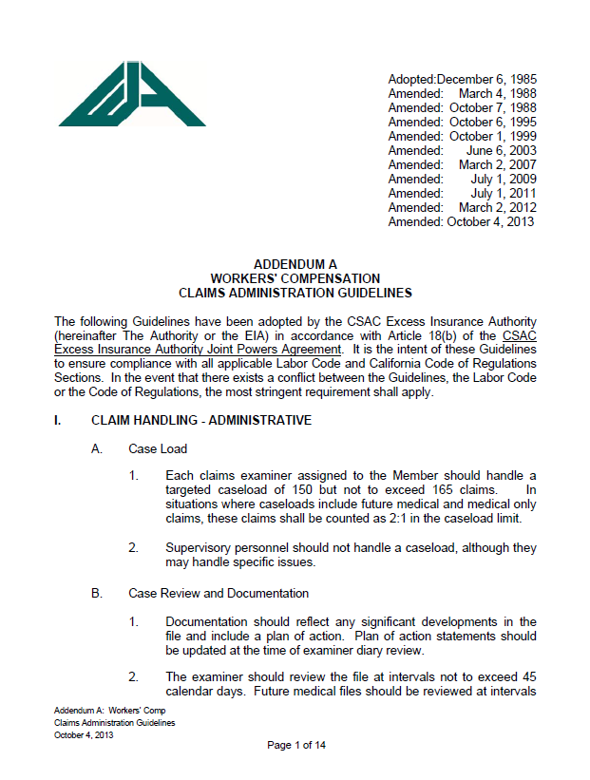
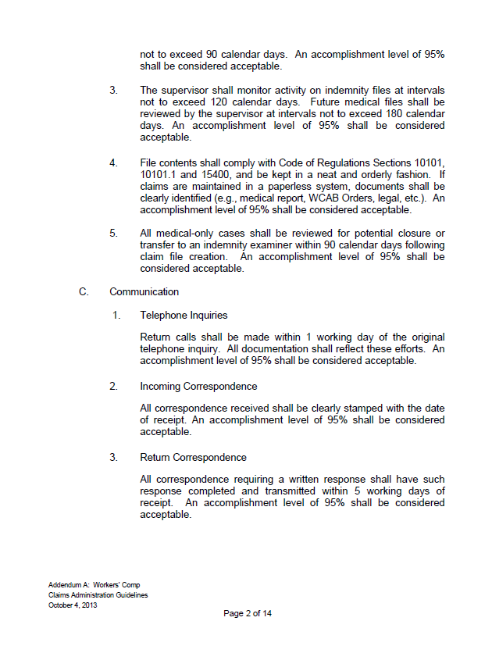

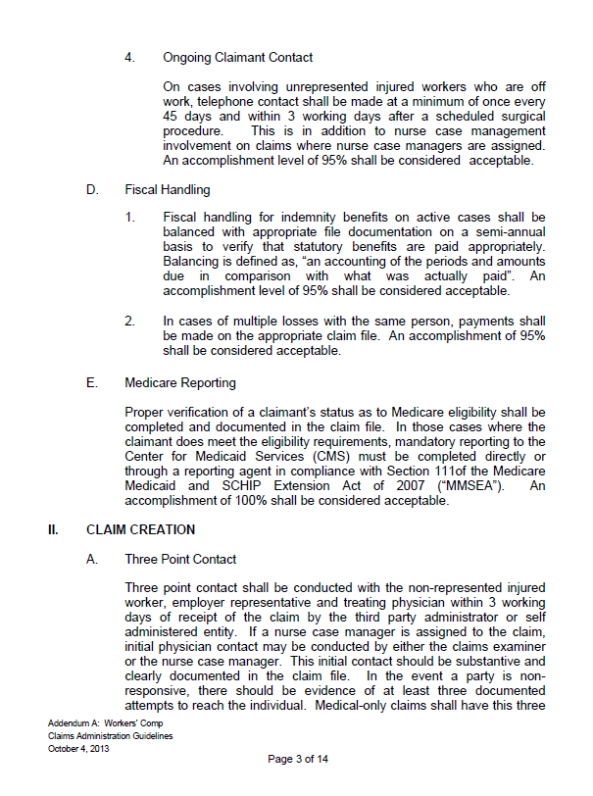

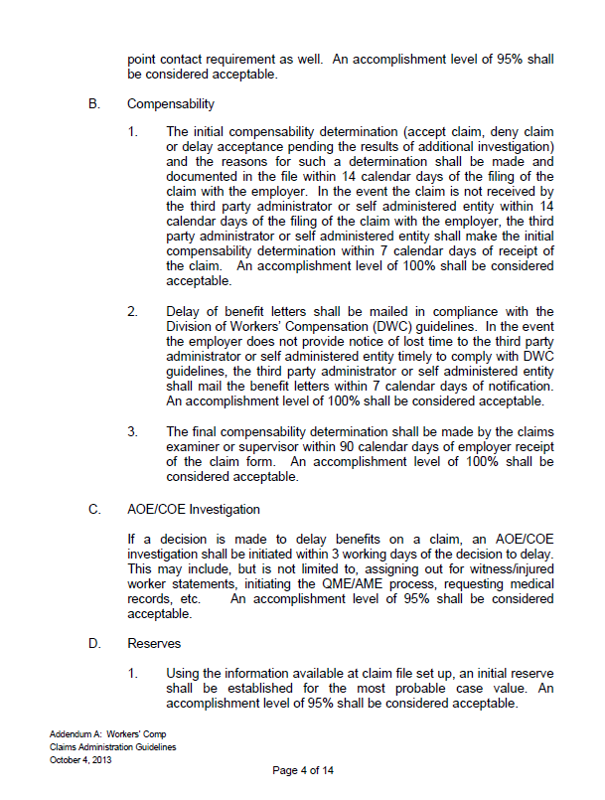

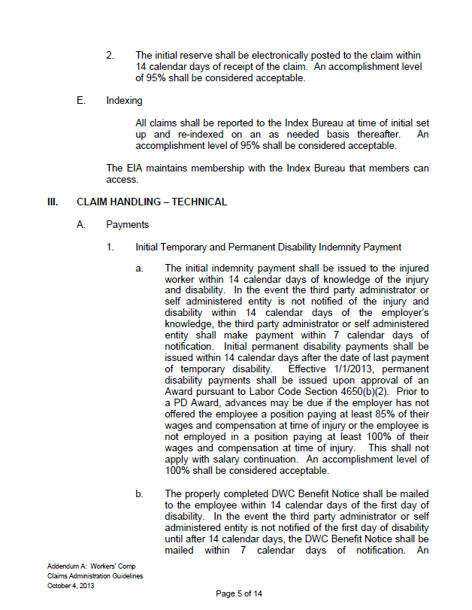

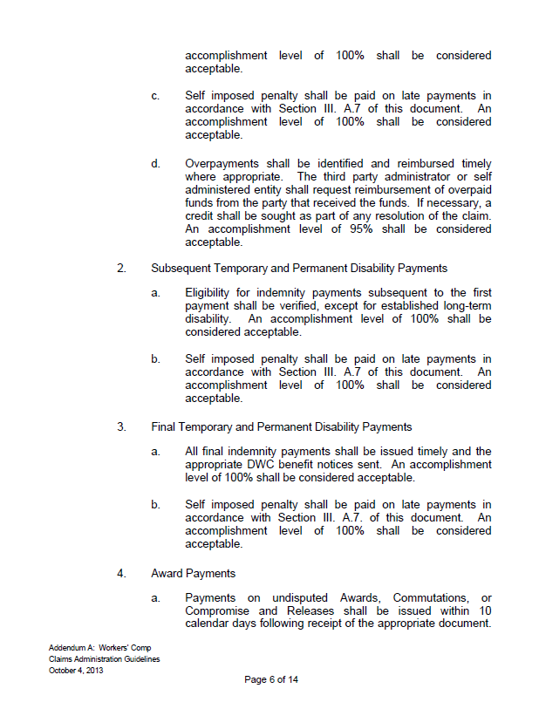

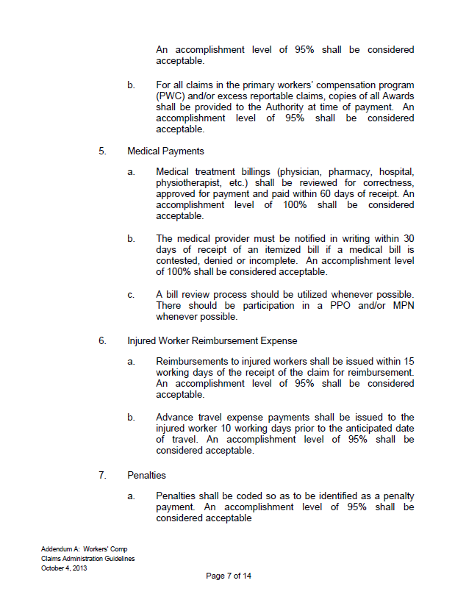
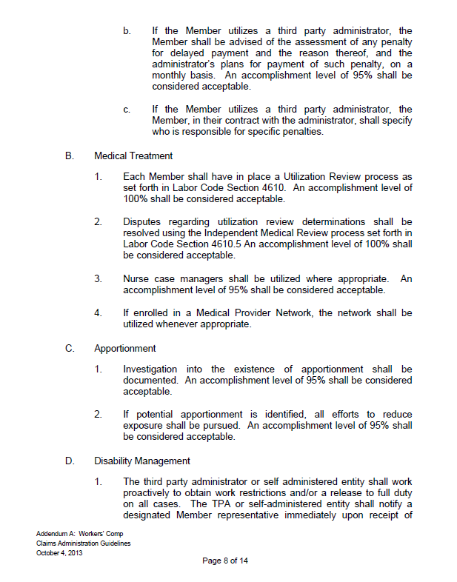

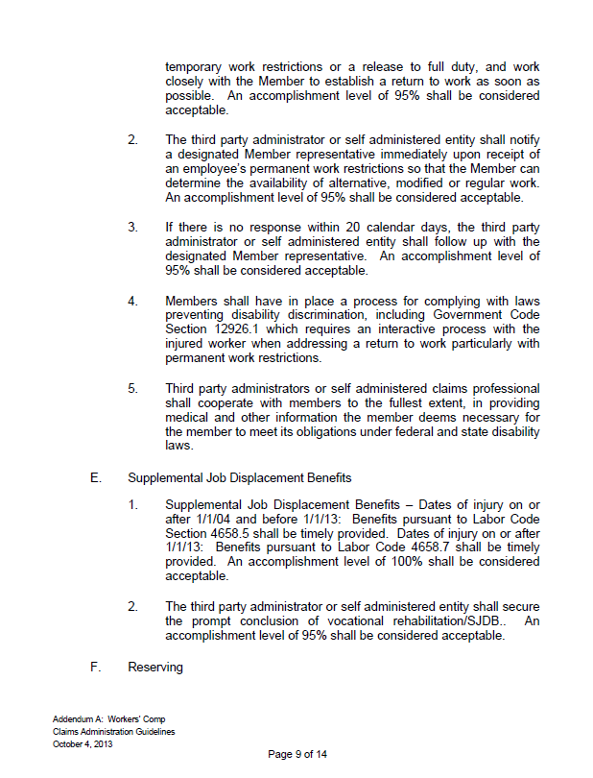

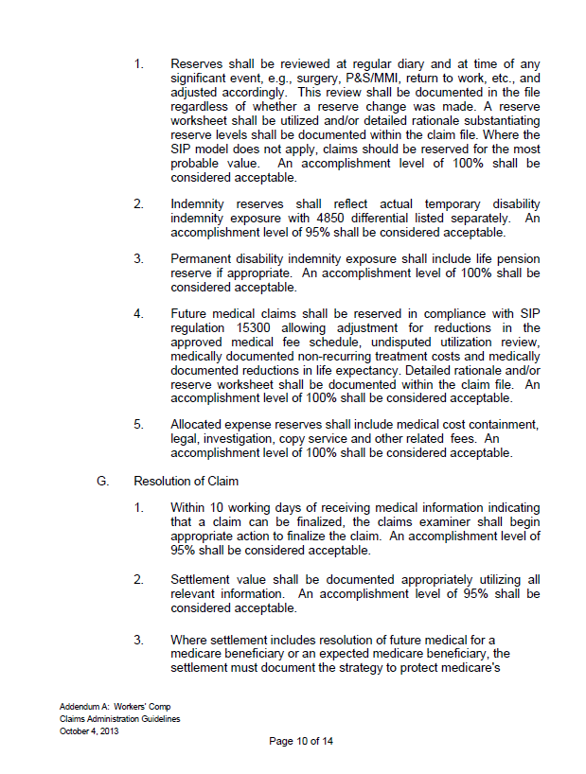
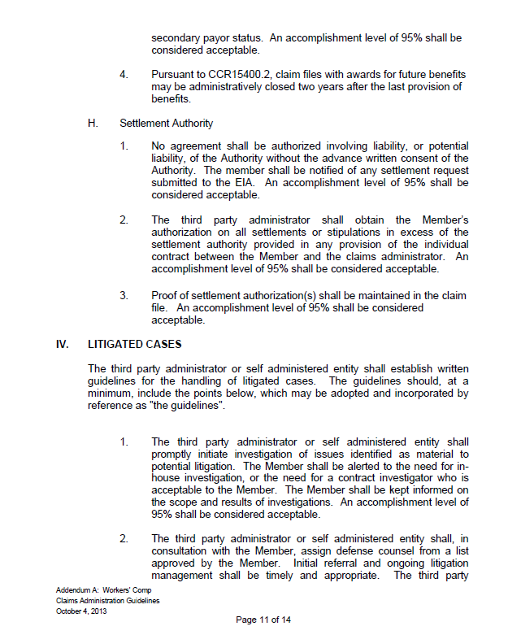
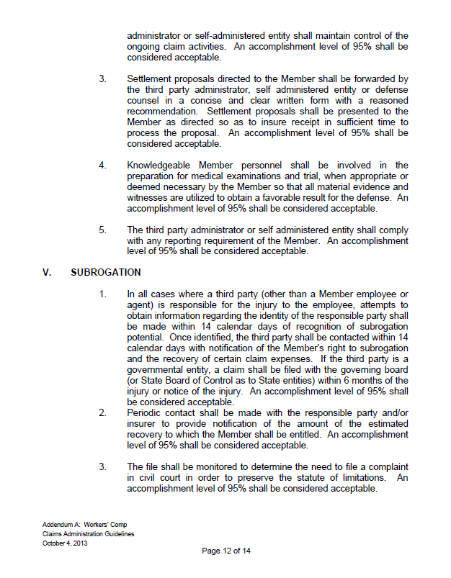
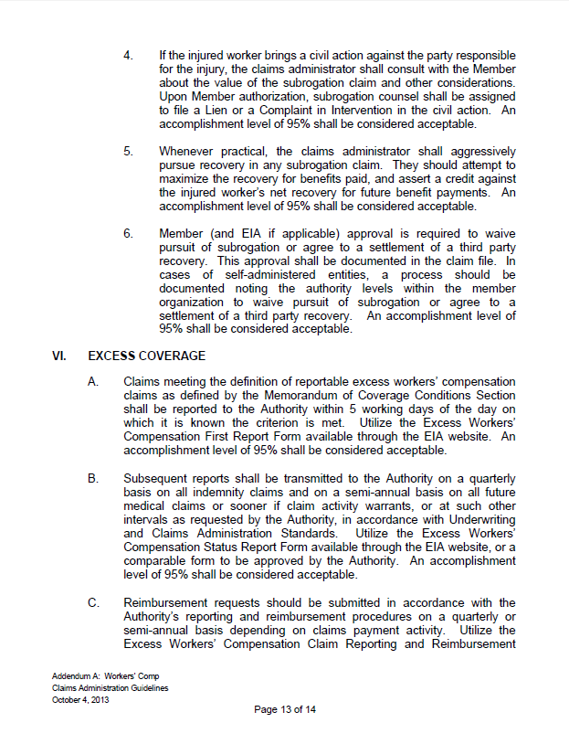

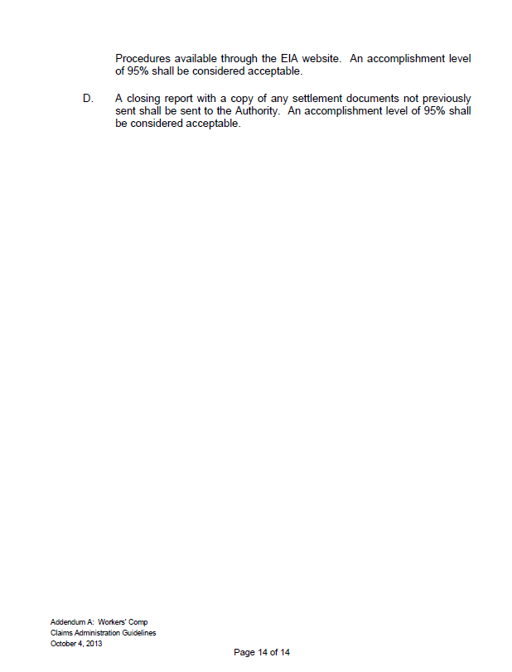

EXHIBIT f
CSAC-EIA EXCESS WORKERS’ COMPENSATION CLAIM REPORTING AND REIMBURSEMENT PROCEDURES

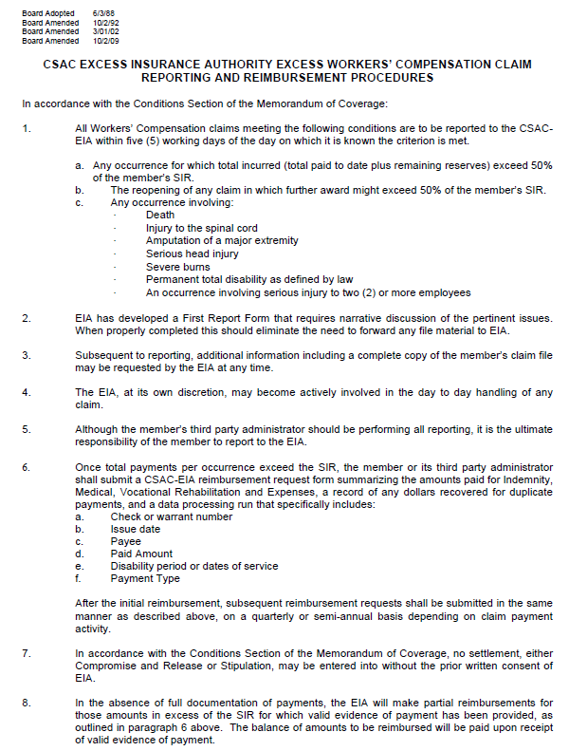

EXHIBIT g
COUNTY’S SELF INSURED RETENTION (SIR)



