**IMPORTANT NOTICE**
ONLINE BIDDING PROCESS

- Bid pricing must be submitted online through Alameda County EZSourcing Supplier Portal.
- The following pages require signatures and must be scanned and uploaded to Alameda County EZSourcing Supplier Portal:
- Exhibit A – Bid Response Packet, Bidder Information and Acceptance page
  - Must be signed by Bidder
- Exhibit A – Bid Response Packet, SLEB Information Sheet
  - Must be signed by Bidder
  - Must be signed by SLEB Partner if subcontracting to a SLEB

Please read EXHIBIT A – Bid Response Packet carefully, INCOMPLETE BIDS MAY BE REJECTED. Alameda County will not accept submissions or documentation after the bid response due date. Successful uploading of a document does not equal acceptance of the document by Alameda County.

COUNTY OF ALAMEDA

REQUEST FOR PROPOSAL No. 901997

for

Shuttle Bus Services

For complete information regarding this project, see RFP posted at http://www.acgov.org/gsa_app/gsa/purchasing/bid_content/contractopportunities.jsp or contact the County representative listed below. Thank you for your interest!

Contact Person: Bee Srey, Procurement & Contracts Specialist

Phone Number: (510) 208-9583

E-mail Address: bee.srey2@acgov.org

RESPONSE DUE
by
2:00 p.m.
on
May 11, 2021
through
Alameda County, GSA-Procurement
EZSourcing Supplier Portal
https://ezsourcing.acgov.org/


Alameda County is committed to reducing environmental impacts across our entire supply chain.
If printing this document, please print only what you need, print double-sided, and use recycled-content paper.

CALENDAR OF EVENTS
REQUEST FOR PROPOSAL No. 901997
SHUTTLE BUS SERVICES
EVENT | DATE/LOCATION
Request Issued | March 31, 2021
Networking/Bidders Conference  **ONLINE ONLY** | April 8, 2021 @ 10 a.m. (PST)  Microsoft Teams meeting  Join on your computer or mobile app  Click here to join the meeting  Or call in (audio only)  +1 415-915-3950,,485442756# United States, San Francisco  Phone Conference ID: 485 442 756#
Written Questions Due via Email:  bee.srey2@acgov.org | April 9, 2021 by 5:00 p.m. (PST)
List of Attendees | April 12, 2021
Q&A Issued | April 27, 2021
Addendum Issued [only if necessary to amend RFP] | April 27, 2021
Response Due and Submitted through EZSourcing Supplier Portal | May 11, 2021 by 2:00 p.m. (PST)
Evaluation Period | May 11 – June 6, 2021
Vendor Interviews | Week of May 24, 2021
Notice of Intent to Award Issued | June 7, 2021
Board Consideration Award Date | July 13, 2021
Contract Start Date | August 1, 2021
NOTE: All dates are tentative and subject to change.

Alameda County Vendor Outreach
Wednesday, April 7, 2021  10:30 a.m. – 11:30 a.m.  Join Microsoft Teams Meeting  **ONLINE ONLY** | COME MEET ALAMEDA COUNTY’S  PROCUREMENT TEAM!  This is a public event where vendors can speak with GSA professionals, get to know them, and learn more about contracting opportunities with the County.
COUNTY OF ALAMEDA
REQUEST FOR PROPOSAL No. 901997
SPECIFICATIONS, TERMS & CONDITIONS
for
SHUTTLE BUS SERVICES

TABLE OF CONTENTS
Page

CALENDAR OF EVENTS 1
I. STATEMENT OF WORK 5
A. INTENT 5
B. SCOPE 5
C. BACKGROUND 5
D. BIDDER QUALIFICATIONS 6
E. SPECIFIC REQUIREMENTS 6
F. DELIVERABLES / REPORTS 12
G. NETWORKING / BIDDERS CONFERENCES 14
II. COUNTY PROCEDURES, TERMS, AND CONDITIONS 15
H. EVALUATION CRITERIA / SELECTION COMMITTEE 15
I. CONTRACT EVALUATION AND ASSESSMENT 19
J. NOTICE OF INTENT TO AWARD 20
K. Bid Protest/Appeals Process 20
L. TERM / TERMINATION / RENEWAL 23
M. BRAND NAMES AND APPROVED EQUIVALENTS 23
N. QUANTITIES 23
O. PRICING 24
P. AWARD 25
Q. METHOD OF ORDERING 26
R. INVOICING 27
S. ACCOUNT MANAGER / SUPPORT STAFF 27
III. INSTRUCTIONS TO BIDDERS 28
T. COUNTY CONTACTS 28
U. SUBMITTAL OF BIDS 29
V. RESPONSE FORMAT 30

ATTACHMENTS

EXHIBIT A
EXHIBIT B SHUTTLE MAP & SCHEDULE
EXHIBIT C DL2 NP BIKE RACK SPECIFICATIONS
EXHIBIT D SAMPLE COUNTY INCIDENT REPORT FORM
EXHIBIT E VENDOR BID LIST

STATEMENT OF WORK

INTENT
It is the intent of these specifications, terms and conditions to describe the Shuttle Bus Services required by Alameda County.
The County intends to award a three-year contract (with option to renew for one two-year term) to the Bidder selected as the most responsible Bidder whose response conforms to the RFP and meets the County’s requirements.

SCOPE
The Alameda County General Services Agency (GSA) is seeking a qualified Contractor to provide shuttle bus services consisting of all aspects of shuttle operation including, but not limited to, bus provision, drivers, tracking system, and reporting. The shuttle bus services are promoted to County employees and local businesses through the Alameda County Clean Commute Program, providing “last-mile” shuttle services between local transit hubs (including BART stations) and certain County facilities to ease commuters traveling to and from Alameda County, encourage rideshare, and reduce carbon footprint.
The current established shuttle routes, which run between the hours of 6:30 a.m. and 7:00 p.m. Monday through Friday with the exception of County-observed holidays, are:
    - Juvenile Justice Center/Fairmont Hospital (one shuttle), San Leandro
    - Downtown Oakland (one shuttle), Oakland
    - Hayward Eden Campus (one shuttle), Hayward
    - Edgewater/Eastmont Mall (one shuttle), Oakland
    - Embarcadero Cove (one shuttle), Oakland
The County reserves the rights to establish the shuttle routes and to modify existing routes in any way including, but not limited to, route alterations, route frequency, time, duration of service and/or request “services as needed”.

BACKGROUND
The County has made a commitment to reduce its transportation-related emissions through the initiatives outlined within the County’s Strategic Vision and the Climate Action Plan. In 2010, Alameda County launched its first shuttle bus service to connect County employees and the public between the Juvenile Justice Center (JJC)/Fairmont Hospital and the Bay Fair Bay Area Rapid Transit (BART) Station in San Leandro. Since then, GSA has added shuttle bus routes to the County Center (Oakland), the Hayward Eden Campus (Hayward), and Embarcadero (Oakland), and Edgewater/Eastmont Mall (Oakland).

BIDDER QUALIFICATIONS
    - BIDDER Minimum Qualifications
      - Bidder shall be regularly and continuously engaged in the business of providing shuttle bus services for at least three (3) years.
      - Bidder shall submit verification of compliance with all State of California Department of Transportation (DOT), current DOT number, and/or US Department of Transportation rules, laws, and regulations at time of this bid submittal.
        - If awarded the contract, bidder shall maintain ongoing compliance as describe in b. above and notify GSA of any changes in compliance status occurred during the term of any contract and all amendments that may result from this RFP immediately or upon request.
      - Bidder shall possess all professional permits, licenses, and credentials necessary to perform the services specified under this RFP.

SPECIFIC REQUIREMENTS
    - Contractor shall provide all aspects of the shuttle bus services and operations including but not limited to, vehicle purchase or lease (if applicable), cleaning, maintenance, staffing, permitting, compliance with Americans with Disabilities Act (ADA), fueling, and reporting.
    - Contractor shall provide shuttle bus services between the hours of 6:30 a.m. and 7:00 p.m., Monday through Friday with the exception of County-observed holidays as published on the County website annually https://www.acgov.org/government/holidays.htm
Alameda County Holidays | Date Observed
New Years Day | January 1
Martin Luther King Jr.’s Birthday | Third (3rd) Monday in January
Lincoln’s Birthday | February 12
Washington’s Birthday | Third (3rd) Monday in February
Memorial Day | Last Monday in May
Independence Day | July 4
Labor Day | First (1st) Monday in September
Veterans Day | November 11
Thanksgiving | Fourth (4th) Thursday in November
Day after Thanksgiving  Christmas | Day after Thanksgiving  December 25
    - The shuttles frequency shall be every 15 minutes during peak hours and every 30 minutes during non-peak hours.
    - Contractor shall provide shuttle bus services in accordance with the current predetermined routes as listed below:
- San Leandro: Juvenile Justice Center/Fairmont Hospital Shuttle runs to the Juvenile Justice Center and the Fairmont Hospital from the Bay Fair BART station (one shuttle),

- Oakland: Downtown Oakland Shuttle runs between the 12th Street and Lake Merritt BART stations and stops in County Center in Downtown Oakland (one shuttle),
- Hayward: Hayward Eden Campus Shuttle runs between Hayward BART station and the Winton campus (one shuttle),

- Oakland: Edgewater/Eastmont Town Center Shuttle runs between Coliseum BART and Eastmont, Edgewater, and Enterprise offices (one shuttle),

- Oakland: Embarcadero Cove Shuttle runs between the Embarcadero Cove offices and Lake Merritt BART (one shuttle).

    - Contractor shall accommodate temporary routes and schedule changes on “as needed” basis when requested by County. County will use its best efforts to provide a forty-eight (48) hours advance notice for as needed services when possible.
    - Contractor understands that full advance notice may not always be possible and shall use its best efforts to accommodate any requests to add/use alternate routing locations and/or reduce/extend the hours of operation.
    - Contractor shall provide shuttle bus services for Special Events service requests, based on staffing and shuttle bus availability, for a minimum of three hours, and may include weekends, holidays, and evenings.
    - The County shall pay for the operational hours of each of the shuttle bus while in service only.
    - The County shall not pay for daily vehicle inspections, vehicle fueling, and Contractor employee training, and/or missed shuttle service.
    - Contractor shall fully staff and deploy only qualified drivers to perform the shuttle bus services in an organized, professional, and efficient manner.
    - All drivers providing the shuttle services through the Contractor, MUST meet all state and federal licensing requirements in addition to the following requirements:
      - shall be at least 21 years of age;
      - shall possess a valid State of California Commercial Driver’s license (CDL) Class B driver’s license with Passenger (P) endorsements;
      - shall have no more than one moving violation or accident within the past three years and no convictions for driving under the influence (DUI); and
      - must pass and maintain a criminal background check.
    - Selected Contractor shall provide the names of the proposed staff/drivers, their qualifications, background verification, and current licenses to GSA Logistics Services Manager within five (5) calendar days of receiving the Notice of Board Award Date from the County Contacts listed in III.X. above.
    - All drivers must be approved by GSA Logistics Services Manager or designee prior to work assignment.
    - By providing background check on all drivers assigned to County facilities, Contractor testifies that a thorough criminal background check has been conducted to ensure that driver has and maintains a satisfactory background.
    - Contractor shall supply drivers with clean and free-from-defect uniforms clearly exhibiting the company decals and driver name to be worn at all times while on duty.
    - Drivers shall always be respectful of others and not engage in profanity, unsafe, or illegal behavior.
    - Contractor shall ensure proper conduct of all drivers including quality customer service as deemed appropriate by the County.
    - Drivers shall adhere to the County’s Drug-free workplace policy which states “Neither Contractor nor Contractor's employees shall unlawfully manufacture, distribute, dispense, possess or use controlled substances, as defined in 21 U.S. Code § 812, including, but not limited to, marijuana, heroin, cocaine, and amphetamines, at any County facility or work site.”
      - Drivers shall refrain from using personal cell phones or other devices to take photos or recordings while parked at County facilities. Recordings of any kind (photo, audio, or video recordings) and the posting of any recorded material on social media is strictly prohibited.
      - The County reserves the right to remove, for any reason, Contractor employee whom the County deems unacceptable.
    - Bus requirements: Contractor shall provide buses that are model year 2012 or newer with a minimum carrying capacity of 20 passengers and two bicycles.
      - All vehicles used to transport passengers shall be in good mechanical and operating condition. At no time shall passengers be transported in unsafe equipment.
      - Any shuttle bus that is deemed to be unsafe for the transport of passengers or failed to meet standards of maintenance, repairs, cleanliness, overall appearance by the County, shall be removed from service immediately upon request by County.
      - All shuttle bus shall be washed inside and out at least twice per month.
      - All shuttle bus which have a diesel engine must be equipped with a Diesel Particulate Filter (DPF).
      - All shuttle buses must be in compliance with Federal and State laws for operation, including all applicable safety, emissions, and ADA regulations.
      - All shuttle buses shall be equipped with a bicycle rack that meets the Occupational Safety and Health Administration (OSHA) and National Institute for Occupational Safety and Health (NIOSH).
        - Bicycle racks shall be mounted on the exterior of the shuttle bus with a minimum capacity of two units and accommodates tire sizes from 20” to 29” and up to 44” wheel base such as the “DL2 NP©” by Sportworks©.
        - Bicycle racks shall be foldable, easy to use, and have support/locking mechanism to ensure no damage to bicycles while in transport.
      - All shuttle buses shall have operating heating and air cooling systems.
      - All shuttle buses shall be equipped with a reliable direct communication system for communication with its drivers while on the road.
      - The communication device shall be reliable and allow drivers to respond even if standing outside of the vehicle.
      - All shuttle buses shall be equipped with NextBus© tracking method or equivalent as approved by County, to allow the County staff to track, at minimum, exact location and speed of shuttle.
      - Contractor shall acquire and maintain an active membership with NextBus©, or equivalent, shuttle tracking system to allow passengers and County staff the ability to track the exact location of all shuttle buses on a route and back-up shuttles.
        - Contractor shall provide County staff with administrative access to the system and any Application Program Interface (API) data associated with shuttles on County routes which includes real-time and historical data from the on-board GPS system.
        - Contractor shall train designated County staff on the system functionalities and reporting at the onset of the contract.
      - Contractor shall provide an established method on each shuttle for tracking the number of passengers per stop on a daily basis in addition to the NextBus© system. This information shall be turned in to GSA as part of the monthly report.
      - Contractor shall provide details of on-board security features that will be equipped with their proposed buses such as cameras, object sensors, etc. to ensure mechanisms are in place to increase rider safety.
      - All shuttle buses shall be exteriorly decorated with County’s decals for shuttle identification purposes at the County’s expense. Removal of these decals shall be at the selected bidder’s expense.
      - The County, as its sole discretion, reserves the right to make modifications or additions to the shuttle buses that service County routes, including, but not limited to outreach materials such as posters, brochures, pamphlets, etc. to hardware upgrades such as on-board badge readers or cameras. Such modifications shall be at the cost of the County and shall remain the property of the County upon contract succession.
      - Contractor shall secure an adequate number of reserved shuttle buses of similar size with comparable equipment stored in close proximity to County service routes to be deployed within one hour in the event of an existing shuttle bus goes out of service.
      - Replacement shuttle buses must have appropriate, temporary signage, and be equipped with the NextBus© or equivalent system.
    - Parking of shuttle buses overnight on County property will be permitted to selected Contractor, where parking is available, but the County will not be liable for any loss, damage, and/or theft to bidder’s property.
    - Shuttle drivers may pay to park at County public parking facilities while on duty.
    - Selected Contractor shall designate a Field Supervisor(s) to act as a supervisor and the liaison between GSA and the Contractor’s key personnel overseeing the County’s account and to be responsible for the following:
      - being immediately available on an on-call basis via pager or cell phone number to the shuttle bus drivers and designated GSA personnel;
      - notify to the designated GSA personnel when any of the shuttle buses are more than 10 minutes off their scheduled stop times and/or any service interruptions;
      - respond in a timely manner, within two hours or less, to requests from County management staff for follow-up with appropriate action and/or recommendations on any incidents or complaints involving drivers;
      - keep County management staff appraised of security issues, which affect the safety of the staff, employees, and visitors, and make appropriate recommendations for improvement;
      - promptly report any unusual event or emergency occurring on the shuttle bus route to GSA and Contractor’s key personnel;
      - provide replacement drivers to fill in for regular drivers’ sick and vacation leave with proper qualification screening by submitting written verification of the proposed replacement drivers’ experience, current driver’s licenses, and proof driver has passed background check to GSA Logistics Services Manager and obtaining an approval to do so;
      - investigate all complaints received about the shuttle bus driver(s), report findings, and inform County staff of remedial action(s) taken within 72 hours of occurrence;
      - ensure that incident reports and other written documentation requested are forwarded to the appropriate County staff member in the time specified; and
      - ensure all drivers sign, understand, and maintain compliance with the Alameda County Administrative Code Chapter 3.32 Use of County-Owned Vehicles, Section 3.32.040 Driver responsibilities, Item P. Anti-idling policy. (Ord. No. 2011-20, § 1, 5-10-11) which is consistent with diesel engine idling law (Title 13 of the California Code of Regulations).

DELIVERABLES / REPORTS
    - Selected Contractor shall submit the following reports throughout the term of any contract and amendments resulting from this RFP:
      - Activity Reports: shall be submitted on a monthly basis by the 15th calender date containing the following details:
- Number of passengers per stop;
- Total passengers by stop, totaled by each route; and
        - Total mileage driven per route.
      - Maintenance logs: shall be submitted on a monthly basis by the 15th calendar date showing all shuttle buses are in compliance with maintenance regulations containing the following details:
        - Service summary; and
        - Details of any incidents.
      - Incident Report: shall be submitted whenever an incident occurs during the shuttle operating hours.
        - The shuttle bus driver shall notify the Field Supervisor immediately and complete the County’s Incident Report form (Sample Report attached as Exhibit - D) in addition to the Contractor’s Incident report and activity log.
        - The Field Supervisor shall notify the designated GSA personnel immediately of the incident and forward the incident report within 24 hours of the incident.
    - Selected Contractor shall fulfill the following deliverables:
      - Guaranteed Performance:
        - maintain compliance with all State of California Department of Transportation and US Department of Transportation rules, laws, and regulations, ongoing compliance shall be adhered to;
        - notify GSA of any changes in compliance immediately or upon request;
        - maintain compliance with California Air Resources Board (CARB) emissions regulations and shall provide validation of such compliance upon request to GSA of any changes in compliance immediately or upon request; and
        - grant the County the right to inspect Contractor’s place of business prior to award or at any time during the contract term or any extension thereof, to aid GSA Logistics Services Manager in determining Contractor’s capabilities and qualifications.
      - Account Management/Support:
        - deliver customer service with familiarity to the County requirements and standards;
        - work with the GSA-Parking Division to ensure that established standards are adhered to;
        - provide a dedicated and competent Account Manager who shall be responsible for the County account/contract, including but not limited to, receiving County orders and being the main point of contact for all issues relating to any contract or amendment that may arise pursuant to this RFP;
        - provide adequate and competent support staff that shall be able to service the County during normal working hours, Monday through Friday. Such representative(s) shall be knowledgeable about the contract, services offered and able to identify and resolve quickly any issues including but not limited to service, drivers, and invoicing problems.
        - ensure that every driver operating the shuttle is trained on tracking activities performed for accuracy in reporting.
    - Contractor shall provide County with administrative access to its NextBus© system or equivalent and any Application Program Interface (API) data associated with shuttles on County routes which includes real-time and historical data from the on-board GPS system.
    - Contractor shall modify its tracking account to adhere to County reporting standards if requested by County.
    - Contractor shall be assessed a 1.5% late fee, per day of monthly invoice charges, if reports, logs and receivables are not remitted to the County in conformity with the requirements of this RFP.

NETWORKING / BIDDERS CONFERENCES
    - The Bidders conference held on Thursday, April 8th, 2021 will have an online conference option enabled for remote participation. Bidders can opt to participate via a computer with a stable internet connection (the recommended Bandwidth is 512Kbps) at
Microsoft Teams meeting Or call in (audio only) +1 415-915-3950, 485442756# United States, San Francisco, Phone Conference ID: 485 442 756#
In order to get the best experience, the County recommends that Bidders who participate remotely use equipment with audio output such as speakers, headsets, or a telephone.
    - Networking/Bidders conferences will be held to:
      - Provide an opportunity for Small Local Emerging Businesses (SLEBs) and large firms to network and develop subcontracting relationships in order to participate in the contract(s) that may result from this RFP.
      - Provide an opportunity for Bidders to ask specific questions about the project and request RFP clarification.
      - Provide the County with an opportunity to receive feedback regarding the project and RFP.
    - The list of Bidder conference attendees will be released in a separate document.
    - Only written questions submitted via email and by the stated deadline will be addressed in an RFP Question and Answer (Q&A) following the networking/Bidders conference(s). Should there be a need to amend or revise the RFP, an addendum will be issued following the Networking/Bidders Conferences. The Q&A and Addendum are the final stance of the County.
    - All questions regarding these specifications, terms and conditions are to be submitted in writing via e-mail by 5:00 p.m. on April 9, 2021 to:
Bee Srey, Procurement & Contracts Specialist
Alameda County, GSA-Procurement
1401 Lakeside Drive, Suite 907
Oakland, CA 94612
E-Mail: bee.srey2@acgov.org
Phone: (510) 208-9583
    - Potential Bidders are strongly encouraged to attend networking/bidders conference(s) in order to further facilitate subcontracting relationships. Vendors who attend a networking/bidders conference will be added to the Vendor Bid List. Failure to participate in a networking/bidders conference will in no way relieve the Contractor from furnishing goods and/or services required in accordance with these specifications, terms and conditions. Attendance at a networking/bidders conference is highly recommended but is not mandatory.

COUNTY PROCEDURES, TERMS, AND CONDITIONS

EVALUATION CRITERIA / SELECTION COMMITTEE
All proposals that pass the initial Evaluation Criteria which are determined on a pass/fail basis will be evaluated by a County Selection Committee (CSC). The County Selection Committee may be composed of County staff and other parties that may have expertise or experience in shuttle bus services. The CSC will score and recommend a Contractor in accordance with the evaluation criteria set forth in this RFP. Other than the initial pass/fail Evaluation Criteria, the evaluation of the proposals shall be within the sole judgment and discretion of the CSC.
All contact during the evaluation phase shall be through the GSA-Procurement department only. Bidder shall neither contact nor lobby evaluators during the evaluation process. Attempts by Bidder to contact and/or influence members of the CSC may result in disqualification of Bidder.
The CSC will evaluate each proposal meeting the qualification requirements set forth in this RFP. Bidder should bear in mind that any proposal that is unrealistic in terms of the technical or schedule commitments, or unrealistically high or low in cost, will be deemed reflective of an inherent lack of technical competence or indicative of a failure to comprehend the complexity and risk of the County’s requirements as set forth in this RFP.
Bidder(s) are advised that in the evaluation of cost it will be assumed that the unit price quoted is correct in the case of a discrepancy between the unit price and an extension.
As a result of this RFP, the County intends to award a contract to the responsible Bidder whose response conforms to the RFP and whose bid presents the greatest value to the County, all evaluation criteria considered. The combined weight of the evaluation criteria is greater in importance than cost in determining the greatest value to the County. The goal is to award a contract to the Bidder that proposes the County the best quality as determined by the combined weight of the evaluation criteria. The County may award a contract of higher qualitative competence over the lowest priced response.
The basic information that each section should contain is specified below, these specifications should be considered as minimum requirements. Much of the material needed to present a comprehensive proposal can be placed into one of the sections listed. However, other criteria may be added to further support the evaluation process whenever such additional criteria are deemed appropriate in considering the nature of the services being solicited.
Each of the Evaluation Criteria below will be used in ranking and determining the quality of Bidders’ proposals. Proposals will be evaluated according to each Evaluation Criteria, and scored on the zero to five-point scale outlined below. The scores for all Evaluation Criteria will then be added, according to their assigned weight (below), to arrive at a weighted score for each proposal. A proposal with a high weighted total will be deemed of higher quality than a proposal with a lesser-weighted total. The final maximum score for any project is 550 points, including the possible 50 points for local and small, local and emerging, or local preference points (maximum 10% of final score).
The evaluation process may include a two-stage approach including an initial evaluation of the written proposal and preliminary scoring to develop a short list of Bidders that will continue to the final stage of oral interview and reference checks. The preliminary scoring will be based on the total points, excluding points allocated to references and oral interview.
If the two-stage approach is used, the three (3) Bidders receiving the highest preliminary scores and with at least 200 points will be invited to an oral interview. Only the Bidders meeting the short list criteria will proceed to the next stage. All other Bidders will be deemed eliminated from the process. All Bidders will be notified of the short list participants; however, the preliminary scores at that time will not be communicated to Bidders.
The zero to five-point scale range is defined as follows:
0 | Not Acceptable | Non-responsive, fails to meet RFP specification. The approach has no probability of success. If the unmet specification is a mandatory requirement, this score may result in disqualification of proposal.
1 | Poor | Below average, falls short of expectations, is substandard to that which is the average or expected norm, has a low probability of success in achieving objectives per RFP.
2 | Fair | Has a reasonable probability of success, however, some objectives may not be met.
3 | Average | Acceptable, achieves all objectives in a reasonable fashion per RFP specification. This will be the baseline score for each item with adjustments based on interpretation of proposal by Evaluation Committee members.
4 | Above Average / Good | Very good probability of success, better than that which is average or expected as the norm. Achieves all objectives per RFP requirements and expectations.
5 | Excellent / Exceptional | Exceeds expectations, very innovative, clearly superior to that which is average or expected as the norm. Excellent probability of success and in achieving all objectives and meeting RFP specification.

The Evaluation Criteria and their respective weights are as follows:
 | Evaluation Criteria | Weight
 | Completeness of Response:  Responses to this RFP must be complete. Responses that do not include the proposal content requirements identified within this RFP and subsequent Addenda and do not address each of the items listed below will be considered incomplete, be rated a Fail in the Evaluation Criteria and will receive no further consideration. | Pass/Fail
 | Debarment and Suspension:  Bidders, its principal and named subcontractors are not identified on the list of Federally debarred, suspended or other excluded parties located at www.sam.gov/SAM/. | Pass/Fail
 | Cost:  The points for Cost will be computed by dividing the amount of the lowest responsive bid received by each Bidder’s total proposed cost.  While not reflected in the Cost evaluation points, an evaluation may also be made of:  - Reasonableness (i.e., does the proposed pricing accurately reflect the Bidder’s effort to meet requirements and objectives?);  - Realism (i.e., is the proposed cost appropriate to the nature of the products and/or services to be provided?); and  - Affordability (i.e., the ability of the County to finance shuttle bus services).  Consideration of price in terms of overall affordability may be controlling in circumstances where two or more proposals are otherwise adjudged to be equal, or when a superior proposal is at a price that the County cannot afford. | 20 Points
 | Understanding of the Project:  Proposals will be evaluated against the RFP specifications and the questions below:  - Has proposer demonstrated a thorough understanding of the purpose and scope of the project?  - How well has the proposer identified their shuttle bus equipment, ADA compliance, maintenance standards, and plan to maintain the standards of the County?  - How well has proposer demonstrated their ability to deploy qualified drivers on contract start date?  - How well has the proposer identified pertinent issues and potential problems related to the project?  - Has well has proposer detailed how they will adhere to the designated County routes and pickup schedules?  - Has the proposer demonstrated that it understands the deliverables the County expects it to provide?  - Does bidder offer security features on its buses such as continuous digital recording cameras? | 15 Points
 | Relevant Experience:  Proposals will be evaluated against the RFP specifications and the questions below:  - Do the individuals assigned to the project have experience on similar projects?  - How extensive is the applicable education and experience of the personnel designated to work on the project?  - How well has proposer demonstrated the ability and have fully functional shuttle buses to perform the services requested within this RFP?  - How well does bidder explain the usage, tracking and reporting capabilities of its NextBus© or Equivalent account? | 20 Points
 | Implementation Plan:  An evaluation will be made of the likelihood that Bidder’s implementation plan will meet the County’s schedule. Contractor shall submit a business plan that identifies staffing levels, ability to obtain permitting, maintenance procedures, operation logs, driver training material and schedule, insurance levels, and a system in place to provide logs and other reporting required by the RFP.  - Does the bidder’s implementation plan exhibit an understanding of the County’s time schedule and can meet it? | 15 Points
 | References (See Exhibit A – Bid Response Packet) | 15 Points
 | Oral Interview:  The oral interview on the proposal shall not exceed 60 minutes. The oral interview may include responding to standard and specific questions from the CSC regarding the Bidder’s proposal. The scoring may be revised based on the oral interview. | 15 Points
SMALL LOCAL EMERGING BUSINESS PREFERENCE
 | Local Preference: Points equaling five percent of the Bidder’s total score, for the above Evaluation Criteria, will be added. This will be the Bidder’s final score for purposes of award evaluation. | 5%
 | Small and Local or Emerging and Local Preference: Points equaling five percent of the Bidder’s total score, for the above Evaluation Criteria, will be added. This will be the Bidder’s final score for purposes of award evaluation. | 5%

CONTRACT EVALUATION AND ASSESSMENT
During the initial 60 day period of any contract which may be awarded to the Contractor, the County may review the proposal, the contract, any goods or services provided, and/or meet with the Contractor to identify any issues or potential problems.
The County reserves the right to determine, at its sole discretion, whether:
    - The contractor has complied with all terms of this RFP; and
    - Any problems or potential problems with the proposed goods and services were evidenced which make it unlikely (even with possible modifications) that such goods and services have met or will meet the County requirements.
If, as a result of such determination, the County concludes that it is not satisfied with Contractor, Contractor’s performance under any awarded contract and/or Contractor’s goods and services as contracted for therein, the Contractor will be notified that the contract is being terminated. The contractor shall be responsible for returning County facilities to their original state at no charge to the County. The County will have the right to invite the next highest ranked Bidder to enter into a contract. The County also reserves the right to re-bid this project if it is determined to be in its best interest to do so.

NOTICE OF INTENT TO AWARD
    - At the conclusion of the RFP response evaluation process (“Evaluation Process”), all Bidders will be notified in writing by e-mail, fax, or US Postal Service mail, of the contract award recommendation, if any, by GSA-Procurement. The document providing this notification is the Notice of Intent to Award.
The Notice of Intent to Award will provide the following information:
      - The name of the Bidder being recommended for contract award; and
      - The names of all other parties that submitted proposals.
    - At the conclusion of the RFP response evaluation process and negotiations, debriefings for unsuccessful Bidders will be scheduled and provided upon written request and will be restricted to discussion of the unsuccessful offeror’s bid. Under no circumstances will any discussion be conducted with regard to contract negotiations with the successful Bidder.
    - The submitted proposals shall be made available upon request no later than five calendar days before approval of the award and contract is scheduled to be heard by the Board of Supervisors.

Bid Protest/Appeals Process
GSA-Procurement prides itself on the establishment of fair and competitive contracting procedures and the commitment made to follow those procedures. The following is provided in the event that Bidders wish to protest the bid process or appeal the recommendation to award a contract for this project once the Notices of Intent to Award/Non-Award have been issued. Bid protests submitted prior to issuance of the Notices of Intent to Award/Non-Award will not be accepted by the County.

    - Any bid protest by any Bidder regarding any other Bid must be submitted in writing to the County’s GSA–Office of Acquisition Policy, ATTN: Contract Compliance Officer, located at 1401 Lakeside Drive, 10th Floor, Oakland, CA 94612, Fax: (510) 208-9720, before 5:00 p.m. of the FIFTH (5th) business day following the date of issuance of the Notice of Intent to Award, not the date received by the Bidder. A Bid protest received after 5:00 p.m. is considered received as of the next business day.
      - The bid protest must contain a complete statement of the reasons and facts for the protest.
      - The protest must refer to the specific portions of all documents that form the basis for the protest.
      - The protest must include the name, address, email address, fax number and telephone number of the person representing the protesting party.
      - The County Agency/Department will notify all Bidders of the protest as soon as possible.
    - Upon receipt of the written protest, GSA–Office of Acquisition Policy, or designee, will review and evaluate the protest and issue a written decision. The GSA–Office of Acquisition Policy, may, at its discretion, investigate the protest, obtain additional information, provide an opportunity to settle the protest by mutual agreement, and/or schedule a meeting(s) with the protesting Bidder and others (as appropriate) to discuss the protest. The decision on the bid protest will be issued at least ten (10) business days prior to the Board hearing or GSA award date.
The decision will be communicated by e-mail, fax, or US Postal Service mail, and will inform the Bidder whether or not the recommendation to the Board of Supervisors or GSA in the Notice of Intent to Award is going to change. A copy of the decision will be furnished to all Bidders affected by the decision. As used in this paragraph, a Bidder is affected by the decision on a Bid protest if a decision on the protest could have resulted in the Bidder not being the apparent successful Bidder on the Bid.
    - The decision of the GSA-Office of Acquisition Policy on the bid protest may be appealed to the Auditor-Controller's Office of Contract Compliance & Reporting (OCCR) located at 1221 Oak St., Room 249, Oakland, CA 94612, Fax: (510) 272-6502 unless the OCCR determines that it has a conflict of interest in which case an alternate will be identified to hear the appeal and all steps to be taken by OCCR will be performed by the alternate. The Bidder whose bid is the subject of the protest, all Bidders affected by the GSA-Office of Acquisition Policy's decision on the protest, and the protestor have the right to appeal if not satisfied with the GSA-Office of Acquisition Policy's decision. All appeals to the Auditor-Controller's OCCR shall be in writing and submitted within five (5) business days following the issuance of the decision by the GSA-Office of Acquisition Policy, not the date received by the Bidder. An appeal received after 5:00 p.m. is considered received as of the next business day. An appeal received after the FIFTH (5th) business day following the date of issuance of the decision by the GSA-Office of Acquisition Policy shall not be considered under any circumstances by the GSA or the Auditor-Controller OCCR.
      - The appeal shall specify the decision being appealed and all the facts and circumstances relied upon in support of the appeal.
      - In reviewing protest appeals, the OCCR will not re-judge the proposal(s). The appeal to the OCCR shall be limited to review of the procurement process to determine if the contracting department materially erred in following the bid or, where appropriate, County contracting policies or other laws and regulations.
      - The appeal to the OCCR also shall be limited to the grounds raised in the original protest and the decision by the GSA-Office of Acquisition Policy. As such, a Bidder is prohibited from stating new grounds for a Bid protest in its appeal. The Auditor-Controller (OCCR) shall only review the materials and conclusions reached by the GSA-Office of Acquisition Policy or department designee, and will determine whether to uphold or overturn the protest decision.
      - The Auditor’s Office may overturn the results of a bid process for ethical violations by Procurement staff, County Selection Committee members, subject matter experts, or any other County staff managing or participating in the competitive bid process, regardless of timing or the contents of a bid protest.
      - The decision of the Auditor-Controller’s OCCR is the final step of the appeal process. A copy of the decision of the Auditor-Controller’s OCCR will be furnished to the protestor, the Bidder whose Bid is the subject of the Bid protest, and all Bidders affected by the decision.
    - The County will complete the Bid protest/appeal procedures set forth in this paragraph before a recommendation to award the Contract is considered by the Board of Supervisors or GSA.
    - The procedures and time limits set forth in this paragraph are mandatory and are each Bidder's sole and exclusive remedy in the event of Bid Protest. A Bidder’s failure to timely complete both the Bid protest and appeal procedures shall be deemed a failure to exhaust administrative remedies. Failure to exhaust administrative remedies, or failure to comply otherwise with these procedures, shall constitute a waiver of any right to further pursue the Bid protest, including filing a Government Code Claim or legal proceedings.

TERM / TERMINATION / RENEWAL
    - The term of the contract, which may be awarded pursuant to this RFP, will be three (3) years.
    - By mutual agreement, any contract which may be awarded pursuant to this RFP, may be extended for an additional two-year term at agreed prices with all other terms and conditions remaining the same.

BRAND NAMES AND APPROVED EQUIVALENTS
    - Any references to manufacturers, trade names, brand names and/or catalog numbers are intended to be descriptive, but not restrictive, unless otherwise stated, and are intended to indicate the quality level desired. Bidders may offer any equivalent product that meets or exceeds the specifications. Bids based on equivalent products must:
      - Clearly describe the alternate offered and indicate how it differs from the product specified; and
      - Include complete descriptive literature and/or specifications as proof that the proposed alternate will be equal to or better than the product named in this bid as PDF attachments to your online bid submission.
    - The County reserves the right to be the sole judge of what is equal and acceptable and may require Bidder to provide additional information.
    - If Bidder does not specify otherwise, it is understood that the referenced brand will be supplied.

QUANTITIES
Quantities listed herein are estimates and are not to be construed as a commitment. No minimum or maximum is guaranteed or implied.

PRICING
    - All pricing as quoted will remain firm for the term of any contract that may be awarded as a result of this RFP.
    - Unless otherwise stated, Bidder agrees that, in the event of a price decline, the benefit of such lower price shall be extended to the County.
    - All prices are to be F.O.B. destination. Any freight/delivery charges are to be included.
    - Any price increases or decreases for subsequent contract terms may be negotiated between Contractor and County only after completion of the initial term.
    - Taxes and freight charges:
      - The County is soliciting a total price for this project. The price quoted shall be the total cost the County will pay for this project including all taxes (excluding Sales and Use taxes) and all other charges.
      - No charge for delivery, drayage, express, parcel post packing, cartage, insurance, license fees, permits, costs of bonds, or for any other purpose, except taxes legally payable by County, will be paid by the County unless expressly included and itemized in the bid.
      - Amount paid for transportation of property to the County of Alameda is exempt from Federal Transportation Tax. An exemption certificate is not required where the shipping papers show the consignee as Alameda County; as such papers may be accepted by the carrier as proof of the exempt character of the shipment.
      - Articles sold to the County of Alameda are exempt from certain Federal excise taxes. The County will furnish an exemption certificate.
    - All prices quoted shall be in United States dollars and "whole cent," no cent fractions shall be used. There are no exceptions.
    - Price quotes shall include any and all payment incentives available to the County.
    - Bidders are advised that in the evaluation of cost, if applicable, it will be assumed that the unit price quoted is correct in the case of a discrepancy between the unit price and an extension.
    - Federal and State minimum wage laws apply. The County has no requirements for living wages. The County is not imposing any additional requirements regarding wages.
    - Prevailing Wages: Pursuant to Labor Code Sections 1770 et seq., Contractor shall pay to persons performing labor in and about Work provided for in Contract not less than the general prevailing rate of per diem wages for work of a similar character in the locality in which the Work is performed, and not less than the general prevailing rate of per diem wages for legal holiday and overtime work in said locality, which per diem wages shall not be less than the stipulated rates contained in a schedule thereof which has been ascertained and determined by the Director of the State Department of Industrial Relations to be the general prevailing rate of per diem wages for each craft or type of workman or mechanic needed to execute this contract.

AWARD
    - Proposals will be evaluated by a committee and will be ranked in accordance with the RFP section titled “Evaluation Criteria/Selection Committee.”
    - The committee will recommend award to the Bidder who, in its opinion, has submitted the proposal that best serves the overall interests of the County and attains the highest overall point score. Award may not necessarily be made to the Bidder with the lowest price.
    - Small and Emerging Locally Owned Business: The County is vitally interested in promoting the growth of small and emerging local businesses by means of increasing the participation of these businesses in the County’s purchase of goods and services.
As a result of the County’s commitment to advance the economic opportunities of these businesses, Bidders must meet the County’s Small and Emerging Locally Owned Business requirements in order to be considered for the contract award. These requirements can be found online at:
http://acgov.org/auditor/sleb/overview.htm
For purposes of this bid, applicable industries include, but are not limited to, the following NAICS Code(s): 485510, 485113, 485119, or 485999.
A small business is defined by the United States Small Business Administration (SBA) as having no more than the number of employees or average annual gross receipts over the last three years required per SBA standards based on the small business's appropriate NAICS code.
An emerging business is defined by the County as having either annual gross receipts of less than one-half that of a small business OR having less than one-half the number of employees AND that has been in business less than five years.
    - The County reserves the right to reject any or all responses that materially differ from any terms contained in this RFP or from any Exhibits attached hereto, to waive informalities and minor irregularities in responses received, and to provide an opportunity for Bidders to correct minor and immaterial errors contained in their submissions. The decision as to what constitutes a minor irregularity shall be made solely at the discretion of the County.
    - Any proposal/bids that contain false or misleading information may be disqualified by the County.
    - The County reserves the right to award to a single or multiple Contractors.
    - The County has the right to decline to award this contract or any part thereof for any reason.
    - Board approval to award a contract is required.
    - A contract must be negotiated, finalized, and signed by the recommended awardee prior to Board approval.
    - Final Standard Agreement terms and conditions will be negotiated with the selected Bidder. Bidder may access a copy of the Standard Services Agreement template can be found online at:
http://www.acgov.org/gsa/purchasing/standardServicesAgreement.pdf
The template contains minimal Agreement boilerplate language only.
    - The RFP specifications, terms, conditions and Exhibits, RFP Addenda and Bidder’s proposal, may be incorporated into and made a part of any contract that may be awarded as a result of this RFP.

METHOD OF ORDERING
    - A written PO and signed Standard Agreement contract will be issued upon Board approval.
    - POs and Standard Agreements will be faxed, transmitted electronically or mailed and shall be the only authorization for the Contractor to place an order.
    - POs and payments for products and/or services will be issued only in the name of Contractor.
    - Contractor shall adapt to changes to the method of ordering procedures as required by the County during the term of the contract.
    - Change orders shall be agreed upon by Contractor and County and issued as needed in writing by County.

INVOICING
    - Contractor shall invoice the requesting department, unless otherwise advised, upon satisfactory receipt of product and/or performance of services.
    - County will use best efforts to make payment within 30 days following receipt and review of invoice and upon complete satisfactory receipt of product and performance of services.
    - County shall notify Contractor of any adjustments required to invoice.
    - Invoices shall contain County PO number, invoice number, remit to address and itemized products and/or services description and price as quoted and shall be accompanied by acceptable proof of delivery.
    - Contractor shall utilize standardized invoice upon request.
    - Invoices shall only be issued by the Contractor who is awarded a contract.
    - Payments will be issued to and invoices must be received from the same Contractor whose name is specified on the POs.
    - The County will pay Contractor monthly or as agreed upon, not to exceed the total quoted in the bid response.

ACCOUNT MANAGER / SUPPORT STAFF
    - Contractor shall provide a dedicated competent account manager who shall be responsible for the County account/contract. The account manager shall receive all orders from the County and shall be the primary contact for all issues regarding Bidder’s response to this RFP and any contract which may arise pursuant to this RFP.
    - Contractor shall also provide adequate, competent support staff that shall be able to service the County during normal working hours, Monday through Friday. Such representative(s) shall be knowledgeable about the contract, products and/or services offered and able to identify and resolve quickly any issues including but not limited to order and invoicing problems.
    - Contractor account manager shall be familiar with County requirements and standards and work with the GSA Logistics Services and Parking Division to ensure that established standards are adhered to.
    - Contractor account manager shall keep the County Specialist informed of requests from departments as required.

INSTRUCTIONS TO BIDDERS

COUNTY CONTACTS
GSA-Procurement is managing the competitive process for this project on behalf of the County. All contact during the competitive process is to be through the GSA-Procurement department only.
The evaluation phase of the competitive process shall begin upon receipt of sealed bids until a contract has been awarded. Bidders shall not contact or lobby evaluators during the evaluation process. Attempts by Bidder to contact evaluators may result in disqualification of Bidder.
Contact Information for this RFP:
Bee Srey, Procurement & Contracts Specialist
Alameda County, GSA-Procurement
1401 Lakeside Drive, Suite 907
Oakland, CA 94612
E-Mail: bee.srey2@acgov.org
Phone: (510) 208-9583

The GSA Contracting Opportunities website will be the official notification posting place of all Requests for Interest, Proposals, Quotes and Addenda. Go to http://www.acgov.org/gsa_app/gsa/purchasing/bid_content/contractopportunities.jsp to view current contracting opportunities.

SUBMITTAL OF BIDS
    - All bids must be completed and successfully uploaded through Alameda County EZSourcing Supplier Portal BY 2:00 p.m. on the due date specified in the Calendar of Events. Technical difficulties in downloading/submitting documents through the Alameda County EZSourcing Supplier Portal shall not extend the due date and time.
    - Bidders must submit an electronic copy of their proposal and must be in a single file (PDF with Optical Character Recognition (OCR) preferred). Proposal shall include Exhibit A – Bid Response Packet, including additional required documentation.
    - Bidders must submit pricing on the Excel Spreadsheet – Bid Form in EZSourcing Supplier Portal.
    - No email (electronic) or facsimile bids will be considered.
    - All costs required for the preparation and submission of a bid shall be borne by Bidder.
    - Only one bid response will be accepted from any one person, partnership, corporation, or other entity; however, several alternatives may be included in one response. For purposes of this requirement, “partnership” shall mean, and is limited to, a legal partnership formed under one or more of the provisions of the California or other state’s Corporations Code or an equivalent statute.
    - All other information regarding the bid responses will be held as confidential until such time as the County Selection Committee has completed its evaluation, a recommended award has been made by the County Selection Committee, and the contract has been fully negotiated with the intended awardee named in the recommendation to award/non-award notification(s). The submitted proposals shall be made available upon request no later than five calendar days before the recommendation to award and enter into a contract is scheduled to be heard by the Board of Supervisors. All parties submitting proposals, either qualified or unqualified, will be sent recommend to award/non-award notification(s), which will include the name of the Bidder to be recommended for award of this project. In addition, award information will be posted on the County’s “Contracting Opportunities” website, mentioned above.
    - Each bid received, with the name of the Bidder, shall be entered on a record, and each record with the successful bid indicated thereon shall, after the award of the order or contract, be open to public inspection.
    - California Government Code Section 4552: In submitting a bid to a public purchasing body, the Bidder offers and agrees that if the bid is accepted, it will assign to the purchasing body all rights, title, and interest in and to all causes of action it may have under Section 4 of the Clayton Act (15 U.S.C. Sec. 15) or under the Cartwright Act (Chapter 2, commencing with Section 16700, of Part 2 of Division 7 of the Business and Professions Code), arising from purchases of goods, materials, or services by the Bidder for sale to the purchasing body pursuant to the bid. Such assignment shall be made and become effective at the time the purchasing body tenders final payment to the Bidder.
    - Bidder expressly acknowledges that it is aware that if a false claim is knowingly submitted (as the terms “claim” and “knowingly” are defined in the California False Claims Act, Cal. Gov. Code, §12650 et seq.), County will be entitled to civil remedies set forth in the California False Claim Act. It may also be considered fraud and the Contractor may be subject to criminal prosecution.
    - The undersigned Bidder certifies that it is, at the time of bidding, and shall be throughout the period of the contract, licensed by the State of California to do the type of work required under the terms of the Contract Documents. Bidder further certifies that it is regularly engaged in the general class and type of work called for in the Bid Documents.
    - The undersigned Bidder certifies that it is not, at the time of bidding, on the California Department of General Services (DGS) list of persons determined to be engaged in investment activities in Iran or otherwise in violation of the Iran Contracting Act of 2010 (Public Contract Code Section 2200-2208).
    - It is understood that County reserves the right to reject this bid and that the bid shall remain open to acceptance and is irrevocable for a period of 180 days, unless otherwise specified in the Bid Documents.

RESPONSE FORMAT
    - Bid responses must be submitted online through Alameda County EZSourcing Supplier Portal.
    - Bid responses are to be straightforward, clear, concise and specific to the information requested.
    - In order for bids to be considered complete, Bidder must provide responses to all information requested. See Exhibit A – Bid Response Packet.
    - Bid responses, in whole or in part, are NOT to be marked confidential or proprietary. County may refuse to consider any bid response or part thereof so marked. Bid responses submitted in response to this RFP may be subject to public disclosure. County shall not be liable in any way for disclosure of any such records. Please refer to the County’s website at: http://www.acgov.org/gsa/departments/purchasing/policy/proprietary.htm for more information regarding Proprietary and Confidential Information policies.

EXHIBIT A
BID RESPONSE PACKET

INSTRUCTIONS

- As described in the submittal of bids section of this RFP, Bidders must submit an electronic copy of the bid in PDF (with OCR preferred). The electronic copy must have all appropriate pages signed ().

- Each page of the Bid Response Packet must be submitted through the EZSourcing Supplier Portal as PDF attachment(s) with all required information included and documents attached; any pages of the Bid Response Packet not applicable to the Bidder must be submitted with such pages or items clearly marked “N/A” or the bid may be disqualified as incomplete.

- Bidders shall not modify the Bid Response Packet or any other County-provided document unless instructed to do so. Modifications Bidders are instructed to make include:

  - On the cover page of the Bid Response Packet, Bidders must replace the information in BLUE font (name of Bidder organization, primary contact name, etc.).

- Bidder must quote price(s) as specified in the RFP, including any addendums, and as specified in the EZSourcing Supplier Portal event.

- Bidders that do not comply with the requirements, and/or submit incomplete bid packages, are subject to disqualification and their bids being rejected.

- If a Bidder is making any clarifications, or taking exception to policies or specifications of this RFP, these must be submitted in the Exceptions and Clarifications form of the Bid Response Packet in order for the bid response to be considered complete.

Date of Submission
Name of Bidding Organization
Primary Contact Name
Primary Contact Title
Address 1
Address 2
City, State Zip Code

Phone Number
Email Address

BID RESPONSE PACKET

RFP No. 901997
Shuttle Bus Services

BIDDER INFORMATION

Official Name of Bidder:

Street Address Line 1:

Street Address Line 2:

City: State: Zip Code:

Webpage:

Type of Entity / Organizational Structure (check one):
Corporation Joint Venture
Limited Liability Partnership Partnership
Limited Liability Corporation Non-Profit / Church
Other:

Jurisdiction of Organizational Structure:

Date of Organizational Structure:

Federal Tax Identification Number:

State of California Departmetn of Transportation (DOT) Number:

Alameda County Supplier Identification Number (if applicable):

DIR Contractor Registration Number (if applicable):

Primary Contact Information:

Name / Title:

Telephone Number: Alternate Number:

E-mail Address:

BIDDER ACCEPTANCE

- The undersigned declares and agrees that the Bid Documents, including, without limitation, the RFP, Q&A, Addenda, and Exhibits have been read and accepted.
- The undersigned is authorized, offers, and agrees to furnish the articles and/or services specified in accordance with the Specifications, Terms & Conditions of the Bid Documents of RFP No. 901997 – Shuttle Bus Services.
- The undersigned has reviewed the Bid Documents and fully understands the requirements in this Bid including, but not limited to, general County requirements, and that each Bidder who is awarded a contract shall be, in fact, a prime Contractor, not a subcontractor, to County, and agrees that its Bid, if accepted by County, will be the basis for the Bidder to enter into a contract with County in accordance with the intent of the Bid Documents.
- The undersigned agrees to the following terms, conditions, certifications, and requirements found on the County’s website:
- Debarment / Suspension Policy
[http://www.acgov.org/gsa/departments/purchasing/policy/debar.htm]

- Iran Contracting Act (ICA) of 2010
[http://www.acgov.org/gsa/departments/purchasing/policy/ica.htm]

- General Environmental Requirements
http://www.acgov.org/gsa/departments/purchasing/policy/environ.htm

- Small Local Emerging Business Program
[http://acgov.org/auditor/sleb/overview.htm]

- Online Contract Compliance System
[http://acgov.org/auditor/sleb/elation.htm]

- General Requirements
[http://www.acgov.org/gsa/departments/purchasing/policy/genreqs.htm]

- The undersigned acknowledges that Bidder is and will remain in good standing in the State of California, with all the necessary licenses, permits, certifications, approvals, and authorizations necessary to perform all obligations in connection with this RFP.
- It is the responsibility of each Bidder to be familiar with all of the specifications, terms and conditions and, if applicable, the site condition. By the submission of a Bid, the Bidder certifies that if awarded a contract they will make no claim against the County based upon ignorance of conditions or misunderstanding of the specifications.
- Patent indemnity: Vendors who do business with the County shall hold the County of Alameda, its officers, agents and employees, harmless from liability of an nature or kind, including cost and expenses, for infringement or use of any patent, copyright or other proprietary right, secret process, patented or unpatented invention, article or appliance furnished or used in connection with the contract or purchase order.
- The undersigned acknowledges ONE of the following (please check only one box):
Bidder is not local to Alameda County and is ineligible for any bid preference; or
Bidder is a certified SLEB at the time of bid submittal and is requesting 10% bid preference; (Bidder must check the first box and provide its SLEB Certification Number in the SLEB INFORMATION SHEET); or
Bidder is LOCAL to Alameda County and is requesting 5% bid preference, and has attached the following documentation to this Exhibit:
- Copy of a verifiable business license, issued by the County of Alameda or a City within the County; and
- Proof of six months business residency, identifying the name of the vendor and the local address. Utility bills, deed of trusts or lease agreements, etc., are acceptable verification documents to prove residency.

SIGNATURE: 

Name/Title of Authorized Signer:

Dated this day of 20

TABLE OF CONTENTS

Instructions: Bidder shall remove this page and replace it with a Table of Contents listing the individual sections of the proposal and their corresponding page numbers. The page(s) inserted shall be clearly marked Table of Contents.

LETTER OF TRANSMITTAL

Instructions: Bidder shall remove this page and replace it with a Letter of Transmittal. The letter shall include a description of Bidder’s capabilities and approach in providing its services to the County, and provide a brief synopsis of the highlights of its proposal and overall benefits to the County. The page(s) inserted shall be clearly marked Letter of Transmittal.

Maximum Length: 2 pages

BID FORM

Instructions: Bidder must use the separate Excel Bid Form provided.

COST SHALL BE SUBMITTED AS REQUESTED ON THE EXCEL BID FORM(S). NO ALTERATIONS OR CHANGES OF ANY KIND ARE PERMITTED. Bid responses that do not comply will be subject to rejection in total. The cost quoted shall include all taxes (excluding sales and use tax) and all other charges, including travel expenses, and is the maximum cost the County will pay for the term of any contract that is a result of this RFP.

Quantities listed on Alameda County EZSourcing Supplier Portal Excel Bid Form are estimates and are not to be construed as a commitment. No minimum or maximum is guaranteed or implied.

By submission through the Alameda County EZSourcing Supplier Portal Bidder certifies to County that all representations, certifications, and statements made by Bidder, as set forth in each entry in the Alameda County EZSourcing Supplier Portal and attachments are true and correct and are made under penalty of perjury pursuant to the laws of California.

Partical bids are not permitted. Bidder(s) must bid on all items requested in the the bid form.

DESCRIPTION OF PROPOSED SERVICES

Instructions: This page must be included as part of the Bid Response Packet. Following this page, Bidder shall provide a Description of Proposed Services.

The Description of Proposed Service shall describe the overall shuttle operation. The Bidder must address how they will meet or exceed each requirement listed in Section E (SPECIFIC REQUIREMENTS) and Section F (Deliverables/Reports).
At minimum, the Bidder must include the following details:
- Describe on-board security features and safety mechanisms put in place to enhance rider safety.
- Describe the proposed method for tracking the shuttle schedule and number of passengers per stop on a daily basis.

- Explain any special resources, procedures, or approaches that make the services of Bidder particularly advantageous to the County.
- Identify any limitations or restrictions of Bidder in providing the services that the County should be aware of in evaluating its Response to this RFP. (Please note any requests for exceptions or clarifications MUST be identified on Exceptions and Clarification form below and the County is under no obligation to accept any exceptions or clarifications and any such exceptions and clarifications may be a basis for bid disqualification.)
Maximum Length: none
TABLE OF KEY PERSONNEL

Instructions: This page must be included as part of the Bid Response Packet. Following this page, Bidder shall provide a Table of Key Personnel. The table shall include all key personnel associated with the RFP.
This table must include all key personnel who will provide services to the County. The table must include the following information for each key person:
- The person’s relationship with Bidder, including job title and years of employment with Bidder;
- Work contact information including, but not limited to, the following: work address, office telephone number, mobile work number, and e-mail address;
- The role that the person will play in connection with the RFP;
- Related experience on similar projects, certifications, and merits.
Maximum Length: There is no limit to the table.

IMPLEMENTATION PLAN AND SCHEDULE

Instructions: This page must be included as part of the Bid Response Packet. Following this page, Bidder shall provide an Implementation Plan and Schedule.

Bidder must include an Implementation Plan and Schedule that specifically addresses a business plan that identifies staffing levels, ability to obtain permitting, maintenance procedures, operation logs, driver training material and schedule, insurance levels, and a system in place to provide logs and other reporting required by the RFP.
The Implementation Plan and Schedule should provide a clear picture of what a the County can expect, and when to expect it, upon entering the program or starting the contract. Bidders should also take into consideration the information and questions contained in the Evaluation Criteria in preparing the Implementation Plan and Schedule.

Maximum Length: 4 pages

REFERENCES

Instructions: On the following pages are the templates that Bidders must use to provide references. Bidders are to provide a list of three (3) references. References must be satisfactory as deemed solely by County. Services or goods provided by Bidder to the references should have similar scope, volume and requirements to those outlined in these specifications, terms and conditions.
Bidders must verify that the contact information for all references provided is current and valid. If a reference cannot be contacted it may affect the qualification and scoring of Bidders submission.

Bidders are strongly encouraged to notify all references that the County may be contacting them to obtain a reference.

The County may contact some or all of the references provided in order to determine Bidder’s performance record on work similar to that described in this request. The County reserves the right to contact references other than those provided in the Response and to use the information gained from them in the evaluation process.

REFERENCES

RFP No. 901997 - Shuttle Bus Services

Bidder Name:

Company Name: | Contact Person:
Address: | Telephone Number:
City, State, Zip: | E-mail Address:
Services Provided / Date(s) of Service:

Company Name: | Contact Person:
Address: | Telephone Number:
City, State, Zip: | E-mail Address:
Services Provided / Date(s) of Service:

Company Name: | Contact Person:
Address: | Telephone Number:
City, State, Zip: | E-mail Address:
Services Provided / Date(s) of Service:

EXCEPTIONS AND CLARIFICATIONS

Instructions: On the following page is the Exceptions and Clarifications form. Bidders must use this form to identify any and all exceptions and/or clarifications to the RFP and associated Bid Documents.

THE COUNTY IS UNDER NO OBLIGATION TO ACCEPT ANY EXCEPTIONS AND CLARIFICATIONS ANY SUCH EXCEPTIONS AND CLARIFICATIONS MAY BE A BASIS FOR BID DISQUALIFICATION.

EXCEPTIONS AND CLARIFICATIONS

RFP No. 901997 - Shuttle Bus Services

Bidder Name:

List below requests for exceptions and clarification, if any, to the RFP and associated Bid Documents, and submit with your bid response.

The County is under no obligation to accept any exceptions and clarifications and such exceptions and clarifications may be a basis for bid disqualification.
Reference to: |  |  | Description
Page No. | Section | Item No.
p. 23 | D | 1.c. | Vendor takes exception to…
*Use additional pages as necessary

SLEB INFORMATION SHEET

Instructions: On the following page is the SLEB Information Sheet. Every Bidder must fill out and submit a signed SLEB Information Sheet, indicating their SLEB certification status. If Bidder is not certified, the information sheet must be completed with the name, identification information, and goods/services to be provided by the CERTIFIED SLEB partner(s) with whom the Bidder will subcontract to meet the County SLEB participation requirement. The Exhibit must be signed by EACH of the named CERTIFIED SLEB(s) that will be subcontractors.
SLEB certification must be complete at the time of bid submittal for SLEB primes and SLEB subcontractor(s).

- For SLEB Subcontracting Questions: Please contact the General Services Agency-Office of Acquisition Policy - Ratha Chuon, ratha.chuon@acgov.org, (510) 208-9617.
- For questions/information regarding SLEB certification including requirements, please contact the Auditor-Controller Agency, Office of Contract Compliance & Reporting – SLEB Certification Unit at (510) 891-5500.

SMALL LOCAL EMERGING BUSINESS (SLEB)
INFORMATION SHEET

RFP No. 901997 - Shuttle Bus Services

In order to meet the Small Local Emerging Business (SLEB) requirements of this RFP, all Bidders must complete this form.
Bidders that are not certified SLEBS (for definition of a SLEB see http://acgov.org/auditor/sleb/overview.htm) are required to subcontract with a SLEB for at least 20% of the total estimated bid amount in order to be eligible for contract award. SLEB subcontractors must be independently owned and operated from the prime Contractor with no employees of either entity working for the other. A copy of this form must be submitted for each SLEB that the Bidder will subcontract with, as evidence of a firm contractual commitment to meeting the SLEB participation requirement.
Bidders are encouraged to form a partnership with a SLEB that can participate directly with this contract. One of the benefits of the partnership will be economic, but this partnership will also assist the SLEB to grow and build capacity to eventually bid as a prime on their own.
Once a contract has been awarded, substitutions of the named subcontractor(s) are not allowed without prior written approval from the Auditor-Controller, Office of Contract Compliance & Reporting (OCCR).
County departments, prime and subcontractors are required to use the web-based Elation Systems to monitor SLEB subcontractor compliance with Elation Systems: http://www.elationsys.com/elationsys/.
BIDDER IS A CERTIFIED SLEB (sign at bottom of page)

SLEB BIDDER Business Name:
SLEB Certification #: SLEB Certification Expiration Date:
NAICS Codes Included in Certification:
OR
BIDDER IS NOT A CERTIFIED SLEB and will subcontract % with the SLEB named below for the following goods/services:

SLEB Subcontractor Business Name:
SLEB Certification #: SLEB Certification Expiration Date:
SLEB Certification Status: Small / Emerging
NAICS Codes Included in Certification:

SLEB Subcontractor Principal Name:

SLEB Subcontractor Principal Signature:  Date:

Upon award, Bidder (the prime Contractor) and all SLEB subcontractors agree to register and use the secure web-based ELATION SYSTEMS. ELATION SYSTEMS will be used to submit SLEB subcontractor participation including, but not limited to, subcontractor contract amounts, payments made, and confirmation of payments received.

Bidder Printed Name/Title: ____________________________________________________________________________

Street Address: ________________________________________City_____________State______ Zip Code______

Bidder Signature:  Date:

CREDENTIALS

Instructions: This page must be included as part of the Bid Response Packet. Following this page, Bidders are to provide proof of any permits, licenses, and/or professional credentials necessary to supply product and perform services as specified in this RFP.
- Business license
- Verification of compliance with all State of California Department of Transportation (DOT), current DOT number, and/or US Department of Transportation rules, laws, and regulations
- Professional permits and credentials (if applicable)

INSURANCE REQUIREMENTS

Insurance certificates are not required at the time of submission; however, by signing the Bid Response Packet, the Bidder agrees to meet the minimum insurance requirements prior to award. Insurance documentation must be provided to the County, prior to award, and include an insurance certificate and additional insured certificate, naming the County of Alameda, which meets the minimum insurance requirements, as stated in the RFP.

The following page contains the minimum insurance limits, required by the County of Alameda, to be held by the Contractor performing on this RFP:

see next page for county of alameda
minimum insurance requirements

COUNTY OF ALAMEDA MINIMUM INSURANCE REQUIREMENTS
Without limiting any other obligation or liability under this Agreement, the Contractor, at its sole cost and expense, shall secure and keep in force during the entire term of the Agreement or longer, as may be specified below, the following insurance coverage, limits and endorsements:
TYPE OF INSURANCE COVERAGES |  | MINIMUM LIMITS
A | Commercial General Liability  Premises Liability; Products and Completed Operations; Contractual Liability; Personal Injury and Advertising Liability | $1,000,000 per occurrence (CSL)  Bodily Injury and Property Damage  $1,000,000 aggregate
B | Commercial or Business Automobile Liability  All owned vehicles, hired or leased vehicles, non-owned, borrowed and permissive uses. Personal Automobile Liability is acceptable for individual contractors with no transportation or hauling related activities | $1,000,000 per occurrence (CSL)  Any Auto  Bodily Injury and Property Damage  $1,000,000 aggregate
C | Workers’ Compensation (WC) and Employers Liability (EL)  Required for all contractors with employees | WC: Statutory Limits  EL: $1,000,000 per accident for bodily injury or disease
D | Commercial Excess/Umbrella Liability  Over the Commercial General Liability and Commercial or Business Automobile Liability Insurance | $4,000,000 total combined single limit per occurrence and $4,000,000 aggregate
E | Endorsements and Conditions:  ADDITIONAL INSURED: All insurance required above with the exception of Commercial or Business Automobile Liability, Workers’ Compensation and Employers Liability, shall be endorsed to name as additional insured: County of Alameda, its Board of Supervisors, the individual members thereof, and all County officers, agents, employees, volunteers, and representatives. The Additional Insured endorsement shall be at least as broad as ISO Form Number CG 20 38 04 13.  - DURATION OF COVERAGE: All required insurance shall be maintained during the entire term of the Agreement. In addition, Insurance policies and coverage(s) written on a claims-made basis shall be maintained during the entire term of the Agreement and until 3 years following the later of termination of the Agreement and acceptance of all work provided under the Agreement, with the retroactive date of said insurance (as may be applicable) concurrent with the commencement of activities pursuant to this Agreement.  - REDUCTION OR LIMIT OF OBLIGATION: All insurance policies, including excess and umbrella insurance policies, shall include an endorsement and be primary and non-contributory and will not seek contribution from any other insurance (or self insurance) available to the County. The primary and non-contributory endorsement shall be at least as broad as ISO Form 20 01 04 13. Pursuant to the provisions of this Agreement insurance effected or procured by the Contractor shall not reduce or limit Contractor’s contractual obligation to indemnify and defend the Indemnified Parties.  - INSURER FINANCIAL RATING: Insurance shall be maintained through an insurer with a A.M. Best Rating of no less than A:VII or equivalent, shall be admitted to the State of California unless otherwise waived by Risk Management, and with deductible amounts acceptable to the County. Acceptance of Contractor’s insurance by County shall not relieve or decrease the liability of Contractor hereunder. Any deductible or self-insured retention amount or other similar obligation under the policies shall be the sole responsibility of the Contractor.  - SUBCONTRACTORS: Contractor shall include all subcontractors as an insured (covered party) under its policies or shall verify that the subcontractor, under its own policies and endorsements, has complied with the insurance requirements in this Agreement, including this Exhibit. The additional Insured endorsement shall be at least as broad as ISO Form Number CG 20 38 04 13.  - JOINT VENTURES: If Contractor is an association, partnership or other joint business venture, required insurance shall be provided by any one of the following methods:  - Separate insurance policies issued for each individual entity, with each entity included as a “Named Insured (covered party), or at minimum named as an “Additional Insured” on the other’s policies.  - Joint insurance program with the association, partnership or other joint business venture included as a “Named Insured.”  - CANCELLATION OF INSURANCE: All required insurance shall be endorsed to provide thirty (30) days advance written notice to the County of cancellation.  - CERTIFICATE OF INSURANCE: Before commencing operations under this Agreement, Contractor shall provide Certificate(s) of Insurance and applicable insurance endorsements, in form and satisfactory to County, evidencing that all required insurance coverage is in effect. The County reserves the rights to require the Contractor to provide complete, certified copies of all required insurance policies. The required certificate(s) and endorsements must be sent as set forth in the Notices provision.
Certificate C-1_Transportation Services_03132017 Page 1 of 1 Form 2003-1 (Rev. 3/13/17)


EXHIBIT B

SHUTTLE MAP & schedule

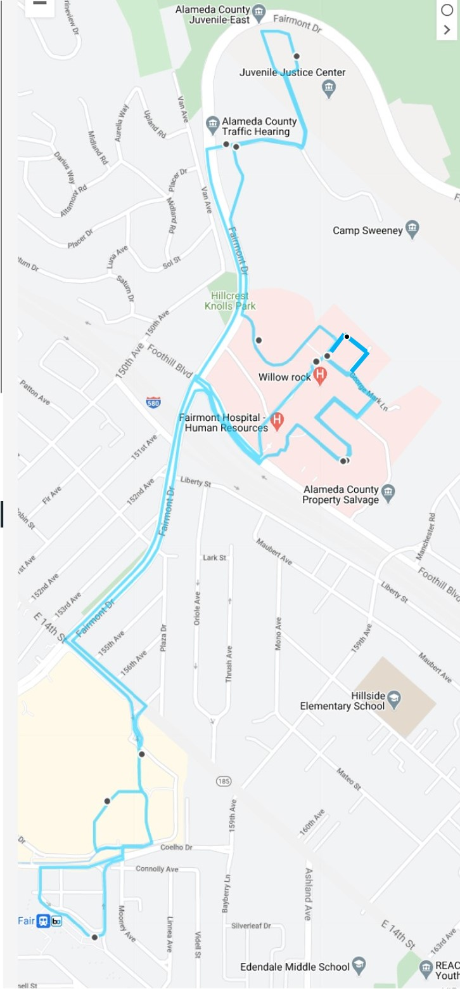
ROUTE NO. 1 – JUVENILE JUSTICE CENTER & FAIRMONT HOSPITAL

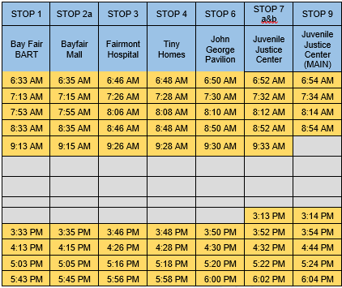
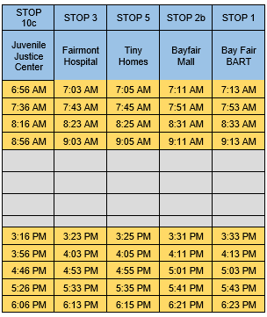

ROUTE NO. 2 – DOWNTOWN OAKLAND

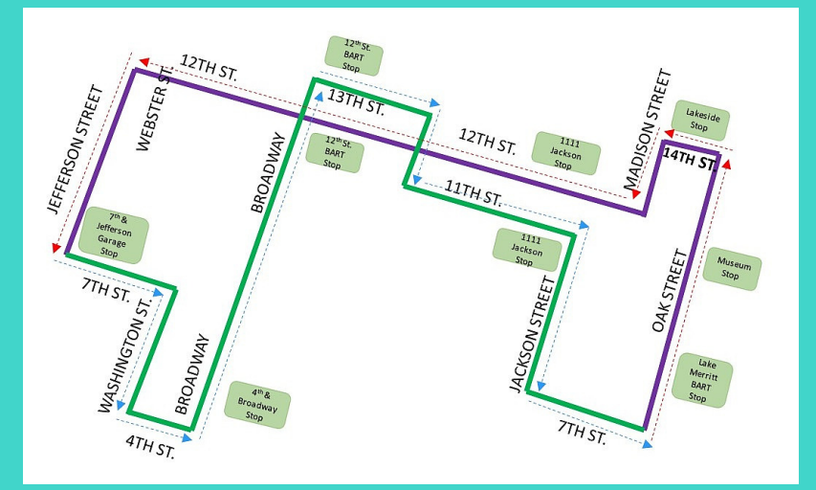
 | STOP 2 | STOP 3 | STOP 4 | STOP 5 | STOP 6 | STOP 7 | STOP 8 | STOP 9
Lake Merritt BART Station (Oak St. Bus Stop) | Oakland Museum (Corner of Oak & 12th Streets) | Lakeside Building (14th St. Bus Stop) | 1111 Jackson Bldg. (Bus Stop on 12th St.) | 12th Street BART Station Entrance | 7th & Jefferson Garage | 12th St. BART Station Entrance | 393 - 13th St. (ITD Building Entrance) | 1111 Jackson Bldg.
6:30 AM | 6:31 AM | 6:33 AM | 6:35 AM | 6:37 AM | 6:40 AM | 6:44 AM | 6:48 AM | 6:51 AM
6:56 AM | 6:57 AM | 6:59 AM | 7:01 AM | 7:03 AM | 7:06 AM | 7:10 AM | 7:14 AM | 7:17 AM
7:22 AM | 7:23 AM | 7:25 AM | 7:27 AM | 7:29 AM | 7:32 AM | 7:36 AM | 7:40 AM | 7:43 AM
7:48 AM | 7:49 AM | 7:51 AM | 7:53 AM | 7:55 AM | 7:58 AM | 8:02 AM | 8:06 AM | 8:09 AM
8:14 AM | 8:15 AM | 8:17 AM | 8:19 AM | 8:21 AM | 8:36 AM | 8:40 AM | 8:44 AM | 8:47 AM
8:52 AM | 8:53 AM | 8:55 AM | 8:57 AM | 8:59 AM | 9:09 AM | 9:14 AM | 9:19 AM | 9:22 AM
9:27 AM | 9:28 AM | 9:30 AM | 9:32 AM | 9:34 AM | 9:44 AM | 9:48 AM | 9:52 AM | 9:55 AM
2:58 PM | 2:59 PM | 3:01 PM | 3:03 PM | 3:05 PM | 3:18 PM | 3:22 PM | 3:26 PM | 3:29 PM
3:05 PM | 3:07 PM | 3:09 PM | 3:12 PM | 3:14 PM | 3:19 PM | 3:25 PM | 3:30 PM | 3:35 PM
3:42 PM | 3:44 PM | 3:46 PM | 3:49 PM | 3:51 PM | 3:56 PM | 4:02 PM | 4:07 PM | 4:12 PM
4:19 PM | 4:21 PM | 4:23 PM | 4:26 PM | 4:28 PM | 4:33 PM | 4:39 PM | 4:44 PM | 4:49 PM
4:56 PM | 4:58 PM | 5:00 PM | 5:03 PM | 5:05 PM | 5:20 PM | 5:26 PM | 5:31 PM | 5:36 PM
5:43 PM | 5:45 PM | 5:47 PM | 5:50 PM | 5:52 PM | 5:57 PM | 6:03 PM | 6:08 PM | 6:13 PM
6:20 PM | 6:22 PM | 6:24 PM | 6:27 PM | 6:29 PM | 6:34 PM | 6:40 PM | 6:45 PM | 6:50 PM
6:57 PM | 6:59 PM | 7:00 PM

ROUTE NO. 3 – HAYWARD EDEN CAMPUS
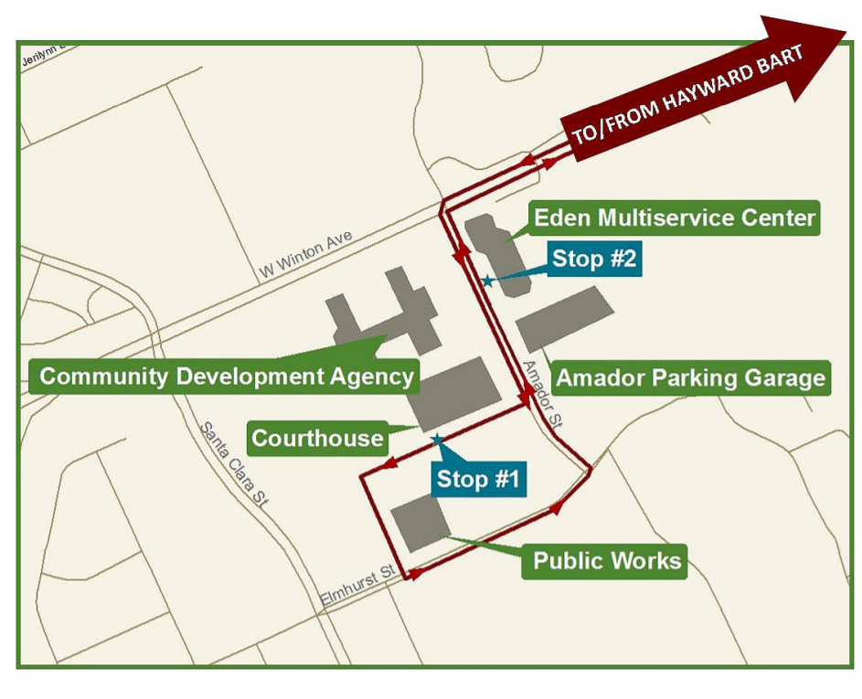
Hayward BART | Courthouse | Eden Multiservice Center |  | Hayward BART | Courthouse | Eden Multiservice Center
6:38 AM | 6:46 AM | 6:51 AM |  | 3:38 PM | 3:56 PM | 4:01 PM
6:58 AM | 7:06 AM | 7:11 AM |  | 4:08 PM | 4:16 PM | 4:21 AM
7:18 AM | 7:26 AM | 7:31 AM |  | 4:28 PM | 4:36 PM | 4:41 PM
7:38 AM | 7:46 AM | 7:51 AM |  | 4:48 PM | 4:56 PM | 5:01 PM
7:58 AM | 8:06 AM | 8:11 AM |  | 5:08 PM | 5:16 PM | 5:21 PM
8:18 AM | 8:26 AM | 8:31 AM |  | 5:28 PM | 5:36 PM | 5:41 PM
8:38 AM | 8:46 AM | 8:51 AM |  | 5:48 PM | 5:56 PM | 6:01 PM
8:58 AM | 9:06 AM | 9:11 AM |  | 6:08 PM | 6:16 PM | 6:21 PM
9:18 AM | 9:36 AM |  |  | 6:28 PM | 6:36 PM | 6:41 PM
 |  |  |  | 6:48 PM

Route No. 4 – Edgewater/eastmont
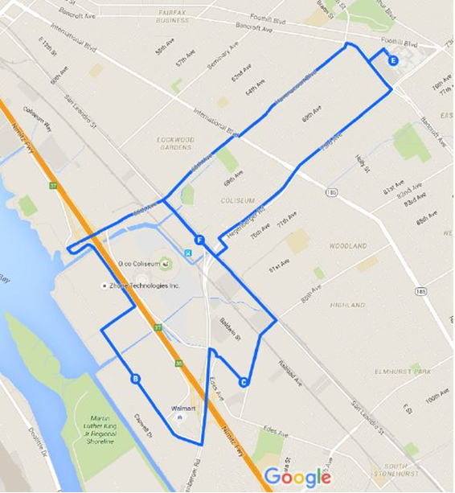

Coliseum BART (to Edgewater) | Edgewater | Enterprise | Coliseum BART (to Eastmont) | SSA - Eastmont Town Center (to BART)
6:25 AM | 6:33 AM | 6:40 AM | 6:47 AM | 6:57 AM
7:05 AM | 7:13 AM | 7:20 AM | 7:27 AM | 7:37 AM
7:45 AM | 7:53 AM | 8:00 AM | 8:07 AM | 8:17 AM
8:25 AM | 8:33 AM | 8:40 AM | 8:47 AM | 8:57 AM
9:05 AM | 9:13 AM | 9:20 AM | 9:27 AM | 9:52 AM
2:50 PM | 2:58 PM | 3:05 PM | 3:12 PM | 3:22 PM
3:10 PM | 3:18 PM | 3:25 PM | 3:32 PM | 3:57 PM
3:30 PM | 3:38 PM | 3:45 PM | 3:52 PM | 4:20 PM
4:10 PM | 4:18 PM | 4:25 PM | 4:32 PM | 4:42 PM
4:30 PM | 4:38 PM | 4:45 PM | 4:52 PM | 5:02 PM
4:50 PM | 4:58 PM | 5:05 PM | 5:12 PM | 5:22 PM
5:10 PM | 5:18 PM | 5:25 PM | 5:32 PM | 5:42 PM
5:30 PM | 5:38 PM | 5:45 PM | 5:52 PM | 6:02 PM
5:50 PM | 5:58 PM | 6:05 PM | 6:12 PM | 6:22 PM
6:10 PM | 6:18 PM | 6:25 PM | 6:32 PM | 6:42 PM
6:30 PM | 6:38 PM | 6:45 PM
Route No. 5 – EMBARCADERO COVE

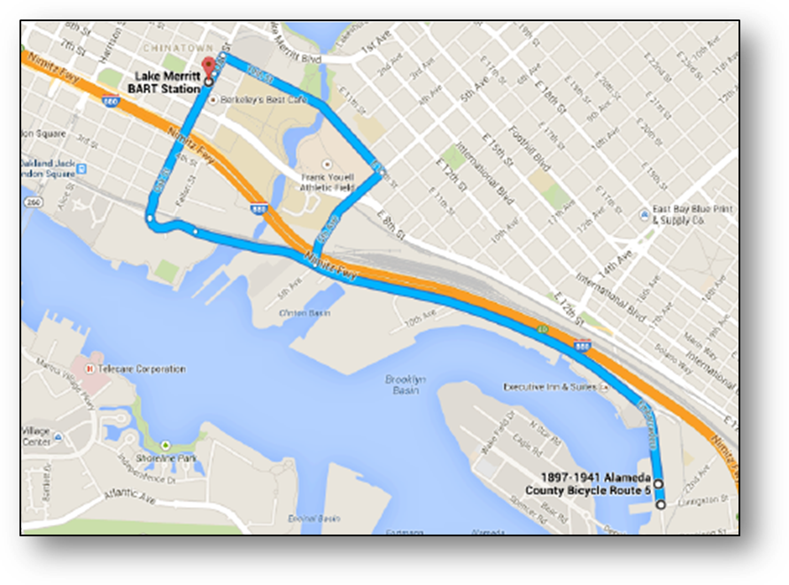

Morning Schedule
Lake Merritt BART | 1900 Embarcadero | 2000 Embarcadero
6:50 AM | 7:02 AM | 7:03 AM
7:15 AM | 7:27 AM | 7:28 AM
7:40 AM | 7:52 AM | 7:53 AM
8:05 AM | 8:17 AM | 8:18 AM
8:30 AM | 8:42 AM | 8:43 AM
8:55 AM | 9:07 AM | 9:23 AM
9:35 AM | 9:47 AM | 9:48 AM
10:00 AM | 10:12 AM | 10:15 AM
Afternoon Schedule
Lake Merritt BART | 1900 Embarcadero | 2000 Embarcadero
 |  | 3:30 PM
3:42 PM | 3:43 PM | 3:55 PM
4:07 PM | 4:08 PM | 4:20 PM
4:32 PM | 4:33 PM | 4:45 PM
4:57 PM | 4:58 PM | 5:10 PM
5:22 PM | 5:23 PM | 5:35 PM
5:47 PM | 5:48 PM | 6:00 PM
6:12 PM | 6:13 PM | 6:25 PM
6:47 PM | 6:59 PM | 7:00 PM
7:12 PM | 7:24 PM | 7:30 PM

EXHIBIT c

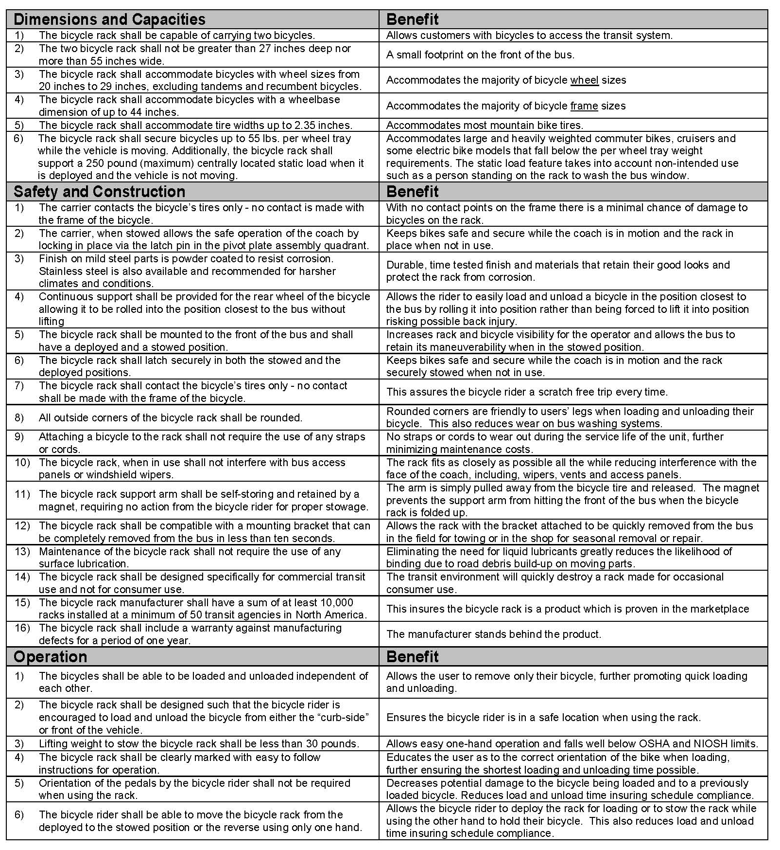
dl2 np bike rack specifications

EXHIBIT D
Sample County Incident Report Form

EXHIBIT E

VENDOR BID LIST

Below is the Vendor Bid List for this project consisting of vendors who have responded to RFP No. 901997 and/or been issued a copy of this RFP. This Vendor Bid List is being provided for informational purposes to assist bidders in making contact with other businesses as needed to develop local small and emerging business subcontracting relationships to meet the requirements of the Small Local Emerging Business (SLEB) Program: http://www.acgov.org/gsa/departments/purchasing/policy/slebpref.htm.

RFP 901997 Shuttle Bus Services
Business Name | Contact Name | Phone | Address | City | Email
AC Transit | Robert Del Rosario | 510-891-4734 | 1600 Franklin Street | OAKLAND | rdelrosa@actransit.org
Altrans TMA, Inc. | Stephen Blaylock | 855-232-2020 | 2055 Junction Avenue, Suite 208 | SAN JOSE | sblaylock@altrans.net
AMERICAN MEDICAL RESPONSE | RANDY STROZYK | ( 510 ) 895-7668 | 640 143RD AVE | SAN LEANDRO | RANDY-STROZYK@AMR-EMS.COM
American Passenger | Larry Arnone | 650-401-6879 | 932 So. Claremont St. | SAN MATEO | larnone@charteraps.com
A-Para Transit Corporation | Sunny Kumar | 510-732-6304; 510-732-1608 | 22990 Clawiter Rd | HAYWARD | sunny@aparatransit.com; pardeep@aparatransit.com
A-Para Transit Corporation | Gina Kumar; Mark Weinstein | ( 925 ) 305-7608; ( 510 ) 459-4702 | 1400 Doolittle Drive | SAN LEANDRO | gina@aparatransit.com; mark.weinstein@aparatransit.com
Bauer's Transportation | Alisha Stanfield | 415-740-5363 | Pier 27, The Embarcadero | SAN FRANCISCO | alisha@bauersit.com
Bay Area Transport Services | Marlon L. McWilson | (510) 812-4247 | 2012 99th Avenue | OAKLAND | Marlon@BayExecutiveTransport.com
Bell Transit Corp | Reena Kumar | (510) 825-2476 | 1400 Doolittle Drive | SAN LEANDRO | reena@belltransit.com
Code 3 Entertainment Services | Alisha Stanfield | ( 800 ) 727-0279 | 6200 Stoneridge Mall Road | PLEASANTON | alisha@c3transit.com
Corinthian International | Eloy Soto | 408-314-2836 | 2990 Winchester Blvd. | CAMPBELL | eloy@corinthianparking.com
CUSA, LLC | Mike Waters | 415-642-9400 | 300 Toland St. | SAN FRANCISCO | michael.waters@coachamerica.com
Douglas Parking | Andy Storm | 510-715-0188 | 1721 Webster St. | OAKLAND | andy@douglasparking.com
El Camino Charter Lines, Inc. dba  El Camino Charters | Kumar Shah | 650.989.2600 | 214 Shaw Road | SAN FRANCISCO | kumar@ElCaminoCharters.com
Go Green Transportation, Inc. | Rita Hoopes | ( 510 ) 464-7336 | 20630 John Drive | CASTRO VALLEY | begreengogreen@yahoo.com
Horizon Coach Lines | Mark Frailey | 415-500-3945 | 300 Toland St. | SAN FRANCISCO | mfrailey@horizoncoachlines.com
ISDPlanning | Xinyuan Yang | ( 510 ) 292-6963 | 1620 Milvia Street | BERKELEY | catherineyang9@gmail.com
Keolis Transit America | Scott Williams | 310-981-9500 | 6053 W. Century Blvd | LOS ANGELES | busdev@keolistransit.com
LAZ Parking | Curtis Boardman | (510) 295-9517 | 5901 Christie Ave. Suite 202 | EMERYVILLE | CBoardman@lazparking.com
Livermore-amador Transit | Barbara Duffy | ( 925 ) 455-7555 | 1362 Rutan Ct # 100 | LIVERMORE | tedwards@lavta.org
Lux Bus America | Casey Collier | ( 415 ) 871-8663 | 560 Lincoln Ave | SAN JOSE | ccollier@luxbusamerica.com
Michael's Transportation | Michael Brown | 707-643-2099 | 140 Yolano Drive | VALLEJO | michaelb@bustransportation.com; carlm@bustransportation.com
Mobility Plus | Scott Williams | 310-981-9500 | 6053 W. Century Blvd. | LOS ANGELES | swilliams@tectransinc.com
MV Transportation, Inc. | David Smith | 707-863-8710 | 360 Campus Lane, Ste. 201 | FAIRFIELD | david.smith@mvtransit.com
Pacific Coast Bus | James Casey | 415-284-1600 | 214 Shaw Road | SAN FRANCISCO | james.casey@coachamerica.com
PCA | B. Watson | 415-378-0996 | 523 West 6th Street | LOS ANGELES | bwatson@parkpca.com
SDV Services Inc | Victor Rollandi | ( 510 ) 521-8170 | 2236 Mariner Square Drive, Suite 101 | ALAMEDA | vic@sdvservicesinc.com
Secure Transportation | Gerard Linsmeier | ( 310 ) 433-4006 | 22237 Main St. #4 | HAYWARD | glinsmeier@securetransportation.com
Serendipity Land Yachts | Teri Hayes | 408-566-0430 | 1051 Richard Ave | SAN JOSE | teri@landyacht.com
SFO Shuttle Bus | Broyce Batchan | 510-382-2140 | 325 5th St. | SAN FRANCISCO | jeff.leonoudakis@sfoshuttle.net; broyce@sfparkinginc.com
Silverado Stages, Inc. | Mike Watson | 415-272-8730; 805-432-0875 | 241-B Prado Road | SAN LUIS OBISPO | mwatson@silveradostages.com
SP Plus | Paul Halsch | 415-990-6431 | 1750 Montgomery | SAN FRANCISCO | aaron@silveradostages.com
Starzz Management | Joe Thompkins | 510-632-5533 | 8393 Capwell Dr., Suite 220 | OAKLAND | pahalsch@parking.com
Transmetro, Inc. | Fred Khan | 415-513-5777 | 2388 Mariner Square Drive | ALAMEDA | fred@transmetro.org
Transportation Management Services | Ryan Mead | ( 301 ) 3000-9007 | 17810 Meeting House Road | SANDY SPRING | rmead@tms.com
UCS Worldwide | Lohan Caetano | 650.863.3984 | 1710 S Amphlett St. | SAN MATEO | lohan@ucslimo.com
United Shuttle | Mohammad Zarif | ( 510 ) 978-1544 | 1277 ALDER CREEK CIR | SAN LEANDRO | zarif1968@hotmail.com
Vision Communications | Mark Champ | 510-346-0300 | 1770 Neptune Drive | SAN LEANDRO | mchamp@2viscom.com

