The End of the Reform School?

by

Vincent Schiraldi, MSW
Commissioner of Probation for New York City and past Director of DC’s Department of Youth Rehabilitation Services 33 Beaver Street, 23rd Floor New York, NY 10004, vschiraldi@probation.nyc.gov

Marc Schindler, JD,
Interim Director DC Department of Youth Rehabilitation Services1000 Mt. Olivet Road, N.E. Washington, DC 20002, Marc.Schindler@dc.gov

Sean J. Goliday, PhD
Research Analyst, Department of Youth Rehabilitation Services
450 H St NW, Washington DC 20001, sean.goliday@dc.gov

INTRODUCTION

The mood and temper of the public with regard to the treatment of crime and criminals is one of the most unfailing tests of the civilization of any country. Sir Winston Churchill, 1910
Young girls are stripped naked and placed in dank, unlit rooms in a Mississippi youth correctional facility for days at a time for relatively minor misbehavior. While there, they urinate and defecate through a hole in the floor. For punishment, youth report staff force them to eat their own vomit or risk being physically assaulted (US Department of Justice CRIPA Investigation 2003).
Young people confined in our nation’s capitol take their shirts off at night, stuffing them around the toilets in their cells to avoid rats and cockroaches crawling on them while they sleep. Girls in this same Washington, DC facility are deprived of feminine napkins when they have their periods, forcing them to sneak napkins from the cafeteria.
After a 14-year-old girl at a state boot camp died while being forced to exercise without water, stories of human rights abuses poured out of South Dakota’s facilities for delinquent youth. Guards shackled youth to fixed restraints on the floor or beds after cutting their clothes off, chained youths inside their cells and placed them in isolation for 23 hours a day for extended periods of time, and sprayed them with pepper spray while naked and handcuffed, spread-eagled to their beds (www.hrw.org).
Over 160 years ago, in 1848, American reformers began experimenting with a new approach to troubled youth. Dubbed alternatively “training schools” or “reform schools”, these large, congregate care facilities have been guilty of scandalous abuses, unconstitutional conditions and disappointing public safety outcomes almost since their inception.
This article will briefly outline the troubled history of the training school model as a vehicle for rehabilitating or caring for delinquent and status offending youth. Research on the impact of reform school institutionalization on young people’s recidivism, mental health, suicide risk, educational attainment and future employability will be examined. The outcomes of some promising approaches to working with multiple contact delinquent youth in non-institutional settings will then be reviewed. We will then examine three jurisdictions– Massachusetts, Missouri and the District of Columbia – that have entirely eschewed the use of large state reform schools and look at the outcomes in those states. Next we will look at the move to substantially downsize locked custody in the nation’s three largest states, California, Texas and New York, along with the Juvenile Detention Alternatives Initiative which is helping to reduce detention and, in some cases, training school populations in jurisdictions throughout the country.
Finally, we will summarize the implications of this analysis which we believe makes a strong case for the elimination of the use of reform schools in favor of a rational, evidence-based approach to working with delinquent youth. This approach includes the use of a rigorous continuum of services, supports and opportunities, including small, homelike and decent secure care for the small percentage of youth who need to be so confined, all premised on the tenets of Positive Youth Development.

BRIEF HISTORY OF THE REFORM SCHOOL

We have 100 boys sleeping in one room 40 by 80 feet, low ceiling, and the beds are ‘two story’; there are no bathroom privileges of any kind in the building…Can we not prevail upon this assembly to give us relief? In the name of humanity! Superintendent, St. Louis House of Refuge, 1893.
These reports are shocking. It’s appalling to think of guards cutting the clothes off of children, shackling them naked to their beds, or chaining them to their doors. Americans criticize other societies who treat their children this way. They should not allow these kids of practices to take place in their own country. Michael Bochenek, Human Rights Watch, 2000.
For the first half of the19th Century, children were treated as simply smaller versions of adults when it came to arrest, trial, conviction and incarceration. For young and old, conviction and sentencing meant confinement in “penitentiaries” with brutal and mind-numbing conditions, ranging from harsh physical labor, to beatings, to enforced silence whose violation was severely punished. Gradually, reformers, elected officials and judges began a form of nullification, refusing to convict or sentence youthful offenders to incarceration due to the appalling conditions they would experience in confinement.
In the mid-1800’s states began to create separate but similar facilities for youthful offenders to imprison them apart from adults (Miller 1991).In 1886, the Lyman School for Boys opened in Lyman, Massachusetts, the first in what would become a nationwide experiment with placing troubled youth into prison-like facilities to achieve their reformation.
IMPACT OF REFORM SCHOOLS ON THEIR WARDS

When custody meets care, custody always wins. David J.Rothman-1971
Research has borne out that the reformers’, advocates’ and civil litigators’ cause for alarm was justified. Increasingly sophisticated studies have found that placement in congregate care facilities like reform schools may expose youth to more intensely delinquent or disturbed youth, increase recidivism, destabilize the mental health of young people and place them at greater risk of suicide, and retard employment and educational prospects.
In 2006, under funding from the Annie E. Casey Foundation, Justice Policy Institute researchers Barry Holman and Jason Zeidenberg summarized the growing body of research on the impact of congregate care confinement of delinquent youth (Holman and Zeidenberg 2006). The intuitive belief that training schools are “schools for crime” has some support in the research literature. For example, careful studies of youth in Arkansas’ juvenile justice system found that, controlling for other factors, prior juvenile justice institutionalization was the strongest predictor of future reoffending (Benda and Tollet 1999). The chances of being recommitted to the Arkansas Department of Youth Services (DYS) increased 13-fold for youth with prior commitments. As a predictor of recommitment to DYS, previous commitment was four times stronger than carrying a weapon, six times stronger than membership in a gang, and 22 times stronger than poor parental relationships.
The Oregon Social Learning Center coined the phrase “peer deviancy training” to explain their findings that delinquent youth grouped in congregate care were significantly more likely to reoffend than those who receive individualized treatment (Dishion and Poulin 1999). Such youth also experienced higher rates of substance abuse, school difficulties, violence and adjustment difficulties.
Researchers have also shown that delinquent behavior, even serious delinquency, is normative behavior for teenage males and that incarceration can slow the natural process of maturing out of delinquency. Dr. Delbert Elliott, past-President of the American Society of Criminology and Director of the Center for the Study of Violence Prevention has found that as many as a third of adolescent males engage in serious and violent delinquent behavior but that most “age out” of their delinquency in young adulthood, particularly if they establish a relationship with a significant other or obtain gainful employment (Elliot 1994). Researchers at Carnegie Mellon University have found that incarceration may interrupt this maturation process as it disrupts the youth’s natural engagement with significant others and employment (Golub 1990).
Researchers estimate that as many as two-thirds of youth in confinement meet diagnostic criteria for mental illness, with one-third needing ongoing clinical care (Grisso 2004). Yet such facilities often exacerbate mental illness, rather than ameliorate it.
Research from Psychiatry Resources has found that, for one-third of incarcerated youth diagnosed with depression, the onset of their depression occurred post-confinement (Kashani et al. 1980). “The transition into incarceration itself may be responsible for some of the observed effect,” wrote one researcher in Pediatrics (Forrest, Riley, and Starfield 2000).
Some research has also found that youth in confinement are two to four times as likely to commit suicide as youth in the general public, a particularly appalling finding given that staff at such facilities are specifically charged with the duty of preventing suicides (Parent et al 1994). The Office of Juvenile Justice and Delinquency Prevention reports that 11,000 youth engaged in 17,000 suicidal acts in juvenile justice facilities annually and that juvenile justice systems often engage in practices, such as the use of isolation (Parent et al 1994), that are antithetical to suicide prevention (Hayes 1999). Far too often, education and employment for youth in confinement is irrevocably interrupted, giving the lie to the “reform school” euphemism (see also Vaught chapter, this volume). The U.S. Department of Education has found that 43 percent of incarcerated youth receiving remedial education services in detention did not return to school after release, and another 16 percent dropped out within 5 months (LeBlanc 1991). Research has also found that within a year, two-thirds to three-quarters of 9th graders released from incarceration had dropped out (Balfanz, Spiridakis, and Legters 2003).
This failure to reconnect with schools, combined with the stigma associated with incarceration, negatively impacts job prospects for former training school residents. One study by the National Bureau of Economic Research found that incarcerating youth reduced work time over the next decade by 25-30 percent (Freeman 1991). Bruce Western and Katherine Beckett of Princeton University found that, when controlling for other factors, youth who had been incarcerated spent three fewer weeks working in the following year, on average, than non-incarcerated youth; for African-American youth, it was five fewer work weeks post-incarceration (Western and Beckett 1999). One researcher concluded “the process of incarceration could actually change an individual into a less stable employee” (Bushway 1998).
In a recent report published by the Annie E. Casey Foundation, Mendel (2009) found that confinement is associated with a variety of “negative life consequences” including rendering youth less likely to complete high school, avoid re-arrest, find employment and form stable families (see Figure 1).

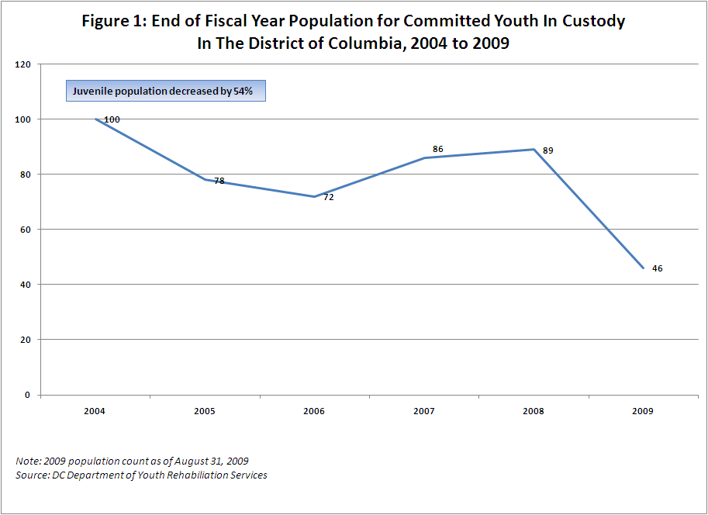

EVIDENCE BASED PRACTICES AND PROGRAMING APPROACHES

These “negative life consequences” as the Casey article dubs them, stand in stark contrast to some of the outcomes being experienced by Evidence Based programs and promising approaches.
The Center for the Study and Prevention of Violence (CSPV) at the University of Colorado at Boulder – in its Blueprints for Violence Prevention initiative -- has studied and written extensively about which violence prevention programs are effective.
CSPV has reviewed more than 800 programs and has found 11 that meet the criteria for “model” programs and 17 that meet the criteria for “promising approaches.”
Three of the Blueprints evidence based model programs are widely used with youth in the juvenile justice system:
- Multisystemic Therapy (MST) is an intensive treatment program for serious youth offenders focused on improving the family’s capacity to overcome the known causes of delinquency. A masters-level therapist with a very small caseload comes to the youth’s home and other places where the youth is involved in the community, and is available to the family 24 hours per day, 7 days per week. MST interventions typically aim to improve families’ discipline practices and abilities to communicate, decrease youth association with deviant peers, increase youth association with positive peers and recreational activities, improve youth school or vocational performance, and develop a support network of extended family, neighbors, and friends to help youth and their families achieve and maintain such changes (www.colorado.edu). MST has been shown to decrease recidivism up to 70% as well as achieving other positive outcomes (mstservices.com).
- Functional Family Therapy (FFT) is a structured family-based prevention and intervention program for at-risk youth that works to change behaviors by engaging and motivating families and youth. A short-term intervention of up to 30 hours offered mainly in clinical settings but sometimes in-home, this therapy focuses on family communication, parenting skills, and conflict management skills (www. strengtheningfamilies.org). FFT has been shown to reduce recidivism between 25% and 60% (www.colorado.edu).
- Multidimensional Treatment Foster Care (MTFC) places adolescents who need out-of-home placement due to serious delinquency in specially-trained and supported foster homes, rather than incarceration or group home settings. The foster care placements, which last for six to nine months, focus on academic and positive living skills; daily structure and supervision based on clear expectations, limits and consequences; and support for youth in developing positive peer relationships. At the same time, the youth’s family receives therapy and parenting skills training to promote successful return after the program (www.mtfc.com). Studies have found that placement in MTFC can prevent escalation of delinquency and other problem behaviors such as youth violence. Placement in MTFC is more economical and more effective than placement in group/congregate care settings like reform schools in decreasing offense and incarceration rates after program completion (www.mtfc.com).
Another emerging approach to working with youth in the juvenile justice system is based on the tenets of Positive Youth Development (“PYD”). While most juvenile justice practice seeks (often unsuccessfully) only to extinguish negative behaviors, jurisdictions are beginning to embrace PYD as a key to preventing and reducing delinquent behavior through a combination of identifying and building on youths’ strengths as well as meeting their needs. PYD, as it is being defined by the District of Columbia Department of Youth Rehabilitation Services (DYRS), means purposefully seeking to meet the needs of young people and building their competencies to enable them to become successful adults. Rather than seeing young people as problems, this developmental approach views youth and their families as resources and builds on their strengths and capabilities.
Thus, a PYD approach views the youth as an active participant in the change process, instead of as a client or target of change. While traditional juvenile justice work with young people has often favored control of their behavior as a central goal, for PYD, connecting the youth with community resources is the focus. For example, a traditional juvenile justice approach might involve sending a youth to job counseling and order community service as a punishment; PYD, in contrast, looks to engage the youth in career exploration and career-path work experience and use community service as service learning and job preparation. Most importantly, in the traditional juvenile justice approach, the aim is to diminish a youth’s problems or deficits; in PYD, it is to build on a youth’s strengths and assets. DYRS’s leadership came to the decision to implement this approach based on a review of the research literature (e.g., see Schwartz 2000; Butts et al. 2005; and Butts 2008) and its belief that this approach is the best way to improve public safety in communities.

SMALLER IS BETTER

Juvenile facilities should be small enough so the facility administrator can know the life story of every kid in them. Paul DeMuro
Although there had been calls to reform the training school model almost since its inception, the first successful juvenile justice deinstitutionalization effort came in the early 1970’s in the state of Massachusetts under the stewardship of Jerome G. Miller, then-Secretary of the state’s Department of Youth Services.
After spending years attempting to reform the state’s training schools, Miller decided that it was the institutional model itself that was broken and needed to be dismantled. Over a two year period, Miller closed all 8 training schools in Massachusetts which, at the time, housed approximately 1,000 youth, replacing them with two 30-bed facilities and a network of in-home services, group homes and residential placements (Krisberg and Austin 1998).
Two separate analyses by the Harvard University and National Council on Crime and Delinquency found numerous benefits to Miller’s deinstitutionialized and regionalized system. Harvard researchers Coates, Miller and Ohlin (1978) found that, while overall recidivism rates for youth in the Massachusetts system rose slightly shortly following the closing of the institutions (from 66% in the institution-based system, pre-Miller to 74% post-reforms), regions of the state where a fuller continuum of care was put into place experienced a significant decline in recidivism. The Harvard researchers also found that “graduates” of the new system were half as likely to go to adult prison as participants in the old, institution-based system.
By the time the National Council on Crime and Delinquency (1991) published its analysis, recidivism rates for youth in the deinstitutionalized Massachusetts system declined considerably. Among other findings, NCCD researchers concluded that, 15 years after the “Massachusetts Experiment”:
- Massachusetts ranked 46th nationally in overall rates of juvenile delinquency
- Department of Youth Services youth made up only 1.3% of all youth arrests statewide in 1984
- In the decade following Miller’s reforms, the number of DYS youth arraigned for new offenses declined by 36%
- There were not only fewer arraignments of DYS youth, but the ones who were arraigned were arraigned for less serious offenses
- By 1985, only 51% of DYS youth were rearraigned within a year of release, a significant decline from the 74% figure reported by the Harvard researchers shortly after the closing of the institutions in 1974
- Recidivism rates for youth in Massachusetts’ system were lower than delinquent youth in nine other state systems analyzed by NCCD
- If Massachusetts were to return to confining youth for the average length of stay for most systems nationwide at the time (1985), the state would have needed to spend an additional $11 million dollars annually and open 287 new secure beds
Although the “Massachusetts Experiment” did not unleash a wave of successful juvenile justice deinstitutionalization efforts in other states, it did provide policy makers, researchers, lawyers and advocates with a strong alternative example of a system that did not rely on large, locked institutions as its foundation, and yet was able to provide public safety and youth rehabilitation. Miller’s innovations also helped lay the groundwork for robust continua of care for delinquent youth – a model that is considered the “gold standard” nationally for diversifying youth services and reducing overreliance on training schools to the present day.
With an eye in the direction of Massachusetts’ experiment in downsizing large training schools, Missouri officials began to experiment with smaller secure care facilities in the 1970’s. The experiment really took off in the early 1980’s when, in short order, the state closed its one girls’ reform school (the facility in Chillicothe closed in 1981) and the brutal Booneville training school for boys, which closed in 1983 (Abrams 2004).
In their place, Missouri officials had begun opening small secure care facilities throughout the state, generally much closer to the youth’s homes than the distant training schools had been. At first, these facilities were located in abandoned schools, residential homes, even a convent – none larger than three dozen beds. Eventually, as the “Missouri Model” began to take off, the state built new facilities of 40 or fewer beds, in dormitory settings. At first, as Dick Mendel points out in “Small is Beautiful: The Missouri Division of Youth Services”, going small was no panacea, and the youth in the Missouri facilities began to act out in their smaller, more decent and less hardware-driven facilities. But in 1988, Mark Steward took over as the Department’s director and initiated a successful effort to reform DYS inside and out. He launched a Positive Peer Culture (PPC) environment in DYS’ secure units, improved case management and case coordination with secure care programming, and created a network of day treatment centers to help ease the transition of youth back into the community following release from secure care.
The results have been impressive. Three years after discharge, 91 percent of DYS youth have avoided reincarceration and 70% have remained crime-free (Decker 2009). Eighty-four percent of DYS youth are productively involved in their communities through either school or work. Outcomes like these led to Missouri’s receiving the prestigious Innovations in American Government award from Harvard’s Kennedy School of Government in 2008, being named a Guiding Light in Reform by the American Youth Policy Forum, and being designated as a model site by the Annie E. Casey Foundation, the Edna McConnell Clark Foundation and the National Council on Crime and Delinquency.
As Missouri’s outcomes have garnered attention, replication of the Missouri Model has begun in several jurisdictions throughout the country. In 2005, Steward retired and started the Missouri Youth Services Institute (MYSI) - a consulting firm he runs with several former DYS staff. MYSI is now providing training, coaching and technical assistance to juvenile justice agencies in the District of Columbia, Louisiana, New Mexico, and San Francisco County, California, and have recently completed work in Santa Clara County, California. Steward reports that they have had inquiries for technical assistance from another half dozen states.
In the District, the Department of Youth Rehabilitation Services (DYRS) – Washington, DC’s cabinet level juvenile justice agency -- has been engaged in a major reform effort since 2005. Between 2005 and 2009, the agency cut the population of committed youth in locked custody in half, closed its one remaining large (212 beds) training school and replaced it with a 60-bed facility – the New Beginnings Youth Development Center -- partially modeled after the Hillsborough facility outside of St. Louis. All of the agency’s staff at New Beginnings has been trained on the “DC Model” (DC’s version of the “Missouri Model”) by MYSI staff, which provides ongoing coaching and technical assistance as the agency makes the difficult transition from a correctional model to a deinstitutionalized system.
DYRS’ innovation is noteworthy given that the agency has been deeply troubled for decades. DYRS is in its twenty-fourth year under a court consent decree for deplorable conditions in its facilities and inadequate community-based services. In 2004 Plaintiffs in the lawsuit moved to place the agency in court receivership, then withdrew the motion in December 2007 as the reforms progressed. Reducing unnecessary use of incarceration has been a hallmark of the reform effort. For youth in locked custody, DYRS has reduced the population in its one secure facility for committed youth from 130 committed youth in 2005 to 60 by 2009, and from approximately 125 pre-trial detained youth in 2005 to an average of 94 in 2008. As a participating jurisdiction in JDAI, city agencies and the courts have developed an array of detention alternatives, including evening reporting centers, balanced and restorative justice centers, third-party monitoring and others. Between January 2006 and December 2009, 93% of youth released from a DYRS alternative to detention appeared in court without rearrest while awaiting their hearings, with only 5% rearrested and 2% failing to appear for a court hearing.
DYRS has revised its approach to direct care within its facilities to create a positive peer culture and therapeutic milieu modeled after the Missouri Division of Youth Services. Consistent with the PYD approach, DYRS has engaged youth in positive activities such as performing Shakespeare in their communities, rebuilding homes destroyed by Hurricane Katrina, participating in citywide football and basketball leagues (including being the Junior Varsity Champions in 2006), and engaging in a wilderness/cultural exchange on the Navajo Nation in the Southwest that simply were not permitted or encouraged during the agency’s prior correctionally-oriented era. For youth under DYRS’ care who are in the community, DYRS is creating a continuum of youth- and family-focused, asset-based services, supports and opportunities for youth either in lieu of secure confinement or as aftercare following secure confinement.
As DYRS adopted a PYD focus in 2005, it achieved a substantial movement of less seriously-delinquent youth from deep-end, secure custody to community-based care, thereby reserving the most expensive (i.e., locked) programming for the youth with the most serious offenses. DYRS concurrently improved secure care for youth involved in serious and violent offenses, assuring that they remain confined longer in order to receive appropriate treatment services. This reform has substantially reduced the number of youth in secure care while improving conditions for those who remain confined, all through a strength-based approach. Importantly, these changes have occurred while there has also been a reduction in recidivism amongst DYRS youth compared to 2004, and a continued decline in serious juvenile crime in Washington, D.C. (see Figure 2).

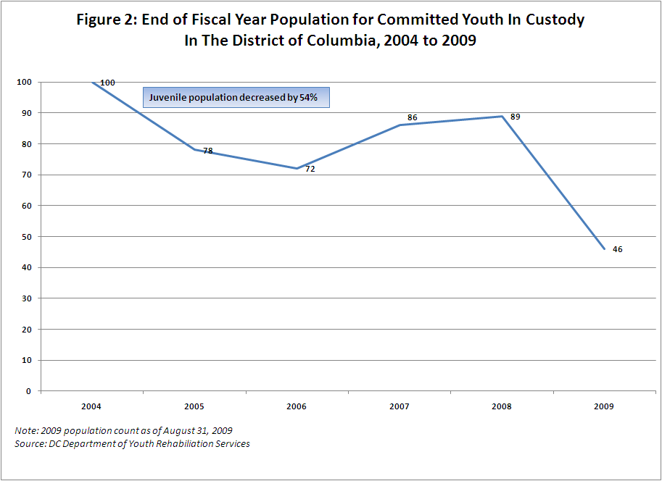

DYRS has also created evidence-based and promising programs based on research from OJJDP and others and consistent with the tenets of PYD. For example, the Civic Justice Corps (“CJC”) is a workforce development program modeled on the Depression-era Civilian Conservation Corps program. DYRS has also helped to create Multi-Systemic Therapy, Multidimensional Treatment Foster Care, and Functional Family Therapy as part of its community-based continuum of care. These have all been utilized to build on young people’s assets in non-institutional settings. In addition, DYRS has created a Youth Family Team Meeting (“YFTM”) case planning process, combined with a basic screening system to develop case plans for all DYRS-committed youth. In its YFTMs, youth and their parents have a substantial voice in developing the youths’ case plan (now called an “Individual Development Plan”) and each case plan builds upon the youths’ strengths as well as attempts to meet their needs. This in turn helps steer youth into appropriate placements in either community settings or secure confinement.
The Structured Decision Making (SDM) assessment used by DYRS is a

validated risk instrument used to ensure that all youth are assessed using an equitable set

of criteria. DYRS’ adaptation of SDM seeks to balance public safety concerns with

effective individualized service interventions, based on the tenets of positive youth

development. The SDM model used by DYRS is driven by a robust risk assessment that

collects data on two axes: risk and current offense severity. Each axis produces a

composite scale that takes into account a number of factors known to stimulate or buffer

against future delinquency. For example, the SDM risk assessment axis considers such

factors as age at first offense, number of prior adjudications, number of prior

adjudications for violent offenses, number of prior placements, school attendance,

substance abuse, family criminality, abuse and neglect. Each factor is assigned a

weighted numeric value (positive or negative depending on the relationship to

delinquency) and summed to generate two composite scores: (1) one related to offense

severity and (2) another related to the risk level. These two scores are subsequently

combined and each youth is placed in a nine cell matrix created to determine the level of

restrictiveness for each youth.

DYRS youth typically fall in one of three risk categories: (1) high risk- those

youth with a high risk and high offense score, poses very serious risk to public safety

and/or self, requires 24 hour close supervision in a residential, staff-secured facility (e.g.,

DYRS’ New Beginnings Youth Development Center or Residential Treatment Center);

medium risk- those youth with a moderate SDM score, poses serious threat to public

safety and/or self, requires intense supervision and close monitoring, can be placed in

staff-supervised facility, in a home-like environment in a community setting, or closely

monitored home environment (e.g., group home or foster care); and low risk- those youth

with a low SDM score, poses minimum risk to public safety and/or self, requires strong

and effective in-home supervision by vendor or parent/guardian (e.g., at-home

wraparound services or independent living program with moderate to low supervision).

DYRS uses this information in each Youth Family Team Meeting to determine the level

of restrictiveness and to ensure that youth are linked to the appropriate services, supports

and opportunities.

In 2005 when the reforms were first initiated, DYRS engaged a representative cross-section of community stakeholders and interagency representatives in a planning process to guide and inform the development of a community based continuum of services, supports and opportunities for court involved youth in the District of Columbia. These stakeholders recommended that DYRS implement a decentralized and regionally-based structure that would support youth as much as possible within their own families and neighborhoods, referred to as the Lead Entity – Service Coalition model.
Based on the design recommendations, in 2009 DYRS established two Lead Entities (community-based organizations) to implement Service Coalitions for defined regions of the District of Columbia. Region I – with the East of the River Clergy Police Partnership as the Lead Entity -- is comprised of youth residing in Wards 7 and 8 (East of the River); while Region II – with Progressive Life, Inc, as the Lead Entity -- comprised of youth residing in Wards 1- 6 (West of the River).
The familiar approach to working with youth involved in the juvenile justice system has provided scant investment, involvement and input from families or the community. Research finds that youth from disjointed neighborhoods end up in the juvenile justice systems at higher rates than youth from more organized communities (Shaw and McKay 1941). Ironically, research also shows that incarcerating large numbers of people from neighborhoods further destabilizes those neighborhoods (Clear et al. 2001). The Lead Entity – Service Coalition concept incorporates these research findings in an approach that will focus on building the capacity of DC’s communities to work with their own court-involved youth. An important part of the Service Coalition concept is to help rebuild fragmented communities and involve young people and their families in community development, thereby improving their and their communities by promoting community cohesiveness; encouraging reliance on community resources; contributing to community development; and enhancing community capacity to respond to the needs of DYRS youth and families.
The tension between public safety and providing court-involved youth with the opportunity to become productive citizens by building on their and their families’ strengths in the least restrictive, most homelike environment was paramount in the design of the Lead Entity – Service Coalition concept. Community service plans for youth, which the Lead Entities/Service Coalitions will be responsible for resourcing, will be guided by a series of complimentary formal assessments and the Youth Family Team meeting process that will inform decisions on: 1) services needed to support the youth and their family; 2) whether a youth can be served safely in the community; and 3) the level of restrictiveness that is needed to accommodate the youth’s needs, which could include placement in a residential treatment facility, secure care facility, independent living or home.
Effective community organizing and partnerships will be key to successful implementation of the Lead Entity - Service Coalition concept. These relationships will result in increased monitoring and support of youth involved in the juvenile justice system, ultimately through a shared responsibility between government and the community in which youth live. Creating this sense of shared responsibility and accountability for our youth will no longer rest with a single case manager or government agency. The Lead Entities will have the ability to provide increased oversight and monitoring of youth through the Service Coalition partners; develop, maintain and sustain working partnerships with critical public sector agencies; educate, motivate, organize and mobilize communities in which they are work to support DYRS youth and their families consistent with the principles of PYD; and establish partnerships/relationships with an array of neighborhood/community based youth and family serving organizations, programs and individuals that have strong ties to the community and experience and/or a desire to work with DYRS youth and families.
The Service Coalitions will be responsible for arranging the provision of core services, supports and opportunities that will include, but not be limited to the following: independent and transitional living, transformative mentoring, third party monitoring, residential services (therapeutic group homes etc.), mental health and substance abuse services, work readiness, job placement, tutoring, recreation and sports activities, leadership development, college preparation, vocational training, arts and cultural activities as well as parent/family support.
The Lead Entity – Service Coalition concept will be the centerpiece of the DYRS’ reform effort in creating an effective neighborhood- community-based network of caring and support for committed youth and their families that will have the capacity to extend beyond a youth’s formal involvement with DYRS while helping to support families and strengthen communities.
While DYRS has undergone significant reform, many challenges remain. Many correctional-minded staff have been resistant to the strength-based approach. Personnel policies and civil service protections reduce the ability of management to make the kinds of sweeping staff changes required to dramatically affect the required change in agency culture. Similarly, community providers in the District of Columbia were accustomed to a correctional-oriented approach to working with delinquent youth. Although community vendors are generally more familiar with youth development practices and therefore less resistant to these reforms than DYRS secure custody staff, DYRS expects that new PYD-oriented requests for proposals for community- based programming and a system-wide PYD training requirement for all DYRS vendors will improve practice even further and make the DYRS continuum even more asset-based.

LESS IS MORE

An honest appraisal of the long-term consequences of confining juveniles demonstrates its destructiveness. Former New York City Probation Commissioner Martin Horn.
After what seemed like an unrelenting increase in incarcerated juvenile justice populations in the waning decades of the 20th Century, states around the country have begun to make more sparing use of incarceration in the new millennium. While these states are not necessarily entirely abandoning the use of reform schools, the substantial and widespread decline in the population of youth in custody in America has not been widely publicized and is a positive development given the poor outcomes exhibited by the training school model.
In a National Center for Juvenile Justice report sponsored by the Office of Juvenile Justice Prevention, Melissa Sickmund (forthcoming) reports that the number of youth in custody in America, defined as youth who are both detained pre-adjudication and committed post-adjudication, has declined by 27% from 2000 to 2008. Youth custody rates declined in 35 states from 1997 – 2007 (see Figure 3). This stands in stark contrast to the relentless growth of prison populations, up approximately 29% during this same time period, and increasing nationally every year since 1977 despite a substantial decline in the nation’s crime rate (Bureau of Justice Statistics Correctional Surveys various years).
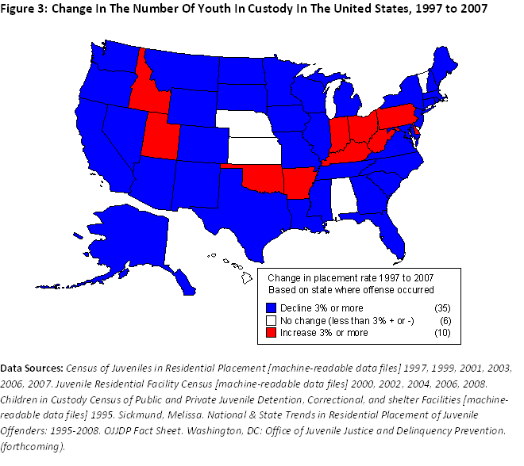

Illustrative of this trend are the nation’s three largest states – California, New York and Texas –which have experienced substantial declines in their juvenile training school populations and have gone about reducing their incarcerated populations in diverse ways.
In 2006, Texas experienced a series of well-publicized scandals in facilities operated by the Texas Youth Commission (TYC). The following year, the Texas legislature passed Senate Bill 103 which precluded Courts from confining misdemeanants in TYC facilities. SB 103 also created a centralized review board to evaluate extensions of lengths of stay for youth, which were common before the law’s passage. Now, a release review panel reviews any proposed extension of a youth’s stay. Overall, TYC’s population has declined by 51.4% since 2006 (see Figure 4), almost all of which occurred since the 2007 scandals broke and SB 103 took effect. Initial signs are that the decline in the population has not negatively affected youth crime. From 2006 to 2008 there was a 4.4% drop in overall juvenile arrests in Texas (Texas Department of Public Safety).

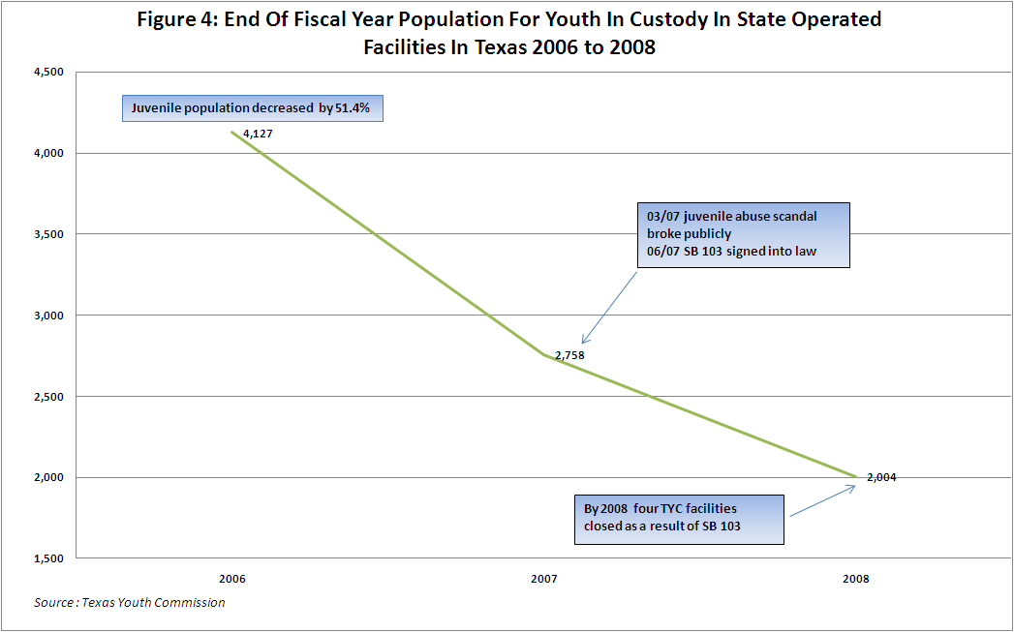
In 2004, under the leadership of Commissioner Martin Horn, New York City’s Probation Department launched “Project Zero” whose ambitious goal was, according to Commissioner Horn “ZERO New York City kids sent to out-of-city placement.” Citing an 81% rearrest rate upon release from state custody, Horn went on to note “Our innovation began with the recognition that an honest appraisal of the long-term consequences of confining juveniles demonstrates its destructiveness. The administration of juvenile justice in our country is marked by an absence of coherent leadership and is essentially unmanaged (2009 Keynote Address: Juvenile Justice Research Symposium p. 2).” Horn’s department created a research-validated instrument to guide sentencing recommendations, which resulted in a reduction in placement recommendations from 40% (1,257) to 18% (795) between 2004 and 2007. The Probation Department also increased the number of youth it diverted by 206% from 1,070 youth in 2002 to 3,271 in 2007. Between 2006 and 2008, incarcerations of New York youth declined overall by 38%, with the greatest reductions experienced in the low (52%) and medium (33%) risk categories (New York City Juvenile Justice Programming 2009).
One of the ways New York’s Probation Department was able to reduce state commitments was through the use of a community-based intensive care program, Project Esperanza. Youth participating in Project Esperanza experienced a drop in recidivism from 50% in 1999 to 16% in 2007 (Morias 2008).
In February 2007, New York City Children’s Services, under the leadership of Commissioner John Mattingly, launched its Juvenile Justice Initiative (JJI) whose goals are to “reduce the number of delinquent youth in residential facilities; shorten lengths of stay of those youth that are placed in residential care; reduce recidivism; and improve individual and family functioning.”
JJI brings together the three evidence based practices mentioned earlier in this article – Multi-Systemic Therapy (MST), Functional Family Therapy (FFT) and Multi-Dimensional Treatment Foster Care (MTFC) – along with its “Blue Sky Project”, a first-ever combination of these three evidence-based programs which will allow youth to transition from one such program to another as their and their families’ needs dictate. While it is impossible to separate the impact of JJI from Project Zero, the number of youth from New York City placed in the Office of Children and Family Services’ (OCFS) facilities and Residential Placements has declined from 1,523 to 955 between 2005 and 2008, in all likelihood due to the combined impact of these two programs. In 2002, 14.3% of all New York City youth arrested were incarcerated in state facilities; by 2008, that had declined to 6.1% (see Figure 5).
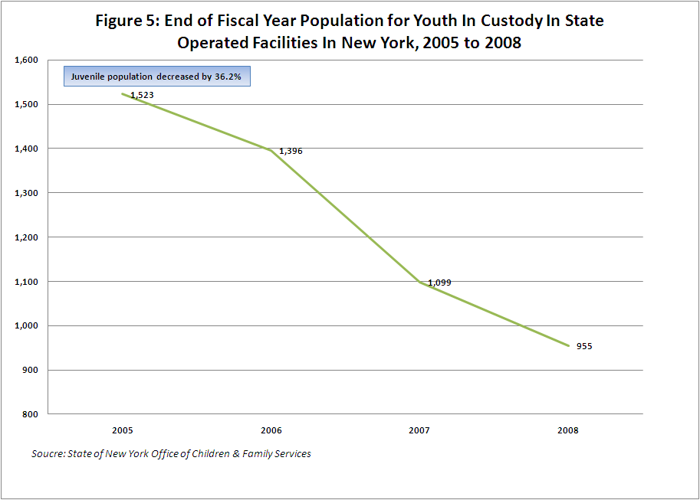Despite the decline in OCFS’ population, the system is very much under siege and
ripe for reform. In August 2009, the United States Justice Department filed a filed a
report outlining abusive conditions in four OCFS facilities, raising the specter of
litigation. The Justice Department documented numerous instances of excessive use of
force by staff, including broken bones and knocked out teeth for minor transgressions like
talking in line or swiping food.
New York Governor David Patterson responded to the pending investigation by
establishing a Task Force on Transforming the Juvenile Justice System chaired by John
Jay College of Criminal Justice President and former Justice Department official Jeremy
Travis with representation by key stakeholders from throughout the state. In December
2009 the Task Force concluded that
New York State’s current approach fails the young people who are drawn into the system, the public whose safety it is intended to protect, and the principles of good governance that demand effective use of scarce state resources(2009 New York Task Force on Reforming Transforming Juvenile Justice Report p. 88).
Summarizing the finding of the report, New York Times reporter Nicholas
Confessore wrote,
New York’s system of juvenile prisons is broken, with young people battling mental illness or addiction held alongside violent offenders in abysmal facilities where they receive little counseling, can be physically abused and rarely get even a basic education, according to a report by a state panel. The problems are so acute that the state agency overseeing the prisons has asked New York’s Family Court judges not to send youths to any of them unless they are a significant risk to public safety, recommending alternatives, like therapeutic foster care (The New York Times December 13, 2009 p. 1).
Travis himself put it more succinctly, “I was not proud of my state when I saw some of
these facilities.”
The Task Force cited several other examples throughout New York State of State-
County partnerships in which alternatives to confinement for training school-bound youth
are being established. The state’s Division of Probation and Correctional Alternatives
has funded the adoption of evidence based correctional alternatives in seven counties:
Dutchess, Monroe, Niagra, Onandoga, Orange, Oswego and Schenectedy. Onandoga’s
Probation Rehabilitation Intensive Services and Management (PRISM) was credited by
the Task Force for contributing to a 73% reduction in commitments from Onandoga
County to OCFS between 1995 and 2008 (from 103 to 28).
As the population in OCFS facilities declined, the state was initially able to close facilities and shift some of the funds saved to community based programs. In 2007, OCFS closed 13 facilities and pumped $17 million in to community based programs through contracts to community vendors. But in 2008, OCFS officials struggled to shutter empty facilities and realign savings to help fund workable alternatives. OCFS announced last year its intentions to close 6 facilities, but state legislators reduced that number to 3, along with the merging of two facilities in distant Adirondack Mountains and the closing of one wing of the Lansing juvenile facility. No additional funds were allocated for community-based programming.
According to State Assemblyman William Scarborough, a Queens Assemblyman who supported closing all six facilities, legislators received letters from unions that represent prison employees with the message “You can’t close our facilities – they contribute a million dollars to our economy.” State Senator Carl Kruger contends that Project Zero is asking too much when it seeks to have the state transfer funds to the City as facilities close to help pay for alternatives “The City would like the state to pay for everything,” Kruger said. “They would like to hijack as much money from us as they can” (Morias 2008).
But in California, that kind of realignment of funds and fiscal incentives is credited with spurring what is likely the most significant percentage reduction in the size of a state juvenile correctional system since the Massachusetts deinstitutionalization of the 1970’s. In 1996, California’s youth corrections population peaked at 9,572, by far the largest system in the country (nearly double the size of the Texas Youth Commission, for example). By the end of 2008, that number had declined to 1,568, an 83.6% decline over a 12-year period. This decline is even more dramatic when juxtaposed to the 21% increase in California’s adult prison population between 1996 and 2008 (see Figure 6).

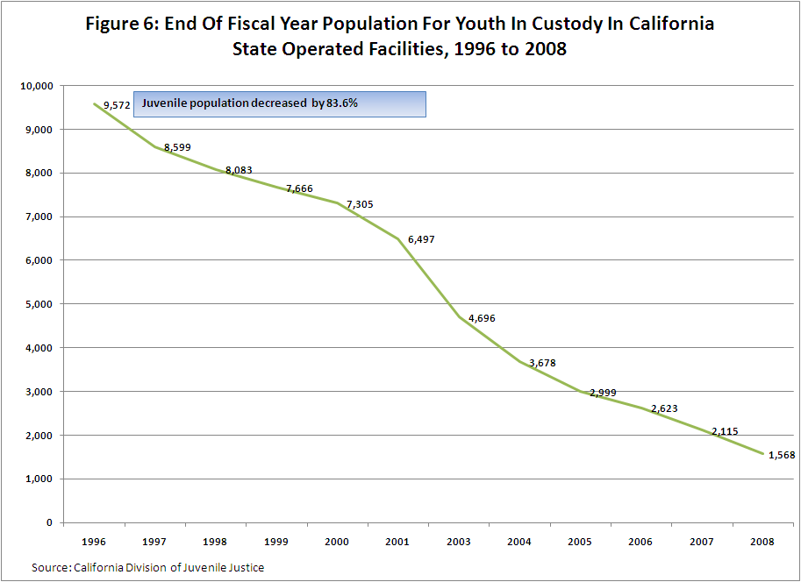

In 1996, after years of criticism about the conditions of confinement in the California’s juvenile prisons, media and academic exposes, and unacceptably high recidivism rates, the California legislature passed a law charging counties on a sliding scale for the state confinement of non-violent youth. This initiated a sharp decline in the population of what was then known as the California Youth Authority.
Still, conditions of confinement continued to be appalling. In 2004, there were several suicides in CYA facilities. In 2005, guards at the Chaderjian youth facility were videotaped beating young wards who lay helpless on the floor. The tape aired in newscasts up and down the state, and state Senator Gloria Romero took this opportunity to call for major system reforms. Public outcry reached a fever pitch, legislative hearings ensued, and the Prison Law Office, a non-profit prisoners’ rights group, filed the Farrell v. Cate law suit. That suit resulted in a Consent Decree requiring the state to implement a set of six remedial plans guaranteeing ward safety, improving conditions of confinement and upgrading its education, health care, sex offender treatment and other programs.
To implement these court-ordered changes, the Legislature began to pour hundreds of millions of dollars into the state’s youth corrections system. This, combined with the population decline and the state’s refusal to close partially filled facilities, drove the unit cost of state youth confinement to new heights. Between 1996 and 2008, annual institutional costs in California’s training schools rose almost seven-fold, from $36,000 per ward per year to $ 252,000.
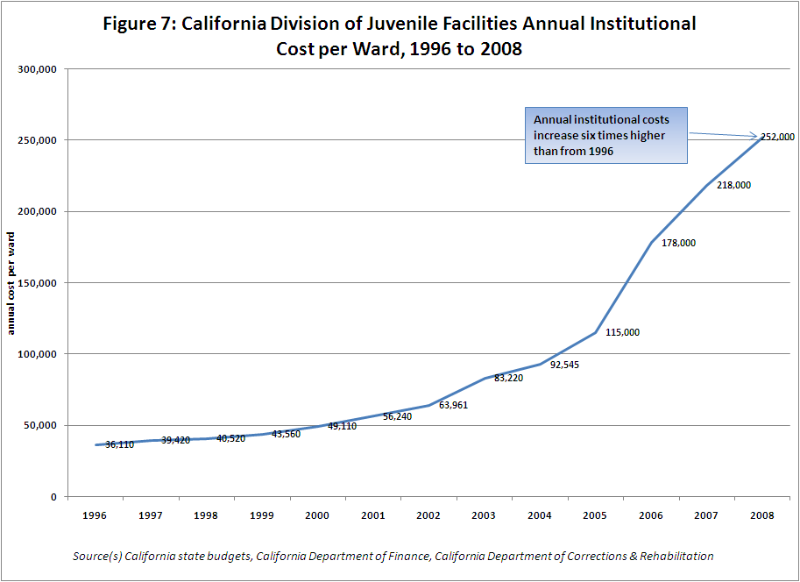
For literally decades, state policy makers and advocates had been discussing the realignment of juvenile justice from the behemoth state system to counties, but could not agree upon the mechanism and a dollar figure for diverted youth. A string of California Governors protected the troubled state youth agency as a “tough on crime” political necessity. County governments turned away from realignment because they were afraid the state would not provide adequate funds for the caseload shift—a fear based in part on their disappointing experience with California’s old “Probation Subsidy” program, in which counties were charged for sending offenders to state prison but received ever-decreasing funds from the state to fund alternative programs. These obstacles to realignment began to evaporate as the cost of operating the state system approached $250,000 per youth per year. Aghast at the cost and under pressure from advocates and disgruntled lawmakers, Governor Arnold Schwarzenegger finally offered counties a youth corrections realignment deal they could live with.
The result, in 2007, was the landmark California youth corrections realignment measure known as Senate Bill 81. SB 81 banned all future commitments of non-violent youth to the state system, allowing state commitment only if the youth was found to have committed an offense on the statutory list of crimes for which juveniles could be tried as adults. SB 81 phased all currently confined non-violent youth out of state custody. Importantly, SB 81 established a state Youthful Offender Block Grant fund that paid counties the equivalent of $117,000 for each non-violent youth retained by or returned to county control. This subsidy to counties is meant to be on-going, renewed from year to year. For FY 09-10, this fund provided nearly $100 million to counties based on a statutory distribution formula. Modest one-time funding ($100 million) was also made available to renovate or build new county juvenile facilities.
Since its enactment in 2007, the realignment package has caused a rapid decline in the state youth training school population, from 2,500 to 1,500 inmates within two years.
While an analysis of the impact of California’s dwindling state training school population on juvenile crime rates is beyond the scope of this chapter, changes in California’s youth crime rates at least support the contention that the massive downsizing of state juvenile corrections in California has not created a juvenile crime wave in the Golden State. While the incarcerated state youth population in California declined by 83.6% from 1996 to 2008, the juvenile arrest rate per 100,000 juveniles declined by 32.2%. Meanwhile, as the adult prison population was increasing by 21.2%, the adult arrest rate per 100,000 declined by a more modest 14.5%. So, despite the fact that the State of California made very deliberate, dichotomous choices about the use of incarceration for its adult and juvenile population, substantially increasing its adult prison population while substantially decreasing its population of confined juveniles, juvenile arrest rates fell at more than twice the rate of the decline in adult arrests.
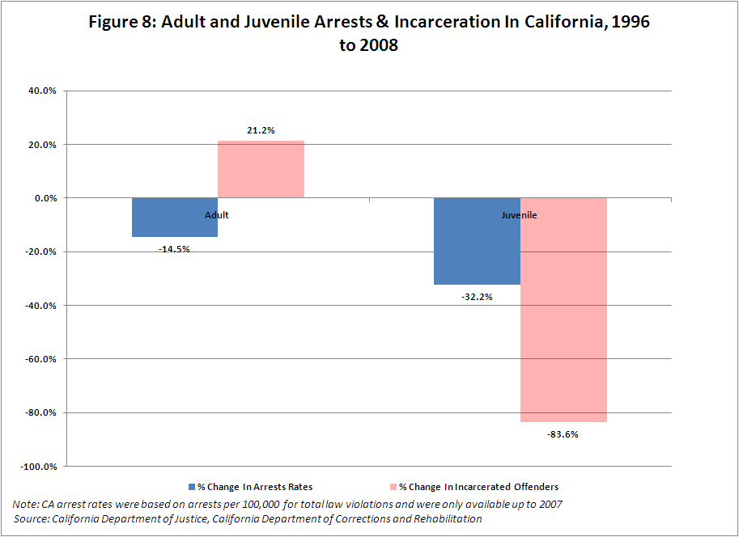

Recently, lawyers from the Prison Law Office moved to place the remainder of the state system into receivership for the state’s alleged failure to comply with the terms of the Consent Decree. The state’s Little Hoover Commission and the California Legislative Analyst Office have both called for the complete closure of the state juvenile corrections system, recommending a full realignment of youth corrections to the counties. As of the writing of this article, the fate of the remaining vestige of the once largest and arguably, most notorious, juvenile justice agency in the nation hangs very much in the balance.
Although its primary focus is on pre-adjudicated, detained populations, no narrative of the juvenile deinstitutionalization movement would be complete without including a discussion of the Juvenile Detention Alternatives Initiative (JDAI), pioneered by the Annie E. Casey Foundation. JDAI, which has been in effect since 1994, is an initiative that brings together a jurisdiction’s key stakeholders to “right size” their use of juvenile detention, improve risk screening, decrease case processing times, improve/expand alternatives to detention, and reduce disproportionate detention of minority youth. Started fifteen years ago as a pilot in 5 sites, JDAI is now operating in 110 jurisdictions in 27 states and the District of Columbia. By August 2009, JDAI sites will be home to 35% of the nation’s young people.
During its impressive replication period, JDAI boasts the following accomplishments:
- JDAI sites have seen their detention populations decline by 35% vs. pre-JDAI, in excess of the declines witnessed in non-JDAI jurisdictions.
- From 2003 to 2006, JDAI sites witnessed a greater reduction in detention population than the remainder of U.S. jurisdictions, combined.
- JDAI model sites Bernalillo County (Albuquerque), New Mexico, Multnomah County (Portland), Oregon, and Santa Cruz County, California, have experienced declines in juvenile arrests for serious offenses of 27 percent, 43 percent and 46 percent, respectively, a far better decline than juvenile violent arrests for the same time period nationally.
- Twenty-seven JDAI sites have closed detention units or whole facilities and a handful of others have obviated the need to construct new facilities, saving taxpayers millions of dollars in construction and operation costs.
For the purposes of this paper, whose focus is on training school populations, there is increasing evidence that, in addition to salutary impacts on detention populations, successful JDAI sites are also experiencing reductions in training school commitments. Given the connection between detention and subsequent conviction and incarceration, this is hardly surprising.
Cook County (Chicago), Illinois, another of JDAI’s model sites, reduced state training school commitments by half between 1997 and 2004, while model site Santa Cruz eliminated state corrections commitments entirely and reduced commitments to its county ranch from 35 to 5 and to residential treatment from 104 to 38 from 1996 to 2005. JDAI sites in Virginia reduced commitments by 45 percent, while Alabama’s JDAI counties reduced commitments by 27 percent. Overall, combined JDAI sites committed 2,015 fewer youth to state training schools in 2007 than they did prior to joining JDAI, a 23 percent decline. Data like these have prompted the Casey Foundation to announce the future expansion of JDAI to focus on training school populations as well as detention.

THE END OF THE REFORM SCHOOL?

It is certainly too soon to sound the death knell for America’s 168 year experiment with the reform school. Despite ample evidence as to the negative outcomes of training school commitments both in terms of well-documented abuses of youth in custody, exacerbating effects on recidivism, and debilitating impacts on mental health, education and employment, the training school model remains the bulwark of most state systems in the 21st Century.
However, there are many promising signs that the reform school’s veneer is irreparably cracked, particularly in comparison to the continued growth of America’s prisons. The United States Justice Department and numerous research organizations are promoting the use of evidence-based practices targeted at training school-bound youth that achieve far better outcomes. More asset-based “Positive Youth Development” programs are showing promising initial signs in the District of Columbia. The State of Missouri, and now the District of Columbia, have closed their training schools and opened significantly smaller rehabilitative programs in their place, utilizing asset-based approaches as their underpinning.
More than two-thirds of America’s states have reduced institutional populations since the advent of the new millennium. The nation’s largest three states, California, Texas and New York, have actively and successfully promoted policies to reduce state training school commitments by 84%, 51% and 37%, respectfully. New York City’s former Probation Commissioner has proposed committing no New York City youth to state training schools (something which San Francisco, San Jose and Santa Clara counties in California have already achieved) and California’s remaining state training schools are facing the very real possibility of being realigned out of existence.
Policy-makers now have a broad menu of approaches to achieve complete deinstitutionalization and replacement of their training school-based systems with a Positive Youth Development/evidence-based continuum of care which, at its deepest end, utilizes small, home-like, Missouri-style facilities that promote rehabilitation and family/community reintegration. The available evidence and experience recommends such an approach over the current institution-based system. If juvenile justice leaders and policy makers pay attention to this kind of evidence, they might truly bring about the End of the Reform School.

End Notes ? See Jerry M. v. District of Columbia, Civil Action, No. 1519-85 (amended complaint filed April 15, 1986; consent decree entered July 10, 1986).
Interview with Plaintiff’s Counsel Stephanie Harrison, Washington, D.C. Public Defender Service (September 15, 2008).
? “Positive Youth Development” (PYD) is a comprehensive way of thinking about the development of children and youth and the factors that facilitate or impede their individual growth and their achievement of key developmental stages. (Butts et al. 2005, p. 4).
Ironically, in 1971, the Lyman School would be the final training school to be shuttered by Massachusetts Department of Youth Services Secretary Jerome Miller, part of what became America’s first system-wide deinstitutionialization of a state training school system during which five reform schools were closed in a two year period and replaced with small secure facilities and a continuum of community-based programs (e.g., see Edward J. Loughran. The Massachusetts Experience: A Historical Review of Reform in the Department of Youth Services; Social Justice, Vol. 24, 1997).
NB: Evidence based practices like MST, FFT and MTFC are individual programs that do not necessarily equate to systemic reform. Positive Youth Development is a paradigm shift which reconceptualizes the focus of juvenile justice efforts from deficit-based to asset-based. For more about establishing an effective continuum of community care, see Greenwood in this volume.
? Recidivism rates were measured by rearaignments in Massachusetts at the time of the NCCD analysis.
? PPC is a peer-helping model designed to improve social competence and cultivate strengths in troubled and troubling youth by demanding responsibility and empowering youth to discover their greatest human potential (www.cachildwelfareclearinghouse.org).
? See Jerry M. v. District of Columbia, Civil Action, No. 1519-85 (amended complaint filed April 15, 1986; consent decree entered July 10, 1986).
? DYRS Research and Quality Assurance Division (data on file with author). In 2005, fully 42% of youth in DYRS’ most secure setting, the Oak Hill Youth Center, were Tier 3 (low offense severity) youth, compared to only 30% who were Tier 1, high severity youth. In December, 2007, the numbers were dramatically different – 59% of Oak Hill youth were Tier 1 youth, while only 10% were Tier 3 youth. In 2005, 19% of the youth committed to DYRS were confined in Oak Hill; 22% were in distant Residential Treatment Centers (“RTCs”); and only 28% were in their own homes. By 2007, 12% of DYRS committed youth were confined in Oak Hill; 11% were in RTCs; and 45% were in their own homes.
See DYRS Research and Quality Assurance Division, DYRS Public Safety Outcomes among DYRS Youth (Oct. 2008) (“Recidivism within 12 months of returning to the community for youth newly committed to DYRS declined by 19% from 2004 to 2007 (from 31% to 25%).
DYRS developed our Structured Decision Making (SDM) with the assistance of the National Council on Crime and Delinquency and in collaboration with the DC Superior Court, the Office of the Attorney General, and DC’s Public Defender Service.
? Interview with Will Harrell, Director of Special Projects, Texas Youth Commission, August 7, 2009.
? Horn, Martin. “Project Zero Presentation at Harvard Kennedy School.” 2008. Project Zero was a finalist in the prestigious Innovations in Government Awards granted by the Kennedy School.
? Children’s Services is New York’s Child Welfare Agency.
? Interview with OCFS Commissioner Joyce Burrell, October 2, 2009.
Margaret Farrell v. Matthew Cate, Civil Action, No. RG 03079344
? New York policy makers should take note here. In 2009, the United States Justice Department investigated several New York facilities and sent a CRIPA Investigation Letter. As of the writing of this chapter, New York officials are in negotiations with the Justice Department over a Consent Decree concerning facility conditions. Meanwhile, in January 2009, New York’s Legal Aid Society filed a class action law suit against OCFS. The downsizing of OCFS facilities, coupled with the increased costs that will almost certainly be attendant upon litigation, could make a California-style realignment of juvenile services to the counties more attractive to both state and county policymakers. Indeed, in the recently-released Task Force for Transforming Juvenile Justice report, New York Governor Patterson’s Task Force recommends a realignment of juvenile services from the State to the counties.
? Mendel, 2009. References Austin, J, Elms, W, Krisberg, B, and Steele, P. (1991). Unlocking Juvenile Corrections: Evaluating The Massachusetts Department of Youth Services. Oakland, CA: National Council on Crime and Delinquency Balfanz, R., Spiridakis, K., Neild, R. and Legters, N. (2003), “Neighborhood Schools and the Juvenile Justice System: How Neither Helps the Other and How that Could Change.” Presented at the School to Jail Pipeline Conference, Harvard University. Benda, B.B. and Tollet, C.L. (1999), “A Study of Recidivism of Serious and Persistent Offenders Among Adolescents,” Journal of Criminal Justice Vol. 27, No. 2 111-126. Bureau of Justice Statistics Correctional Surveys (The National Prisoner Statistics Program,Annual Survey of Jails, Annual Probation Survey, and Annual Parole Survey), 1997 to 2007. Bushway, S.D. (1998), “The Impact of an Arrest on the Job Stability of Young White American Men,” Journal of Research in Crime and Delinquency Vol. 34 No. 4 454-479. Butts, Jeffrey Susan Mayer and Gretchen Ruth, “Focusing Juvenile Justice on Positive Youth Development,” (2005), Issue Brief, Chicago, IL: Chapin Hall Center for Children, University of Chicago. Butts, Jeffrey “A Sensible Model for Juvenile Justice,” (2008), Chicago, IL: Chapin Hall Center for Children, University of Chicago. Clear, TR, Rose, DR, and Rider Judith A. Incarceration and The Community: The Problem of Removing and Returning Offenders. Crime and Delinquency, Vol, 47, No 3. July, 2001. 335-351. Coates, RB, Miller, A D, and Ohlin, L E. Diversity In Youth Correctional System- Handinling Delinquents In Massachusetts. 1978. Cambridge, MA. Ballinger Publishing. Decker, Tim. “The Missouri Division of Youth Services and Juvenile Justice System: Brief Overview.” July 23, 2009. DC Department of Youth Rehabilitation Services Data Reports, 2004 to 2009 Dishion, T. J., McCord, J, and Poulin, F. (1999), “When Interventions Harm: Peer Groups and Problem Behavior.” American Psychologist Vol. 54, No. 9 755-764. Douglass, Abrams E. 2004. Lessons from Juvenile Justice History in the United States, J. Inst. Just. Int’l Stud. 7 Edward J. Loughran. The Massachusetts Experience: A Historical Review of Reform in the Department of Youth Services; Social Justice, Vol. 24, 1997 Elliott, D. S. (1994), “Serious Violent Offenders: Onset, Developmental Course, and Termination. The American Society of Criminology 1993 Presidential Address.” Criminology, Volume 32, Number 1. Forrest, C.B., Tambor, E., Riley, A.W., Ensminger, M.E. and Starfield, B. (2000), “The Health Profile of Incarcerated Male Youths.” Pediatrics Vol. 105, No. 1 286-291. Frabutt, James M, Di Luca, Kristen L, and Graves, Kelly N. 2008. Envisioning A Juvenile Justice System That Supports Positive Youth Development. Notre Dame Journal of Law, Ethics and Public Policy. Freeman, R.B. (1991), Crime and the Employment Disadvantage of Youth, Cambridge, MA: National Bureau of Economic Research. Golub, A. (1990), The Termination Rate of Adult Criminal Careers. Pittsburgh: Carnegie Mellon. Grisso, Thomas (2004), Double Jeopardy: Adolescent Offenders with Mental Disorders. University of Chicago Press. Hayes, L.M. (1999), Suicide Prevention in Juvenile Correction and Detention Facilities. Washington, D.C.: U.S. Department of Justice, Office of Juvenile Justice and Delinquency Prevention. Holman, Barry and Ziedenberg, Jason, The Dangers of Detention: The Impact of Incarcerating Youth in Detention and Other Secure Congregate Facilities. 2006. Baltimore, Maryland: Annie E. Casey Foundation. Kashani, J.H., Manning, G.W., McKnew D.H., Cytryn, L., Simonds, J.F. and Wooderson, P.C. (1980), “Depression Among Incarcerated Delinquents,” Psychiatry Resources Volume 3 185-191. Krisberg, B and Austin, James ( 1998). What Works with Juvenile Offenders: The Massachusetts Experiment. In Dan Macallair and Vincent Schiraldi (Eds), Reforming Juvenile Justice: Reasons and Strategies for the 21st Century, 1998, New York: Kendall Hunt Publishing, pp. 173-196. LeBlanc (1991), Unlocking Learning; Chapter 1 in Correctional Facilities, Washington, DC: US Department of Education. Louisiana Office of Juvenile Justice Research Division, received via email on 8-17-09. Mendel, Richard A. Two Decades of JDAI: From Demonstration Project to National Standard; The Annie E. Casey Foundation. 2009. Miller, Jerome G. (1991). Last One Over the Wall. Ohio State University Press Morias, Betsy. “Close to Home Treatment for Youths Gains Notice.” City Limits Weekly. July 7, 2008. New York City Juvenile Justice Programming; Conference on Evidence-based Re-entry Practice, Research and Policy; Hertogenbosch, Netherlands; November 10, 2009. Parent, D.G., Leiter, V., Kennedy, S., Livens, L., Wentworth, D. and Wilcox, S. (1994), Conditions of Confinement: Juvenile Detention and Corrections Facilities. Washington, D.C.: U.S. Department of Justice, Office of Juvenile Justice and Delinquency Prevention. Schwartz, Robert, “Juvenile Justice and Positive Youth Development,” (2000) in Youth Development: Issues, Challenges and Directions, Philadelphia, PA: Public Private Ventures; Shaw, CR and McKay, HD (1942) Juvenile delinquency and urban areas. Chicago: University of Chicago Press. Sickmund, Melissa. National & State Trends in Residential Placement of Juvenile Offenders: 1995-2008. OJJDP Fact Sheet. Washington, DC: Office of Juvenile Justice and Delinquency Prevention. (forthcoming). Texas Youth Commission Research Division Data Report, received via email on 8-17-2009. Western, Bruce and Beckett, Katherine (1999), “How Unregulated Is the U.S. Labor Market?: The Penal System as a Labor Market Institution,” The American Journal of Sociology, 104: 1030-1060. Websites 2009 New York Task Force on Reforming Transforming Juvenile Justice Report accessed on January 1, 2010 from http://www.vera.org/paterson-task-force-juvenile-justice-report. California Department of Corrections and Rehabilitation website, Spring Adult Population Projection Reports 2003 to 2009 - accessed on 8-11-09 from (www.cdcr.ca.gov) California Department Corrections and Rehabilitation Division of Juvenile Justice website, Juvenile Population Projection Reports 2003 to 2009- accessed on 8-11-09 from (www.cdcr.ca.gov) California Department of Justice website, Crime Data Report 1994 to 2008-accessed on 8-11-09 from (www.ag.ca.gov/crime.php). Human Rights Watch website. South Dakota: Stop Abuses of Detained Kids (http://www.hrw.org/en/news/2000/03/05/south-dakota-stop-abuses-detained-kids) accessed on July 5, 2009. MST services website, accessed on August 15, 2009 from mstservices.com/text/research.html New York City Department of Probation website. A Brief History of Probation. (http://www.nyc.gov/html/prob/html/about/history.shtml), accessed on July 5, 2009. New York State Office of Children and Family Services: Division of Juvenile Justice and Opportunities for Youth, Youth in Care: 2007 Annual Report-accessed on 8-14-09 from (www.ocfs.state.ny.us) New York Finds Extreme Crisis in Youth Prisons, Nicholas Confessore , The New York Times, December 13, 2009 accessed on January 1, 2009 from http://www.nytimes.com/2009/12/14/nyregion/14juvenile.html?_r=1&hp. Strengthening America’s Families website, accessed on August 15, 2009 from www.strengtheningfamilies.org/html/programs_1999/01_FFT.html Texas Department of Public Safety website, accessed on November 12, 2009, http://www.txdps.state.tx.us/administration/crime_records/pages/crimestatistics.htm TFC Consultants, Inc. website, accessed on August 15, 2009 from www.mtfc.com/mtfca.html. University of Colorado at Boulder Center for the Study of Prevention of Violence website, accessed on August 15, 2009 from www.colorado.edu/cspv/blueprints/modelprograms/MST.html. US Department of Justice CRIPA of State of Mississippi’s Juvenile Justice Facilities, 2003. www.usdoj.gov, accessed on August 15, 2009.

